Assignment # 3
Data Structures & Algorithms

Due Date: 11-10-2019 (10 pm) Marks: 30

Submission Guidelines:

- Submit your assignment only on google classroom within deadline.
- Don’t change the name of text file
- Late submissions of upto 15 mins are allowed with a penalty of 30% on google classroom.
- Name/rename your submission files as “Assig#-batch#-roll#.cpp”, e.g., “Assig02-16-955.cpp”.
- Zero marks will awarded in following cases
  - Code with build errors
  - Submitting assignment through email, slate, or any other way other than the google classroom
  - Submitting after the late deadline

Development of English Dictionary

In this assignment, you will create an English dictionary, where user will enter a word, and your program will show its meaning and other details.
Use Chaining to implement this dictionary. Dictionary data is being provided in the form of a text file.

Define a structure “element”, which should contain two members: one to store a word, and the other for storing its meaning and other details.

struct element
{
string word;
string details;
}

Your program should read the provided text file at the start containing dictionary data, hash the data using chaining method and then present an option to search a word and show its meaning/details. Try to make it user friendly.

Create a HashChain class with insert and search functions. Store the dictionary data into the hash table through chaining at the start.
Your class definition should look like:

HashChain
Table: *list<>
size: int
HashChain(int):
~HashChain();
insert(item): void
search(key): bool

Text File:
- The text file contains less than 36,100 words in a format as shown below.
- You need to skip the blank lines and alphabets (marking the new range of words) present in the dictionary.
- A word in a dictionary can be composed of more than one word like “Absolute majority” as shown below
- You need to separate the word and its meaning/details to store it in the struct element.
- Every word(s) in this dictionary is separated from its meaning with two spaces, so you might use this clue to separate out the word from its meaning.

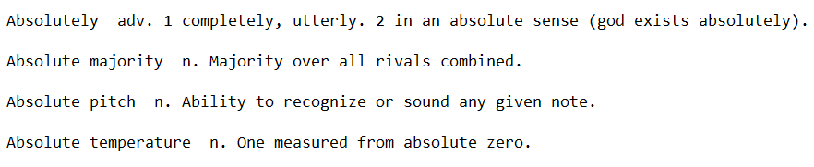

Chaining:
To save up space, create an array of link list of size less than 7000.
You are free to use any hash function
Find out the load factor, which is (Total words)/(Total array slots used)
Experiment with different hash functions in order to lower the value of load factor.
Output the value of the load factor as well.

Submission:
You will submit two files
  - Hashing header file containing the code for HashChain class
  - Source code file

