Dataset Overview
The Airbnb dataset contains 30,478 listings from New York City. It includes 13 columns with different types of information about each listing:
- Host Id: A unique identifier for each host.
- Host Since: The date when the host joined Airbnb.
- Name: The title of the listing.
- Neighbourhood: The area in NYC where the listing is located, like Manhattan or Brooklyn.
- Property Type: The type of property, such as apartment or house.
- Review Scores Rating (bin): A binned version of the review score rating.
- Room Type: The type of accommodation, such as an entire home, private room, or shared room.
- Zipcode: The postal code of the listing.
- Beds: Number of beds in the listing.
- Number of Records: This column contains the same value for all rows.
- Number Of Reviews: Total number of reviews the listing has received.
- Price: The listing price per night in dollars.
- Review Scores Rating: The actual review score given to the listing.
The dataset has 30,478 Airbnb listings with details about properties and their prices. The average price is around 164 dollars, while the median is 125 dollars, which shows there are a few very expensive listings. Most listings have one or two beds, so small apartments and private rooms are common. Many listings have few or no reviews, but some are very popular with hundreds of reviews, so review counts are uneven. Hosts have been active from 2008 to 2015, including both newer and more experienced hosts. The data generally shows moderate pricing and small to medium-sized listings (mostly one or two beds). However, the presence of a few extreme values (like very high prices and review counts) suggests some skewness that we needed to address in the cleaning phase.
Hypothesis
Airbnb listings that offer more privacy (like entire homes), are in popular areas (like Manhattan), are managed by experienced hosts, and have more beds tend to have higher prices.
Data Loading and Cleaning
Before starting the analysis, the dataset was cleaned and prepared to ensure accuracy and consistency. The following steps were taken:
Missing Values:
The dataset was checked for missing values. A few entries in the Host Since and Beds columns were missing. Rows with missing Host Since were removed because they were less than 1% of the total data. The missing values in Beds were replaced with the median value to avoid affecting the overall distribution. All other columns had no missing values.
Data Types:
The data types of each column were examined. Host Since is a date-time column, Beds is numeric, Price is an integer, and Neighbourhood and Room Type are categorical. No changes to data types were needed.
Duplicates:
The dataset was checked for duplicate rows. A total of 2,079 duplicate rows were found and removed. After this step, there were no duplicates remaining in the dataset.
Columns Dropped:
Before analysis, several columns were removed as they were not relevant to the hypothesis or would not provide meaningful insights:
- Host Id: A unique identifier for each host, which does not affect trends or relationships.
- Name: Listing titles are mostly unique text, which is not useful for analyzing pricing patterns.
- Number of Records: This column had the same value for all listings, providing no variability.
- Review Scores Rating (bin) and Review Scores Rating: These columns are either redundant or not required for the current hypothesis.
- Property Type: While informative, it was not considered necessary for examining privacy, location, host experience, or bed count.
- Zipcode: Neighborhood-level analysis is sufficient, so detailed postal codes were not required.
- Number Of Reviews: Not relevant to the hypothesis, which focuses on pricing factors.
By removing these columns, the dataset was simplified to focus only on variables directly related to the hypothesis: Room Type (privacy), Neighbourhood (location), Beds, Host Since (experience), and Price. This step ensures that the analysis remains clear and targeted toward understanding the factors affecting Airbnb pricing.
Feature Engineering
To better understand the influence of host experience on listing prices, a new column called Host Experience Years was created. This column calculates the number of years each host has been active on Airbnb by subtracting the year in the Host Since column from the current year. This new feature allows for easier analysis of whether more experienced hosts tend to have higher listing prices. By converting the Host Since date into a numerical measure, it becomes possible to include host experience in univariate, bivariate, and multivariate analyses.
Uni Variate Analysis
Numerical Variables:
The distribution of numerical variables was examined using histograms.
- Beds: Most listings have 1 or 2 beds, indicating that small apartments and private rooms dominate the market. Very few listings have more than 3 beds.
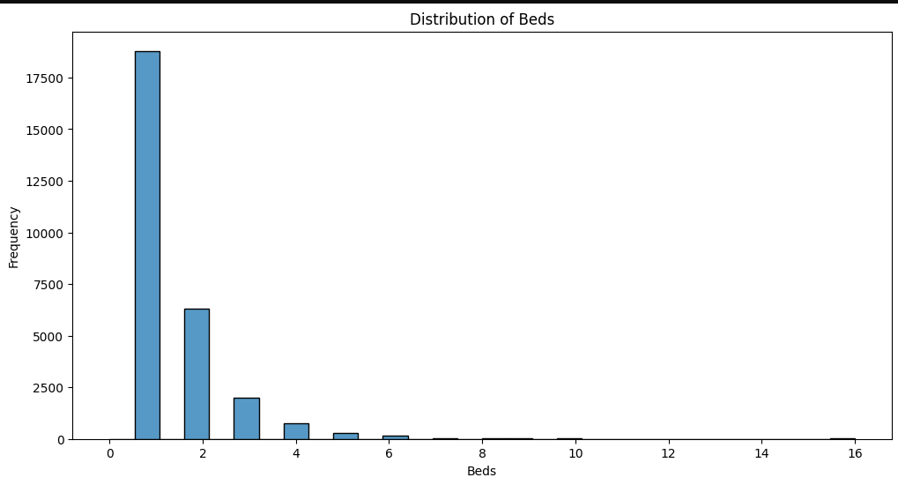
- Price: Most listings are priced under $500, with a few luxury listings reaching very high prices, showing the presence of outliers.
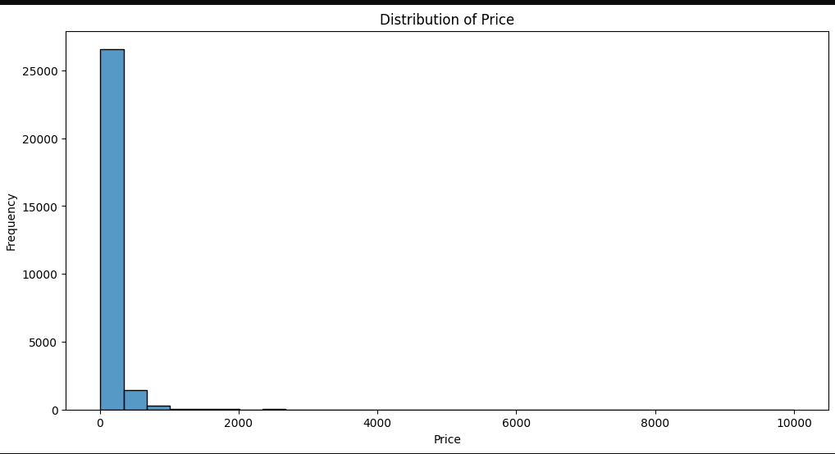
- Host Experience: Most hosts have between 10 and 14 years of experience. The largest group of hosts has around 11 years of experience, and very few hosts exceed 14 years.
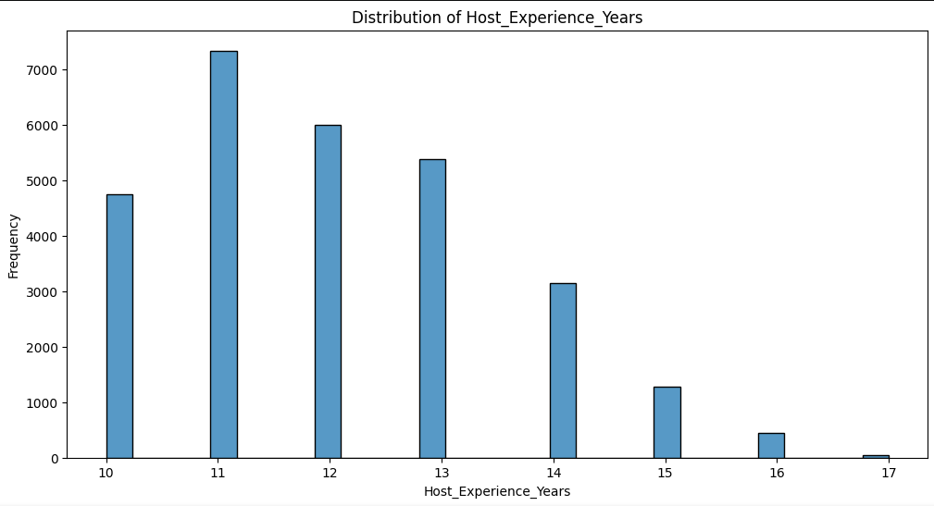
Outlier Detection and Handling:
Box plots were created to detect outliers in numerical variables.
- Price: The boxplot revealed some listings with very high prices compared to most others. To reduce the effect of these outliers and make the analysis clearer, a log transformation was applied.
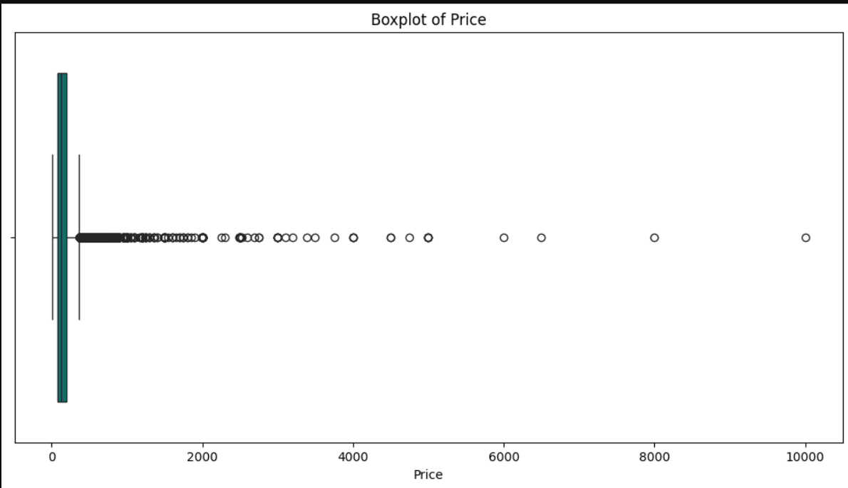
- Beds: The boxplot shows that most listings have 1–2 beds, and there are a few listings with many beds. These extreme values were not transformed since they are meaningful and few in number.
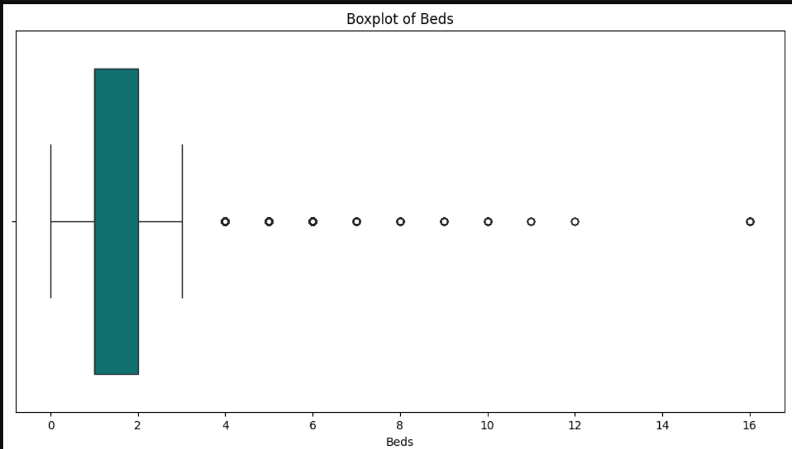
- Host Experience: The boxplot indicates most hosts have 10–14 years of experience, with one or two very experienced hosts being outliers. These were kept as they represent actual host experience and do not distort the data significantly.
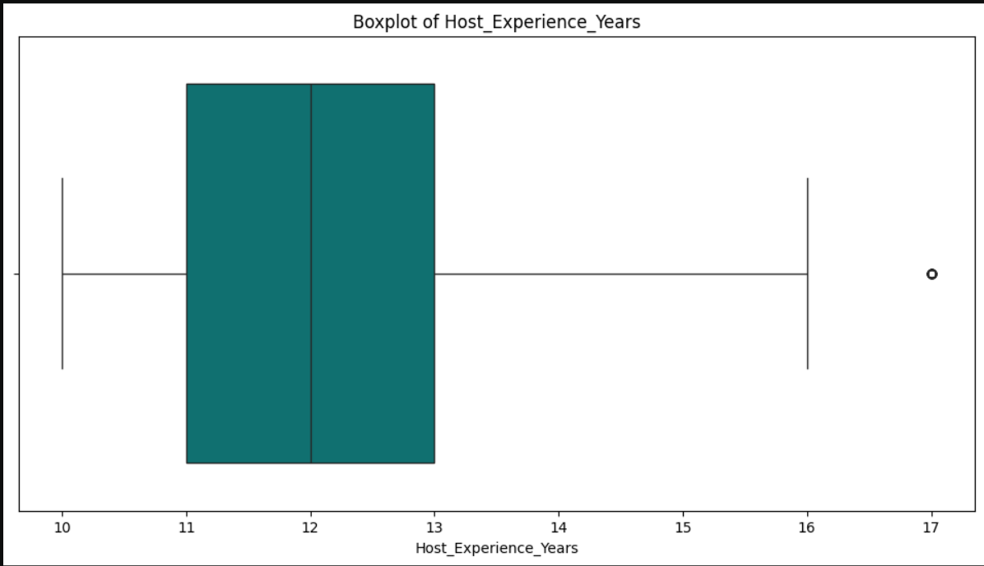
Categorical Variables:
The distribution of categorical variables was examined using count plots.
- Room Type: Most listings are Entire homes or apartments, followed by Private rooms, while Shared rooms are very rare. This shows that most listings are fully or mostly private, while shared rooms are very few.
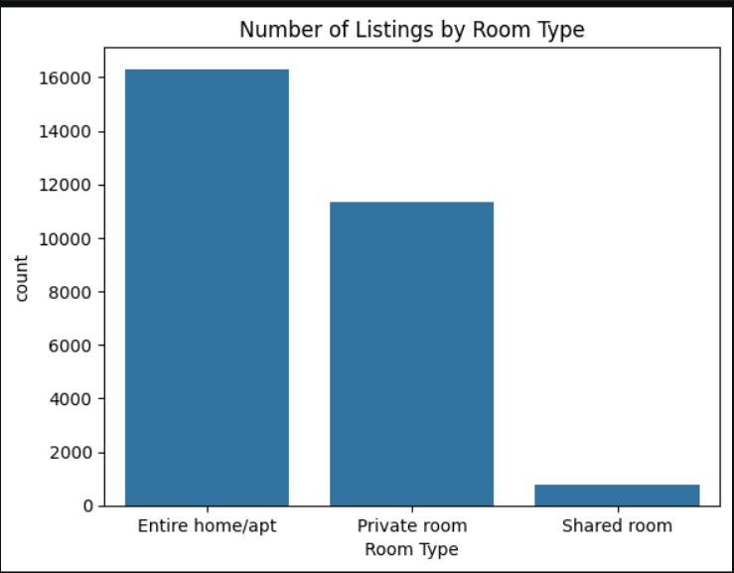
- Neighbourhood: Listings are heavily concentrated in Manhattan and Brooklyn, with Manhattan having the highest number. Queens, the Bronx, and Staten Island have far fewer listings, indicating a strong preference for central and popular areas.
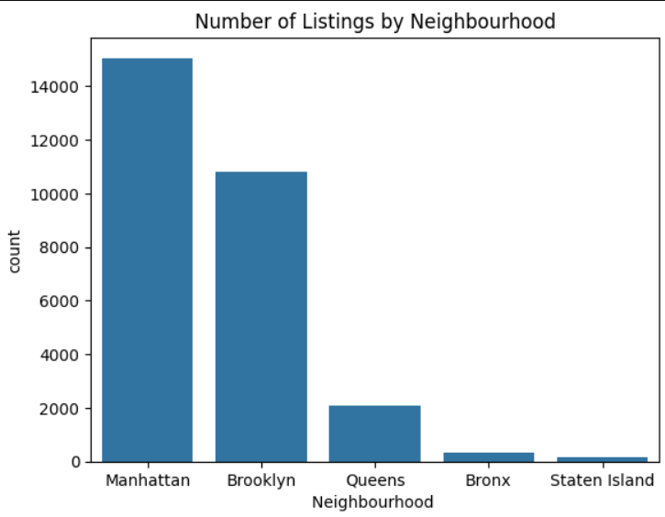
Bi Variate Analysis
Numerical vs Numerical:
- Host Experience vs Price: A scatter plot with a trend line was created to see if host experience affects price. The plot shows that host experience does not have a clear impact on price. Most listings stay at lower prices, and very expensive listings are rare. This does not support the part of our hypothesis that expected more experienced hosts to charge higher prices.
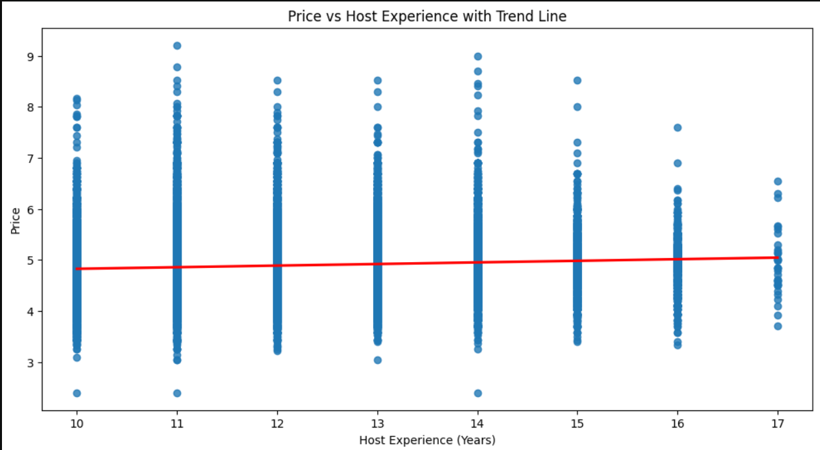

- Beds vs Price: A violin plot was created to check how the number of beds affects price. The plot shows that the number of beds does not strongly influence price. Most listings, no matter how many beds they have, are at lower prices, and the median price is fairly similar across bed counts. This also does not support the hypothesis that larger listings with more beds tend to be more expensive.
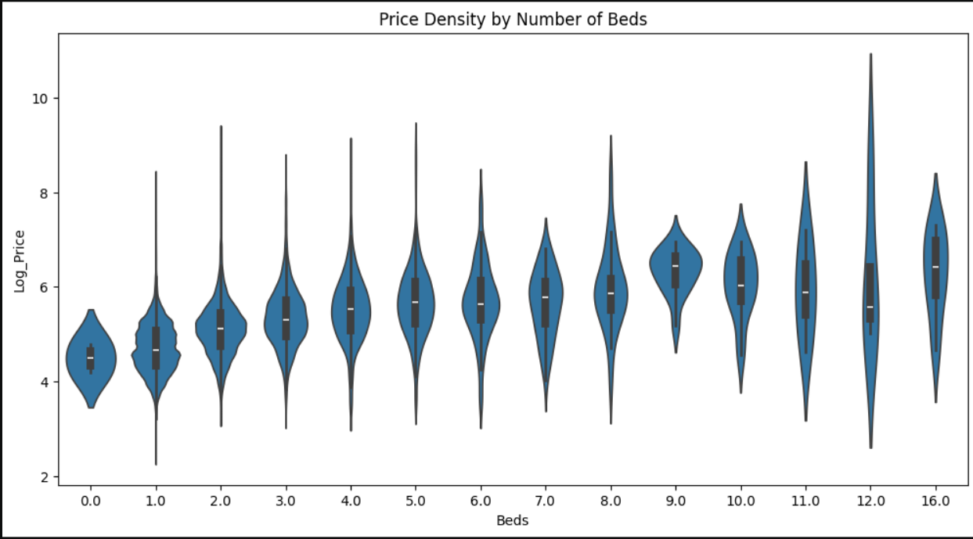
Categorical vs Numerical:
- Room Type vs Price: A box plot was created to see how price varies with room type. Entire homes or apartments are the most expensive, private rooms are moderately priced, and shared rooms are the cheapest. This supports the hypothesis that listings offering more privacy tend to have higher prices.
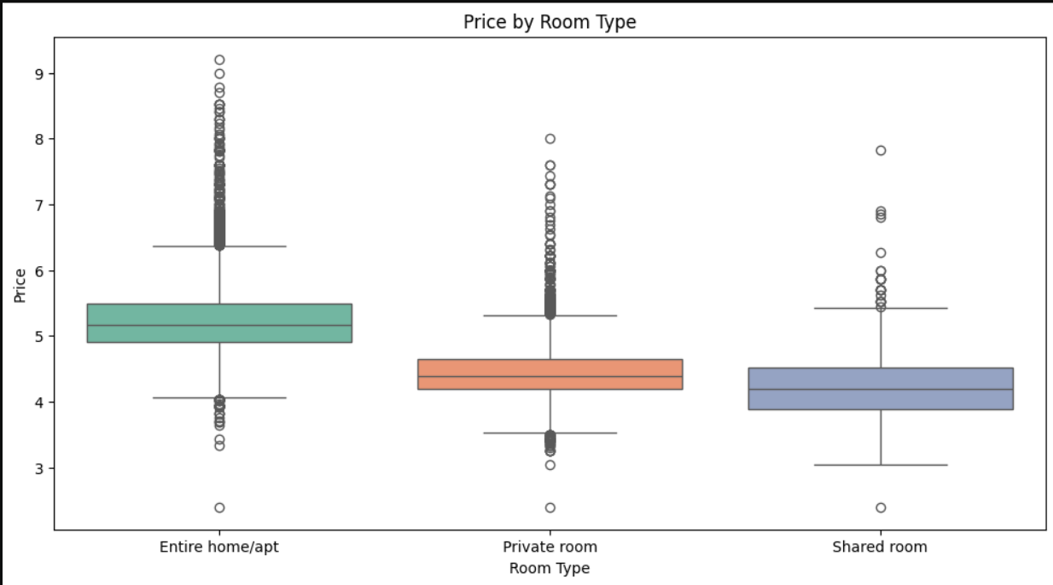

- Neighbourhood vs Price: A box plot was created to examine how price varies across neighborhoods. Manhattan listings are the priciest and show the most variation in price, while the Bronx has the lowest prices. Other neighborhoods fall in between, with a few expensive outliers. This supports the hypothesis that listings in popular areas tend to be more expensive.
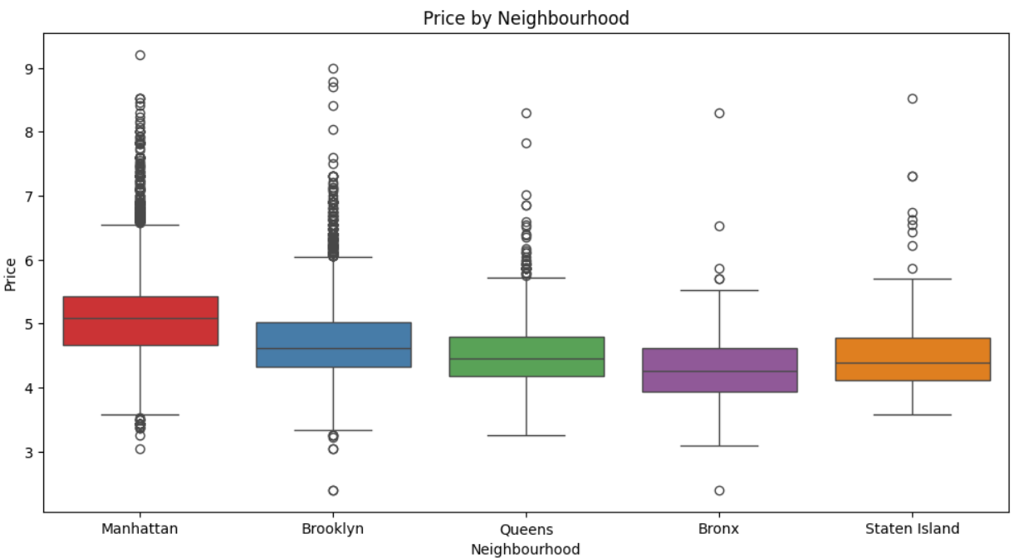

Categorical vs Categorical:
A grouped bar chart was created to compare room types across neighborhoods. Most listings in Manhattan and Brooklyn are entire homes or private rooms, while shared rooms are rare in all areas. The Bronx, Queens, and Staten Island have far fewer listings overall. This supports the hypothesis that more private listings are concentrated in popular areas, which also tend to have higher prices.

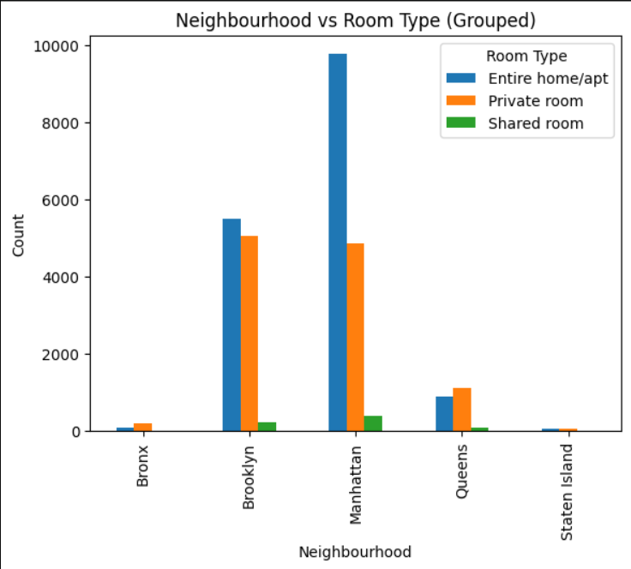
Multivariate Analysis

- A correlation heatmap was created to examine the relationships between numerical variables. Price shows a very weak correlation with host experience, suggesting that host experience does not affect price. Price has a moderate positive correlation with the number of beds, meaning listings with more beds tend to be slightly more expensive, while host experience and number of beds are largely unrelated.
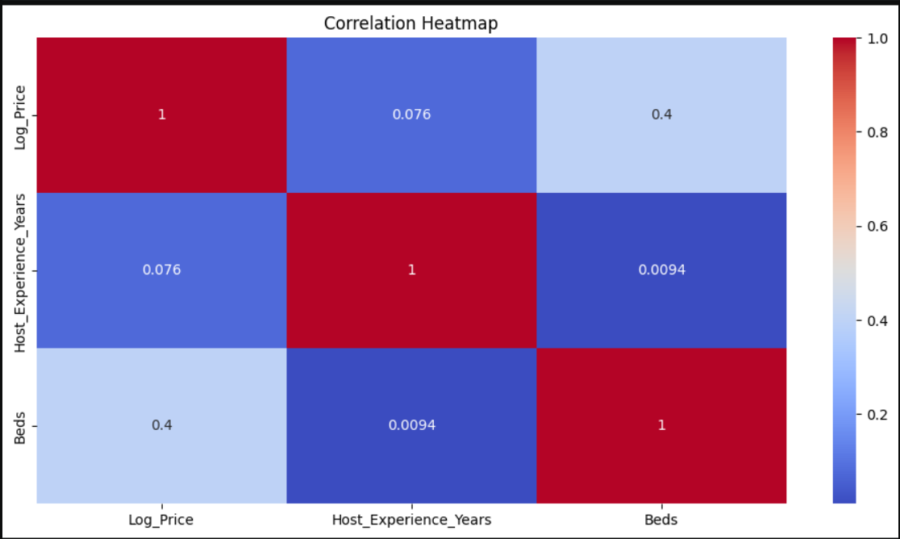

- A box plot was created to explore how price varies by both room type (privacy) and neighborhood (location). Entire homes are the most expensive, private rooms are moderately priced, and shared rooms are the cheapest. Manhattan listings are the priciest, while the Bronx, Queens, and Staten Island are cheaper. Entire homes in Manhattan are the most expensive overall, and shared rooms in outer boroughs are the cheapest.
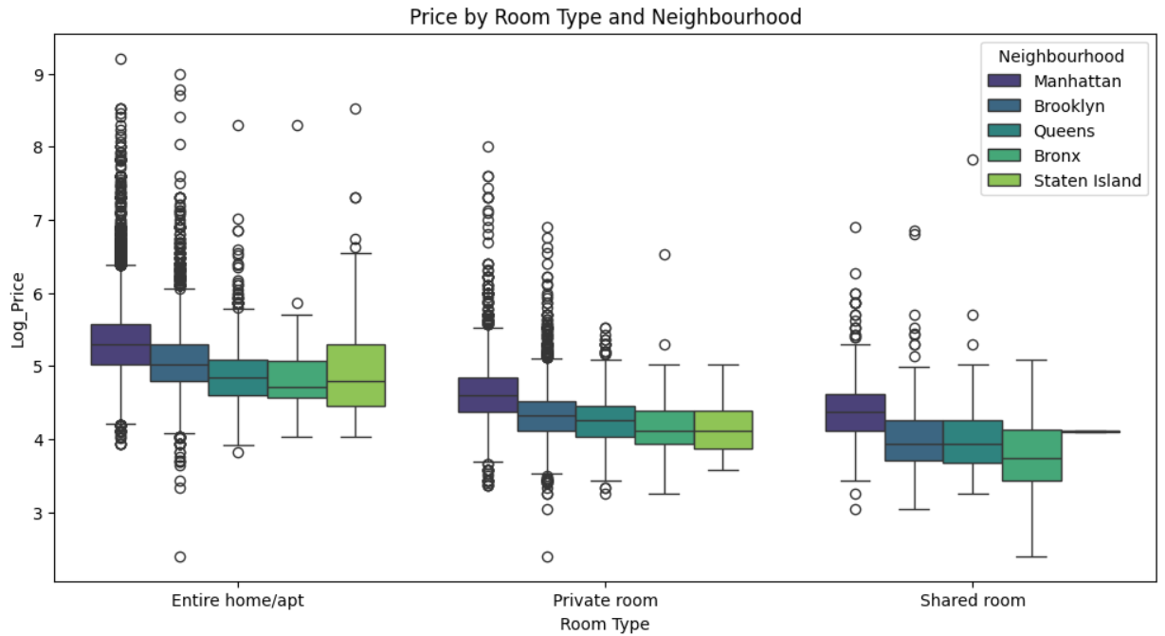
Conclusion
The visual analysis of the Airbnb dataset partially supports the initial hypothesis. Listings that offer more privacy, such as entire homes, and those located in popular areas like Manhattan, tend to have higher prices, confirming the hypothesis for these factors. However, the data shows that host experience and the number of beds do not strongly affect prices, which goes against the hypothesis. In summary, privacy and location clearly influence listing price, while host experience and bed count do not.
Recommendations
For further analysis, it would be helpful to explore reviews, such as how review scores and the number of reviews affect price. It would also be useful to look at neighborhoods in more detail, using Zipcodes to find the most expensive areas within Manhattan or Brooklyn and see how ratings vary by location.

