Assignment
Spring 2026 2nd Semester
Topic(s): Lab 6 Verification Of Kirchhoff’s Laws
SUBMITTED TO:
Mr. Mehmood-ul-Haq
SUBMITTED BY:
Ayesha Naseem (2025-CE-19)
Submission Date: 27 Apr, 2026
Department of Computer Engineering
University of Engineering and Technology Lahore
Main Campus
Course Title: Circuit Analysis Lab
Course Code: CMPE-121L

Experiment 1
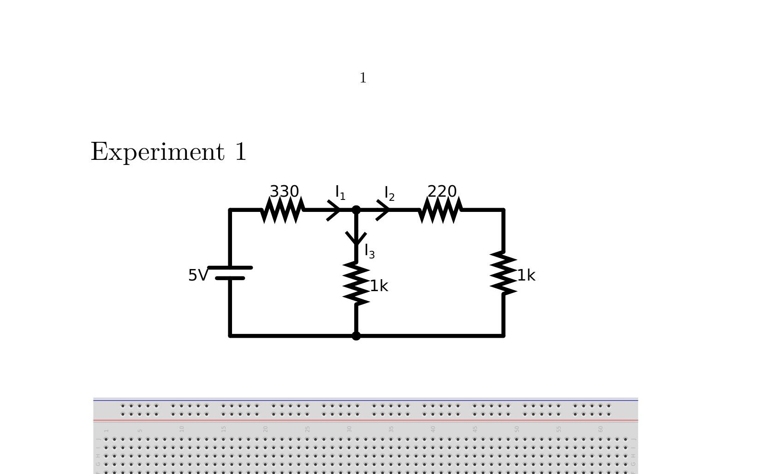
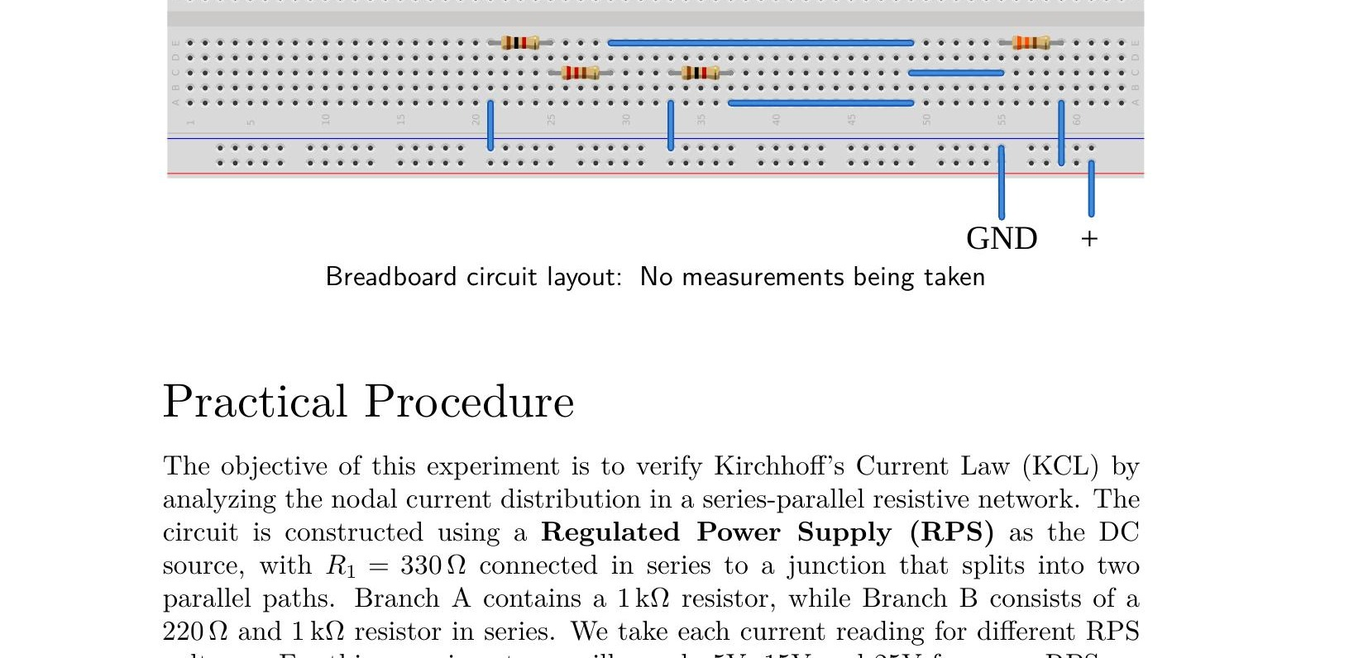
Breadboard circuit layout: No measurements being taken

Practical Procedure
The objective of this experiment is to verify Kirchhoff’s Current Law (KCL) by analyzing the nodal current distribution in a series-parallel resistive network. The circuit is constructed using a Regulated Power Supply (RPS) as the DC source, with R₁ = 330 Ω connected in series to a junction that splits into two parallel paths. Branch A contains a 1 kΩ resistor, while Branch B consists of a 220 Ω and 1 kΩ resistor in series. We take each current reading for different RPS voltages. For this experiment, we will supply 5V, 15V and 25V from our RPS.
To measure the branch currents, the multimeter dial is set to the 20mA or 200mA DC range (indicated by the A— symbol). The black probe is connected to the COM port while the red probe is inserted into the mA μA terminal. Measuring current requires the DMM to be connected in series, which necessitates breaking the circuit at each specific node to allow the charge to flow through the meter.
The total current (I₁) is measured at the output of the RPS, while I₂ and I₃ are captured by placing the meter in series with their respective parallel branches. This arrangement allows us to verify that the current entering the main junction is equal to the sum of the currents exiting through the parallel paths.
Theoretical predictions assume ideal conditions; however, minor discrepancies may be observed in simulated or physical environments. Factors such as the burden voltage of the ammeter and the internal resistance of the connecting leads of the multimeter and/or heat damage and corrosion on the breadboard contact points can introduce slight deviations.
Falstad Simulations – Current I₁
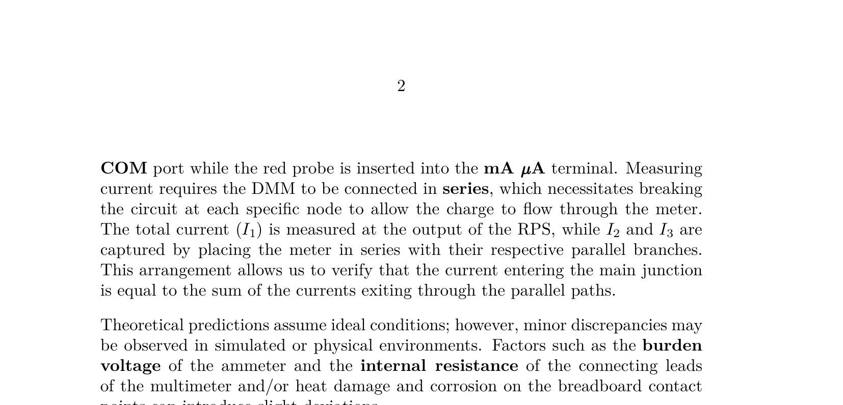
Falstad: Current I₁ due to 5V source

Falstad: Current I₁ due to 15V source

Falstad: Current I₁ due to 25V source
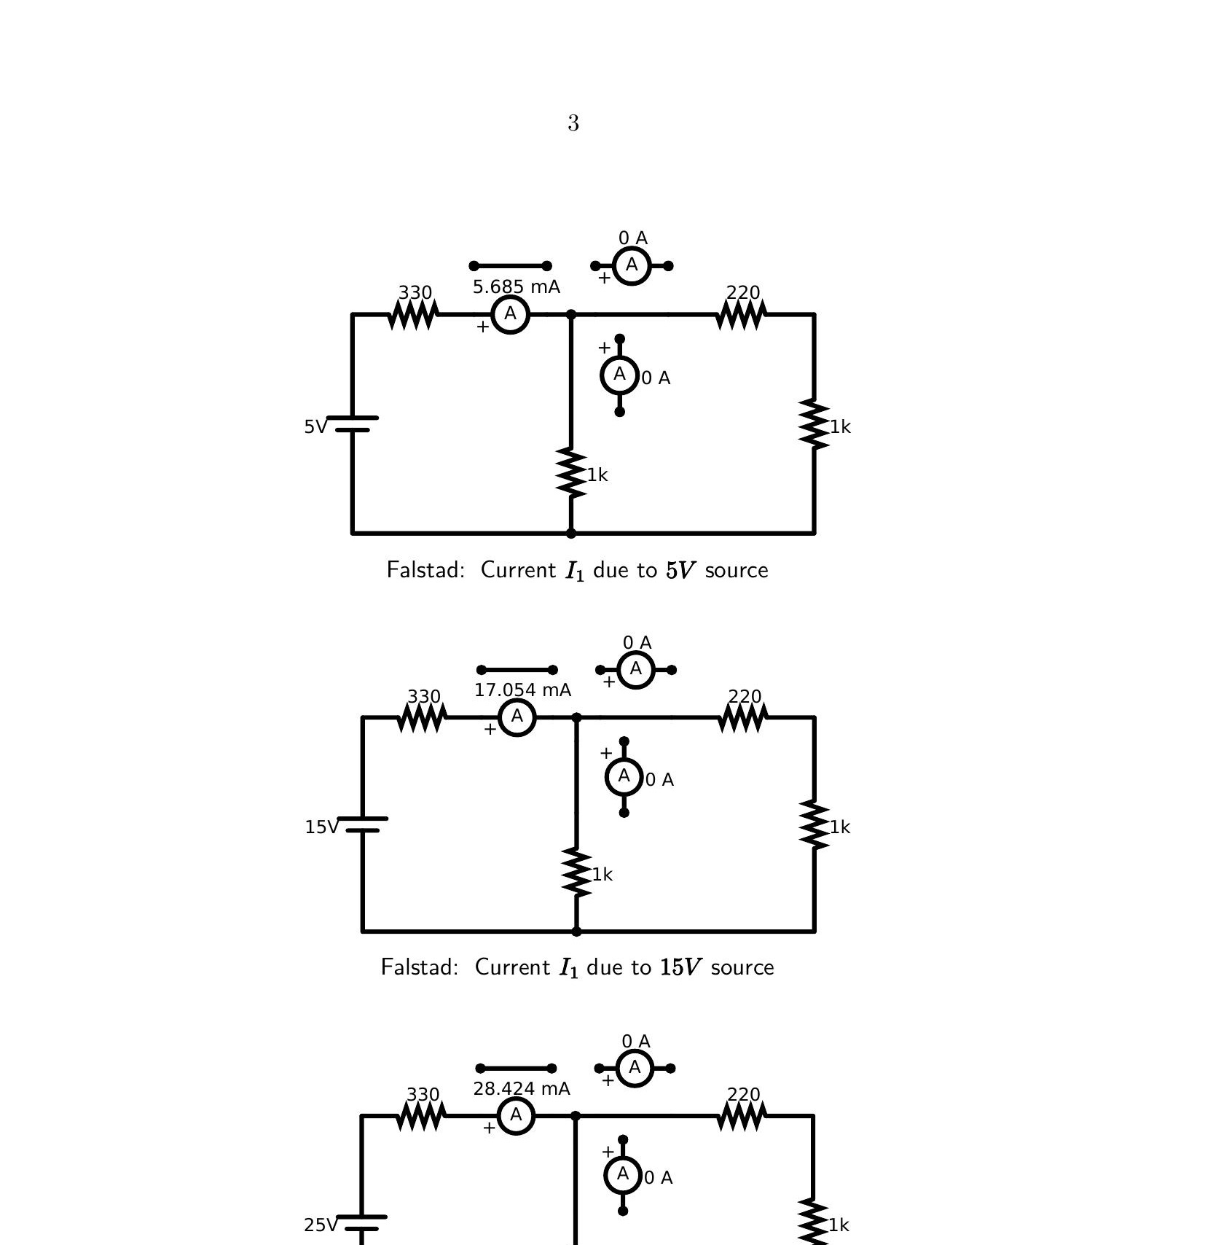
Breadboard circuit layout: Ammeter connection to measure I₁
Falstad Simulations – Current I₂
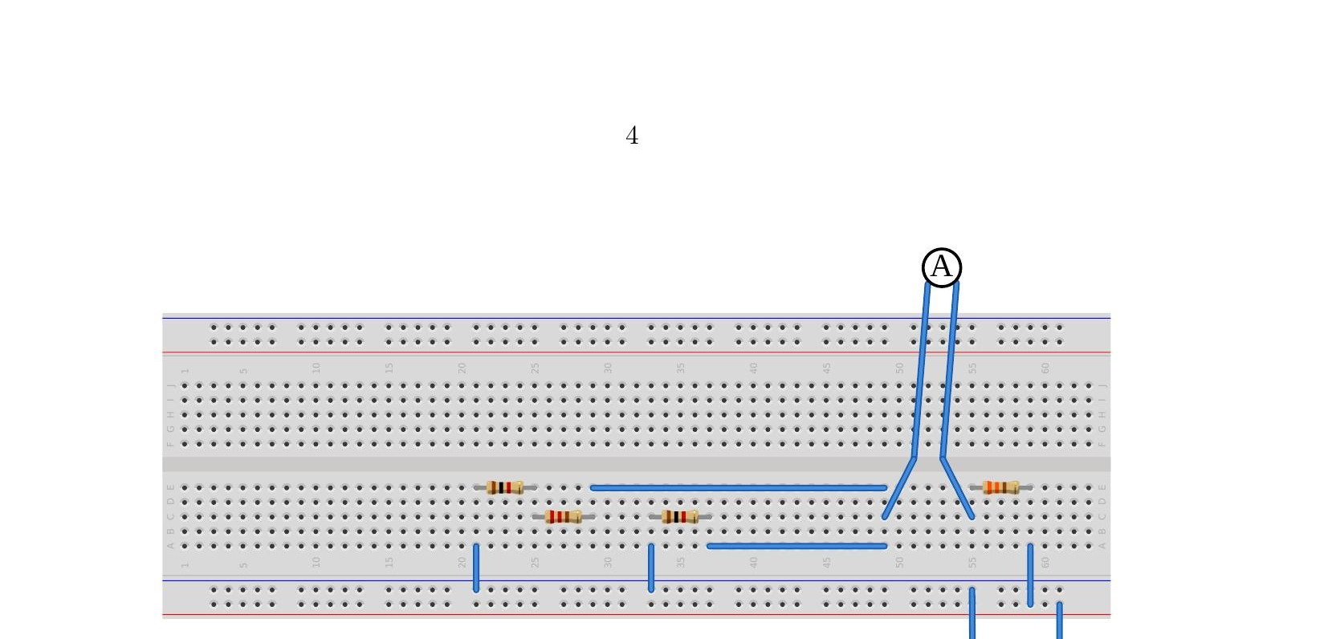
Falstad: Current I₂ due to 5V source
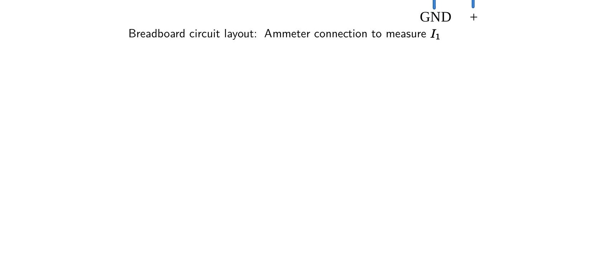
Falstad: Current I₂ due to 15V source

Falstad: Current I₂ due to 25V source
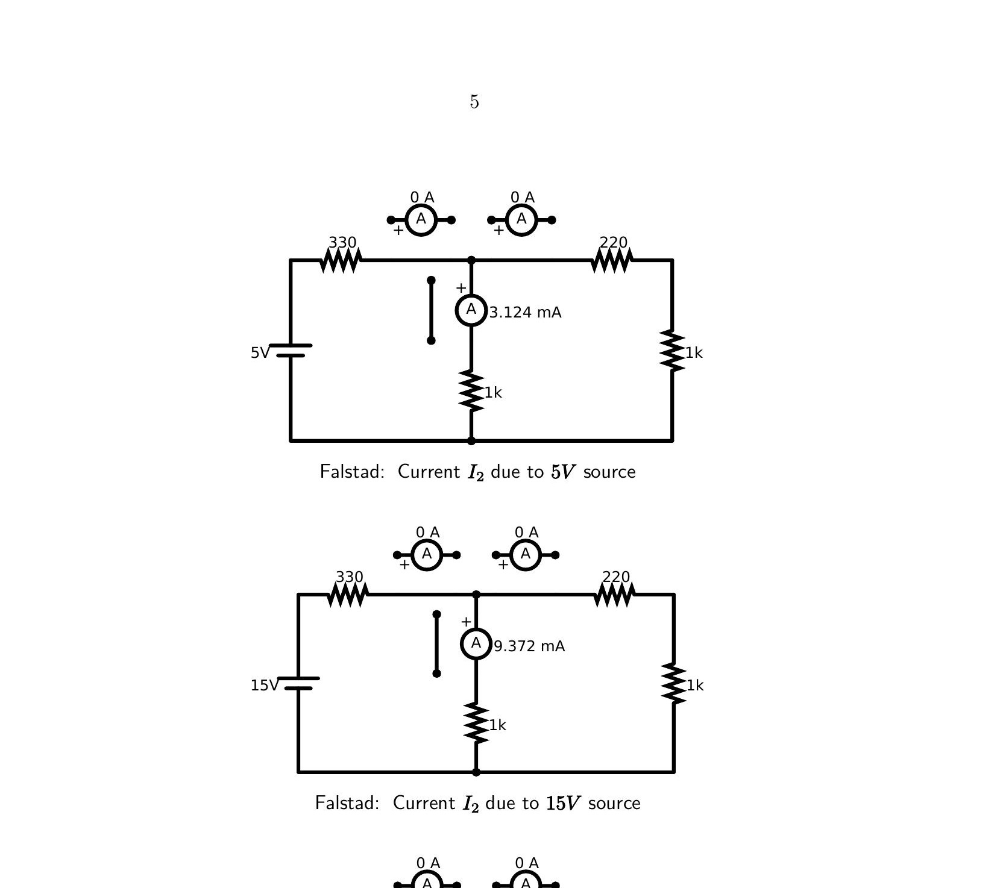
Breadboard circuit layout: Ammeter connection to measure I₂
Falstad Simulations – Current I₃
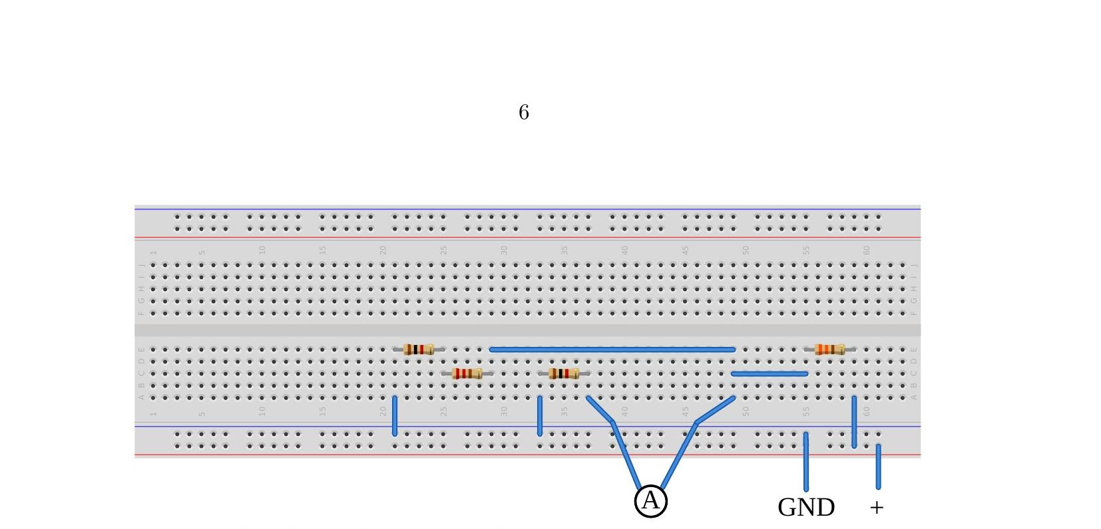
Falstad: Current I₃ due to 5V source
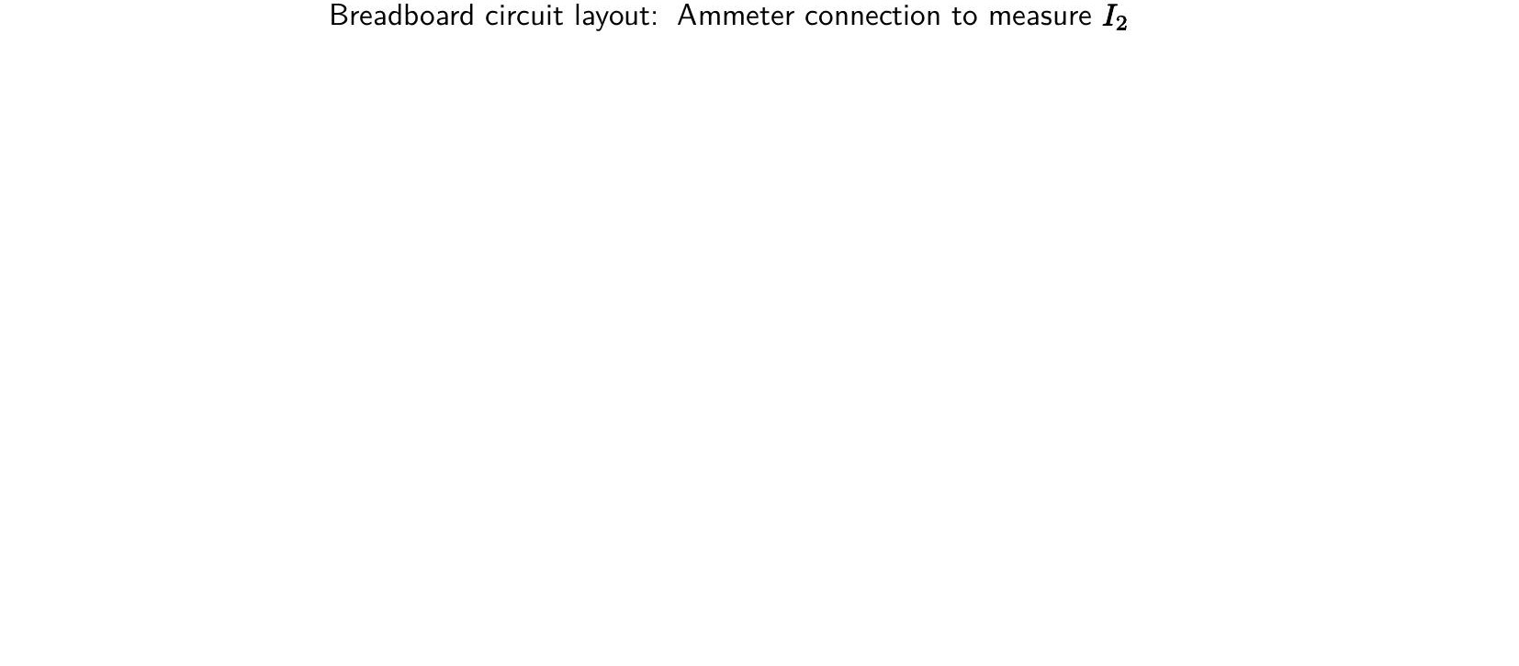
Falstad: Current I₃ due to 15V source

Falstad: Current I₃ due to 25V source
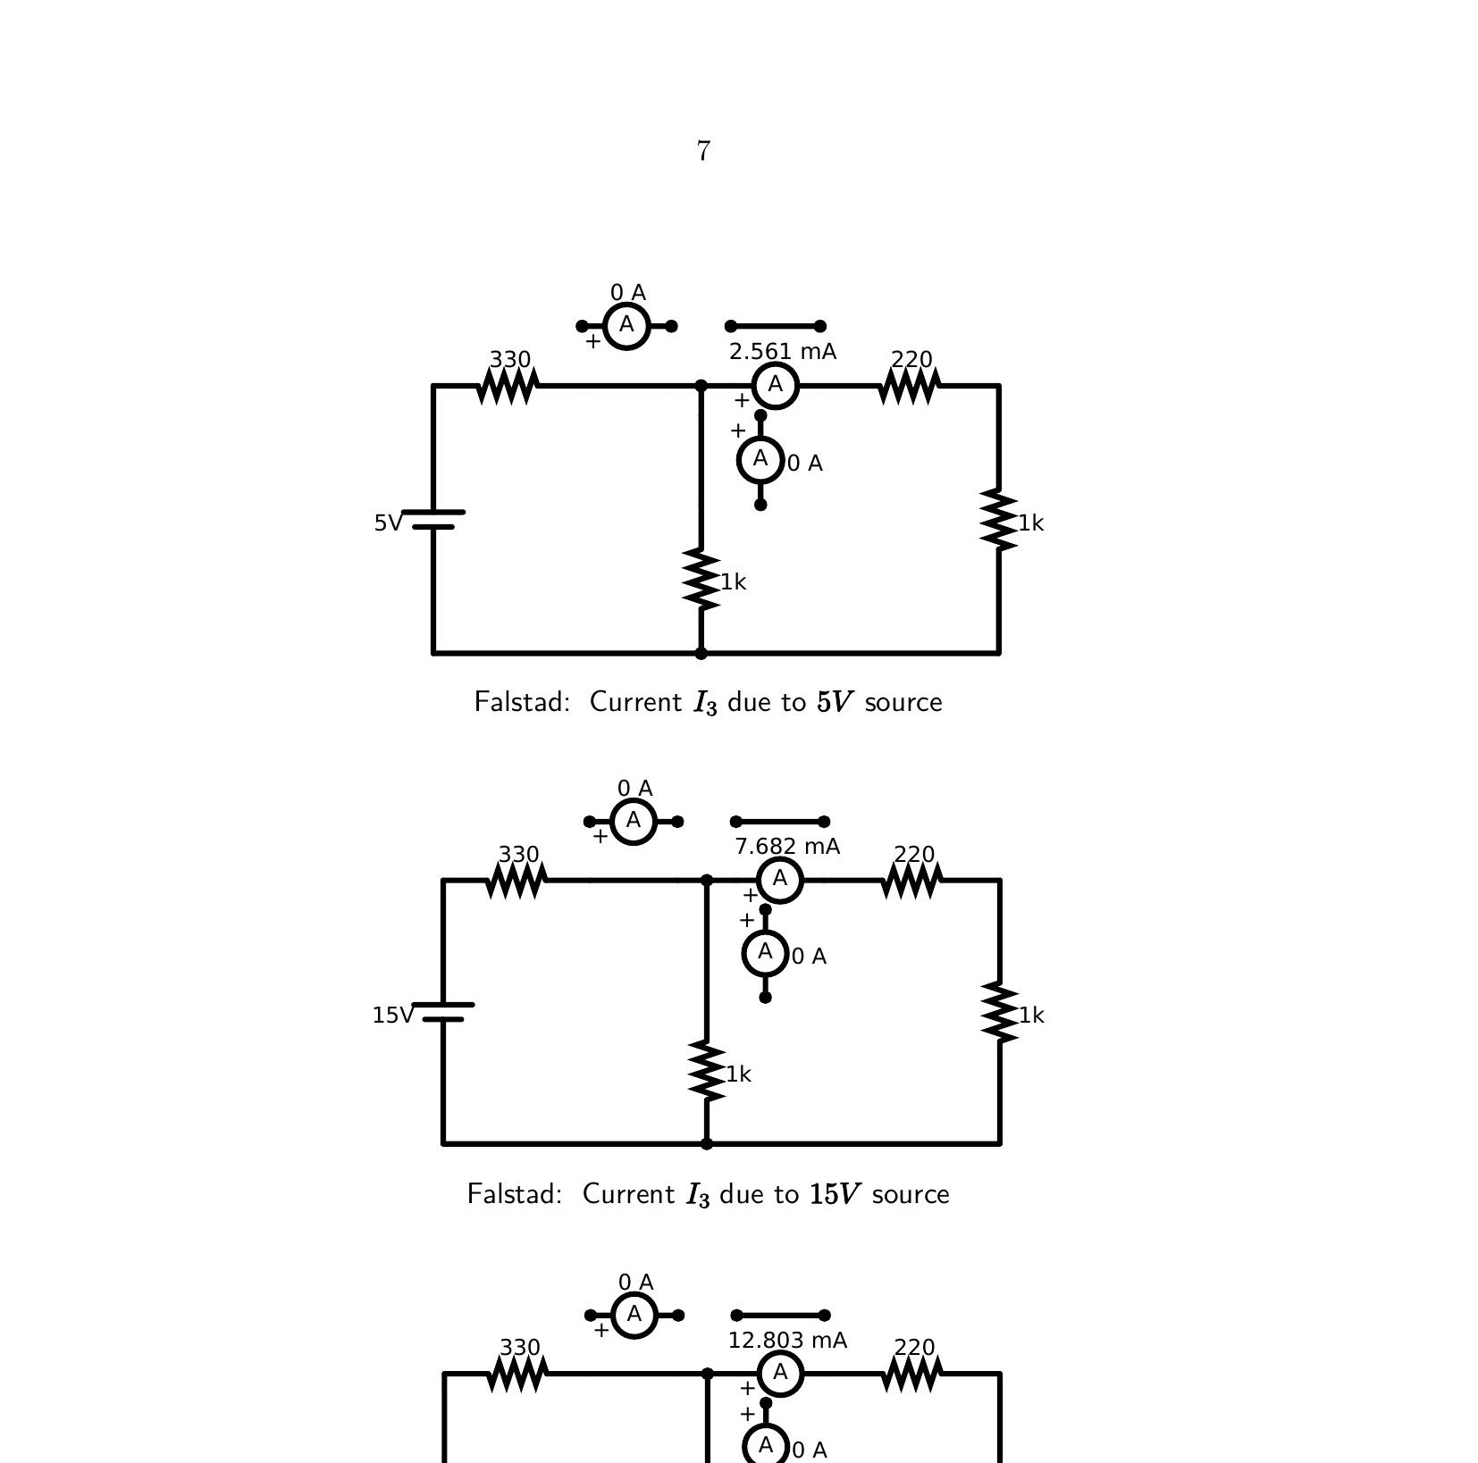
Breadboard circuit layout: Ammeter connection to measure I₃

Experiment 1 Data – Practical Values
Sl. No. | Voltage E | I1 (mA) | I2 (mA) | I3 (mA) | I1 = I2 + I3
1 | 5 | 5.685 | 3.124 | 2.561 | 5.685 = 5.685
2 | 15 | 17.054 | 9.372 | 7.682 | 17.054 = 17.054
3 | 25 | 28.424 | 15.620 | 12.803 | 28.424 ≈ 28.423

Experiment 2
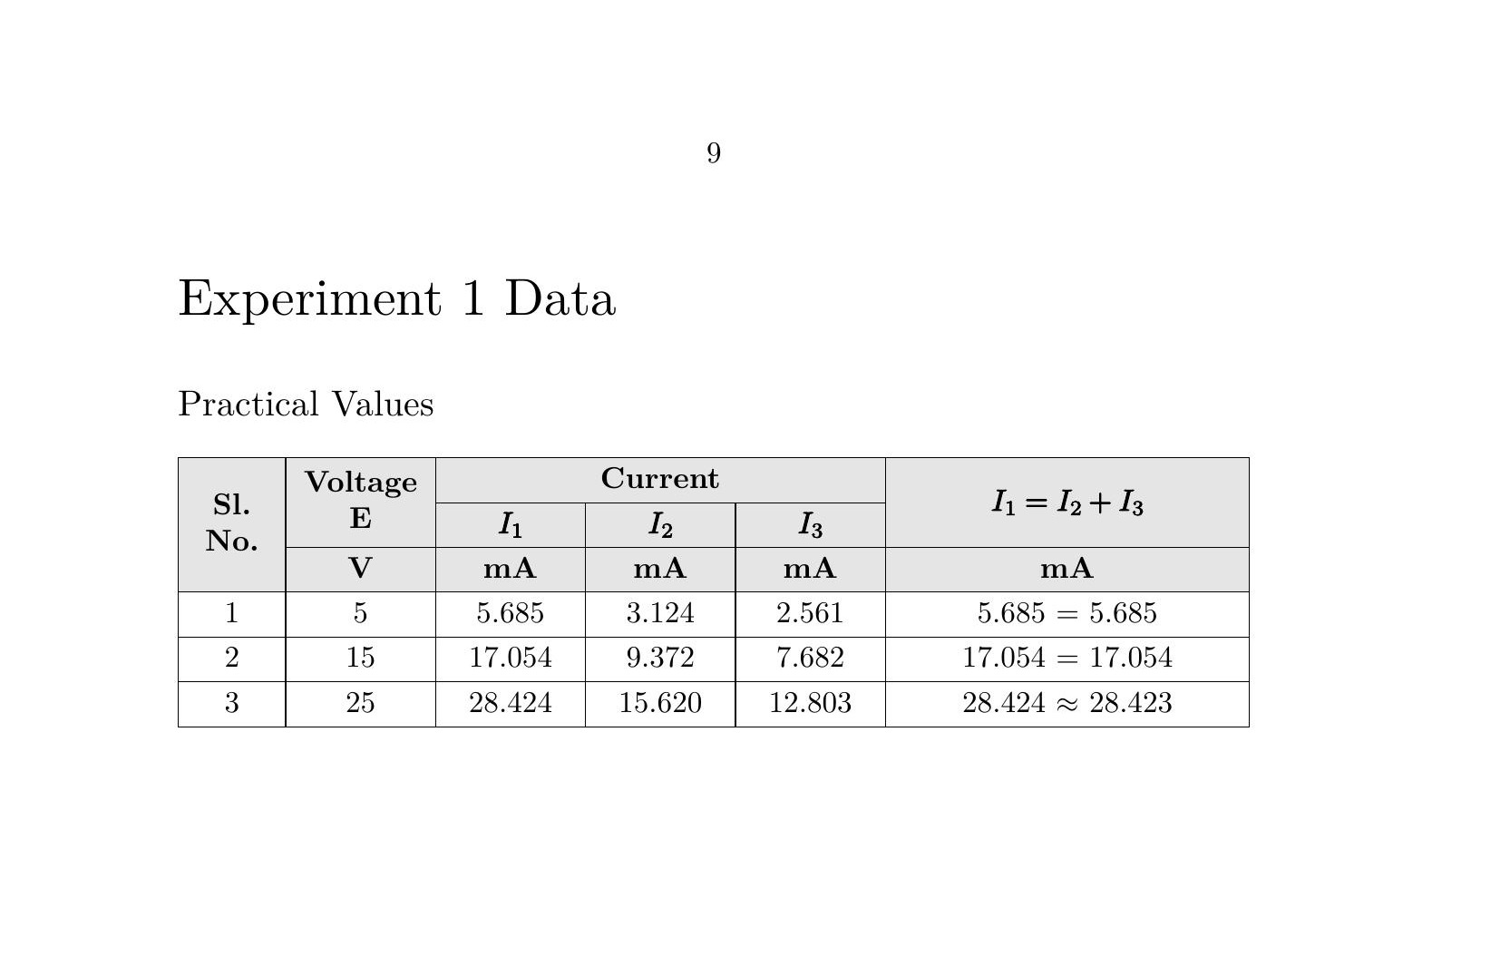

Breadboard circuit layout: No measurement being taken

Practical Procedure
The objective of this experiment is to verify Kirchhoff’s Voltage Law (KVL) by examining the distribution of potential differences across a series-parallel resistive loop. The network is assembled by connecting a 330 Ω resistor in series with a parallel bank composed of a 1 kΩ resistor and a 220 Ω resistor. The circuit is driven by the Regulated Power Supply, and the actual source voltage (E₁) is monitored at increments of 5 V, 10 V, and 15 V to observe how the potential drops scale linearly across the different resistive elements.
For voltage measurements, the multimeter dial is set to the 20V DC range (indicated by the V— symbol). The red probe is inserted into the VΩHz terminal and the black probe into the COM port. To measure the potential drops V₁, V₂, and V₃, the probes are placed in parallel across each resistor. Because V₂ and V₃ are measured across parallel branches, they share common nodes and should yield identical readings. KVL is verified by confirming that the sum of the voltage drop across the series resistor (V₁) and the voltage across the parallel bank (V₂) equals the total electromotive force provided by the RPS.
Discrepancies in KVL measurements typically arise from the loading effect of the voltmeter, which possesses a high but finite internal impedance (typically 10 MΩ). In a physical setup, contact resistance at the breadboard nodes and the precision of the power supply’s voltage regulation can also influence the results.
Falstad Simulations – Voltage V₁
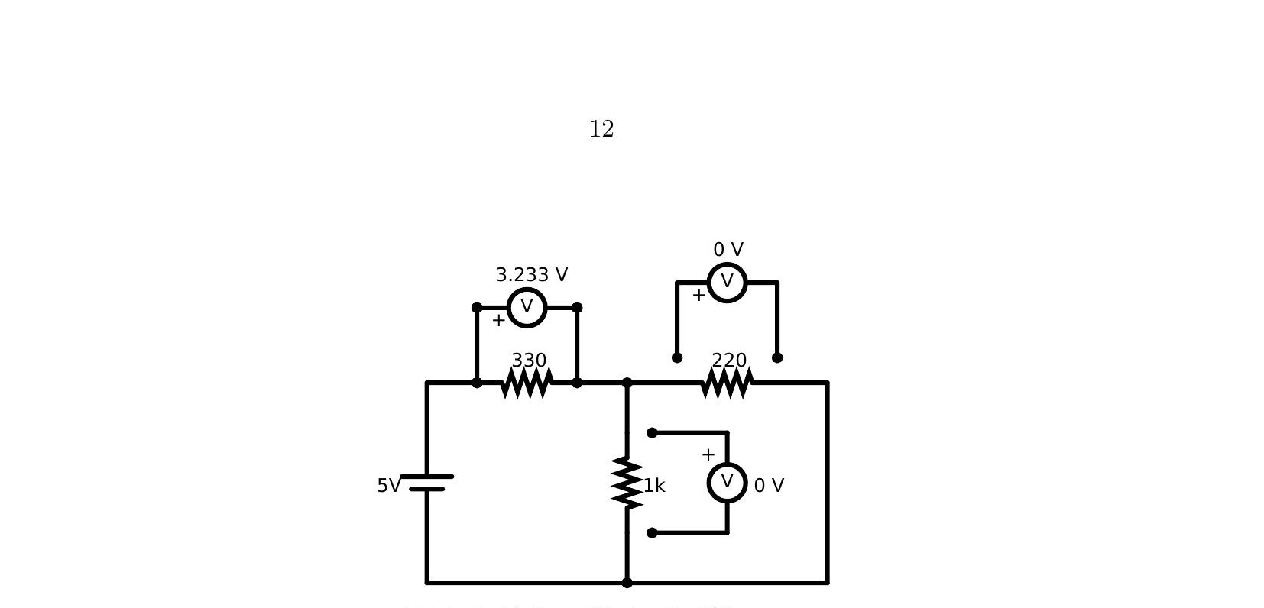
Falstad: Voltage V₁ due to 5V source
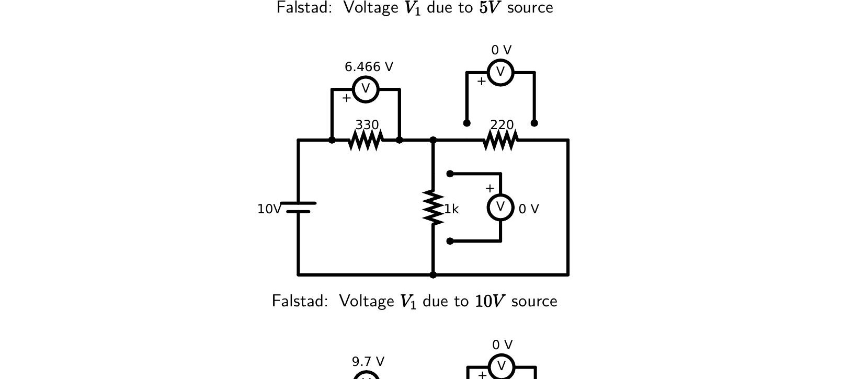
Falstad: Voltage V₁ due to 10V source
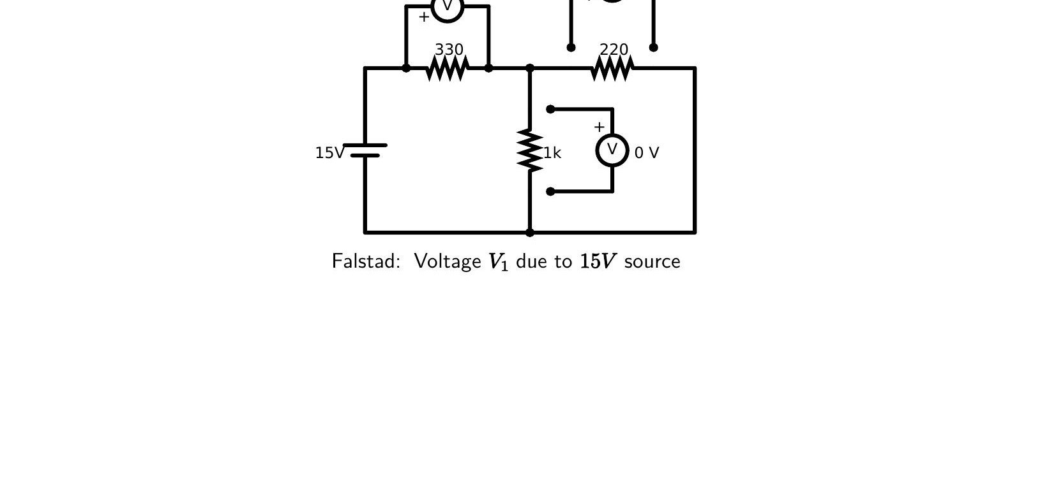
Falstad: Voltage V₁ due to 15V source
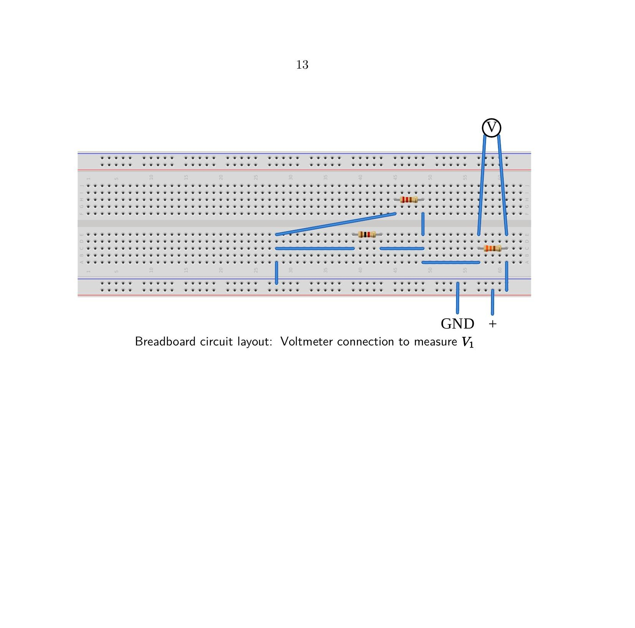
Breadboard circuit layout: Voltmeter connection to measure V₁
Falstad Simulations – Voltage V₂
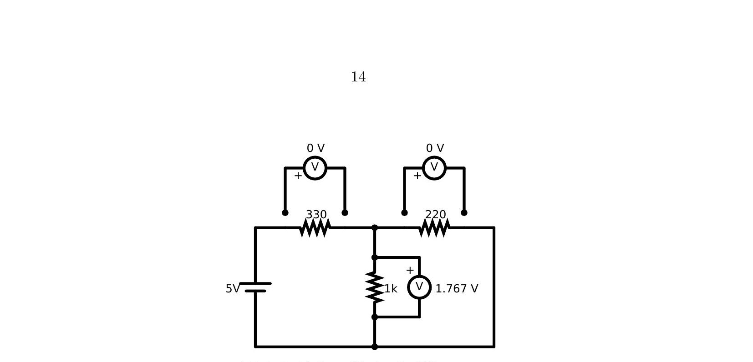
Falstad: Voltage V₂ due to 5V source
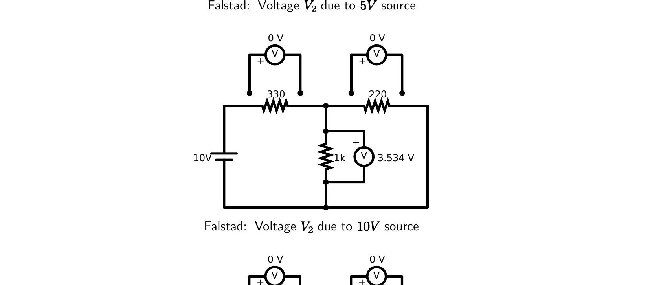
Falstad: Voltage V₂ due to 10V source
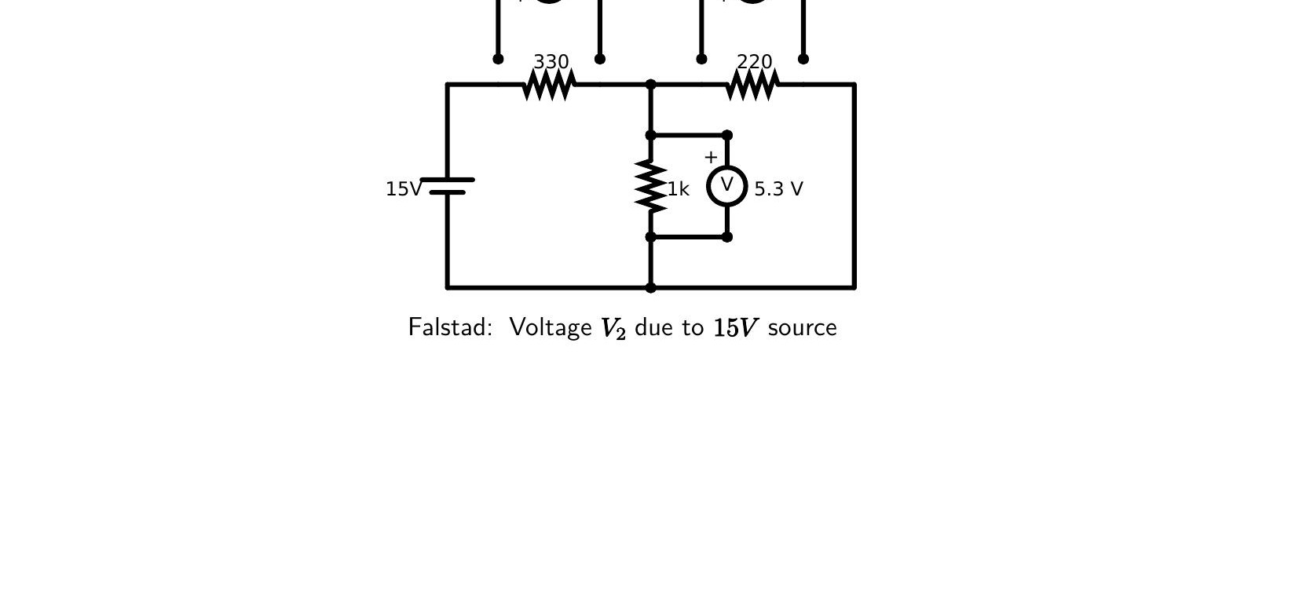
Falstad: Voltage V₂ due to 15V source
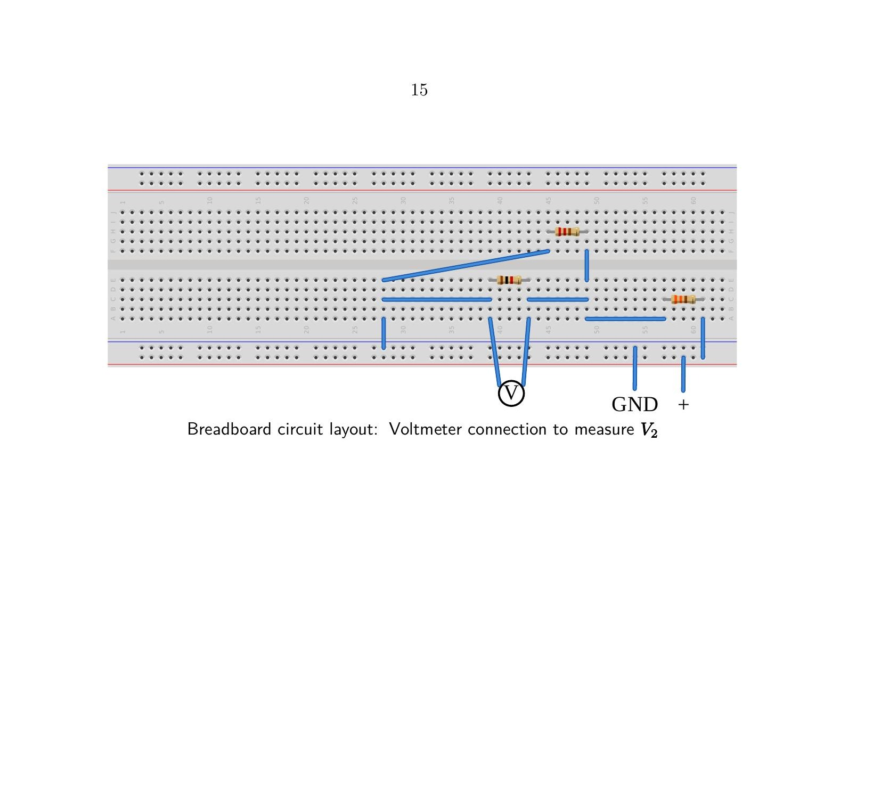
Breadboard circuit layout: Voltmeter connection to measure V₂
Falstad Simulations – Voltage V₃
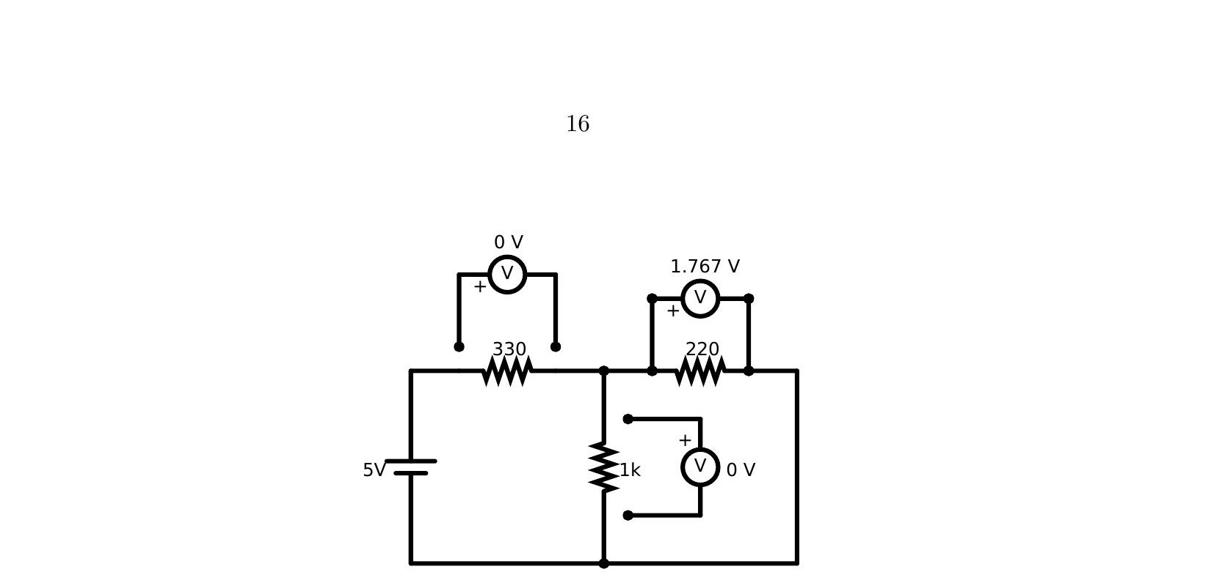
Falstad: Voltage V₃ due to 5V source
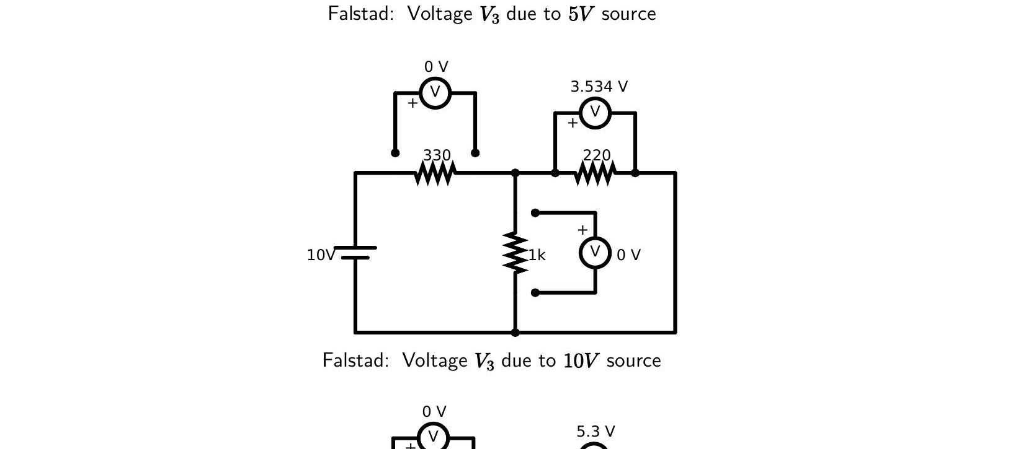
Falstad: Voltage V₃ due to 10V source
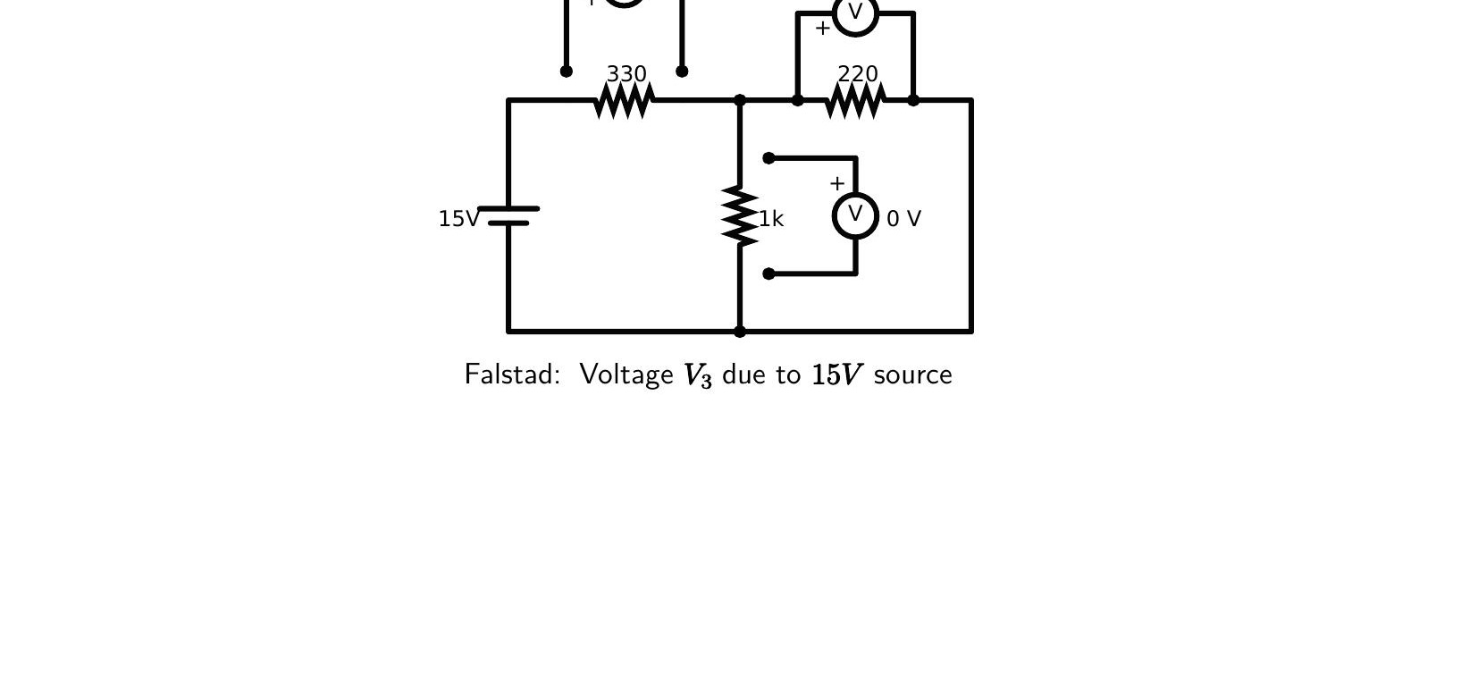
Falstad: Voltage V₃ due to 15V source
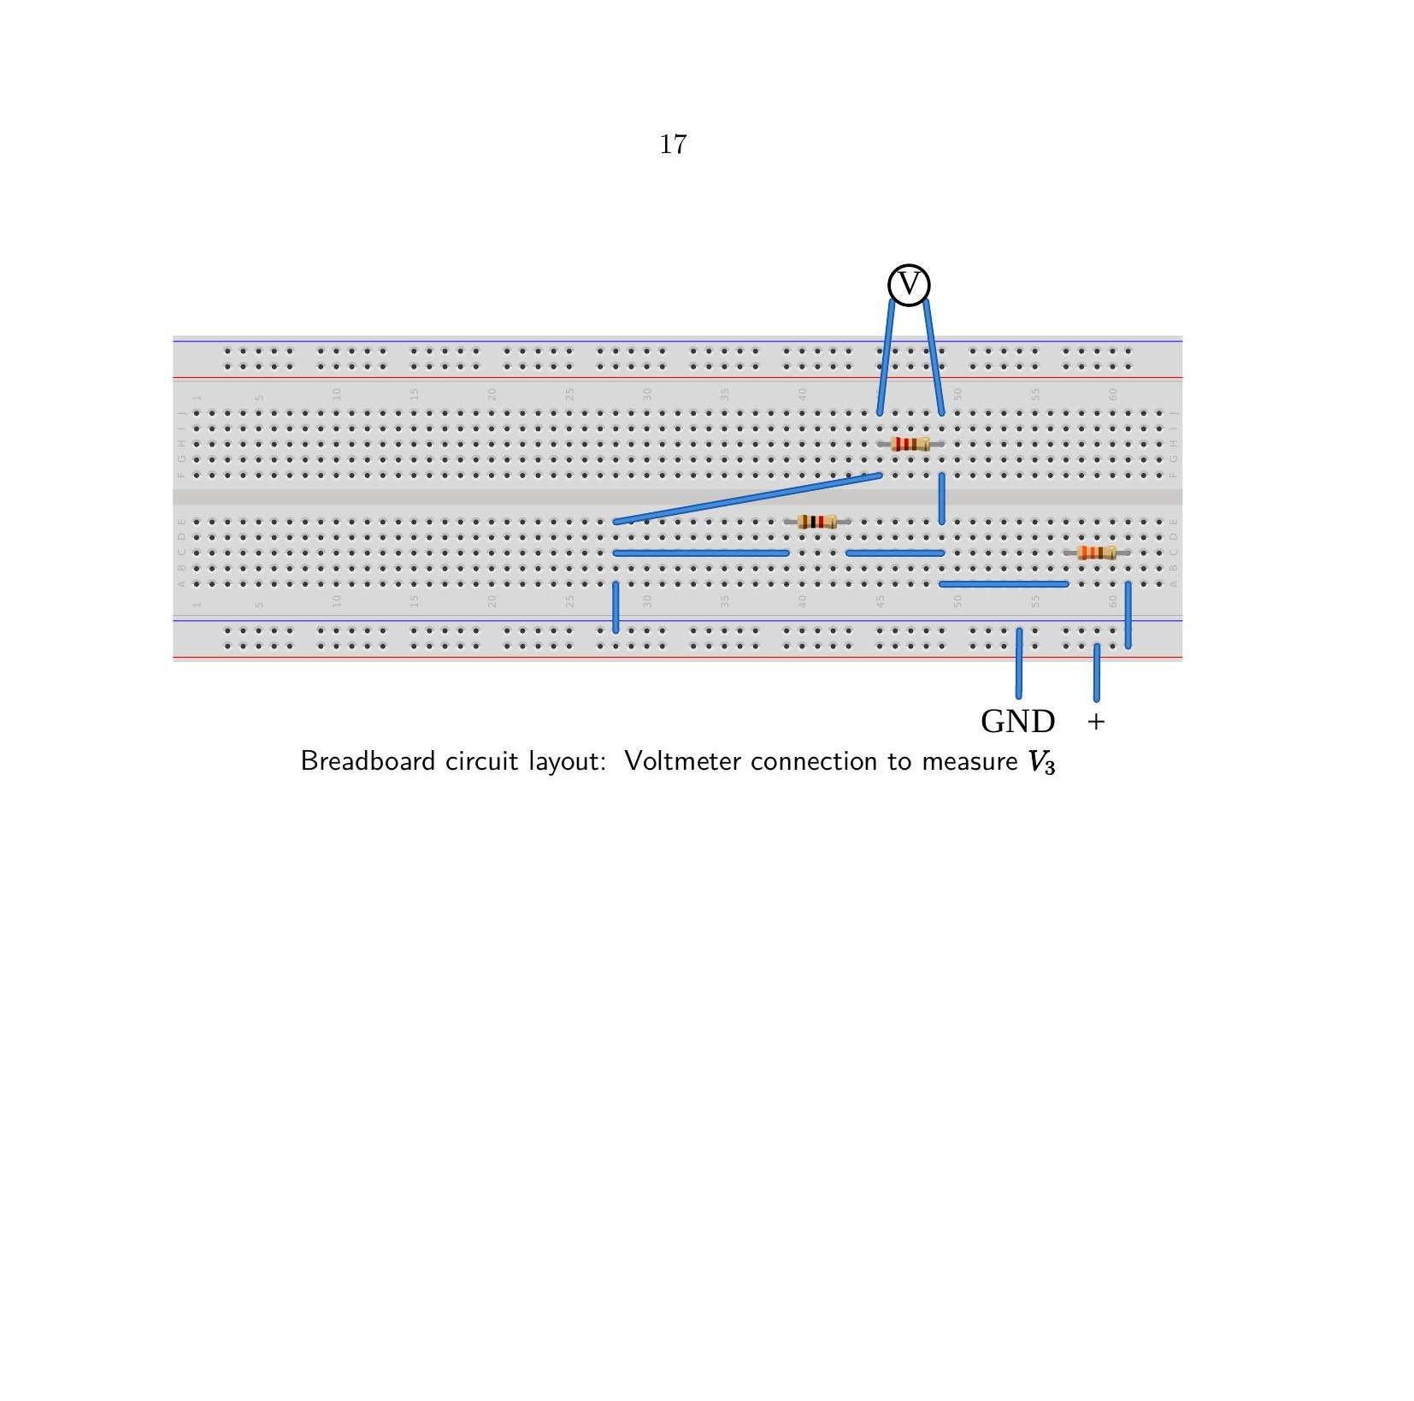
Breadboard circuit layout: Voltmeter connection to measure V₃

Experiment 2 Data – Practical Values
Sl. No. | E1 (V) | V1 (V) | V2 (V) | V3 (V) | E1 = V1 + V2
1 | 5 | 3.230 | 1.767 | 1.767 | 5 ≈ 4.997
2 | 10 | 6.466 | 3.534 | 3.534 | 10 = 10
3 | 15 | 9.700 | 5.300 | 5.300 | 15 = 15

Post-Lab Questions

1. Define Kirchhoff’s current law.
Kirchhoff’s Current Law (KCL), also known as Kirchhoff’s First Law, states that the algebraic sum of all currents meeting at a node or junction in an electrical circuit is zero. This implies that the total current entering a node must be exactly equal to the total current leaving that same node. It is a fundamental consequence of the Law of Conservation of Charge, assuming that charge does not accumulate at any single point within a steady-state circuit.

2. Define Kirchhoff’s voltage law.
Kirchhoff’s Voltage Law (KVL), or Kirchhoff’s Second Law, states that the algebraic sum of all electrical potential differences (voltages) around any closed loop or mesh in a network is zero. In practical terms, this means that the sum of the electromotive forces (EMFs) supplied to the loop is equal to the sum of the potential drops (voltage across resistors) within that same loop. This law is an application of the Law of Conservation of Energy.

3. What are the applications of regulated power supply?
A Regulated Power Supply (RPS) is an essential instrument in electronic design and testing due to its ability to maintain a constant output voltage regardless of variations in load current or input voltage. Its primary applications include:
- Powering sensitive integrated circuits and microprocessors that require stable DC bias.
- Serving as a reference voltage source for laboratory experiments and circuit prototyping.
- Charging batteries with precise voltage and current control.
- Testing the tolerance and operational limits of electronic components under controlled conditions.

4. What are the limitations of KCL?
While KCL is a cornerstone of circuit analysis, it has specific limitations:
- High-Frequency Limits: KCL is only strictly applicable to “lumped” parameter circuits. At very high frequencies (RF/Microwave), where the wavelength of the signal is comparable to the physical dimensions of the circuit, parasitic capacitance and radiation effects cause charge to “leak,” making KCL appear inaccurate.
- Varying Magnetic Fields: If a node is subject to a rapidly changing external magnetic flux, it can induce currents that are not accounted for by simple nodal analysis.
- Non-Steady State: In cases where charge accumulation occurs (such as the interior of a capacitor plate), KCL must be modified to include displacement current (dD/dt).

