**Name: Ayesha Munir**

**Class: BSCS 7B**

**Registration No: 216146**

**Date of Submission: 12th September, 2019**

**Task1:**

**Code:**

|  |
| --- |
| <html>  <head>  <style>  td {  width:80px;  height:80px;  background-color:black;    }  input[type="button"]{  width:80px;  height:80px;  background-color: teal;  font-weight: bold;  font-size:16px;    }  #display {  width:420px;  height:80px;  background-color:white;  font-size:19px;  font-weight:bold;  }  table {  position:absolute;  top:100px;  left: 300px;  width:420px;  height:300px;  border: 2px solid teal;  }  </style>  </head>  <body>  <form name="calculator">  <div class="calculator-keys">  <table class="table">  <table>  <tr>  <td colspan="5">  <input type="text" name="display" value="" id="display" disabled>  </td>  </tr>  <tr>  <td><input type="button" class="spoperator" value="MC" onclick= "MCfunc(calculator.display.value)"></input></td>  <td><input type="button" value="0" onclick="calculator.display.value+='0' "></input></td>  <td><input type="button" value="1" onclick="calculator.display.value+='1' " ></input></td>  <td><input type="button" value="2" onclick="calculator.display.value+='2' "></input></td>  <td> <input type="button" class="operator" value="+" onclick="calculator.display.value+='+' "></input></td>  </tr>  <tr>  <td><input type="button" class="spoperator" value="MS" onclick= "MSfunc(calculator.display.value)"></input></td>  <td><input type="button" value="3" onclick="calculator.display.value+='3' "></input></td>  <td><input type="button" value="4" onclick="calculator.display.value+='4' "></input></td>  <td><input type="button" value="5" onclick="calculator.display.value+='5' "></input></td>  <td> <input type="button" class="operator" value="-" onclick="calculator.display.value+='-' "></input></td>  </tr>  <tr>  <td><input type="button" class="spoperator" value="MR" onclick= "calculator.display.value = MRfunc(calculator.display.value)"></input></td>  <td><input type="button" value="6" onclick="calculator.display.value+='6' "></input></td>  <td><input type="button" value="7" onclick="calculator.display.value+='7' "></input></td>  <td><input type="button" value="8" onclick="calculator.display.value+='8' "></input></td>  <td> <input type="button" class="operator" value="*" onclick="calculator.display.value+='*' "></input></td>  </tr>  <tr>  <td><input type="button" class="spoperator" value="M+" onclick= "Mfunc(calculator.display.value)"></input></td>  <td><input type="button" value="9" onclick="calculator.display.value+='9' "></input></td>  <td><input type="button" class="operator" value="+-" onclick="calculator.display.value+='==' + eval(calculator.display.value *-1) "></input></td>  <td><input type="button" name="operator" value="=" onclick="calculator.display.value +='='+ eval(calculator.display.value)"></td>  <td> <input type="button" class="operator" value="/" onclick="calculator.display.value+='/' "></input></td>  </tr>  <tr>  <td><input type="button" class="operator" value="1/x" onclick="calculator.display.value+='==' + eval(1/calculator.display.value)"></input></td>  <td><input type="button" value="." onclick="calculator.display.value+='.' "></input></td>  <td><input type="button" class="operator" value="x2" onclick="calculator.display.value+='==' + eval(calculator.display.value *calculator.display.value ) "></input></td>  <td><input type="button" class="operator" value="√" onclick="calculator.display.value+='==' + eval(Math.sqrt(calculator.display.value) ) "></input></td>  <td> <input type="button" class="operator" value="C" onclick="calculator.display.value='' "></input></td>  </tr>  </table>  </form>  <script type="text/javascript">  function MCfunc(x) {  value = 0;  calculator.display.value = 'Value is cleared';  }  function MSfunc(x) {  if (isNaN(x)) {  calculator.display.value = 'Not a number';  }  else  {  value = parseInt(calculator.display.value,10);  calculator.display.value = 'Value is stored';  }  }  function MRfunc(x) {    return value ;  }  function Mfunc(x) {  if (isNaN(x)) {  calculator.display.value = 'Not a number';  }  else {  x = Number(calculator.display.value);  value = value + x;  calculator.display.value = 'Value is stored';  }  }  </script>  </body>  </html> |

**Output:**

**Basic Mathematical Operations:**

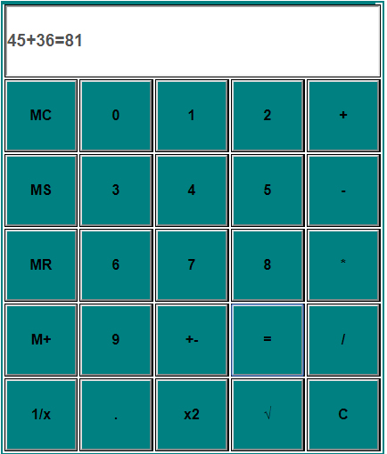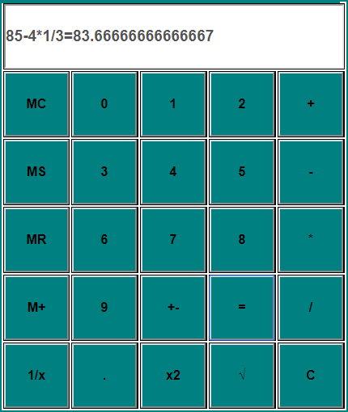

**Square: +-:**

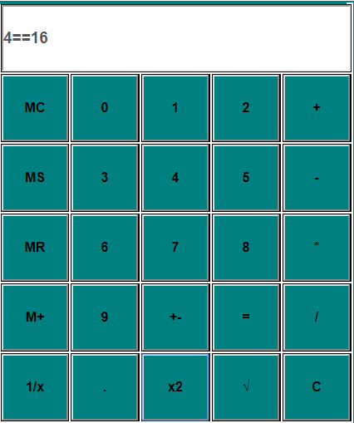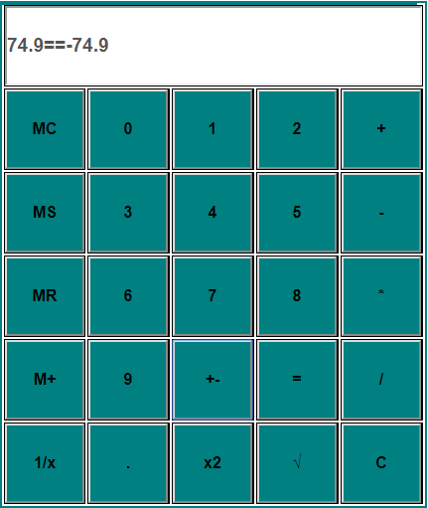

**Square root: 1/x:**

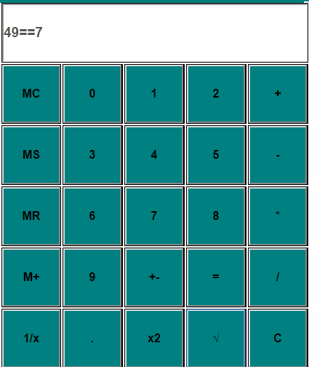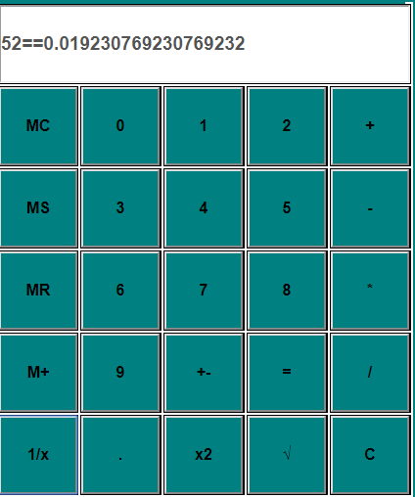

**MS: MC:**

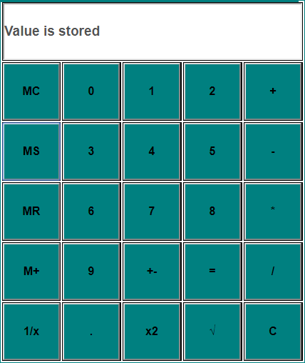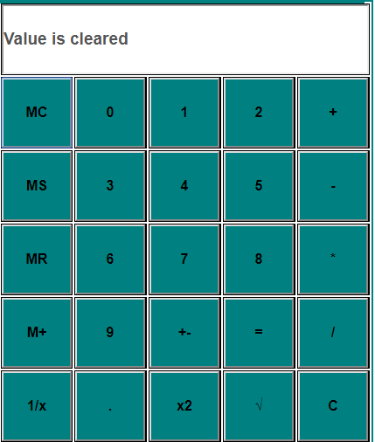

**MR: M+:**

