**Lab #3**

**Advance Programming**

**Name: Ayesha Munir**

**Class: BSCS 7B**

**Registration No: 216146**

**Task1:**

|  |
| --- |
| <!DOCTYPE html>  <html>  <head>  <title>JavaScript &amp; jQuery - Chapter 7: Introducing jQuery - Event Object</title>  <link rel="stylesheet" href="css/c07.css" />  <script src="js/jquery-1.11.0.js"></script>  </head>  <body>  <div id="page">  <h1 id="header">List</h1>  <h2>Buy groceries</h2>  <ul>  <li id="one" class="hot"><em>fresh</em> figs</li>  <li id="two" class="hot">pine nuts</li>  <li id="three" class="hot">honey</li>  <li id="four">balsamic vinegar</li>  </ul>  </div>  <script>  $("li").click(function()  { var today=new Date();  var monthNames = [  "January", "February", "March",  "April", "May", "June", "July",  "August", "September", "October",  "November", "December"  ];  var day = today.getDate();  var monthIndex = today.getMonth();  var year = today.getFullYear();  var date = day + ' ' + monthNames[monthIndex] + ' ' + year;  var time = today.getHours() + ":" + today.getMinutes() + ":" + today.getSeconds();  var st=$(this).html();  $(this).append("<span class=date>" + "clicked on "+ " "+date +" at " + time+ "</span>");  });  </script>  </body>  </html> |

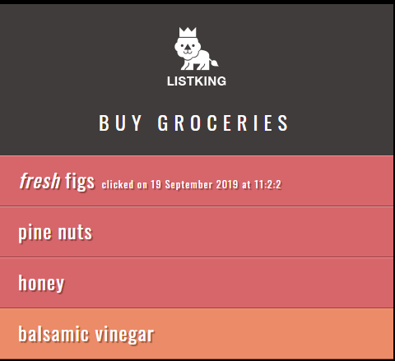

**Task2:**

|  |
| --- |
| <!DOCTYPE html>  <html>  <head>  <title>JavaScript &amp; jQuery - Chapter 7: Introducing jQuery - Event Object</title>  <link rel="stylesheet" href="css/c07.css" />  <script src="js/jquery-1.11.0.js"></script>  </head>  <body>  <div id="page">  <h1 id="header">List</h1>  <h2>Buy groceries</h2>  <ul>  <li id="one" class="hot"><em>fresh</em> figs</li>  <li id="two" class="hot">pine nuts</li>  <li id="three" class="hot">honey</li>  <li id="four">balsamic vinegar</li>  </ul>  <p id="para">click or mouse over a hot item</p>  </div>  <script>  $("li").on("click mouseover",function(event){  var item = $(this).text();  if(item=="honey"||item=="pine nuts")  {  var status="important";  }  else  status="available";  $("#para").html("Item: "+item + "<br />" + "Status: "+status +"<br />"+"event: "+event.type);  });    </script>  </body>  </html> |

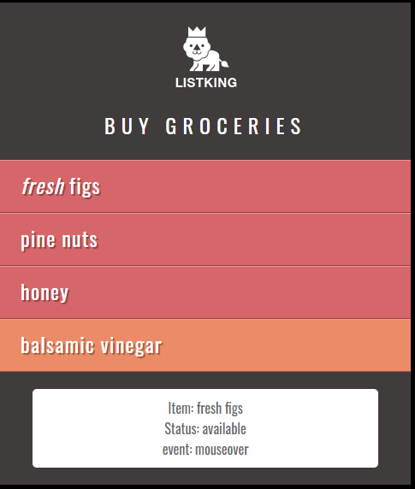

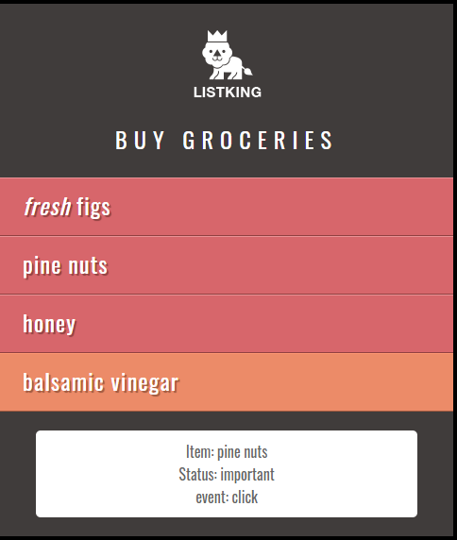

**Task3:**

|  |
| --- |
| <!DOCTYPE html>  <html>  <head>  <title>JavaScript &amp; jQuery - Chapter 7: Introducing jQuery - Event Object</title>  <link rel="stylesheet" href="css/c07.css" />  <script src="js/jquery-1.11.0.js"></script>    </head>  <body>  <div id="page">  <h1 id="header">List</h1>  <h2>Buy groceries</h2>  <ul>  <li id="one" class="hot"><em>fresh</em> figs</li>  <li id="two" class="hot">pine nuts</li>  <li id="three" class="hot">honey</li>  <li id="four">balsamic vinegar</li>  <li>linguine</li>  <li>cream</li>  <li>linguine</li>  <li>linguine</li>  <li>coconut milk</li>  <li>mushrooms</li>  <li>apples</li>  <li>strawberries</li>  <li>rice crackers</li>  <li>brie</li>  <li>rice</li>  <li>green tea</li>  <li>linguine</li>  <li>linguine</li>  <li>linguine</li>  <li>linguine</li>  <li>linguine</li>  <li>linguine</li>  <li>linguine</li>  <li>cream</li>  <li>linguine</li>  <li>linguine</li>  <li>coconut milk</li>  <li>mushrooms</li>  <li>apples</li>  <li>strawberries</li>  <li>rice crackers</li>  <li>brie</li>  <li>rice</li>  <li>green tea</li>  <li>linguine</li>  <li>linguine</li>  <li>linguine</li>  <li>linguine</li>  <li>linguine</li>  <li>linguine</li>  </ul>  <p id="footer">List King</p>    </div>  <div id="slideAd">  <span>Buy Listing pro <br />for only $1.9 </span>  </div>  </div>  <script>  $(window).on("scroll",function()  {  if($(window).scrollTop() >= ($(document).height() - $(window).height()))  {$("#slideAd").animate({right:'15px'});  $("#slideAd").show();  }  var x= $(document).height()-($(window).height()+$(document).scrollTop());  console.log(x);  if(x>500)  $("#slideAd").hide();  }) ;  </script>  </body>  </html> |

