

**Lab#7**

**Advance Programming**

**Name: Ayesha Munir**

**Class: BSCS 7B**

**Registration No: 216146**

**Task1:**

**Index.html:**

|  |
| --- |
| <!DOCTYPE html>  <html>      <head></head>      <body>          <p style="font-size:35px; background-color:indianred; padding:5px" ><b>Personal Information!</b></p>          <form action="myform" method="POST">              <fieldset>                <legend>Personal information:</legend>                Name:<br>                <input type="text" name="fname" value="Enter name"><br>                Email:<br>                <input type="text" name="email" value="Enter email"><br><br>                  <input type="submit" value="Submit">              </fieldset>            </form>      </body>  </html> |

**Task1.js:**

|  |
| --- |
| var express= require('express');  var bodyParser= require('body-parser');  var multer= require('multer');  var upload = multer();  var app = express();  express.urlencoded({ extended: true });  app.use(express.urlencoded());  app.use(express.static('public'));  app.listen(3000,function(){      console.log('server started!');  });  app.get('/', function(req, res){      res.sendFile('index.html');    });  app.post('/myform', function(req,res){      const fname=req.body.fname;      const email=req.body.email;      res.send("your name is:  "+fname+" "+" Your email is:"+email);    }); |

**Output:**

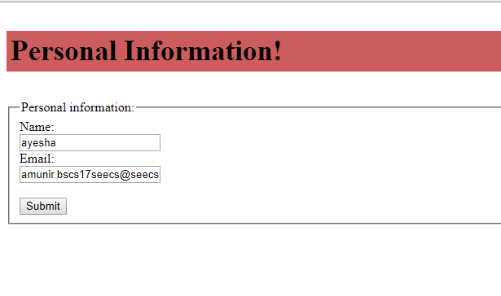

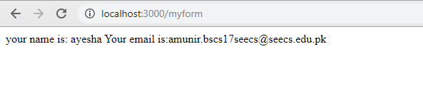

**Task2:**

**Task2.js**

|  |
| --- |
| var express = require ('express');  var app = express();  var router = express.Router();  var multer = require('multer');  var bodyParser = require('body-parser');  var upload = multer();  app.use(bodyParser.urlencoded({ extended: true }));  app.use(bodyParser.json());  app.get('/', function(req,res){  res.sendfile("file.html");  });  app.post('/myform',function(req,res){    res.send("File has been uploaded:");  });  app.listen(3000); |

**File.html:**

|  |
| --- |
| <!DOCTYPE HTML>  <html>  <head>  <title>File Uploader </title>  </head>  <body>  <p style="font-size:35px; background-color:mediumseagreen; padding:5px" ><b>File Upload Form!</b></p>  <form method="POST" action="myform" enctype="multipart/form-data">  <p>Select the file to upload</p>  <input type="file" name="fileuploader" />  <br /><br />  <input type="submit"/>  </form>  </body>  </html> |

**Output:**

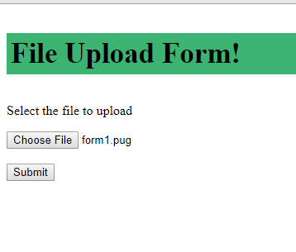

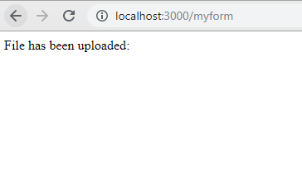

**Task 3:**

**Form.js:**

|  |
| --- |
| var express = require('express');  var bodyParser = require('body-parser');  var multer = require('multer');  var upload = multer();  var app = express();  app.use(express.static('public'));  app.get('/', function(req, res){      res.render('form1'); });  app.set('view engine', 'pug');  app.set('views', './'); // for parsing application/json  app.use(bodyParser.json()); // for parsing application/xwww- app.use(bodyParser.urlencoded({ extended: true })); //form-urlencoded  //for parsing multipart/form-data  app.use(upload.array());  app.use(express.static('public'));  app.post('/', function(req, res){      console.log(req.body);      res.send("recieved your request!"); });  app.listen(3000); |

**Form.pug:**

|  |
| --- |
| html  head  body  include ./firstview.pug  form(action = "/", method = "POST" )  div      label(for = "name") Name:      input(name = "fname" value = "Enter Name")  br  div      label(for = "email") Email:      input(name = "email" value = "Enter Email")  br  div      label(for = "address") Address:      input(name = "address" value = "Enter Address")  br  div      label(for = "password") Password:      input(name = "password" value = "" type="password")  br  div      label(for = "cpassword") Confirm password:      input(name = "cpass" value = "" type="password")  br  button(type = "submit") Login |

**Firstview.pug (for header):**

|  |
| --- |
| doctype html  html      head          title="Hello Pug"          link(rel='stylesheet', href='/styles.css')          style.                h1{                  color:yellow;                  background-color:black;                  text-align:center;                  padding: 30px;              }        body          h1.style Registration Form! |

**Output:**

