**Lab #8**

**Advance Programming**

**Ayesha Munir**

**BSCS 7B**

**216146**

**Task1:**

**Welcome.js:**

|  |
| --- |
| import React from 'react';  class Welcome extends React.Component {  constructor(){  super()  this.state={ message:'hello visitor',  }  }  changeMessage()  {            this.setState({                message:'thankyou for subscribing'              })    }  render(){  return(  <div>    <h1>{this.state.message}</h1>  <button onClick={()=>this.changeMessage()}> subscribe </button>  </div>)  }  }  export default Welcome; |

**App.js:**

|  |
| --- |
| import React ,{Component}from 'react';  import logo from './logo.svg';  import Welcome from './Welcome';  import './App.css';  class App extends Component{  render(){    return <Welcome/>      }  }  export default App; |

**Output:**

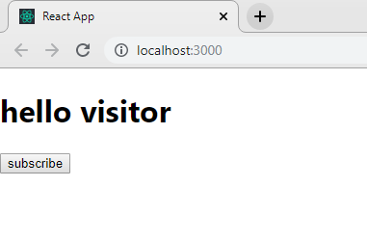

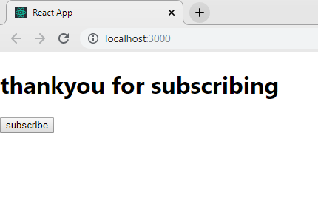

**Counter example:**

**Counter.js:**

|  |
| --- |
| import React from 'react';  class Counter extends React.Component {  constructor(){  super()  this.state={  count:0  }  }  Increment()  {        this.setState({              count:this.state.count+1,                })  }  render(){  return(  <div>    <h1>counter -{this.state.count}</h1>  <button onClick={()=>this.Increment()}> clickme </button>  </div>)  }  }  export default Counter; |

**Output:**

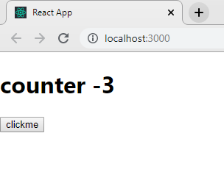

**Call back function:**

**Counter.js:**

|  |
| --- |
| import React from 'react';  class Counter extends React.Component {  constructor(){  super()  this.state={  count:0  }  }  Increment()  {            this.setState({              count:this.state.count+1                },()=>{console.log('call back value',this.state.count)}    )}  render(){  return(  <div>    <h1>counter -{this.state.count}</h1>  <button onClick={()=>this.Increment()}> clickme </button>  </div>)  }  }  export default Counter; |

**Output:**

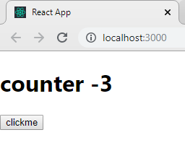

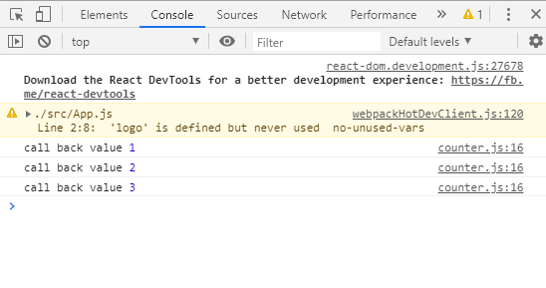

**IncrementFive in count.js:**

|  |
| --- |
| import React from 'react';  class Counter extends React.Component {  constructor(props){  super(props)  this.state={ count:0 } }  increment()  {  this.setState(  { count:this.state.count+1},( )=>{console.log('call back value',this.state.count) })  console.log(this.state.count)  }  IncrementFive() {  this.increment()  this.increment()  this.increment()  this.increment()  this.increment()  }  render(){  return (  <div>  <h1>counter - {this.state.count}</h1>  <button onClick={()=>this. IncrementFive()}>Increment</button>  </div>) } }  export default Counter; |

Output:



**Previous State:**

|  |
| --- |
| import React from 'react';  class Counter extends React.Component {  constructor(props){  super(props)  this.state={  count:0  }  }  Increment()  {            this.setState((prevState)=>{              count:prevState.count+1                },()=>{console.log('call back value',this.state.count)}    )}  render(){  return(  <div>    <h1>counter -{this.state.count}</h1>  <button onClick={()=>this.Increment()}> clickme </button>  </div>)  }  }  export default Counter; |

**Output:**

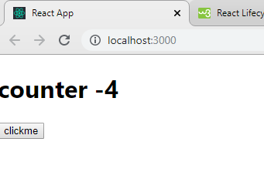

**Task2:**

**Clock.js:**

|  |
| --- |
| import React, {Component} from 'react'  class Timer extends Component{      constructor(props){          super(props);              this.state={              min:"00",              sec:"00",            }            this.setTime=this.setTime.bind(this);          this.startTimer=this.startTimer.bind(this);      }      setTime=(event)=>{          this.setState({min:event.target.value,          sec:0});          //this.setState({sec:s});      }      startTimer=()=>{          this.setState({msg:"started!"});          this.myInterval=setInterval(()=>{              //const {min,sec}=this.state              let min=this.state.min;              let sec=this.state.sec;              if(sec >0){                  this.setState(({sec}) => ({                      sec:sec - 1                  }))              }              if (sec===0){                  if(min===0){                      clearInterval(this.myInterval)                      this.setState({                          min:"00",                          sec:"00"                      })                  }                  else{                      this.setState(({min})=>({                          min:min - 1,                          sec:59                      }))                  }              }          },1000)      }      render(){          return(              <div>                  <input type="text" onChange={this.setTime} />                  <h1> {this.state.min}:{this.state.sec} </h1>                  <button onClick={this.startTimer}>start</button>              </div>          )      }  }  export default Timer; |

**App.js:**

|  |
| --- |
| import React ,{Component}from 'react';  import logo from './logo.svg';  import Timer from './Clock';  import './App.css';  class App extends Component{  render(){    return <Timer/>      }  }  export default App; |

**Output:**

