**Summary:**

In this assignment, first I created a mongoose database with collection people. The user signups and his record is added to the collection. At the time of login the user enters his name and password, which is matched in the collection along with his role (buyer, seller). If the user is not found he is displayed message, ‘could not login’. If the user is a seller and has successfully logged in, he is shown the products page. In products page, all products are displayed in a table, along with the option for add item, delete item and update item. If user wants to update item, he enters the details in the form and item is updated on products table and collection. After completing job, he can logout by clicking on the logout button. If the user is buyer, he is only shown the products. There is no option for add, update or delete product.

**Output:**

**Login Screen:**

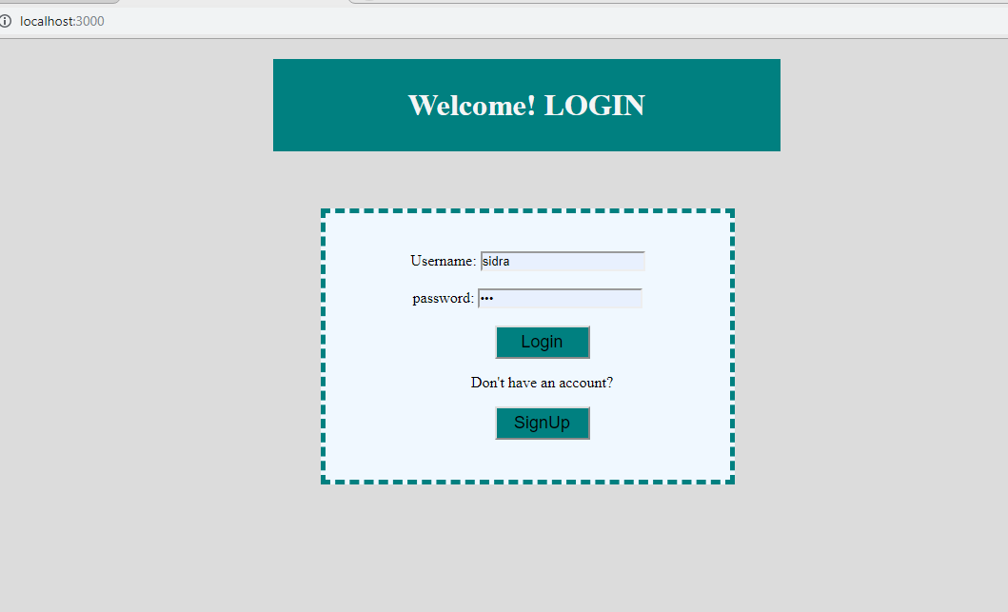

**SignUp Screen:**

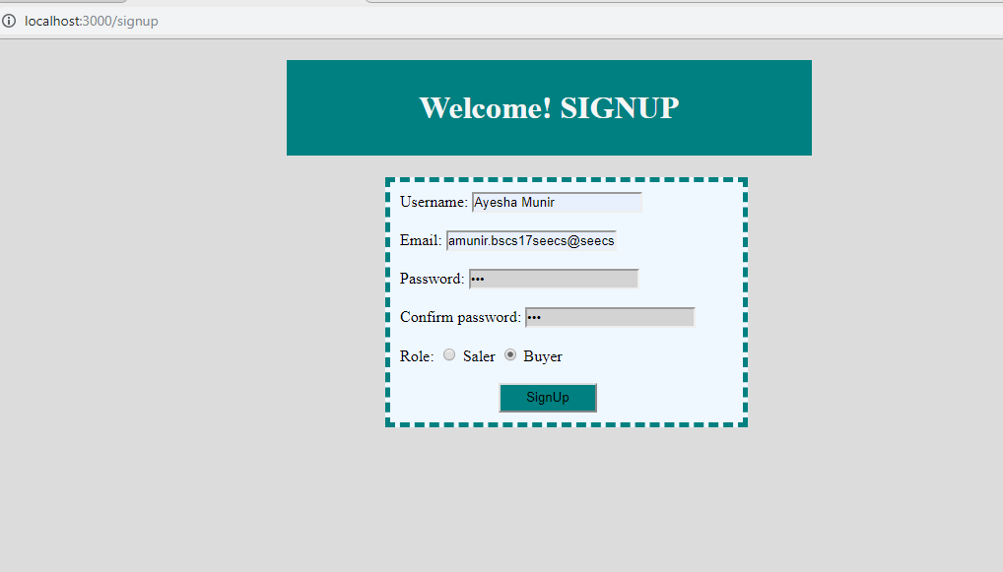

**After Insertion, database:**

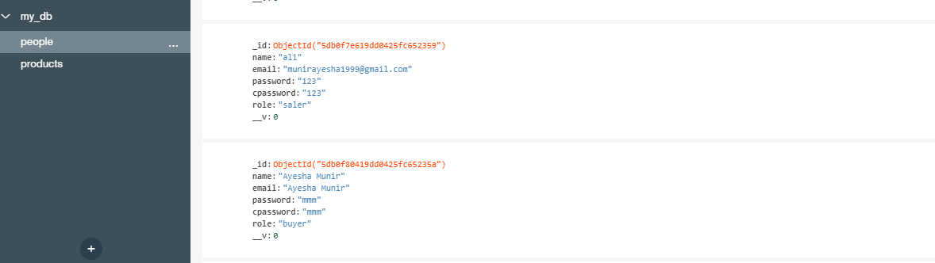

**Products:**

* **If user is a seller:**

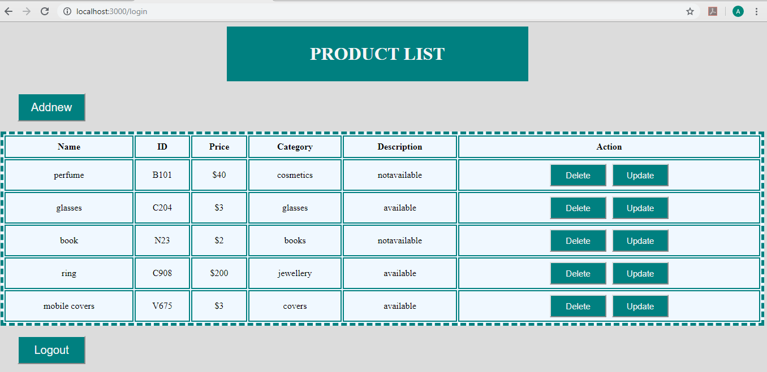

* **If user is a buyer:**

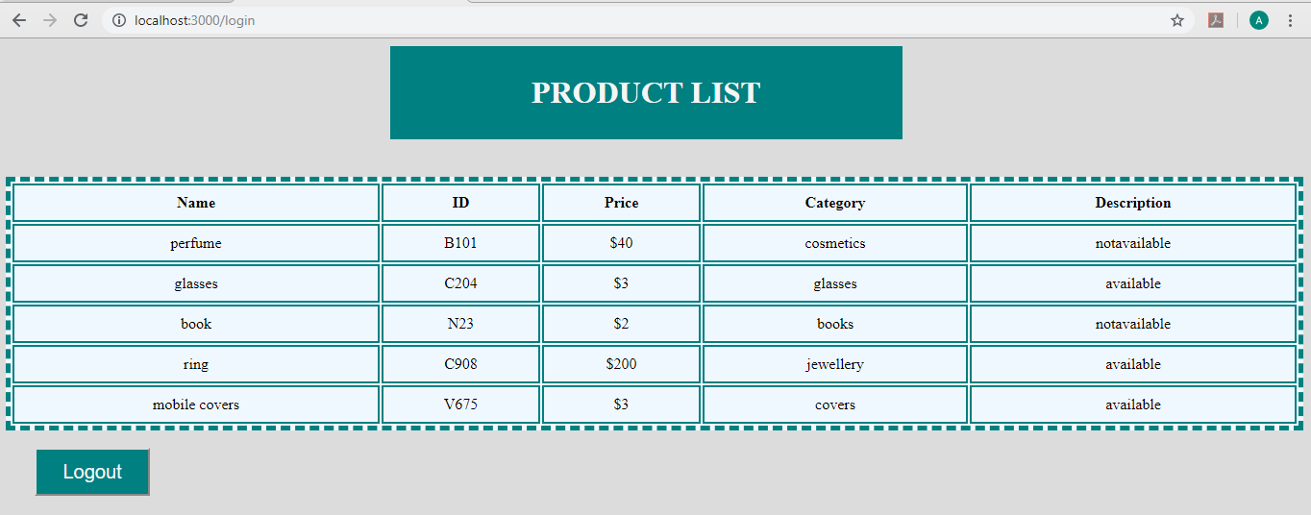

**AddNew Items:**

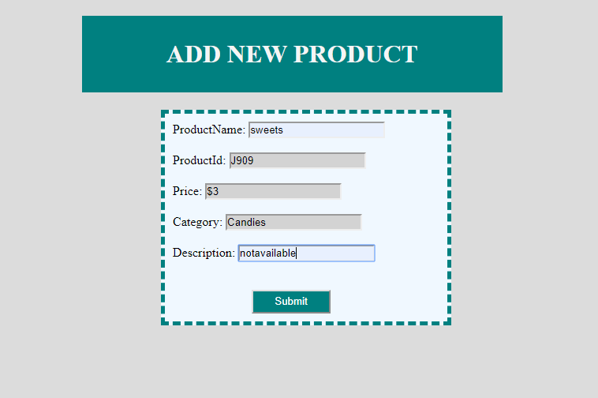

**After Addition:**

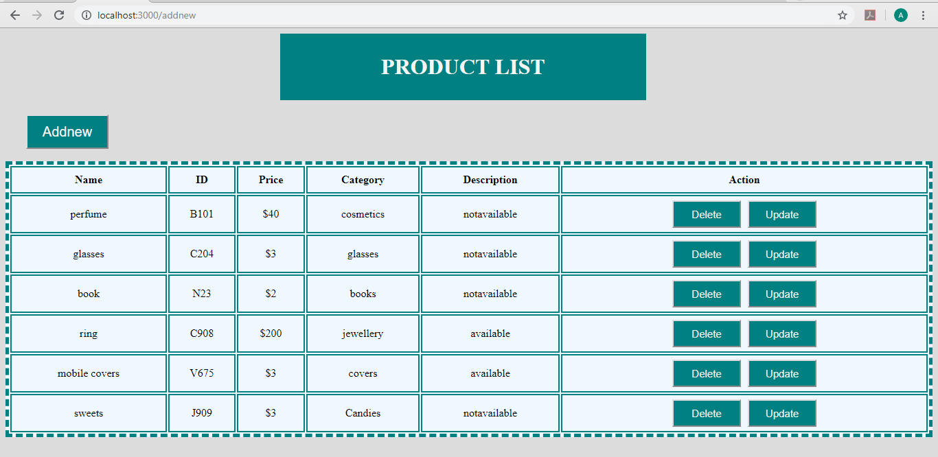

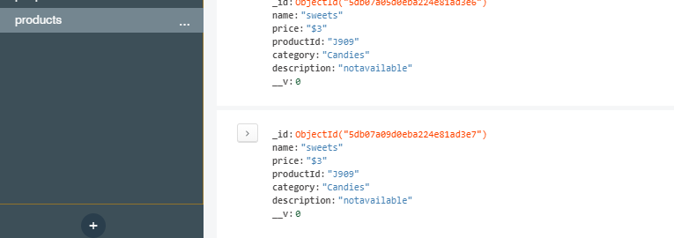

**Updation:**

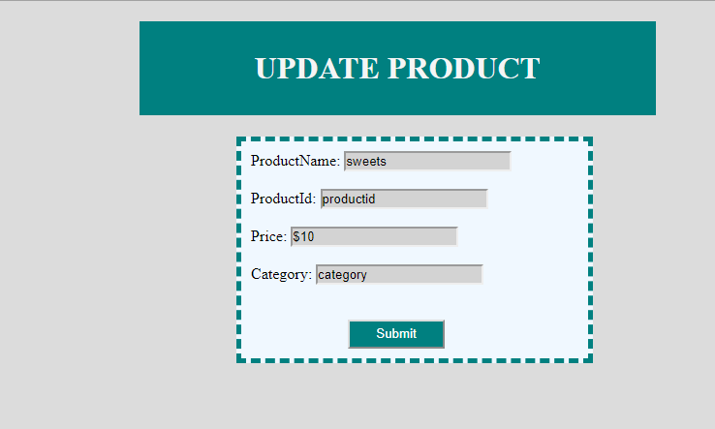

**After Updation:**

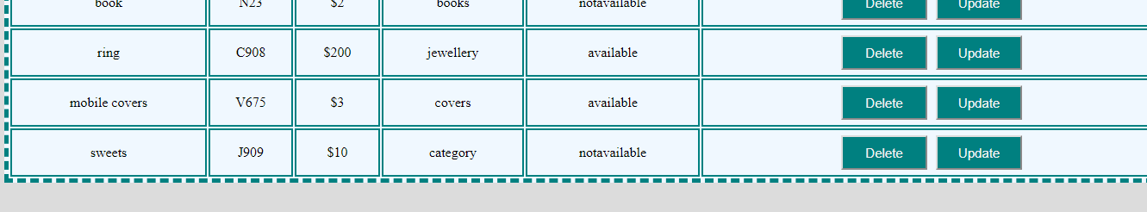

**Deletion:**

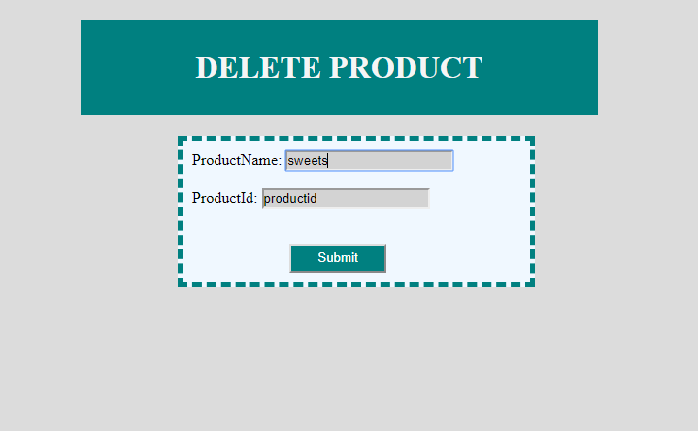

**After Deletion:**

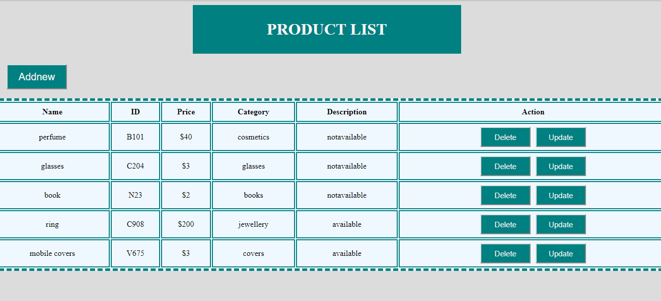

**Logout:**

