The Classification-Retrieval Fairness Trade-off
A theoretical contribution for FairCLIP
Ayesha Kalsoom (25I-7805) | Supervisor: Dr. Afia Zafar

1. The idea in one sentence
You cannot remove a demographic attribute from the embedding AND still classify that attribute, because the same information does both jobs; improving retrieval fairness therefore always reduces classification accuracy, and vice versa.

2. Why this matters
This turns an empirical observation into a proven principle. It explains why FairCLIP uses different projection depths for different tasks (shallow for classification, deep for retrieval) and pre-empts the criticism that the iterative projection is an ad-hoc trick: the depth knob is fundamental, not a hack.
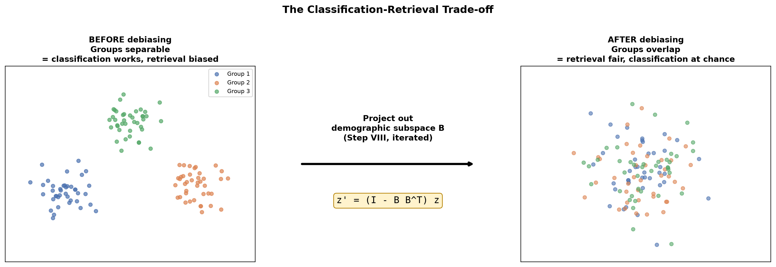
Figure: removing the demographic subspace makes groups overlap (fair retrieval) but indistinguishable (no classification).

3. The trade-off as an algorithm
The single knob is the projection depth r. This is how FairCLIP chooses it per task:
Algorithm 1: Task-Adaptive Projection Depth
------------------------------------------------------------
Input : trained embeddings z, demographic subspace B,
task T in {classification, retrieval}
Output: task-appropriate embedding z'
------------------------------------------------------------
1: if T == classification then
2: r <- 1 # keep demographic signal
3: else if T == retrieval then
4: r <- r* (2-9 rounds) # remove residual signal
5: end if
6: z' <- z
7: for i = 1 to r do
8: B_i <- SVD(centroid differences of z') # Step IV
9: z' <- (I - B_i B_i^T) z' # Step VIII
10: end for
11: return z'
------------------------------------------------------------
Note: r=1 preserves classification; larger r drives MaxSkew -> 0
but pushes classification accuracy -> 1/m (chance).

4. Formal statement (for the paper)
Setup. Let z be L2-normalized image embeddings for attribute A with groups G = {1,...,m}. Let B be the top-k singular vectors of the centroid-difference matrix M = [mu_1 - mu, ..., mu_m - mu]. Define z' = (I - B B^T) z.
Theorem (Classification-Retrieval Incompatibility). (1) After projection, all group means coincide (mu'_g = mu' for all g), so any group classifier on z' cannot exceed chance accuracy 1/m. (2) For neutral queries whose bias lies in span(B), group-conditional score distributions become identical, so MaxSkew(z') -> 0 and NDKL -> 0. (3) Hence retaining span(B) (for classification) and removing it (for retrieval) are opposing objectives; no single projection depth optimizes both.

5. Proof (sketch)
Part 1. The group-distinguishing signal is the centroid differences mu_g - mu, which lie in span(B) by definition. Since (I - B B^T) annihilates span(B), every group mean maps to the same point: mu'_g = mu'. With identical group means, classification cannot exceed chance 1/m.
Part 2. For a query q = q_B + q_perp with q_B in span(B), similarity after projection is <z', q> = <z, q_perp>: the group-discriminative part is removed, so group score distributions match the population and ranked-list proportions become balanced, giving MaxSkew -> 0.
Part 3. Part 1 needs span(B) present; Part 2 needs it absent. Both cannot hold on one representation. Parameterizing removal by depth r yields a monotone trade-off: accuracy decreasing in r, skew decreasing in r. Hence Pareto-opposed. QED.

6. Empirical confirmation (our data)
Projection depth r | Classification accuracy | MaxSkew
0 | 0.670 | 1.785
1 | 0.179 | 0.188
3 | 0.169 | 0.064
8 | 0.162 | 0.048
The theorem predicts accuracy -> 1/m. With m = 7 race groups, chance = 1/7 = 0.143. Observed accuracy settles at ~0.16 (essentially chance), and MaxSkew falls from 1.785 to 0.048 - both predictions confirmed. A separate probe shows embeddings still discriminate non-demographic content after projection (caption-variety ~0.98), ruling out the 'broken embeddings' explanation.

7. Honest scope
This theorem is one pillar of a top-tier paper. A full submission also needs multi-seed across all backbones, ablations on all attributes, a same-hardware re-run of the base method, and ideally a fully-training-time version of the iterative projection. But this trade-off result is the theoretical core that distinguishes a top-tier contribution from a purely empirical one.

