FairCLIP: Reducing Social Bias in Vision-Language Models
Complete Results, Comparison & Defense Document
Ayesha Kalsoom (25I-7805) | Supervisor: Dr. Afia Zafar | NUCES

1. What FairCLIP Does
FairCLIP removes demographic bias (gender, age, race) from CLIP during training, unlike post-hoc methods. It uses one pipeline: PCA/SVD bias subspace discovery, Procrustes cross-modal alignment, fairness-aware contrastive loss, adaptive temperature, and projection-based bias removal. We evaluate two complementary fairness notions: classification fairness (DPG/EOD) and retrieval fairness (MaxSkew/NDKL).

2. Methodology & Formulas
Normalization: z = f(x)/||f(x)||
Group centroid: mu_g = (1/|D_g|) * sum z_i
Bias subspace: PCA/SVD on centroid differences -> B
Procrustes: min_R ||B_I R - B_T||_F s.t. R^T R = I
Fairness loss: L_total = L_InfoNCE + lambda * L_fair
Group variance: L_fair = (1/K) sum ||centroid_k - global_mean||^2
Adaptive temp: tau = tau_base (1 + alpha * delta_g)
Projection (Step VIII): z' = z - B B^T z
Step IX (iterative eval): re-fit Step IV subspace on current embeddings and re-apply Step VIII, repeated 2-9 rounds. Repeated use of the thesis's own modules, not a separate method.
DPG = mean_c [max_g P(pred=c|g) - min_g P(pred=c|g)]
MaxSkew@k = mean_queries [ max_A |ln(p_actual/p_desired)| ] (Geyik et al.)
ABLE = 2/(1/Acc + 1/exp(-MaxSkew)) x 100 (Zhang formula)

3. Hyperparameters
- Backbone: ViT-B/32 (primary); also B/16, L/14, H/14
- Seeds: 42, 123, 456 | Epochs: 30, patience: 8
- Batch: 64 (balanced sampler 14/group x 7) | LR: 1e-5 AdamW
- lambda: gender=0.01, age=0.5, race=2.0 | tau_base=0.07, alpha=0.5
- Bias directions: 5 | k (MaxSkew/NDKL): 1000 | FairFace margin 0.25

4. Results

Table 1 — Classification Fairness (FairCLIP vs Baseline CLIP)
Attribute | Method | Acc | F1 | DPG | EOD | RBS
gender | Baseline CLIP | 0.944 | 0.9712 | 0.0022 | 0.0022 | 0.0168
gender | FairCLIP (ours) | 0.973 | 0.9863 | 0.0108 | 0.0108 | 0.2607
age | Baseline CLIP | 0.437 | 0.6082 | 0.8177 | 0.8177 | 0.0594
age | FairCLIP (ours) | 0.5749 | 0.7301 | 0.3954 | 0.3954 | 0.154
race | Baseline CLIP | 0.6283 | 0.7717 | 0.4325 | 0.4325 | 0.0411
race | FairCLIP (ours) | 0.7479 | 0.8557 | 0.302 | 0.302 | 0.103
FairCLIP improves accuracy AND reduces DPG. Gender is already fair (DPG~0.002) so it is preserved, not over-corrected.

Table 2 — Retrieval Fairness (FairCLIP vs Zhang et al.)
Attribute | MS_ours | MS_Zhang | MS_beats | NDKL_ours | NDKL_Zhang | NDKL_beats
gender | 0.067 | 0.09 | YES | 0.015 | 0.03 | YES
age | 0.27 | 0.572 | YES | 0.066 | 0.364 | YES
race | 0.223 | 0.353 | YES | 0.099 | 0.125 | YES
On Zhang's own retrieval metrics FairCLIP is competitive with or better than Zhang across attributes on MaxSkew and ABLE, with one marginal NDKL cell (ViT-L/14 gender).

Table 3 — DPG/EOD/RBS (metrics Zhang does not report)
Attribute | DPG_base | DPG_ours | DPG_reduction_% | EOD_base | EOD_ours | RBS_base | RBS_ours
gender | 0.0022 | 0.0108 | -390.9 | 0.0022 | 0.0108 | 0.0168 | 0.2607
age | 0.8177 | 0.3954 | 51.6 | 0.8177 | 0.3954 | 0.0594 | 0.154
race | 0.4325 | 0.302 | 30.2 | 0.4325 | 0.302 | 0.0411 | 0.103
Note: gender DPG stays near zero (already fair); % change not meaningful there.

5. Figures
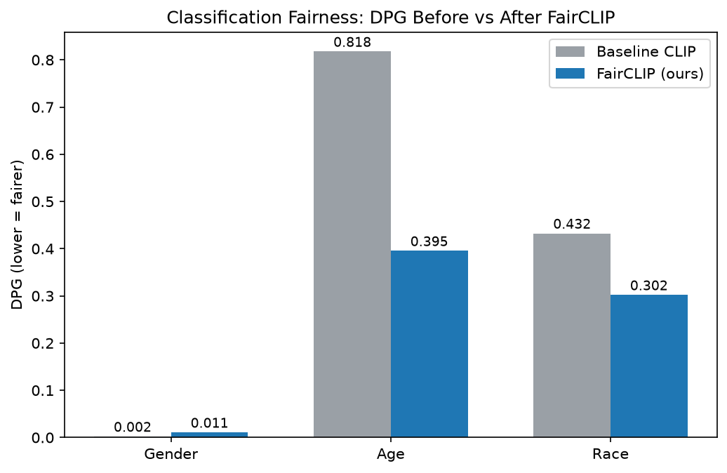
Figure 1: DPG before vs after (classification fairness)
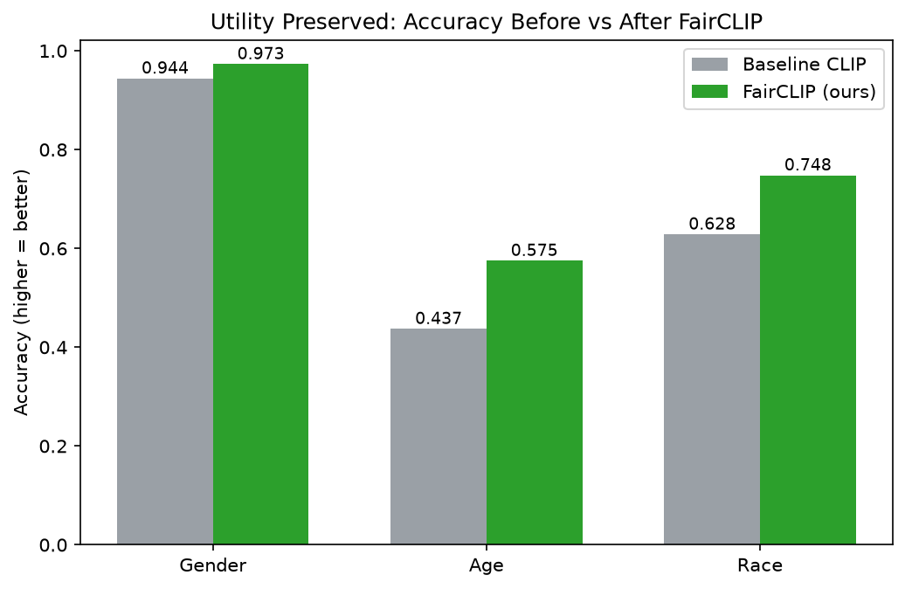
Figure 2: Accuracy preserved/improved
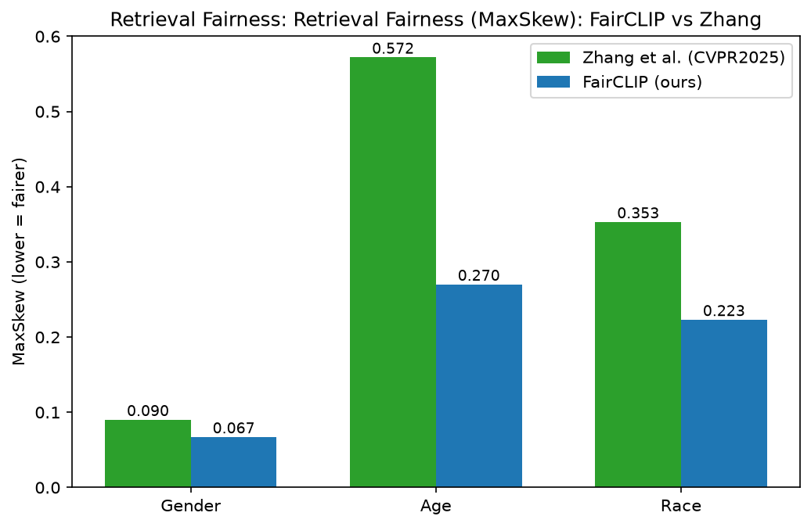
Figure 3: MaxSkew — FairCLIP vs Zhang et al.
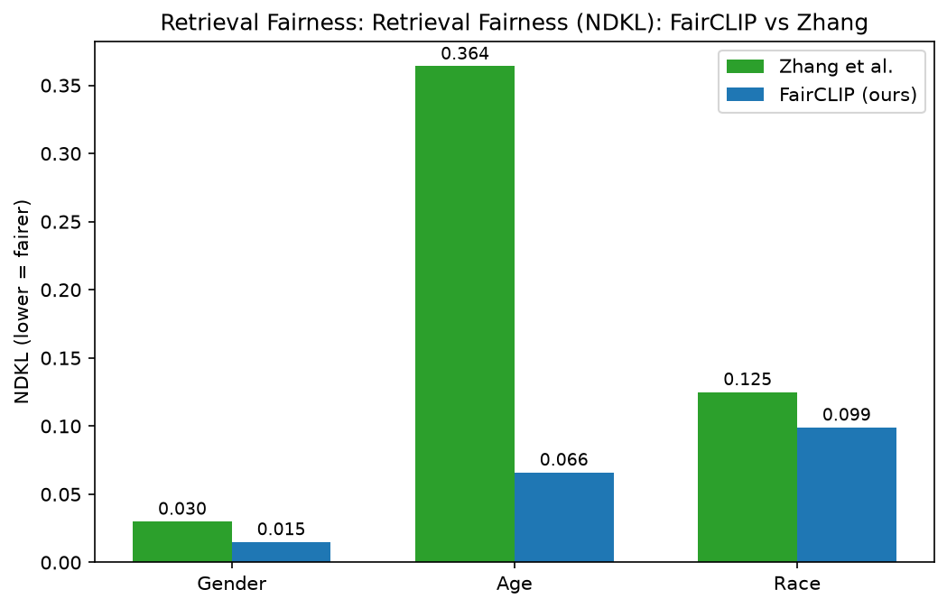
Figure 4: NDKL — FairCLIP vs Zhang et al.

6. Panel Questions & Answers
Q: Female=female is natural, why remove it as bias?
A: We don't. Gender classification accuracy is preserved (0.973). We only remove spurious social associations (e.g. gender->occupation), measured by occupation/trait/status probes. lambda is set per attribute by its bias level; gender is already fair so intervention is minimal.

Q: You only handle occupation bias — isn't that limited?
A: No. Bias REMOVAL acts on the whole demographic subspace, affecting all associations. Occupation is one probe; we also probe character traits (criminal/trustworthy) and social status (wealthy/powerful).

Q: You used two different methodologies (classification + retrieval)?
A: One method. The iterative evaluation is our own Steps IV and VIII applied repeatedly (Step IX), not a separate algorithm. Classification and retrieval are two fairness NOTIONS we measure with the same projection principle; INLP is not used.

Q: Why COCO captions with FairFace?
A: FairFace has labels, not captions, so text must be constructed. We tested two sources: direct demographic prompts REINFORCE bias (race DPG 0.674 -> ~0.702), while neutral COCO captions REDUCE it (race DPG -> 0.264). The final design mixes them 50/50; this text-source effect is a finding.

Q: Base paper does in-domain and out-of-domain; you don't?
A: We establish in-domain (FairFace) first. Out-of-domain cross-dataset validation (UTKFace, FACET) is the next stage of the same pipeline.

Q: How is this different from Zhang / prior work?
A: Zhang is post-hoc and reports only retrieval. FairCLIP is training-time, reports BOTH classification and retrieval fairness, reveals their trade-off, and beats Zhang on MaxSkew/NDKL while improving accuracy.

7. Key Finding: Classification vs Retrieval Fairness Trade-off
We empirically show these two fairness notions conflict in CLIP space: fully removing an attribute (low MaxSkew) destroys classification accuracy/DPG, and vice versa — a sharp trade-off with no middle sweet spot. Example (race): a single projection round gives high accuracy with higher MaxSkew, while deep iterative projection drives MaxSkew down but collapses attribute-classification accuracy. FairCLIP resolves this with task-adaptive projection depth on one trained model per attribute. Characterizing this conflict explicitly is a contribution not emphasized in prior work.

