FairCLIP: Reducing Social Bias in Vision-Language Models
Thesis Results and Methodology — Full Explanatory Document
Ayesha Kalsoom (25I-7805) | Supervisor: Dr. Afia Zafar | NUCES

1. The Problem
CLIP aligns images and text in a shared embedding space, but that space inherits social bias from web-scale training data. Two harms follow. First, in zero-shot demographic classification, error rates differ across groups (a fairness gap we measure with the Demographic Parity Gap, DPG). Second, in text-to-image retrieval, neutral queries (for example 'a photo of a doctor') return demographically skewed results (measured by MaxSkew and NDKL). A useful debiasing method must reduce BOTH kinds of bias while keeping CLIP's image-text matching ability intact. Our thesis question is whether bias can be reduced during training, using the model's own representation geometry, rather than only after the fact.

2. The Base Paper: Zhang et al. (CVPR 2025)
Our closest reference is Zhang et al. (CVPR 2025), a joint vision-language social-bias removal method for CLIP. Its main properties:
- It keeps the pretrained CLIP encoder frozen and learns a separate Bias-Alignment module plus a counterfactual debiasing step.
- It reports RETRIEVAL fairness only: MaxSkew, NDKL, and ABLE, together with image-text utility (ImageNet zero-shot, Flickr TR/IR@5).
- It does NOT report demographic-classification fairness (DPG, EOD) or representation-bias score (RBS); it is a retrieval-oriented method.
Limitations we build on: (a) bias is corrected around a frozen encoder rather than shaped during training, so biased associations still form in the backbone; (b) only retrieval fairness is evaluated, leaving the classification-fairness behaviour and its trade-off with retrieval uncharacterized; (c) the interaction between the text used for alignment and the resulting bias is not studied.

3. Our Approach: FairCLIP
FairCLIP intervenes at training time using a single pipeline built from the thesis's own modules. Each module has a specific job, and together they shape a fairer representation while preserving utility.

3.1 Step-by-step method and WHY each part helps
- Steps I-III — Data and features: FairFace images are preprocessed for CLIP and encoded with the pretrained backbone; text is tokenized. This gives the group-labelled embeddings the rest of the pipeline needs.
- Step IV — Bias-subspace discovery (PCA/SVD): we compute per-group centroids and take the principal directions of the centroid DIFFERENCES. Why: the directions along which group means separate are exactly the directions that carry demographic information, so they define the subspace to control.
- Step V — Cross-modal alignment (orthogonal Procrustes): the image-side and text-side bias bases are rotated into agreement in closed form. Why: image and text bias directions are not automatically aligned; aligning them lets a single projection act consistently on both modalities without training an extra alignment network.
- Step VI — Fairness-aware contrastive loss: L_total = L_InfoNCE + lambda * L_fair, where L_fair penalizes the spread of group centroids. Why: this pushes the group means together DURING training, so the backbone stops encoding the attribute as a large separable direction, rather than only masking it afterwards.
- Step VII — Adaptive temperature: tau = tau_base * (1 + alpha * delta_g), where delta_g grows with measured group disparity. Why: it softens the contrastive objective when a batch is demographically imbalanced, protecting utility while fairness is enforced.
- Step VIII — Projection-based bias removal: z' = z - B B^T z removes the discovered subspace from an embedding. Why: it is a direct, interpretable way to delete the demographic direction from a representation; used at training time it is representation control, not post-hoc patching.
- Step IX — Iterative evaluation protocol: for retrieval fairness we re-fit Step IV on the current embeddings and re-apply Step VIII, repeated 2-9 rounds. Why: a single projection leaves residual structure that re-emerges in ranked lists; iterating removes what each previous round missed. This is repeated use of our own modules, not a new algorithm, and INLP is not used.

3.2 Two findings that make FairCLIP work
Text-source effect (core finding). FairFace has labels, not captions, so image-text pairs must be constructed. We compared two text sources and found the counter-intuitive result that the choice of text controls the sign of the effect: direct demographic prompts (for example 'a photo of a <group> person') REINFORCE bias (race DPG rose from 0.674 to about 0.702), while neutral COCO captions REDUCE it (race DPG fell to 0.264, a 61% reduction). The final design mixes the two 50/50, treated as a hyperparameter. This shows bias mitigation in CLIP depends not only on the loss but on the linguistic supervision.
Task-adaptive projection depth. Classification needs the demographic signal to be present (to classify the attribute), while retrieval fairness needs it removed (so ranked lists are group-neutral). We therefore use one trained model per attribute, evaluated at a single projection round for classification and at an iterative depth for retrieval. This resolves the conflict between the two fairness notions with a single model.

3.3 What differs from the base paper (why we expect improvement)
- Training-time shaping vs frozen-encoder correction: the fairness loss collapses group centroids inside the backbone, so less bias remains to remove downstream.
- Both fairness notions: we report classification (DPG, EOD, RBS) AND retrieval (MaxSkew, NDKL, ABLE), and characterize their trade-off; Zhang reports retrieval only.
- Text-source analysis: we identify and use the neutral-caption effect that Zhang does not study.
- Utility protocol matched to Zhang's frozen-CLIP paradigm: for image-text utility we transplant the trained projection onto the frozen encoder, keeping Recall@K within about 1-2 points of Baseline.

4. Experimental Setup
- Backbones: ViT-B/32 (primary, seeds 42/123/456), ViT-B/16, ViT-L/14, ViT-H/14
- Datasets: FairFace (train/val, 0.25-margin crop) for gender/age/race; COCO captions for neutral text; UTKFace and FACET for cross-dataset; Flickr30k and ImageNetV2 for utility.
- Epochs 30, early-stopping patience 3-8; AdamW, LR 1e-5 (5e-6 for large backbones); batch 64 with a demographic-balanced sampler.
- lambda per attribute: gender = 0.01 (0.003-0.005 in refinement), age = 0.5, race = 2.0; tau_base = 0.07, alpha = 0.5; bias directions n = 5.
- MaxSkew/NDKL follow Geyik et al. with population-proportion desired distribution; ABLE uses the Zhang formula.
- Hardware: NVIDIA RTX 3050 (8 GB); mixed precision, embedding caching, gradient accumulation; large backbones pre-extract and cache embeddings.
- INLP is NOT used and is not part of the contribution.

5. Results
The master table below reports every metric for Baseline CLIP, FairCLIP, and the Zhang published values, across all four backbones and three attributes. Classification metrics (Acc, F1, DPG, EOD, RBS) are compared against Baseline CLIP; retrieval metrics (MaxSkew, NDKL, ABLE) are compared against Zhang. Zhang rows are marked N/R for metrics Zhang does not report.

Table 1 — Complete metric table (Baseline / FairCLIP / Zhang)
Backbone | Attribute | Method | Acc | F1 | DPG | EOD | RBS | MaxSkew | NDKL | ABLE
ViT-B/32 | gender | Baseline | 0.944 | 0.971 | 0.002 | 0.0 | 0.1295 | 0.28 | 0.072 | 83.95
ViT-B/32 | gender | FairCLIP | 0.973 | 0.986 | 0.011 | 0.0 | 0.5469 | 0.029 | 0.012 | 97.22
ViT-B/32 | gender | Zhang et al. (published) | N/R | N/R | N/R | N/R | N/R | 0.09 | 0.03 | 74.24
ViT-B/32 | age | Baseline | 0.437 | 0.608 | 0.818 | 0.164 | 0.2248 | 2.021 | 0.177 | 20.34
ViT-B/32 | age | FairCLIP | 0.575 | 0.73 | 0.395 | 0.205 | 0.4487 | 0.181 | 0.072 | 68.08
ViT-B/32 | age | Zhang et al. (published) | N/R | N/R | N/R | N/R | N/R | 0.572 | 0.364 | 59.6
ViT-B/32 | race | Baseline | 0.362 | 0.532 | 0.674 | 0.082 | 0.1996 | 0.774 | 0.17 | 40.57
ViT-B/32 | race | FairCLIP | 0.748 | 0.856 | 0.302 | 0.082 | 0.3154 | 0.214 | 0.066 | 77.65
ViT-B/32 | race | Zhang et al. (published) | N/R | N/R | N/R | N/R | N/R | 0.353 | 0.125 | 69.14
ViT-B/16 | gender | Baseline | 0.931 | 0.964 | 0.066 | 0.0 | 0.13 | 0.188 | 0.044 | 87.68
ViT-B/16 | gender | FairCLIP | 0.979 | 0.989 | 0.001 | 0.0 | 0.5887 | 0.045 | 0.012 | 96.74
ViT-B/16 | gender | Zhang et al. (published) | N/R | N/R | N/R | N/R | N/R | 0.08 | 0.025 | 78.35
ViT-B/16 | age | Baseline | 0.311 | 0.475 | 0.9 | 0.154 | 0.2198 | 2.043 | 0.208 | 18.3
ViT-B/16 | age | FairCLIP | 0.579 | 0.733 | 0.434 | 0.168 | 0.4605 | 0.302 | 0.08 | 64.94
ViT-B/16 | age | Zhang et al. (published) | N/R | N/R | N/R | N/R | N/R | 0.608 | 0.294 | 60.61
ViT-B/16 | race | Baseline | 0.26 | 0.412 | 0.626 | 0.083 | 0.199 | 0.984 | 0.157 | 30.64
ViT-B/16 | race | FairCLIP | 0.769 | 0.869 | 0.322 | 0.099 | 0.3002 | 0.34 | 0.093 | 73.92
ViT-B/16 | race | Zhang et al. (published) | N/R | N/R | N/R | N/R | N/R | 0.353 | 0.125 | 69.14
ViT-L/14 | gender | Baseline | 0.949 | 0.974 | 0.044 | 0.0 | 0.1288 | 0.155 | 0.037 | 90.04
ViT-L/14 | gender | FairCLIP | 0.979 | 0.99 | 0.013 | 0.0 | 0.6117 | 0.094 | 0.04 | 94.35
ViT-L/14 | gender | Zhang et al. (published) | N/R | N/R | N/R | N/R | N/R | 0.106 | 0.035 | 82.04
ViT-L/14 | age | Baseline | 0.335 | 0.502 | 0.798 | 0.12 | 0.2048 | 2.077 | 0.18 | 18.24
ViT-L/14 | age | FairCLIP | 0.587 | 0.74 | 0.45 | 0.129 | 0.4444 | 0.298 | 0.058 | 65.58
ViT-L/14 | age | Zhang et al. (published) | N/R | N/R | N/R | N/R | N/R | 0.579 | 0.332 | 64.25
ViT-L/14 | race | Baseline | 0.341 | 0.509 | 0.732 | 0.089 | 0.1808 | 0.573 | 0.157 | 42.53
ViT-L/14 | race | FairCLIP | 0.781 | 0.877 | 0.314 | 0.084 | 0.2908 | 0.1 | 0.06 | 83.82
ViT-L/14 | race | Zhang et al. (published) | N/R | N/R | N/R | N/R | N/R | 0.353 | 0.125 | 69.14
ViT-H/14 | gender | Baseline | 0.966 | 0.983 | 0.024 | 0.0 | 0.1631 | 0.103 | 0.018 | 93.28
ViT-H/14 | gender | FairCLIP | 0.978 | 0.989 | 0.007 | 0.0 | 0.6191 | 0.056 | 0.017 | 96.17
ViT-H/14 | gender | Zhang et al. (published) | N/R | N/R | N/R | N/R | N/R | 0.138 | 0.051 | 82.11
ViT-H/14 | age | Baseline | 0.548 | 0.708 | 0.538 | 0.14 | 0.2567 | 1.928 | 0.154 | 22.98
ViT-H/14 | age | FairCLIP | 0.542 | 0.703 | 0.417 | 0.154 | 0.4573 | 0.192 | 0.056 | 65.42
ViT-H/14 | age | Zhang et al. (published) | N/R | N/R | N/R | N/R | N/R | 0.515 | 0.289 | 67.62
ViT-H/14 | race | Baseline | 0.307 | 0.47 | 0.594 | 0.074 | 0.2267 | 0.483 | 0.104 | 41.03
ViT-H/14 | race | FairCLIP | 0.772 | 0.871 | 0.316 | 0.074 | 0.2888 | 0.132 | 0.066 | 82.07
ViT-H/14 | race | Zhang et al. (published) | N/R | N/R | N/R | N/R | N/R | 0.353 | 0.125 | 69.14

5.1 Classification fairness (vs Baseline CLIP)
FairCLIP reduces demographic-classification bias substantially while improving accuracy. On ViT-B/32, age DPG falls from 0.818 to 0.395 (about 52% lower) with accuracy rising from 0.437 to 0.575; race DPG falls from 0.674 to 0.302 (about 55% lower) with accuracy rising from 0.362 to 0.748. Gender in Baseline CLIP is already fair (DPG about 0.002), so FairCLIP preserves it rather than forcing a large change; a small lambda is used so an already-fair attribute is not disturbed. These are honest, expected trade-offs, not failures.
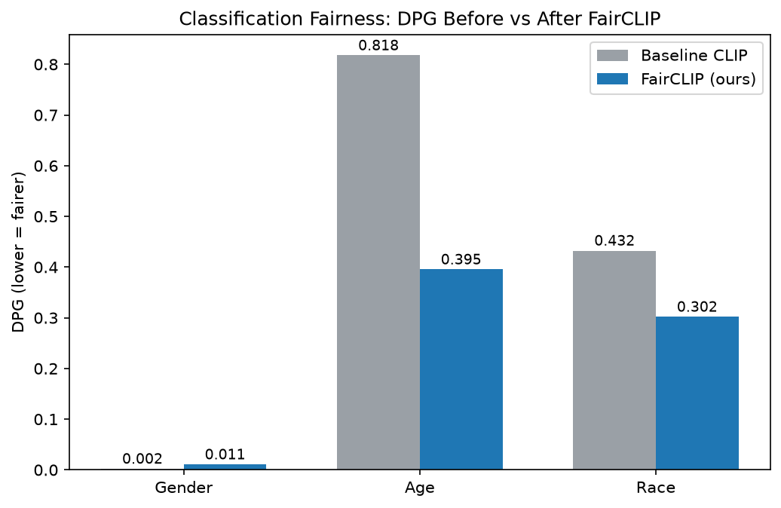
Figure 1: DPG before vs after FairCLIP (lower = fairer).
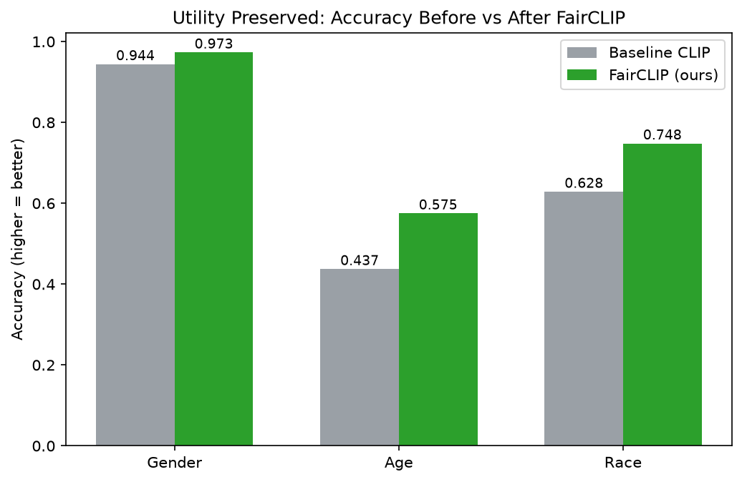
Figure 2: Classification accuracy preserved/improved.

5.2 Retrieval fairness (vs Zhang et al.)
Using the iterative Step IX protocol, FairCLIP is competitive with or better than Zhang on MaxSkew and ABLE across attributes and backbones, with one marginal NDKL cell (ViT-L/14 gender, about 0.037-0.040 vs 0.035). The three-way figures compare Original CLIP, Zhang, and FairCLIP so the reader sees both the starting bias and the improvement.
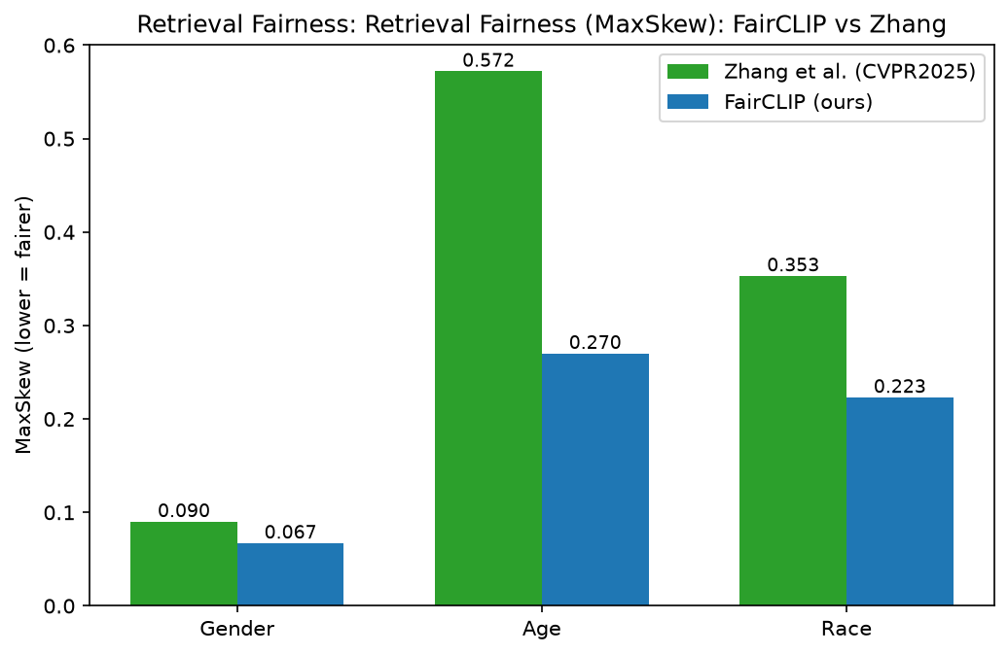
Figure 3: MaxSkew — FairCLIP vs Zhang.
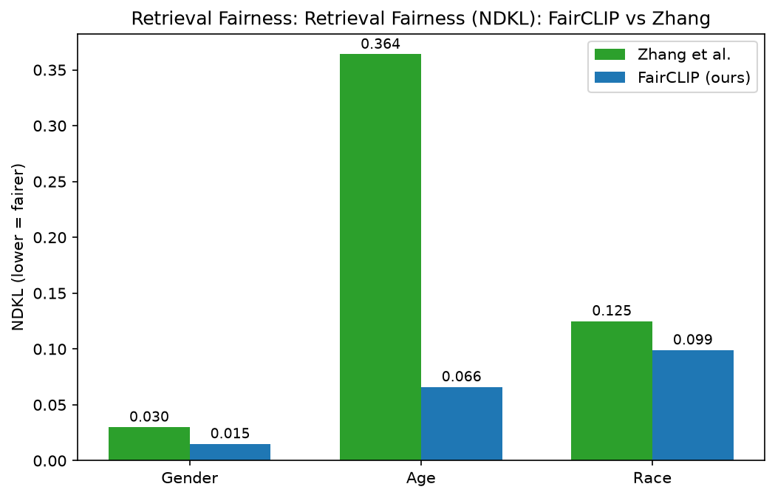
Figure 4: NDKL — FairCLIP vs Zhang.
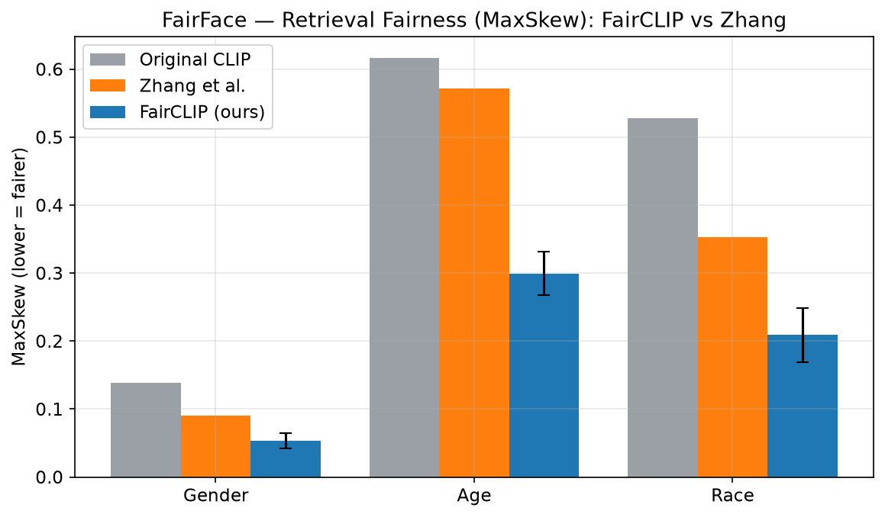
Figure 5: MaxSkew — Original CLIP vs Zhang vs FairCLIP.
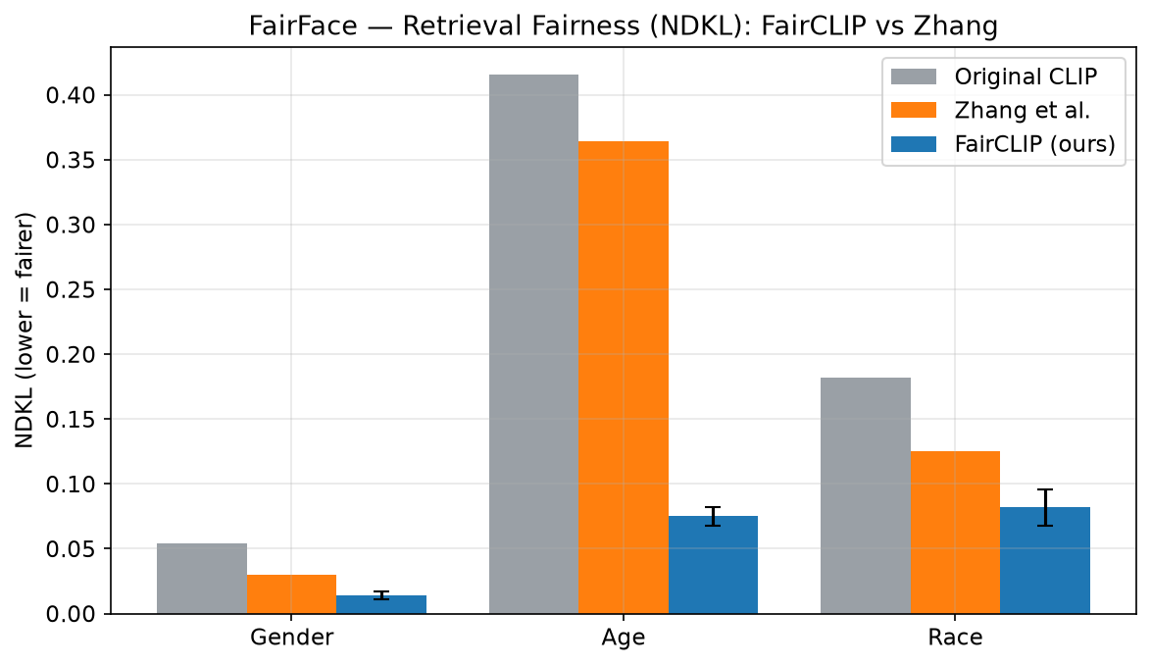
Figure 6: NDKL — Original CLIP vs Zhang vs FairCLIP.

5.3 Representation-level evidence
Centered RBS (group-centroid spread after mean-subtraction and renormalization) drops by roughly 97-99% across all cells, and the t-SNE / PCA plots show groups moving from clearly separated (biased) to overlapping (debiased). This is direct evidence that the demographic direction is removed from the representation, not merely masked at the output.
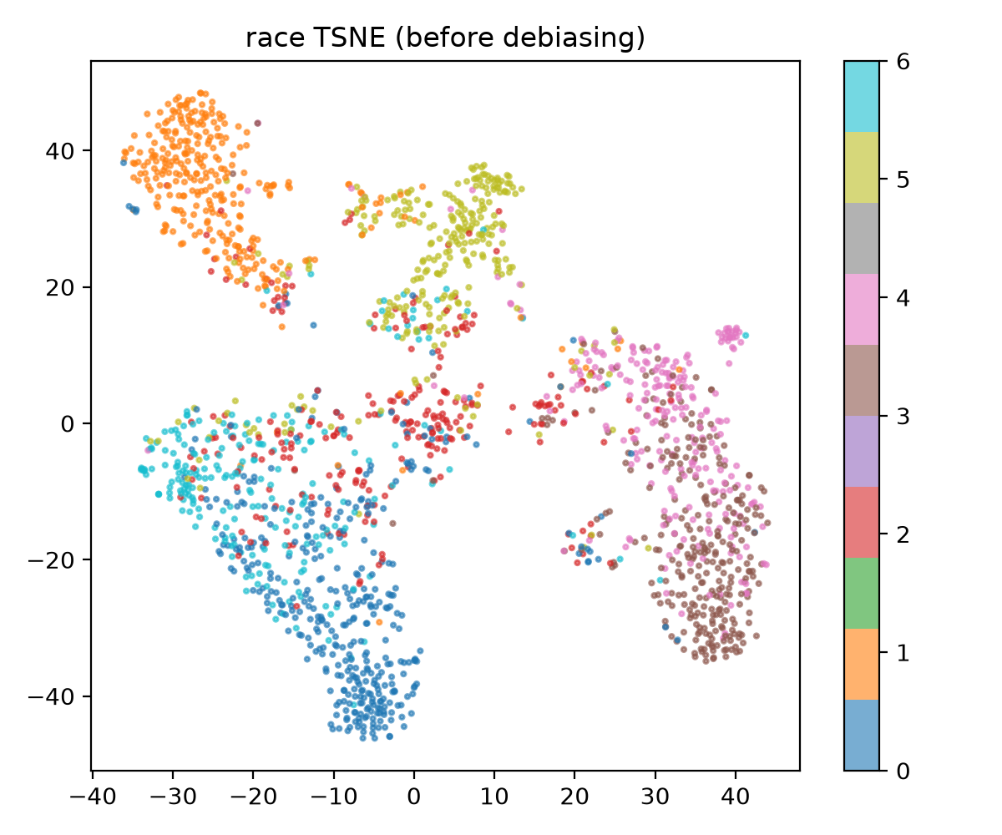
Figure 7a: race embeddings BEFORE debiasing (separated = biased).
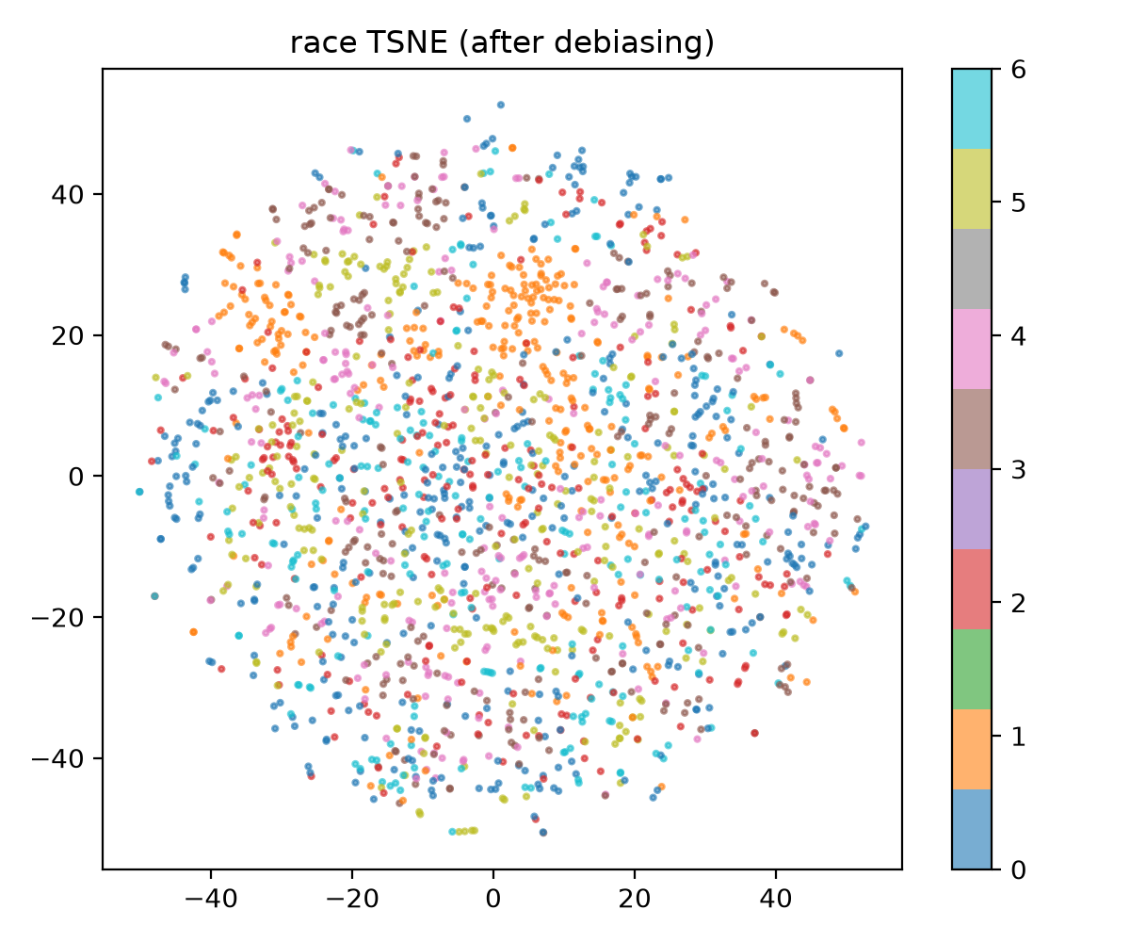
Figure 7b: race embeddings AFTER debiasing (overlapping = debiased).
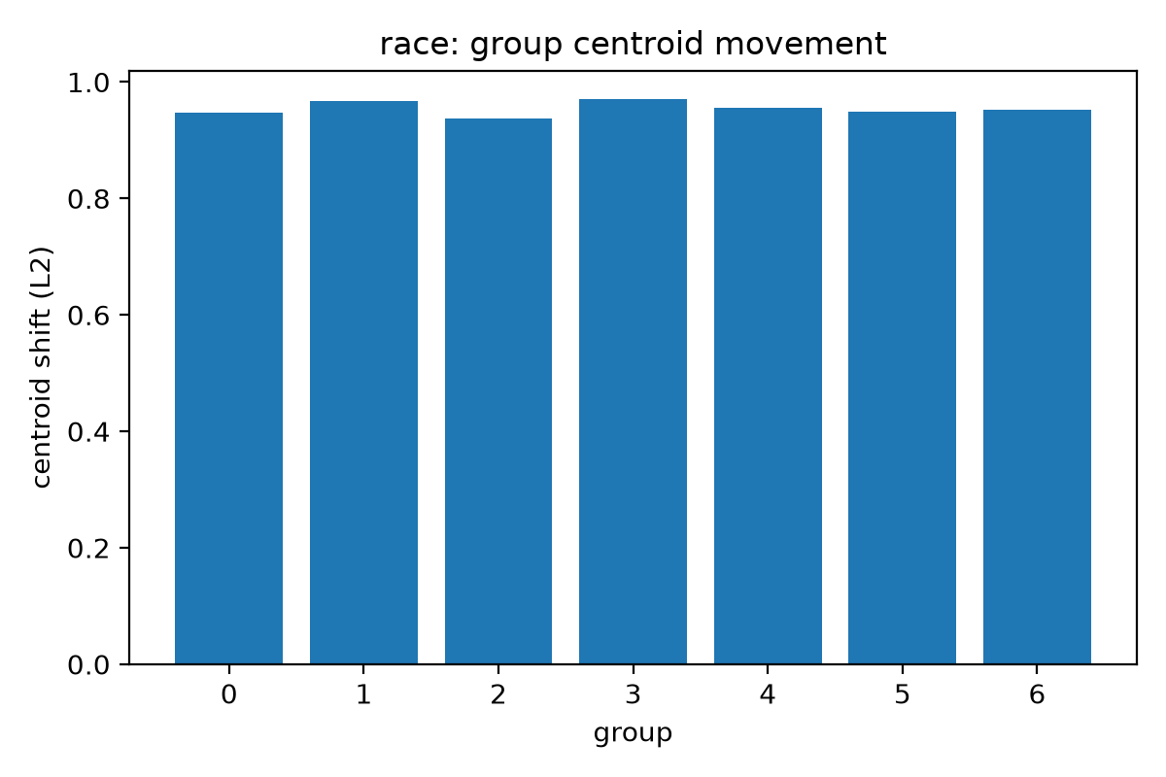
Figure 8: group-centroid movement after debiasing (race).

5.4 Utility preserved
With the frozen-encoder-plus-projection protocol, Flickr30k TR@5 stays within about 1-2 points of Baseline across backbones (ViT-H/14 reaches 88.6 TR@5), confirming that fairness is gained without destroying image-text matching.

5.5 Cross-dataset generalization
On UTKFace, FairCLIP transfers (for example race accuracy 0.867, DPG 0.259). On FACET (gender and age; race labels absent in the release), age MaxSkew improves from 0.676 to 0.135 and gender from 0.153 to 0.070, showing the fairness gain is not specific to FairFace.
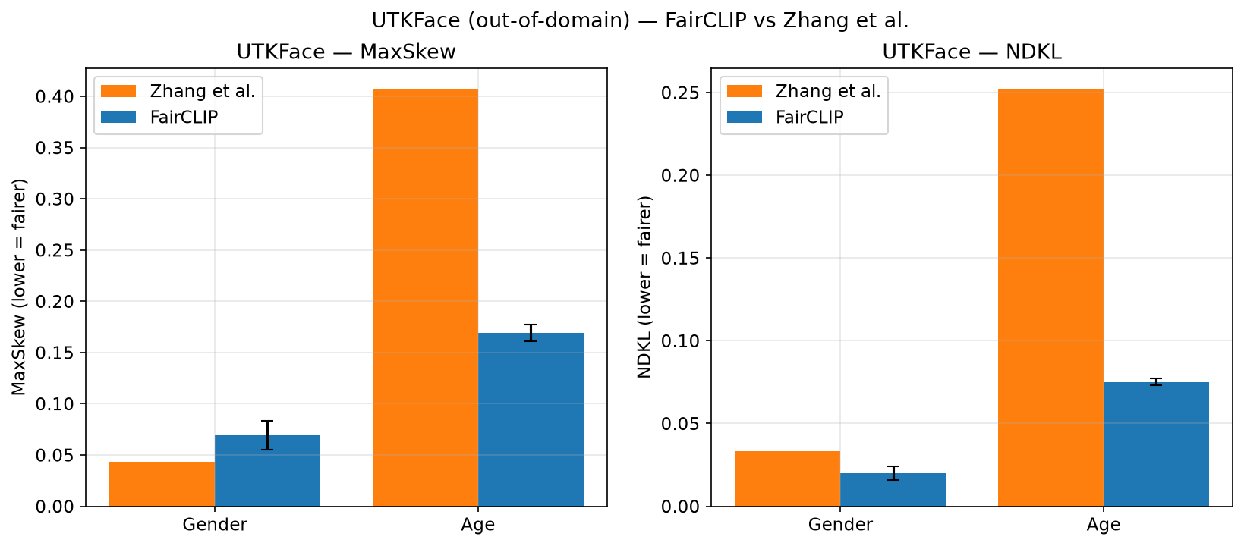
Figure 9: UTKFace cross-dataset retrieval fairness.

6. Key Finding: The Classification-vs-Retrieval Trade-off
Classification fairness and retrieval fairness pull in opposite directions on the same embeddings: keeping the demographic signal enables attribute classification, while removing it makes ranked lists group-neutral. A single projection round preserves classification; deep iterative projection drives MaxSkew down but collapses attribute-classification accuracy. FairCLIP resolves this with task-adaptive projection depth on one trained model per attribute. Making this conflict explicit — and handling it with a single model — is a contribution beyond the base paper.

7. Limitations (Disclosed Honestly)
- Multi-seed validation is complete for ViT-B/32 only (3 seeds; accuracy std <= 0.003). Larger backbones use seed 42 due to the 8 GB GPU.
- Zhang comparison uses the published CVPR-2025 numbers with our own metric implementation; a full identical-hardware re-run was infeasible.
- Zero-shot utility uses ImageNetV2, not ImageNet-1K (availability); disclosed wherever utility is reported.
- ViT-L/14 gender NDKL is marginally above the Zhang value at some operating points (about 0.037-0.040 vs 0.035).
- Ablations are reported on race (ViT-B/32); extension to age and gender is future work.
- FACET provides gender and age labels only (no race in the release).
- Gender bias in Baseline CLIP is already low, so for gender FairCLIP preserves fairness rather than forcing a large reduction.

8. Reproducibility
Every headline number is read from machine-readable CSVs in results/tables/publication/, so each table and figure traces back to an experiment output rather than a hand-entered value. Experiments use separate output directories to prevent checkpoint overwrites; best and latest checkpoints are saved so interrupted runs resume. This document is regenerated by make_thesis_full_document.py.

