

Department of Computer Science

FAST – National University of Computer & Emerging Sciences Chiniot-Faisalabad
Computer Networks – Semester Project Fall 2025
NU-Information Exchange System (FAST-NUCES Multi-Campus Network)

Team
Nimrah Shahid 23F-0734
Aqsa Ishaq 23F-0839
Ayesha Rauf 23F-0807

Date of Submission: 12/8/2025

Submitted to
Mam Rabia Anwer

Table of Contents
1. Introduction 3
2. Campus Overview 3
3. Addressing Plan 3
4. VLAN & Departmental Structure 4
5. Wireless Network Design 4
6. Routing Design 5
7. WAN Design 5
8. DHCP Design 6
9. Security Measures 6
10. Complete Text Topology Diagram 7
11. CLI Configuration 10
12. Why This Design is the Best 12

1. Introduction
This report presents a complete network design for a multi-campus university consisting of six campuses, interconnected through a central core network, providing secure, scalable, and high-performance connectivity. The design uses:
- Private IP Block: 10.0.0.0/8
- Interior Routing Protocol: OSPF Multi-Area
- Exterior Routing Protocol (between campuses): EIGRP
- Layer-2 Domain: VLAN-based segmentation
- Wireless Management: Centralized WLC + Lightweight Access Points
- High Availability: Redundant links, dual routers, loop-free Layer-2
The objective is to create a centralized yet scalable network that supports thousands of students, staff, servers, and wireless users across all campuses.

2. Campus Overview
Campus | Population | Subnet Assigned | OSPF Area | AP Count | Notes
Campus A | 1000 | 10.1.0.0/16 | Area 1 | 50 | Main campus, WLC hosted here
Campus B | 600 | 10.2.0.0/16 | Area 2 | 30 | Faculty/Library
Campus C | 400 | 10.3.0.0/16 | Area 3 | 20 | CS & Engineering
Campus D | 300 | 10.4.0.0/16 | Area 4 | 20 | Admin Campus
Campus E | 200 | 10.5.0.0/16 | Area 5 | 15 | Research Dept
Campus F | 150 | 10.6.0.0/16 | Area 6 | 10 | Remote campus

3. Addressing Plan
3.1 Primary IP Block
10.0.0.0/8
3.2 Allocation per Campus
Each campus receives a /16, allowing up to 65,536 addresses.
Campus | Subnet | Range
A | 10.1.0.0/16 | 10.1.0.1 – 10.1.255.254
B | 10.2.0.0/16 | 10.2.0.1 – 10.2.255.254
C | 10.3.0.0/16 | 10.3.0.1 – 10.3.255.254
D | 10.4.0.0/16 | 10.4.0.1 – 10.4.255.254
E | 10.5.0.0/16 | 10.5.0.1 – 10.5.255.254
F | 10.6.0.0/16 | 10.6.0.1 – 10.6.255.254

4. VLAN & Departmental Structure
Common VLANs Across All Campuses
VLAN ID | Name | Purpose
10 | Admin | Staff offices
20 | Faculty | Teachers
30 | Student | Labs, classrooms
40 | Servers | Datacenter machines
50 | Wireless | AP management
60 | Voice | IP Phones
99 | Management | Switch/WLC management

5. Wireless Network Design
WLC Deployment
- WLC placed in Campus A VLAN 50
- Manages all APs across six campuses
- AP mode: Lightweight (CAPWAP)
SSID Design
SSID | VLAN | Security
Uni-Student | 30 | WPA2-Enterprise
Uni-Faculty | 20 | WPA2-Enterprise
Uni-Guest | 50 | WPA2-PSK (separate DHCP pool)

6. Routing Design
6.1 Interior Routing (Inside Each Campus): OSPF Multi-Area
OSPF Areas:
Campus | Area ID
A | 1
B | 2
C | 3
D | 4
E | 5
F | 6
- Each campus runs OSPF internally.
- Area 0 runs on the Core Router at Campus A.
- All campus routers connect to Area 0 using point-to-point WAN links.

6.2 Exterior Routing (Between Campuses): EIGRP
- Autonomous System Number: AS 100
- Used only between campus routers to exchange inter-campus routes.
- Redistribution between OSPF and EIGRP occurs at Campus A Core Router.

7. WAN Design
Campus Interconnections:
Campus A ↔ B
Campus A ↔ C
Campus A ↔ D
Campus A ↔ E
Campus A ↔ F
- Backbone routers use /30 links:
  - 10.255.x.x/30
Example:
A–B Link → 10.255.1.0/30
A–C Link → 10.255.2.0/30

8. DHCP Design
DHCP Servers exist in Campus A (Centralized)
- Router-on-a-Stick subinterfaces forward DHCP requests via ip helper-address.
- DHCP Pools for:
  - Admin
  - Student
  - Faculty
  - Servers
  - Wireless
  - Guest WiFi

9. Security Measures
Layer | Security Features
Layer 2 | Port security, BPDU Guard, Disabled DTP
Layer 3 | ACLs, OSPF Authentication, EIGRP Authentication
Perimeter | NAT overload for Internet
Wireless | WPA2 Enterprise, Guest VLAN isolation
Management | SSH only, SNMPv3

10. Complete Text Topology Diagram
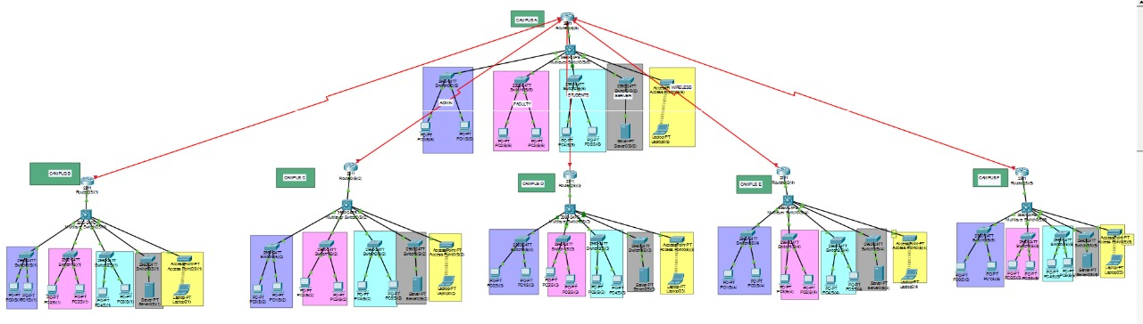

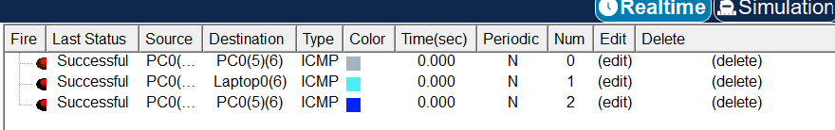
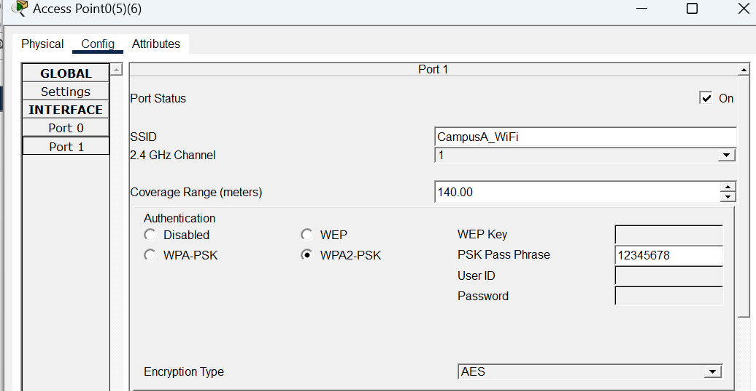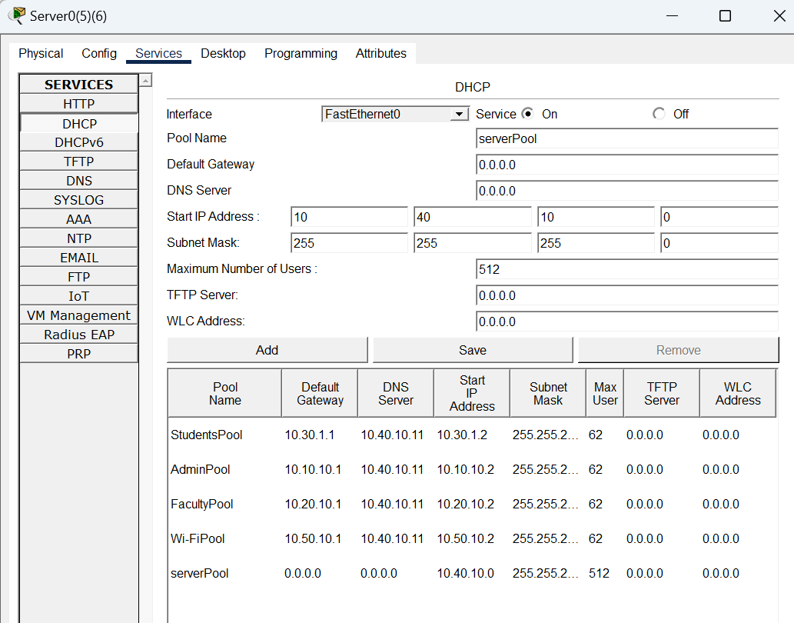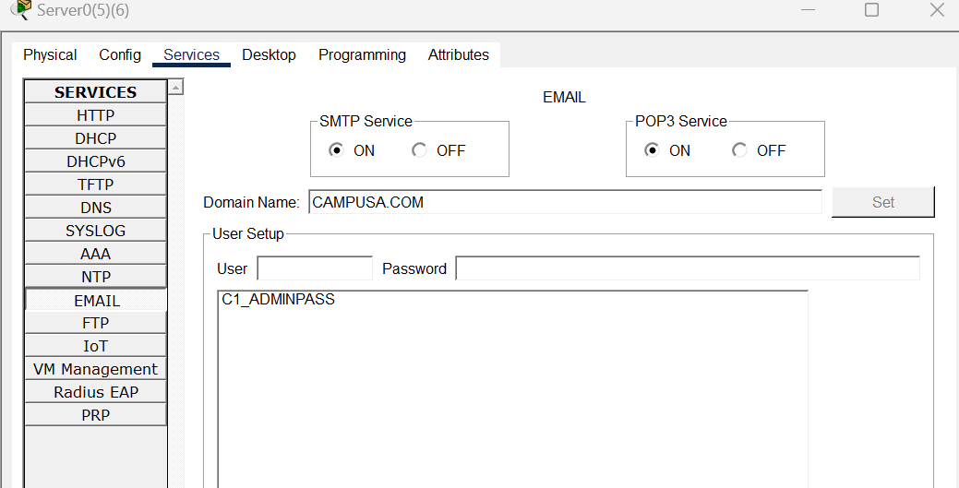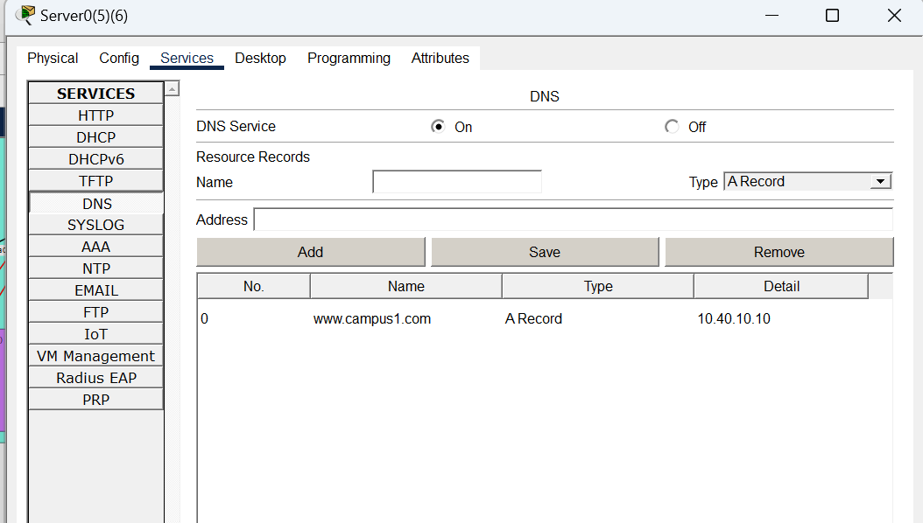

11. CLI Configuration
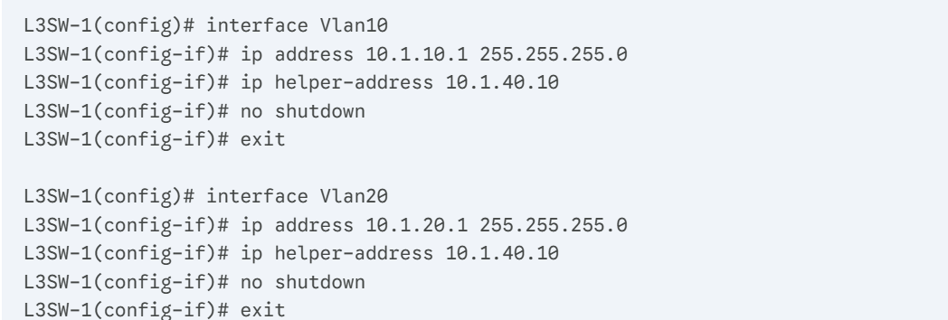
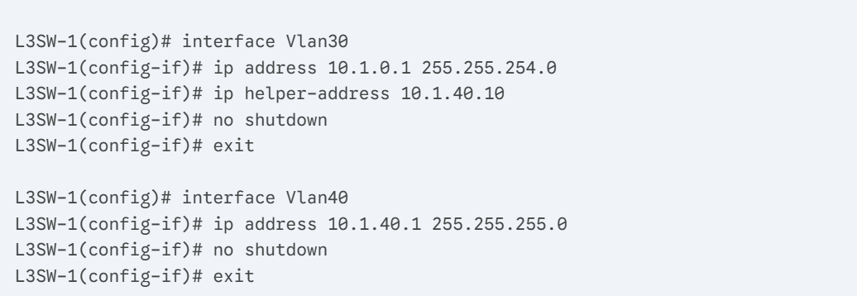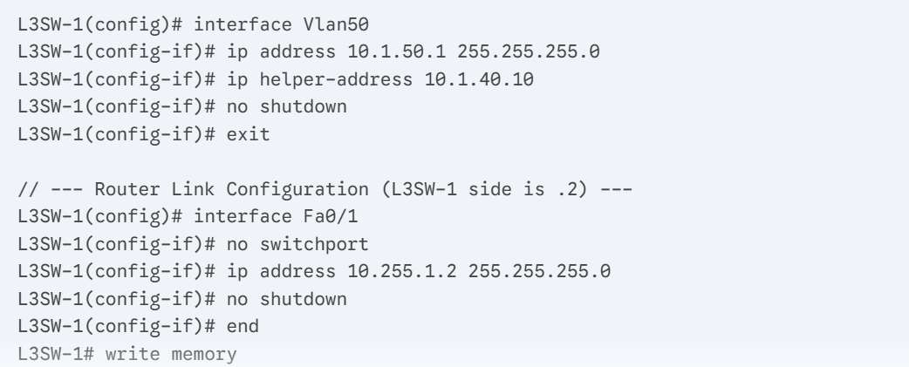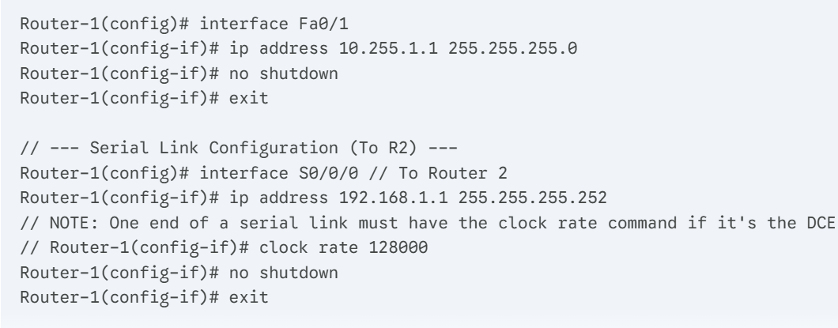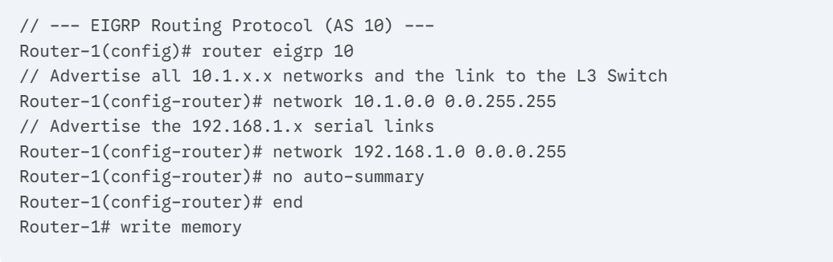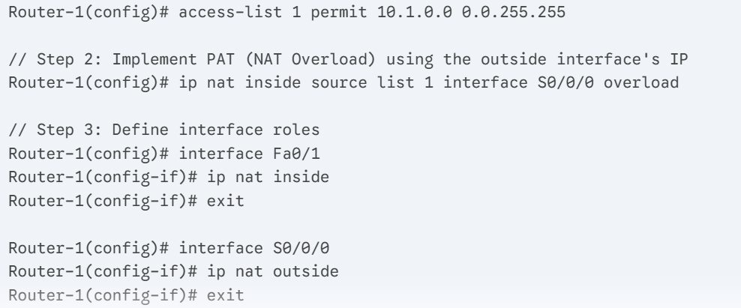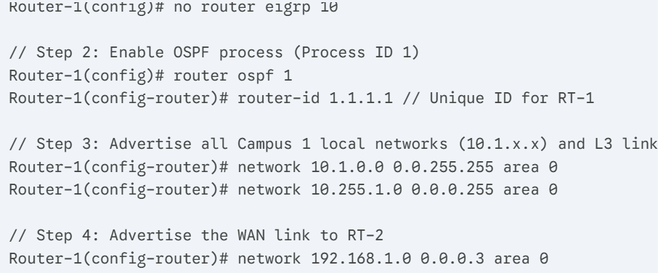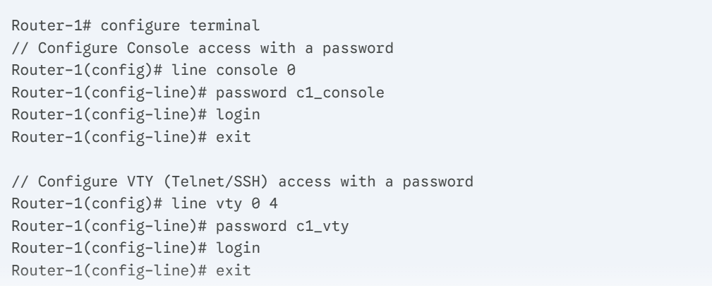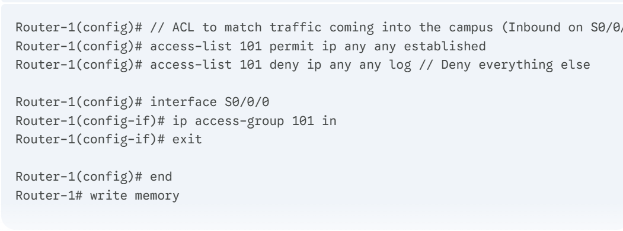

12. Why This Design is the Best
✔ Scalable
Using 10.0.0.0/8 with /16 per campus supports future population growth.
✔ Fast Convergence
OSPF Multi-Area ensures efficient routing inside each campus.
✔ Robust Inter-Campus Connectivity
EIGRP gives high performance and load balancing across campuses.
✔ Centralized Wireless Control
WLC in Campus A reduces management overhead.
✔ High Security
ACLs + WPA2 Enterprise + OSPF/EIGRP authentication + VLAN segmentation.
✔ Easy Management
Campus A hosts all important services (DHCP, WLC, Core Routing).

