Data Visualization Project: Autism Screening Analysis

Introduction

This project explores autism screening outcomes across different life stages—children, adolescents, and adults—using three related datasets. By analysing patterns across these age groups, we aim to gain insights into how autism screening results vary across age, gender, and geography. By exploring broad trends in screening outcomes, this analysis aims to highlight potential disparities and provide meaningful insights into autism screening patterns.

The project will utilise three related datasets from the UCI Machine Learning Repository, each representing a distinct age group, to build a comprehensive, interactive visualisation dashboard. The visualisations will provide insights into how autism screening patterns change over time and highlight key influencing factors.

Data Cleaning, Preprocessing, and Merging of Autism Screening Datasets

The objective of this stage was to clean, preprocess, and merge three distinct datasets related to autism spectrum disorder (ASD) screenings for different age groups: Adults, Adolescents, and Children. This unified dataset will later be used for exploratory data analysis (EDA) and interactive visualizations.

1. Data Loading and Inspection:
- Loaded three separate datasets from ARFF files:
  - Autism-Adult-Data.arff
  - Autism-Adolescent-Data.arff
  - Autism-Child-Data.arff
- Converted ARFF files to CSV format for easier handling using Python.
- Inspected the data to identify:
  - Byte-string formatting issues (e.g., b'1')
  - Missing values
  - Inconsistent column names and categorical values

2. Data Cleaning:
- Removed Byte Strings: Converted byte-encoded strings (e.g., b'1') into standard readable strings (e.g., 1).
- Handled Missing Values:
  - Replaced ? entries with NaN for accurate detection of missing values.
  - Filled missing values in:
    - age column: Imputed using the median of the respective dataset.
    - ethnicity column: Filled with the category "Unknown".
    - relation column:
      - Filled using the mode if a single relation category represented over 60% of the data.
      - Otherwise, assigned "Unknown".
- Corrected Outliers:
  - Unrealistic ages (e.g., values above 100) were replaced with the median age for valid data points in each dataset.

3. Data Standardization:
- Standardized Column Names:
  - Converted all column names to lowercase.
  - Replaced spaces with underscores for consistency.
  - Corrected typos (e.g., jundice → jaundice, contry_of_res → country_of_res).
- Standardized Categorical Variables: Ensured consistency for categorical features:
- Standardized gender values (male, female, other).
- Converted categorical text data to lowercase for uniformity.

4. Dataset Merging:
- Added an age_group column to differentiate data by group (adult, adolescent, child).
- Merged all datasets into a single, unified DataFrame using pd.concat().
- Verified the merged dataset:
  - Total records: 1100
- Age group distribution:
  - Adult: 704 records
  - Child: 292 records
  - Adolescent: 104 records

Exploratory and Statistical Data Analysis

Age Group Comparisons:
Q1: Which age group shows the highest rates of positive ASD diagnoses?
- How do positive diagnosis rates differ across adults, adolescents, and children?
- Is there a significant difference in screening scores (result) across age groups?

We firstly explored how autism screening scores and positive diagnoses vary across three age groups: children (4-11 years), adolescents (12-16 years), and adults (18+ years). The goal is to determine whether autism traits and diagnosis rates differ across life stages.

1. Normalised ASD Diagnosis Rate

To ensure a fair comparison across age groups, we calculated the percentage of individuals who received a positive ASD diagnosis within each group:

Positive ASD Diagnoses by Age Group
Age Group | Total Cases | Positive ASD Diagnoses | Diagnosis Rate (%)
Adult | 704 | 189 | ~26.8%
Child | 292 | 141 | ~48.3%
Adolescent | 104 | 63 | ~60.6%
While adults had the highest absolute number of ASD diagnoses due to their larger sample size, the normalised diagnosis rate revealed that adolescents were the most likely group to screen positive for ASD.
- Adolescents had the highest diagnosis rate (60.6%), suggesting that ASD traits may be most recognizable in this group.
- Children followed with a moderate diagnosis rate (48.3%), supporting the idea that autism is often detected in early life.
- Adults had the lowest diagnosis rate (26.8%), which may be due to factors such as masking, coping mechanisms, or late recognition of ASD traits in adulthood.
- A bar chart visualizing these findings highlights the differences in diagnosis rates among age groups.
2. Screening Score Distribution

We examined the distribution of screening scores (0-10) across age groups:

Screening Score Analysis by Age Group
Age Group | Mean Screening Score | Median Screening Score
Adolescent | 6.72 | 7.0
Child | 6.24 | 6.0
Adult | 4.88 | 4.0

- Adolescents had the highest screening scores (Mean = 6.72, Median = 7), indicating that ASD traits may be most strongly expressed in this group.
- Children followed closely (Mean = 6.24, Median = 6), reinforcing that ASD traits are often detected earlier in life.
- Adults had the lowest scores (Mean = 4.88, Median = 4), which may suggest that self-awareness, coping mechanisms, or differences in self-reporting reduce ASD detection later in life.

A boxplot visualizing the screening score distribution confirmed these findings, showing that adolescents tend to score higher with fewer extreme outliers, while adults display greater variability in their screening scores.
3. Statistical Analysis: ANOVA and Chi-Square Tests:

To determine whether the observed differences in AQ-10 screening scores and diagnosis rates across age groups were statistically significant, we conducted two key statistical tests:
- ANOVA (Analysis of Variance): Compared AQ-10 scores across age groups.
- Chi-Square Test: Evaluated whether ASD diagnosis rates significantly varied across life stages.

Results:
Test | Statistic | p-value | Interpretation
ANOVA (F-test) | 49.6874 | P<0.001 | Significant difference in AQ-10 scores across age groups
Chi-Square Test | 72.2076 | P<0.001 | Significant relationship between age group and ASD diagnosis rates
Key Takeaways:
- The ANOVA test confirmed that AQ-10 scores significantly differ between age groups, reinforcing the trend observed in our screening score analysis.
- The Chi-Square test showed a statistically significant relationship between age group and ASD diagnosis rates, supporting the idea that age influences autism detection rates.

Demographic Influences:

In this section, we explore the relationship between demographic factors—gender and ethnicity—and AQ-10 screening scores, as well as autism diagnosis rates. By examining the mean AQ-10 scores within each demographic group, we can assess variations in autism screening outcomes. Additionally, the diagnosis rate within each category is computed to determine whether certain groups exhibit higher or lower ASD identification trends.

1. Mean AQ-10 Scores by Gender & Diagnosis Status

The table below presents the mean AQ-10 scores for diagnosed and non-diagnosed individuals across gender groups, along with their standard deviations:

Gender | Non-Diagnosed (Mean ± SD) | Diagnosed (Mean ± SD)
Female | 3.74 ± 1.57 | 8.18 ± 1.00
Male | 3.92 ± 1.54 | 8.28 ± 1.06
- Diagnosed males had a slightly higher mean AQ-10 score (8.28) compared to diagnosed females (8.18).
- Non-diagnosed males also had slightly higher mean scores (3.92) than non-diagnosed females (3.74).
- The small difference in mean AQ-10 scores suggests that males may exhibit slightly stronger autistic traits on screening but does not necessarily translate into higher diagnosis rates.

2. Mean AQ-10 Scores by Ethnicity & Diagnosis Status

The table below shows the mean AQ-10 scores across different ethnic groups, including standard deviations:

Ethnicity | Mean AQ-10 Score (Non-Diagnosed) | Std (Non-Diagnosed) | Mean AQ-10 Score (Diagnosed) | Std (Diagnosed)
Asian | 3.94 | 1.45 | 8.15 | 1.01
Black | 3.47 | 1.85 | 8.16 | 1.10
Hispanic | 3.25 | 2.01 | 7.92 | 1.12
Latino | 4.53 | 1.36 | 8.22 | 1.06
Middle Eastern | 3.65 | 1.53 | 7.85 | 0.88
Others | 4.24 | 1.44 | 8.17 | 0.92
Pasifika | 3.17 | 1.59 | 8.50 | 2.12
South Asian | 3.88 | 1.58 | 7.83 | 1.11
Turkish | 3.00 | 1.15 | 9.00 | N/A
Unknown | 3.53 | 1.50 | 7.52 | 0.59
White-European | 4.14 | 1.56 | 8.44 | 1.03
- Diagnosed individuals across all ethnicities consistently scored above 8 on the AQ-10.
- The highest mean score for diagnosed individuals was in the Turkish group (9.00), followed by Pasifika (8.50) and White-European (8.44).
- Among non-diagnosed groups, Latino individuals had the highest mean score (4.53), while Hispanic and Pasifika individuals had the lowest (3.25 and 3.17, respectively).
- Greater variability (higher standard deviations) was observed in the non-diagnosed groups compared to the diagnosed groups.

3. Diagnosis Rate by Gender
The table below presents the percentage of diagnosed and non-diagnosed individuals within each gender group:
Gender | Non-Diagnosed (%) | Diagnosed (%)
Female | 62.7% | 37.3%
Male | 65.4% | 34.6%
- Despite diagnosed males having slightly higher AQ-10 scores on average, the diagnostic rate was higher for females (37.26%) compared to males (34.56%).
- This discrepancy suggests potential differences in how ASD presents and is diagnosed across genders.
- One possible explanation is that males who receive an ASD diagnosis tend to have more extreme AQ-10 scores (closer to 9-10), raising their mean, while diagnosed females may have a broader range of scores.
- Alternatively, diagnostic criteria may be biased toward identifying ASD in males, potentially leading to underdiagnosis in females.

4. Diagnosis Rate by Ethnicity
The table below shows the percentage of diagnosed and non-diagnosed individuals across different ethnic groups:
Ethnicity | Non-Diagnosed (%) | Diagnosed (%)
Asian | 75.1% | 24.9%
Black | 52.3% | 47.7%
Hispanic | 48.0% | 52.0%
Latino | 45.5% | 54.5%
Middle Eastern | 84.4% | 15.6%
Others | 57.9% | 42.1%
Pasifika | 85.7% | 14.3%
South Asian | 80.0% | 20.0%
Turkish | 87.5% | 12.5%
Unknown | 82.6% | 17.4%
White-European | 47.2% | 52.8%
- The highest diagnosis rates were observed in Latino (54.55%), Hispanic (52.00%), and White-European (52.76%) individuals.
- The lowest diagnosis rates were found among Turkish (12.50%), Pasifika (14.29%), and Middle Eastern (15.63%) individuals.
- These differences could be influenced by cultural perceptions of autism, access to healthcare, or differences in self-reporting.
- Higher diagnosis rates in Hispanic and White-European groups align with findings from other studies showing greater autism awareness and diagnosis in Western populations.

Key Findings
- Overall, gender differences exist, but not in the way typically expected—more females were diagnosed than males in this dataset. Ethnicity-based disparities may reflect accessibility and cultural attitudes toward ASD screening.

5. Statistical Analysis: Chi-Square Tests
To determine if the differences in diagnosis rates across gender and ethnicity were statistically significant, we conducted Chi-Square tests:
Test | Chi-Square Statistic | p-value | Interpretation
Gender & Diagnosis Rate | 0.7451 | P = 0.3880 | No statistically significant difference in ASD diagnosis rates between genders.
Ethnicity & Diagnosis Rate | 125.4767 | P <0.001 | Statistically significant difference in ASD diagnosis rates across ethnic groups.
Key Takeaways:
- There is no statistically significant difference in ASD diagnosis rates between males and females (p = 0.3880).
  - This suggests that while we see slight numerical differences, they are not strong enough to conclude a true difference at a population level.
  - The higher female diagnosis rate might be due to external factors rather than a fundamental gender-based diagnostic difference.
- There is a statistically significant difference in ASD diagnosis rates across ethnicities (p < 0.001).
  - This confirms that ethnicity plays a role in autism diagnosis likelihood, possibly due to cultural, healthcare access, or genetic factors.

Geographical Patterns:

This section examines the geographical distribution of AQ-10 scores and autism diagnosis rates across different regions. To ensure meaningful comparisons, we included only countries with at least 20 participants, removing 81 countries with insufficient sample sizes. The final analysis includes 8 countries with robust participant representation.
Mean AQ-10 Scores by Region
We computed the mean AQ-10 scores for each country, along with the standard deviation to reflect variability in responses. The results are summarized in the table below:
Country | Mean AQ-10 Score | Standard Deviation | Sample Size
Canada | 6.92 | 2.10 | 25
United States | 6.53 | 2.41 | 167
Australia | 6.44 | 2.48 | 52
United Kingdom | 6.27 | 2.46 | 155
India | 4.69 | 2.19 | 130
New Zealand | 4.55 | 2.44 | 95
Jordan | 3.97 | 1.79 | 68
United Arab Emirates | 3.64 | 1.48 | 90
- The highest mean AQ-10 scores were observed in Canada (6.92) and the United States (6.53), while the United Arab Emirates (3.64) and Jordan (3.97) reported the lowest scores.
- The variation (standard deviation) was highest in Australia (2.48) and lowest in the UAE (1.48), suggesting greater consistency in AQ-10 responses in the UAE.

A bar chart was created to illustrate the mean AQ-10 scores across countries, revealing notable differences in self-reported ASD traits across regions.

Weighted Diagnosis Rates by Region
We calculated the percentage of participants diagnosed with autism in each country. The table below presents the findings:
Country | Diagnosis Rate (%)
Canada | 68.00
United States | 56.89
Australia | 50.00
United Kingdom | 49.03
India | 20.77
New Zealand | 22.11
Jordan | 10.29
United Arab Emirates | 3.33

Interpretation:
- The highest diagnosis rates were in Canada (68.00%), the United States (56.89%), and Australia (50.00%).
- In contrast, Jordan (10.29%) and the United Arab Emirates (3.33%) had notably lower diagnosis rates, which may reflect differences in autism awareness, healthcare accessibility, or cultural perceptions of neurodevelopmental conditions.
- India (20.77%) and New Zealand (22.11%) showed moderate diagnosis rates compared to Western countries.
- Higher AQ-10 scores in Western countries may reflect greater autism awareness and self-recognition of traits.
- Lower scores in Middle Eastern countries might indicate underreporting due to stigma, lack of awareness, or differences in self-perception

A bar chart was generated to illustrate the weighted ASD diagnosis rates across countries, revealing significant geographical disparities in autism identification.

- Choropleth Map: Global Distribution of Mean AQ-10 Scores → Provides a geographic heatmap of AQ-10 score variations.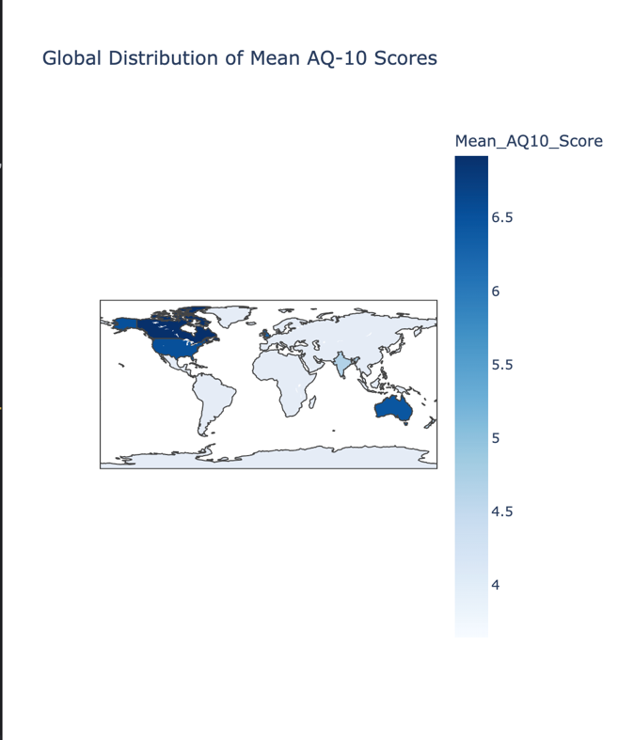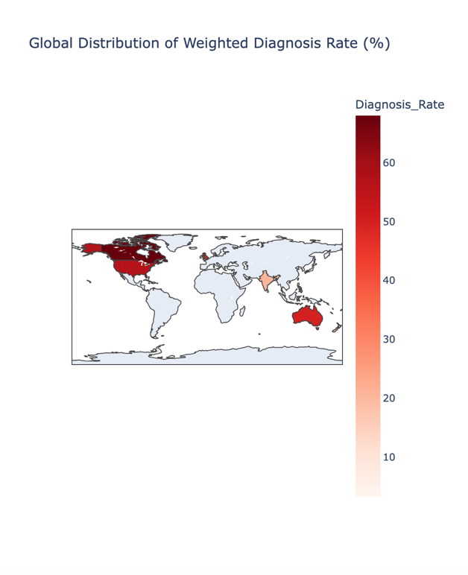

4. Statistical Analysis: Chi-Square Test for Geographic Differences

To determine whether the differences in diagnosis rates were statistically significant, we performed a Chi-Square test.
  - Chi-Square statistic: 142.51
  - p-value: < 0.0001
  - Conclusion: Statistically significant difference in ASD diagnosis rates across countries.

5. Interpretation & Possible Explanations

Why do some countries have higher/lower ASD diagnosis rates?

Potential reasons for geographic differences include:
- Differences in Autism Awareness: Higher diagnosis rates in Canada, the US, and Australia may reflect greater public awareness and screening initiatives.
- Healthcare System Variations: Countries with more accessible mental health services may detect and diagnose autism more frequently.
- Cultural Perceptions of ASD: Social stigma and lack of autism awareness may contribute to underdiagnosis in countries like India, UAE, and Jordan.
- Screening & Reporting Differences: Some countries may use different diagnostic criteria or have less access to formal ASD assessments, leading to lower reported diagnosis rates.
Geographic Trends & Global Implications
- The choropleth maps visually highlight global disparities in mean AQ-10 scores and diagnosis rates, reinforcing that autism diagnosis likelihood is influenced by regional factors.
- Countries with higher AQ-10 scores tend to have higher diagnosis rates, but not always, suggesting possible underdiagnosis in some regions.
- Future research could investigate how policy changes, healthcare improvements, and education initiatives impact autism diagnosis rates worldwide.

