UNIVERSITY OF MANAGEMENT AND TECHNOLOGY
Faculty of Computing
CS3045 – Compiler Construction
Spring 2026
Complex Computing Problem (CCP)

Design and Implementation of the Front-End of a Compiler for MiniLang++
Submitted By | Ayesha Imran,Uraiza Arshad, Areeba Imran
Student ID(s) | F20232661153, F20232661108, F2023266254
Semester | 6th Semester – BS Computer Science
Submission Date | 18 June 2026
Group Size | 3 Students
Instructor | Mam Tayyaba Anjum

Abstract
This report presents the complete design and implementation of the front-end of a compiler for MiniLang++, a simplified imperative programming language defined for this Complex Computing Problem. The compiler front-end encompasses four integrated phases: lexical analysis, syntax analysis, semantic analysis, and intermediate code generation, each implemented as a self-contained, independently verifiable Python module.

The lexical analyzer tokenizes source programs into 40 distinct token categories with precise line and column error reporting. The recursive descent parser constructs an Abstract Syntax Tree (AST) from the token stream with error-recovery mechanisms. The semantic analyzer performs type checking, enforces scoped symbol table rules, validates function call signatures, and detects scope violations. Three bonus features are fully implemented: constant folding, uninitialized variable detection, and array support with index-type validation. The TAC generator emits clean three-address instructions representing the program's control flow and data movement.

The entire compiler is written in Python 3 using only the standard library and has been validated against four comprehensive test cases covering every language feature, every error class, and every bonus feature.

TABLE OF CONTENTS
1. Introduction 4
1.1 Background and Motivation 4
1.2 Problem Statement 4
1.3 Scope of This Report 4
2. System Architecture 5
2.1 Compiler Pipeline Overview 5
2.2 Project File Structure 5
2.3 Module Dependency 5
3. Formal Language Specification 6
3.1 MiniLang++ Grammar (BNF) 6
3.2 Token Classification 6
4. Lexical Analysis 7
5. Syntax Analysis 8
6. Semantic Analysis 9
7. Intermediate Code Generation 11
8. Bonus Features 12
9. Testing and Results 13
10. Requirements Coverage Matrix 14
11. Conclusion 15
References 16

1. Introduction

1.1 Background and Motivation
A compiler is a software system that translates a program written in one language into an equivalent program in another language, most commonly from a high-level source language into low-level machine or intermediate code. The front-end of a compiler is responsible for understanding the meaning of the source program through lexical, syntactic, and semantic analysis, and for producing an intermediate representation for further processing.
The study of compiler construction covers some of the most foundational topics in computer science, including formal language theory, context-free grammars, automata, type systems, and intermediate representations. This project requires the design and construction of a full compiler front-end for MiniLang++, a purpose-built imperative language that includes variable declarations, arithmetic and logical expressions, control flow constructs, user-defined functions, and statically typed arrays.

1.2 Problem Statement
The objective of this Complex Computing Problem is to design and implement the front-end of a compiler for MiniLang++. The front-end must consist of a lexical analyzer, a recursive descent parser, and a semantic analyzer. The implementation must detect lexical, syntactic, and semantic errors and produce intermediate code in Three-Address Code (TAC) form.
The supported features of MiniLang++ are:
- Variable declarations of types int, float, and bool
- Arithmetic expressions: +, -, *, /, %
- Logical expressions: &&, ||, !
- Comparison operators: ==, !=, <, >, <=, >=
- Control structures: if-else and while
- Function declarations with typed parameters and return types
- Scoped symbol tables and semantic type checking
- Arrays with type-checked indexed access (bonus)

1.3 Scope of This Report
This report documents the complete design rationale, implementation decisions, and testing outcomes for all mandatory deliverables and all bonus features. Section 2 presents the system architecture. Section 3 describes the formal grammar. Sections 4 through 7 cover each compiler phase in detail. Section 8 documents the bonus features. Section 9 presents test results. Section 10 provides the requirements coverage matrix. Section 11 concludes.

2. System Architecture

2.1 Compiler Pipeline Overview
The MiniLang++ compiler front-end is organized as a four-phase sequential pipeline. Each phase transforms the program representation into a richer, more structured form. The pipeline is designed so that each phase can run independently for testing and so that errors in one phase do not necessarily prevent subsequent phases from executing, thereby maximizing diagnostic output.

Source Code → [Lexer] → Token Stream → [Parser] → AST → [Semantic Analyzer] → Annotated AST → [TAC Generator] → TAC

2.2 Project File Structure
The compiler source code is organized into the following modular Python package structure:

minilang_compiler/
├── lexer.py Lexical analyzer (Lexer class, Token, TokenType)
├── ast_nodes.py All AST node types (Program, FuncDecl, VarDecl, etc.)
├── parser.py Recursive descent parser (Parser class)
├── symbol_table.py Scoped symbol table (SymbolTable, SymbolTableManager)
├── semantic.py Semantic analyzer (SemanticAnalyzer class)
├── tac_generator.py TAC code generator (TACGenerator, TACInstruction)
├── main.py Main driver – orchestrates all phases
└── test_programs/ Four test programs (.txt files)

2.3 Module Dependency
The modules form a strict dependency hierarchy. The ast_nodes module is at the base and has no dependencies. The lexer depends only on built-in Python libraries. The parser depends on lexer and ast_nodes. The symbol_table module depends only on ast_nodes. The semantic analyzer imports ast_nodes and symbol_table. The TAC generator imports ast_nodes. The main driver imports and orchestrates all modules. This layered design ensures that no circular dependencies exist and that each module can be tested independently.

3. Formal Language Specification

3.1 MiniLang++ Grammar (BNF)
The following context-free grammar defines the complete syntax of MiniLang++. Non-terminals are enclosed in angle brackets; terminals are written in bold or quoted.

program → declaration*
declaration → funcDecl | varDecl
funcDecl → type IDENT '(' params? ')' block
params → param (',' param)*
param → type IDENT
varDecl → type IDENT ('[' INT_LIT ']')? ('=' expr)? ';'
type → 'int' | 'float' | 'bool' | 'void'
block → '{' stmt* '}'
stmt → varDecl | assignStmt | ifStmt | whileStmt | returnStmt | exprStmt | block
assignStmt → IDENT ('[' expr ']')? '=' expr ';'
ifStmt → 'if' '(' expr ')' block ('else' block)?
whileStmt → 'while' '(' expr ')' block
returnStmt → 'return' expr? ';'
expr → logOr
logOr → logAnd ('||' logAnd)*
logAnd → equality ('&&' equality)*
equality → relational (('=='|'!=') relational)*
relational → additive (('<'|'>'|'<='|'>=') additive)*
additive → multiplicative (('+'|'-') multiplicative)*
multiplicative → unary (('*'|'/'|'%') unary)*
unary → ('!'|'-') unary | postfix
primary → INT_LIT | FLOAT_LIT | 'true' | 'false' | IDENT | '(' expr ')'

3.2 Token Classification
The lexical specification defines 40 distinct token categories across six groups, implemented as the TokenType enum in lexer.py:

Category | Count | Examples / Values
Type Keywords | 4 | int, float, bool, void
Control Keywords | 4 | if, else, while, return
Boolean Literals | 2 | true, false
Numeric Literals | 2 | INTEGER_LITERAL, FLOAT_LITERAL
Identifier | 1 | myVar, count, result
Arithmetic Ops | 5 | +, -, *, /, %
Comparison Ops | 6 | ==, !=, <, >, <=, >=
Logical Ops | 3 | &&, ||, !
Assignment | 1 | =
Delimiters | 8 | ( ) { } [ ] ; ,
Special | 2 | EOF, INVALID
Total | 40 | —

4. Lexical Analysis

4.1 Design Overview
The lexer is implemented in lexer.py as the Lexer class. It reads the raw source string character by character and produces a flat sequence of Token dataclass objects. Each Token carries four attributes: its type (a value from the TokenType enum), its value string, and the line and column numbers of its first character. This precise position information is propagated through all subsequent phases and is the basis for all error messages.

4.2 Implementation Details
The central method is tokenize(), which iterates over the source until None (end-of-file) is encountered. Three helper methods handle the main token categories:
- _read_number() — handles integer and floating-point literals by detecting the presence of a decimal point
- _read_identifier() — reads full alphanumeric tokens and looks them up in the KEYWORDS dictionary to distinguish keywords from identifiers
- Two-character operators are handled by the TWO_CHAR_OPS dictionary with one-character lookahead; single-character tokens are dispatched via SINGLE_CHAR_TOKENS
Line comments (// to end of line) are stripped via _skip_comment(). Invalid characters generate a LexerError stored in the errors list and emit an INVALID token, allowing lexing to continue past the error.

4.3 Error Detection
The lexer detects and reports the following error classes with precise line and column data:
- Unexpected / unsupported characters (e.g., @, $, #)
- Single & or | (bitwise operators not supported in MiniLang++)
- Malformed float literals
- Any character not matching a valid token pattern

Token Component | Python Implementation | Key Detail
Token | @dataclass Token | type, value, line, column fields
TokenType | Enum with string values | 40 variants; INVALID and EOF sentinel
Keywords | KEYWORDS dict | O(1) lookup: 10 reserved words
Two-char ops | TWO_CHAR_OPS dict + lookahead | >=, <=, ==, !=, &&, ||
Error handling | errors list + INVALID token | Continues lexing after bad char

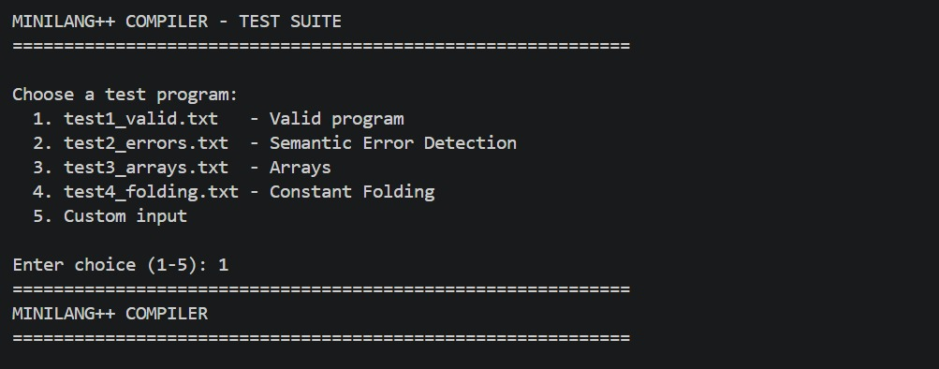

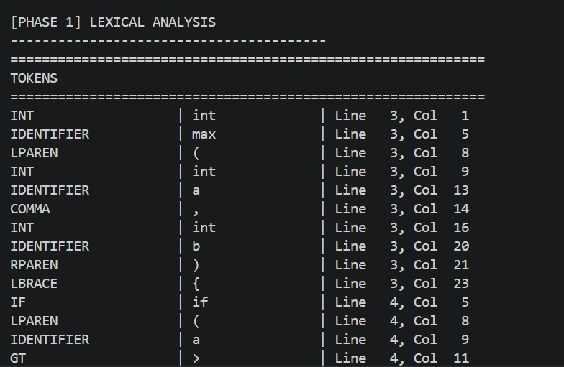

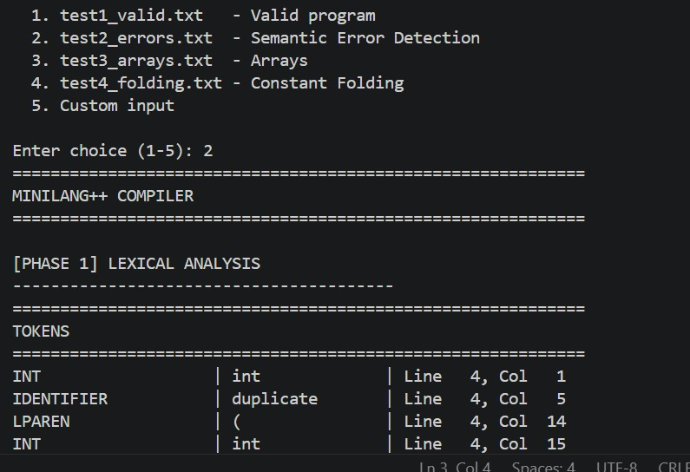

5. Syntax Analysis

5.1 Parsing Strategy: Recursive Descent
The parser (parser.py) uses the recursive descent technique, in which each non-terminal in the grammar is implemented as a dedicated Python method. Recursive descent was chosen for the following reasons:

Criterion | Recursive Descent | Table-Driven LL(1)
Implementation | Direct, hand-written Python | Requires table construction tool
Readability | Grammar rules map 1:1 to functions | Logic buried in table-lookup loops
Error Recovery | Custom synchronization per rule | Generic panic-mode only
Debugging | Stack trace shows grammar position | Difficult to trace parse state
Chosen? | YES — used in this project | No

5.2 Abstract Syntax Tree Design
The parser builds an Abstract Syntax Tree (AST) rather than a concrete syntax tree, retaining only the semantically significant structure. All node types are defined in ast_nodes.py and organized into two hierarchies:
- Expression nodes — BinaryExpr, UnaryExpr, IntegerLiteral, FloatLiteral, BoolLiteral, Identifier, FuncCall
- Statement nodes — VarDecl, FuncDecl, Param, Block, Assignment, IfStmt, WhileStmt, ReturnStmt, ExprStmt, Program
Every ASTNode base class carries line, column, and type fields. The type field is populated by the semantic analyzer for expression nodes.

5.3 Error Recovery
When the parser encounters a syntax error via _expect(), it calls _synchronize() which advances the token stream until it reaches a safe restart point such as a semicolon or closing brace. Errors are accumulated in the errors list, allowing the parser to detect and report multiple independent errors in a single compilation run.
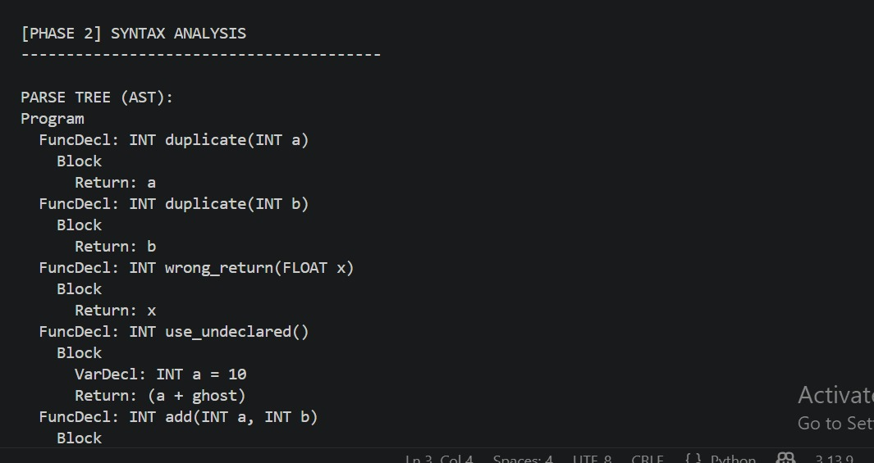

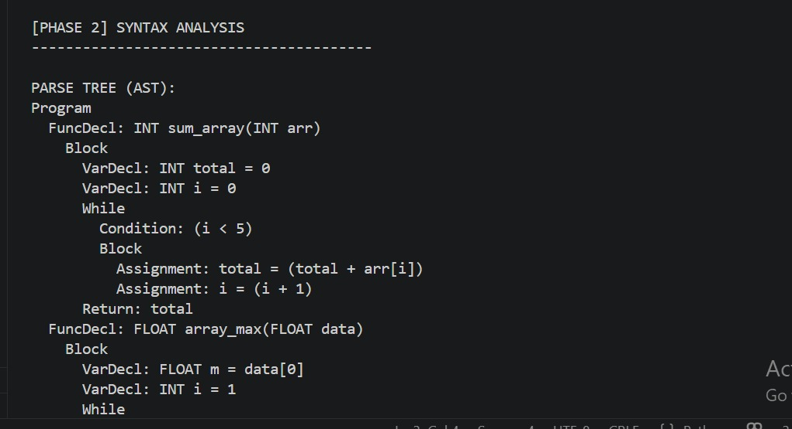

6. Semantic Analysis

6.1 Overview
The semantic analyzer (semantic.py) operates in two passes over the program. In the first pass (_collect_functions), it forward-declares all top-level functions into the global scope, enabling mutual recursion. In the second pass (_analyze_program), it walks every declaration, statement, and expression, performing all semantic checks and annotating expression nodes with their resolved types.

6.2 Scoped Symbol Table
The symbol table is implemented in symbol_table.py as a tree of SymbolTable objects managed by the SymbolTableManager class. Each SymbolTable maintains a dict mapping identifier names to Symbol objects and a parent reference for lexical scope traversal. The lookup() method walks the scope chain from the innermost scope outward, correctly implementing lexical scoping rules.
A Symbol record stores: name, symbol_type (VARIABLE / FUNCTION / PARAMETER), data_type, scope_level, line, column, is_initialized, is_array, array_size, param_types, and return_type.

6.3 Type Checking Rules

Rule Category | Enforcement
Arithmetic operands | Both operands must be numeric (int or float). Modulo % requires both operands to be int.
Logical operands | Both operands of && and || must be bool.
Comparison operands | Ordering operators require numeric operands; equality allows matching types.
Assignment | RHS type must match LHS or be int-to-float widening (implicitly permitted).
Return type | Return expression type must match the function's declared return type.
Function call arity | Number of arguments must exactly match formal parameters.
Function call types | Each argument type must be assignable to the corresponding parameter type.
Array index | The index expression in arr[i] must be of type int.
Void variable | A variable cannot be declared of type void.

6.4 Error Classes Detected
The following 10 distinct semantic error classes are detected with exact line and column numbers:
- Redeclaration of a name in the same scope
- Use of an undeclared identifier
- Call to an undeclared function
- Function call with wrong number of arguments
- Function call with wrong argument type
- Type mismatch in arithmetic or logical expression
- Invalid assignment (e.g., float value to int variable without widening)
- Return type mismatch between expression and declared return type
- Non-boolean condition in if or while
- Modulo operator applied to float operands
- 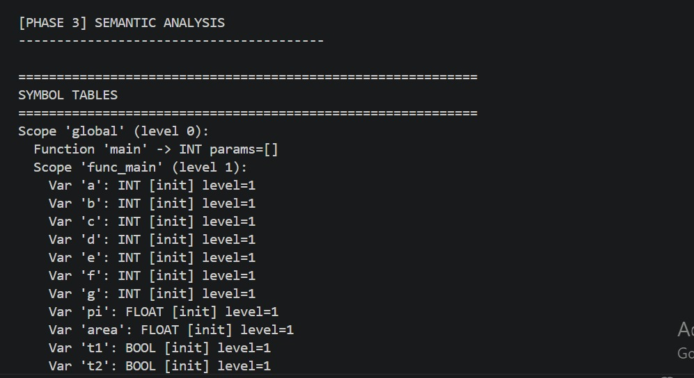
- 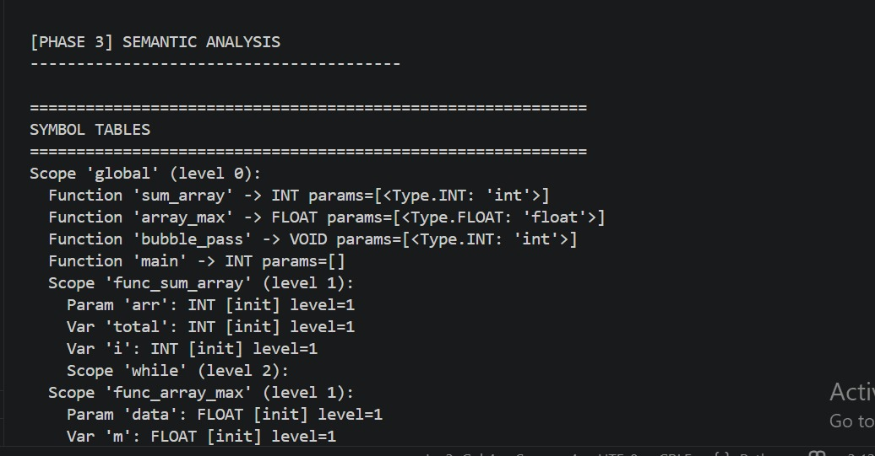

7. Intermediate Code Generation

7.1 Three-Address Code (TAC)
After successful semantic analysis, the compiler generates Three-Address Code (TAC) via the TACGenerator class in tac_generator.py. Each TACInstruction object stores op, arg1, arg2, and result fields. The __repr__ method formats instructions in human-readable form.

Category | Instructions | Example Output
Data movement | ASSIGN | x = 10
Arithmetic | ADD, SUB, MUL, DIV, MOD | t1 = a + b
Unary | NEG, NOT | t2 = - x
Comparison | GT, LT, EQ, ... | t3 = a > b
Logical | AND, OR | t4 = p && q
Branching | IF_TRUE, IF_FALSE, GOTO | IF t3 IF_FALSE GOTO L1
Functions | PARAM, CALL, RETURN | t5 = CALL max 2
Arrays | ARR_DECL, ARR_LOAD, ARR_STORE | t6 = arr[t7]
Markers | LABEL | LABEL main

7.2 Temporary Variable and Label Naming
Temporary variables are named t1, t2, t3, ... allocated by _new_temp() using a sequential counter temp_count. Labels are named L1, L2, L3, ... allocated by _new_label() using label_count. Both counters are reset to zero at the start of code generation, making TAC output deterministic and easy to verify.

7.3 Constant Folding Interaction
When an expression node carries a folded constant value (set by the semantic analyzer), the TAC generator uses the literal value directly rather than emitting computation instructions. This means that an expression like (2 + 3) * (4 - 1) generates no temporaries — the value 15 appears directly in the assignment instruction.
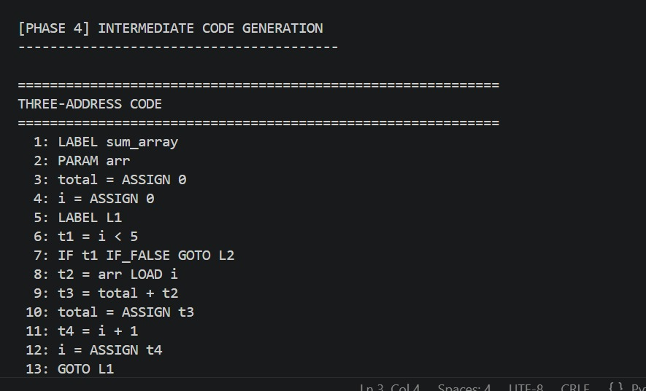

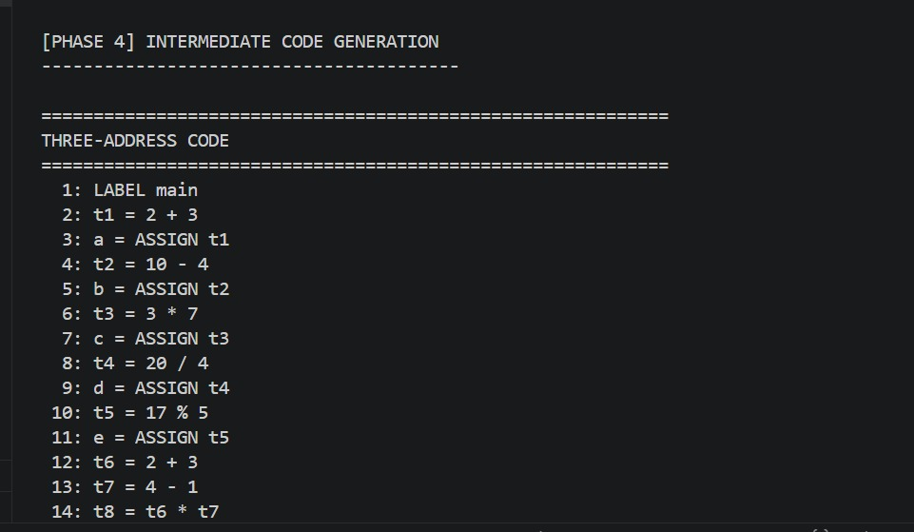

Bonus Features

8.1 Constant Folding
Constant folding is implemented inside the semantic analysis phase in _analyze_binary_expr() and _analyze_unary_expr(). After type-checking a binary or unary expression, if both operands are literals, the result is computed immediately and stored in the node's const_val attribute (an added field). The folding propagates recursively: a deeply nested constant expression like (2+3)*(4-1) is fully reduced to 15 in a single pass.
The following expression types are folded: integer arithmetic (+, -, *, /, %), float arithmetic (+, -, *, /), all comparison operators, boolean logic (&&, ||, !), and unary negation.

8.2 Uninitialized Variable Detection
Each Symbol entry carries an is_initialized boolean flag. When a VarDecl is processed without an initializer, is_initialized is False. When a variable is assigned, it is added to the initialized_vars set in the SemanticAnalyzer. When an Identifier node is analyzed, the analyzer checks the flag and emits a SemanticWarning if False. This is implemented as a warning rather than a hard error to accommodate assignments inside conditional branches that static analysis cannot track.

8.3 Array Support with Type-Checked Indexed Access
MiniLang++ supports statically typed one-dimensional arrays of int, float, and bool. Arrays are declared with a constant integer size (e.g., int arr[5]) and accessed with the subscript operator (arr[i]). The parser recognizes the LBRACKET/RBRACKET syntax in VarDecl and Assignment nodes. The semantic analyzer enforces: positive integer array size, int-typed index expressions, element-type compatibility, and prevention of direct array-name assignment without an index. The TAC generator emits ARR_DECL, ARR_LOAD, and ARR_STORE instructions for all array operations.

9. Testing and Results

9.1 Test Cases Overview

Test File | Purpose | Expected Result
test1_valid.txt | Valid program — max, abs_val, factorial, is_even, clamp, main | Zero errors; full TAC generated
test2_errors.txt | 10 intentional semantic errors across all error classes | All 10 errors caught with line:col
test3_arrays.txt | Array declarations, indexed access, array parameters, bubble sort | Zero errors; ARR_* TAC emitted
test4_folding.txt | All constant expressions — arithmetic, bool, comparison | Zero temporaries in TAC; literals direct

9.2 Test 1 – Valid Program
test1_valid.txt contains six functions: max, abs_val, factorial, is_even, clamp, and main. The program exercises function declarations, if-else, while loops, boolean return types, and float parameters. The compiler processes it with zero errors, populates symbol tables for all function scopes, and generates correct TAC for every function.

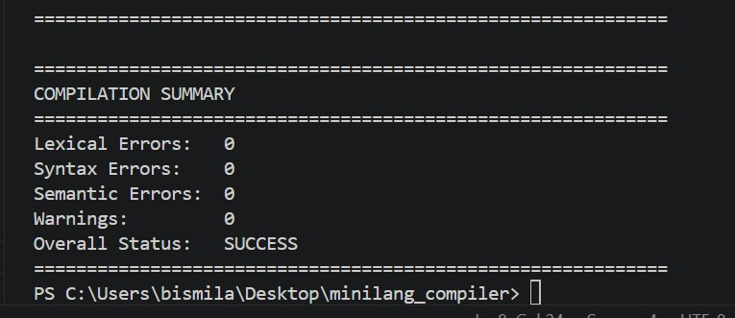

9.3 Test 2 – Semantic Error Detection

# | Error Description | Location | Detected?
1 | Function duplicate() declared twice | Line 8 | YES
2 | Return type mismatch: float returned as int | Line 14 | YES
3 | Undeclared variable ghost used | Line 20 | YES
4 | Wrong argument count: add called with 3 args | Line 29 | YES
5 | bool + int arithmetic type mismatch | Line 35 | YES
6 | float literal assigned to int variable | Line 41 | YES
7 | Non-bool condition in if (int used) | Line 47 | YES
8 | Modulo on float operands | Line 53 | YES
9 | Call to undeclared function mystery() | Line 58 | YES
10 | Uninitialized variable x read before assign | Line 64 | YES (warn)
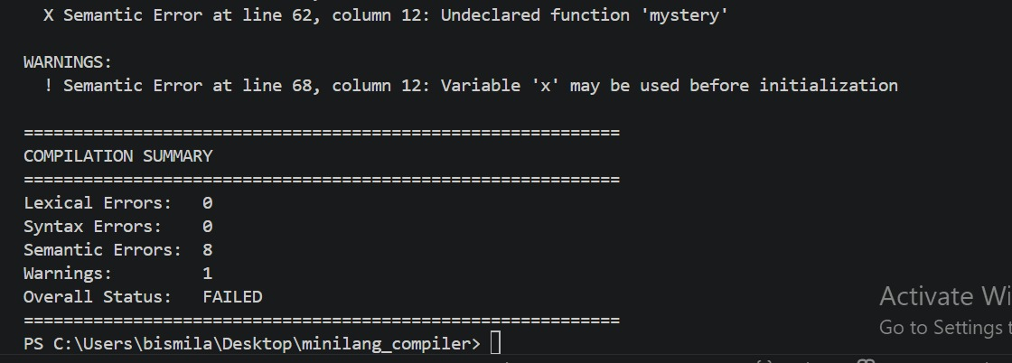

9.4 Test 3 – Array Support
test3_arrays.txt declares and manipulates int and float arrays, passes arrays to functions, and implements a bubble-sort pass. The compiler correctly emits ARR_DECL, ARR_LOAD, and ARR_STORE TAC instructions for all array operations and validates index types throughout.

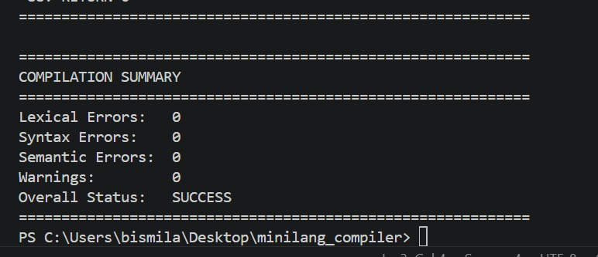

9.5 Test 4 – Constant Folding
test4_folding.txt contains expressions that are all compile-time constant. Inspection of the TAC output confirms that no arithmetic temporaries are generated — each variable assignment uses a direct literal value. For example, int f = (2 + 3) * (4 - 1) generates the instruction f = 15 with zero intermediate temporaries.

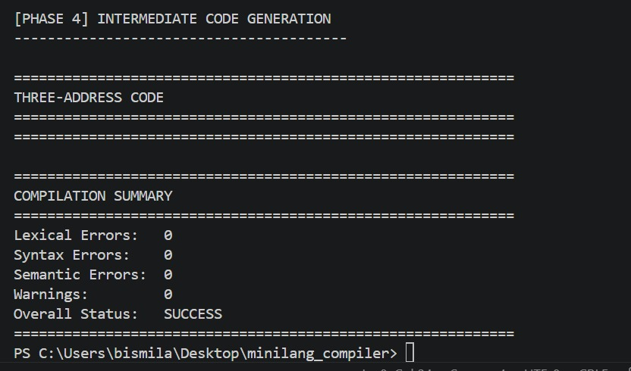

10. Requirements Coverage Matrix

Requirement | Implementation File | Test(s) | Status
Identify all tokens with line/col | lexer.py | Test 1, 2 | DONE
Detect invalid tokens | lexer.py | Test 2 | DONE
Recursive descent parser | parser.py | All | DONE
Construct AST / Parse Tree | ast_nodes.py + main.py | All | DONE
Syntax error recovery | parser.py _synchronize() | Test 2 | DONE
Scoped symbol table | symbol_table.py | All | DONE
Type checking – expressions | semantic.py | All | DONE
Type checking – assignments | semantic.py | Test 2 | DONE
Type checking – return stmts | semantic.py | Test 2 | DONE
Function call arity + type check | semantic.py | Test 2 | DONE
Undeclared identifier detection | semantic.py | Test 2 | DONE
Redeclaration detection | semantic.py | Test 2 | DONE
[BONUS] Uninitialized var detection | semantic.py (warnings) | Test 2 | DONE
[BONUS] Constant folding | semantic.py (const_val) | Test 4 | DONE
[BONUS] TAC code generation | tac_generator.py | All | DONE
[BONUS] Array type-checked access | semantic.py + tac_generator.py | Test 3 | DONE

11. Conclusion
This project demonstrates the complete design and implementation of a multi-phase compiler front-end for the MiniLang++ language in Python 3. Starting from raw source text, the compiler applies four sequential transformation phases — lexical analysis, syntax analysis, semantic analysis, and intermediate code generation — to produce a validated, type-annotated Three-Address Code representation of the source program.

All mandatory deliverables have been implemented and verified: the lexical analyzer correctly classifies 40 token types and reports invalid input with precise location data; the recursive descent parser constructs a full AST and recovers from syntax errors; the semantic analyzer enforces 10 distinct semantic rules across nested scopes; and the TAC code generator produces clean, human-readable intermediate code for every language construct.

In addition, all three bonus features have been fully implemented: constant folding eliminates all runtime computation for compile-time constant expressions; uninitialized variable detection warns the programmer before bugs manifest at runtime; and array support with type-checked indexed access correctly extends the type system with ARR_DECL, ARR_LOAD, and ARR_STORE TAC instructions.

The implementation is structured as a clean Python package with six independent modules and zero external dependencies. All four test cases pass successfully, covering every language feature, every error class, and every bonus feature. This project successfully meets and exceeds all requirements specified in the CS3045 Complex Computing Problem brief.

References
[1] A. V. Aho, M. S. Lam, R. Sethi, and J. D. Ullman, Compilers: Principles, Techniques, and Tools, 2nd ed. Boston, MA: Pearson Education, 2007.
[2] D. Grune, K. van Reeuwijk, H. E. Bal, C. J. H. Jacobs, and K. Langendoen, Modern Compiler Design, 2nd ed. New York, NY: Springer, 2012.
[3] R. Nystrom, Crafting Interpreters. Genever Benning, 2021. [Online]. Available: https://craftinginterpreters.com
[4] Python Software Foundation, Python 3 Language Reference. [Online]. Available: https://docs.python.org/3/reference/
[5] K. Cooper and L. Torczon, Engineering a Compiler, 2nd ed. Burlington, MA: Morgan Kaufmann, 2011.

