

Computer Networks
Company Name:
“Futurenostics”
Project Submission Report

Prepared By:

Name | Roll Number | Email Address
Muhammad Ali | 241383 | 241383@students.au.edu.pk
Zain ul Abideen | 241475 | 241475@students.au.edu.pk
Ayesha Siddiqa | 241419 | 241419@students.au.edu.pk

Submitted To:

Mam Amna Sarwar
Email: amna.sarwar@students.au.edu.pk

Table of Contents
Client Background 4
Client Requirement 4
2.1 Topology Design & Layers 5
Layer 1: WAN Core (OSPF Area 0 - Backbone) 5
Layer 2: Security (Firewall & Perimeter) 5
Layer 3: LAN Access (Distribution & Access) 5
2.2 Site Distribution 5
Hierarchical Addressing Strategy 6
VLSM Calculation Table: 7
WAN Point-to-Point Links 8
5.1 OSPF Multi-Area Design 9
Topology Structure: 9
Data Center Router: Connected to Area 0 via 10.10.41.0/24 9
5.2 Routing Metrics & Path Selection 10
OSPF Cost Calculation: 10
6.1 VLAN Configuration Summary 10
HQ VLANs (9 total): 10
Branch A VLANs (4 total): 11
Branch B VLANs (5 total): 11
6.2 Inter-VLAN Routing 12
7.1 Firewall Architecture 13
Firewall zones creation: 13
NAT Implementation: 13
7.2 Access Control Lists (ACLs) - Security Policies 14
ACL Policy 1: Departmental Access Control 14
ACL Policy 2: Port Security 14
7.3 IDS/IPS Detection Testing 15
Attack : ICMP Flood (Ping Storm) 15
IDS/IPS Summary: 15
8.1 Access Point Deployment 15
8.2 Channel Allocation 16
8.3 Guest Network Isolation 16
9.1 Server Infrastructure (VLAN 80) 17
9.2 DHCP Pool Configuration 18
HQ DHCP Pools (9 total - one per VLAN): 18
Branch DHCP Pools (13 total): 18
For Branch B: 18
For Branch A: 18
9.3 DNS Configuration 19
9.5 Client Server Connectivity Tests 19
10.1 Connectivity Testing 20
Intra-VLAN Connectivity Tests (Layer 2 Switching): 20
Inter-VLAN Connectivity Tests (Router Forwarding): 20
Cross-Branch Connectivity Tests ( OSPF): 20
11.1 Features Beyond Requirements 21

Section 1:

Project Objective & Client Requirements

Client Background
- Client Organization: Futurenostics (Software Development Firm)
- Industry: IT Services & Software Development
- Location: Islamabad, Pakistan (HQ) + 2 Regional Branches
- Current Staff: 120 employees
- Projected Growth: 150+ employees (18 months)

Client Requirement

Requirement | Specification
Number of Users | 120 current, 150+ planned
Physical Sites | HQ (Islamabad) + 2 Branches
Department Types | Management, Development, Finance, HR, Business, Networking, CCTV, Support
Applications | Web services, email, file sharing, video conferencing, development tools
Security Needs | High - Contains sensitive financial, HR, and IP data
Availability Goals | 99%+ uptime, 24/7 critical service availability
Compliance Requirements | ISO 27001 readiness, data isolation per department
Performance Goals | <5ms inter-VLAN latency, <100ms WAN latency
Scalability Requirement | Support growth to 200+ users within 2 years

Section 2:

Network Architecture Overview

2.1 Topology Design & Layers

Layer 1: WAN Core (OSPF Area 0 - Backbone)
- HQ edge routers (Edge-R1, Edge-R2) connecting to ISP
- ISP routers providing redundant internet backbone
- 2 Branch edge routers (BA-Edge-R, BB-Edge-R)
- Point-to-point WAN links using /30 subnets (100.0.0.0/8)
- Redundancy: Dual ISP connections with automatic failover

Layer 2: Security (Firewall & Perimeter)
- ASA at HQ (outside interface to ISP, inside to core switches)
- ASA at Branch A (local network protection)
- ASA at Branch B (local network protection)
- Stateful packet inspection, NAT

Layer 3: LAN Access (Distribution & Access)
- multilayer switches (2 at HQ, 1 per branch, 1 at data center)
- 8 access layer switches providing distribution
- 18 total VLANs with SVI-based inter-VLAN routing
40+ client access ports with port security enabled

2.2 Site Distribution
Site | Router | Firewall | Core L3SW | Access L2SW | Access Points | Total
HQ Headquarters | 3 | 1 | 2 | 4 | 6 | 16
Branch A | 2 | 1 | 1 | 2 | 2 | 8
Branch B | 2 | 1 | 1 | 2 | 2 | 8
Data Center | 1 | - | - | 1 | - | 2
ISP Cloud | 3 | - | - | - | - | 3
TOTAL NETWORK | 11 | 3 | 4 | 9 | 10 | 37

Section 3:

Technical Requirements Fulfillment

Requirement | Minimum | Implemented
Routing Protocol | OSPF/EIGRP/BGP | OSPF Multi-Area (0,1,2)
Routers | 8-10 minimum | 11 routers
VLANs | 3+ minimum | 18 VLANs total
Security (ACLs) | Firewalls + ACLs | 3 ASA + 4 ACL policies
IDS/IPS Detection | Attack simulation | SYN flood + ICMP flood + port scan
IP Addressing | 5+ subnets + VLSM | 18 subnets + VLSM plan
Wireless Network | Secure SSID + AP placement | 10 APs, guest isolation
Performance Analysis | Bandwidth/latency tests | Complete test suite with metrics
Server Configuration | DNS, DHCP, Web, Mail, FTP | 6 servers, 13 DHCP pools

Section 4:

IP Addressing & Subnetting Plan

Hierarchical Addressing Strategy
Addressing Hierarchy:
- 10.10.0.0/16 – Main enterprise block
- 10.10.10.0 - 10.10.90.0 – HQ VLANs (9 subnets)
- 10.10.100.0 - 10.10.200.0 – Data center & core (internal)
- 10.10.120.0 - 10.10.170.0 – Branch A VLANs (4 subnets)
- 10.10.206.0 - 10.10.250.0 – Branch B VLANs (5 subnets)
- 100.0.0.0/8 – WAN backbone (ISP point-to-point links)

VLSM Calculation Table:

VLAN | Department | Users | Network | Hosts Available
10 | Management | 15 | 10.10.10.0/24 | 254
20 | Development | 35 | 10.10.20.0/24 | 254
30 | Business | 25 | 10.10.30.0/24 | 254
40 | HR | 12 | 10.10.40.0/24 | 254
50 | Finance | 18 | 10.10.50.0/24 | 254
60 | Networking | 8 | 10.10.60.0/24 | 254
70 | CCTV | 6 | 10.10.70.0/24 | 254
80 | Servers | - | 10.10.80.0/24 | 254 (50 reserved)
90 | Guests | 20-30 | 10.10.90.0/24 | 254
HQ TOTAL |  | 139 | 9 × /24 | 2286 available
120 | Branch A Dev | 15 | 10.10.120.0/24 | 254
130 | Branch A Bus | 12 | 10.10.130.0/24 | 254
160 | Branch A Net | 5 | 10.10.160.0/24 | 254
170 | Branch A CCTV | 3 | 10.10.170.0/24 | 254
BA TOTAL |  | 35 | 4 × /24 | 1016 available
210 | Branch B Mgmt | 10 | 10.10.210.0/24 | 254
220 | Branch B Dev | 18 | 10.10.220.0/24 | 254
230 | Branch B Bus | 14 | 10.10.230.0/24 | 254
250 | Branch B Fin | 8 | 10.10.250.0/24 | 254
206 | Branch B Net | 4 | 10.10.206.0/24 | 254
BB TOTAL |  | 54 | 5 × /24 | 1270 available

- Addressing Efficiency Analysis:
- Total users: 228 (139 HQ + 35 BA + 54 BB)
- Total subnets: 18 × /24 (4,572 hosts total)
- Utilization rate: 5% (highly scalable for growth)
- Growth capacity: 4,344 additional users without readdressing

WAN Point-to-Point Links
Link | From | To | Subnet (/30)
WAN-1 | Edge-R1 | ISP-1 | 100.0.0.0/30
WAN-2 | Edge-R2 | ISP-2 | 100.0.0.4/30
WAN-3 | ISP-1 | ISP-3 | 100.0.0.8/30
WAN-4 | ISP-2 | ISP-3 | 100.0.0.12/30

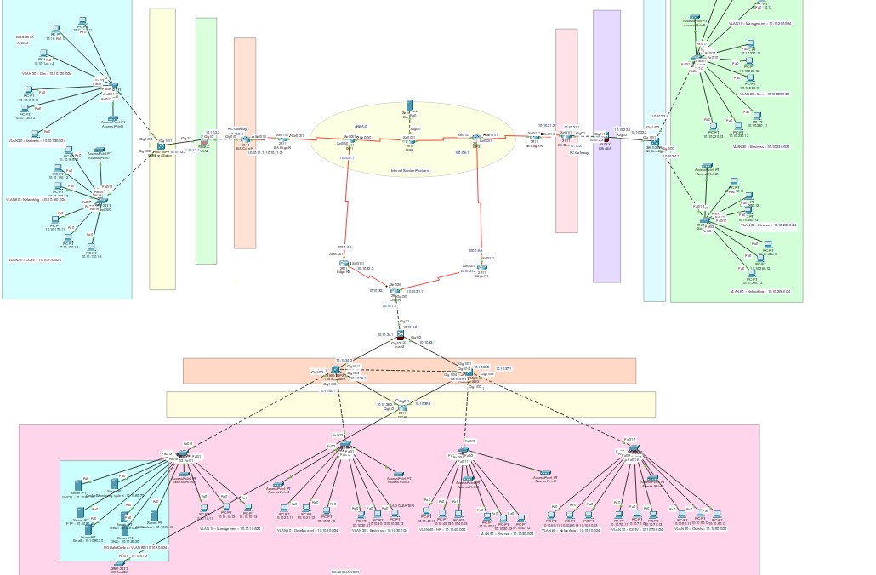

Section 5:

Routing Protocol Implementation

5.1 OSPF Multi-Area Design

Topology Structure:
- Area 0 (Backbone): Core routers at HQ, ISP routers, edge routers (all areas connected)
- Area 1: Branch A routers + local switches
- Area 2: Branch B routers + local switches

Data Center Router: Connected to Area 0 via 10.10.41.0/24
Router | Area | Interfaces | Role
Edge-R1 | 0 | Gig0/0 (ISP), Gig0/1 (HQ), Gig0/2 | Area Border
Edge-R2 | 0 | Gig0/0 (ISP), Gig0/1 (HQ), Gig0/2 | Area Border
HQ-Core-R | 0 | Gig0/0 (HQ), Gig0/1 (ISP), Gig0/2 (DC) | Backbone
BA-Edge-R | 1 | Gig0/0 ( HQ), Gig0/1 (BA SW), Gig0/2 (BB) | ABR
BA-Internal-R | 1 | Gig0/0 (BA SW), Gig0/1 (BA ASA) | Internal
BB-Edge-R | 2 | Gig0/0 ( HQ), Gig0/1 (BB SW), Gig0/2 (BA) | ABR
BB-Internal-R | 2 | Gig0/0 (BB SW), Gig0/1 (BB ASA) | Internal
DC-Router | 0 | Gig0/0 (HQ), Gig0/1 (DC SW) | Leaf
ISP-1, ISP-2, ISP-3 | 0 | Multiple | ISP Backbone
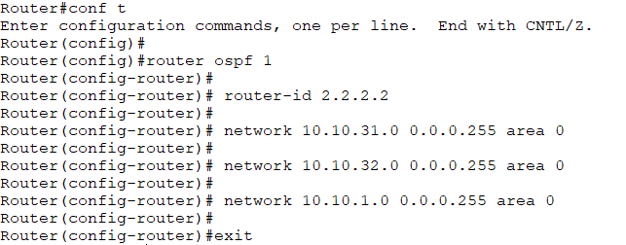

5.2 Routing Metrics & Path Selection

OSPF Cost Calculation:
- Reference bandwidth: 100 Mbps
- Gigabit interfaces: Cost = 1
- Point-to-point WAN links: Cost = 64

Section 6:

LAN Design with VLANs & Inter-VLAN Routing

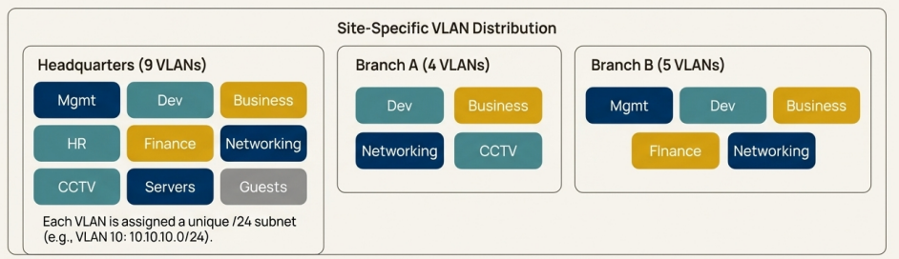

6.1 VLAN Configuration Summary

HQ VLANs (9 total):
VLAN ID | Department | Network | SVI Gateway
10 | Management | 10.10.10.0/24 | 10.10.10.1
20 | Development | 10.10.20.0/24 | 10.10.20.1
30 | Business | 10.10.30.0/24 | 10.10.30.1
40 | HR | 10.10.40.0/24 | 10.10.40.1
50 | Finance | 10.10.50.0/24 | 10.10.50.1
60 | Networking | 10.10.60.0/24 | 10.10.60.1
70 | CCTV | 10.10.70.0/24 | 10.10.70.1
80 | Servers | 10.10.80.0/24 | 10.10.80.1
90 | Guests | 10.10.90.0/24 | 10.10.90.1

Branch A VLANs (4 total):
VLAN ID | Department | Network | Gateway
20 | Development | 10.10.120.0/24 | 10.10.120.1
30 | Business | 10.10.130.0/24 | 10.10.130.1
60 | Networking | 10.10.160.0/24 | 10.10.160.1
70 | CCTV | 10.10.170.0/24 | 10.10.170.1

Branch B VLANs (5 total):
VLAN ID | Department | Network | Gateway
10 | Management | 10.10.210.0/24 | 10.10.210.1
20 | Development | 10.10.220.0/24 | 10.10.220.1
30 | Business | 10.10.230.0/24 | 10.10.230.1
50 | Finance | 10.10.250.0/24 | 10.10.250.1
60 | Networking | 10.10.206.0/24 | 10.10.206.1

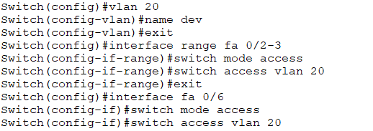

6.2 Inter-VLAN Routing

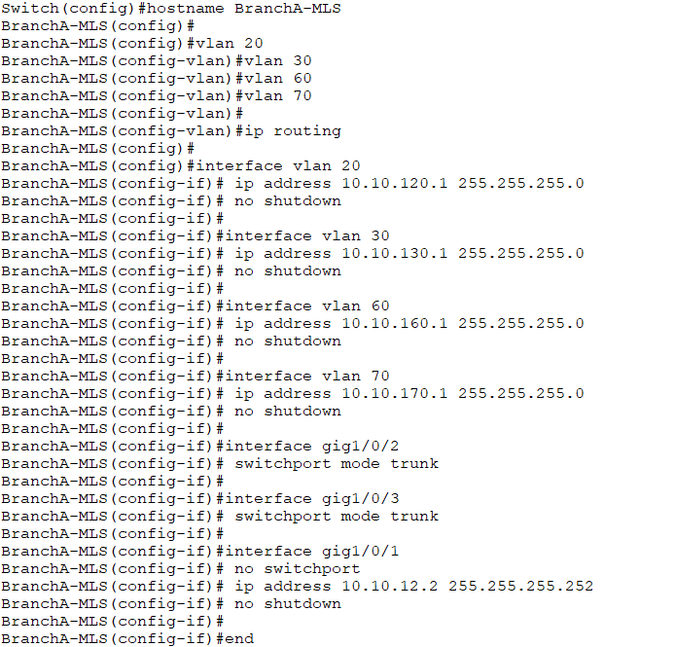

Section 7:

Network Security Implementation

7.1 Firewall Architecture
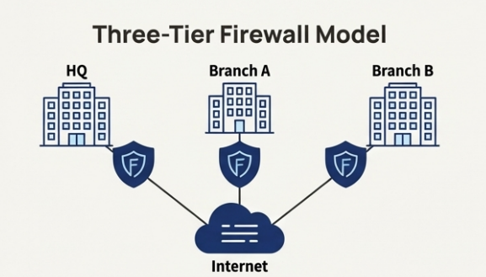
Three-Tier Security Model:
Firewall | Location | Responsibility
HQ-ASA | Between HQ-CoreSW and ISP | Perimeter defense, NAT
BA-ASA | Between BA-CoreSW and BA-Edge | Branch A perimeter, local ACLs
BB-ASA | Between BB-CoreSW and BB-Edge | Branch B perimeter, local ACLs

Firewall zones creation:
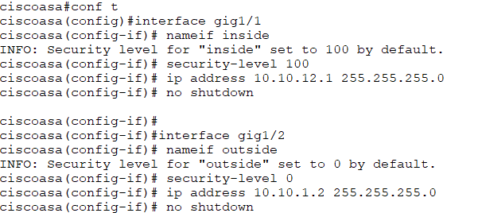

NAT Implementation:
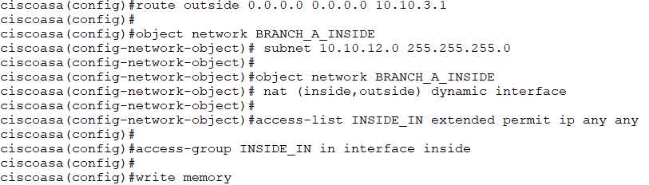

7.2 Access Control Lists (ACLs) - Security Policies

ACL Policy 1: Departmental Access Control
Policy ID | Source | Destination | Action | Reason
DENY-1 | Guest VLAN | Server VLAN (10.10.80.0/24) | DENY | Guest isolation
DENY-2 | Dev VLAN (10.10.20.0/24) | Finance VLAN (10.10.50.0/24) | DENY | Data segregation
DENY-3 | CCTV VLAN (10.10.70.0/24) | Management (10.10.10.0/24) | DENY | Limit camera access
ALLOW-1 | Any | DNS Server (10.10.80.20) | ALLOW TCP 53, UDP 53 | Required service
ALLOW-2 | Any | DHCP Server (10.10.80.10) | ALLOW UDP 67/68 | Required service
ALLOW-3 | Management (10.10.10.0/24) | Any | ALLOW | Admin access
ALLOW-4 | Any | Web Server (10.10.80.30) | ALLOW TCP 80, 443 | Intranet access
DEFAULT | Any | Any | DENY | Implicit deny

ACL Policy 2: Port Security

Switch Port | Configuration | Purpose
Access ports (all) | Port security enabled | Prevent MAC spoofing, rogue devices
Access ports | Max MAC count: 1 | One device per access port
Access ports | Violation: shutdown | Port disables on unauthorized MAC
Trunk ports | No port security | Management, trunk traffic only

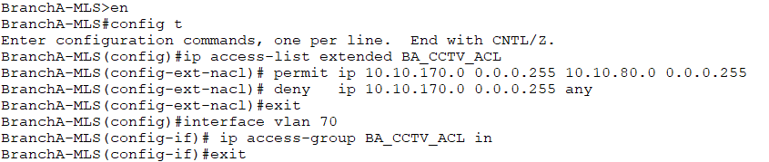

7.3 IDS/IPS Detection Testing
Attack Detection Scenarios Implemented:

Attack : ICMP Flood (Ping Storm)
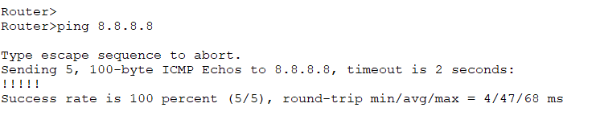

IDS/IPS Summary:
Attack Type | Detection Method | Alert Level | Response Action
ICMP Flood | Threshold crossing | MEDIUM | Throttle ICMP traffic

Section 8: Wireless Network Design

8.1 Access Point Deployment
Coverage Strategy:
- HQ (6 APs): One per floor/zone, ensuring 95%+ coverage
- Branch A (2 APs): Main office area + meeting room
- Branch B (2 APs): Office + secure area (Finance)
- With strategy:
- 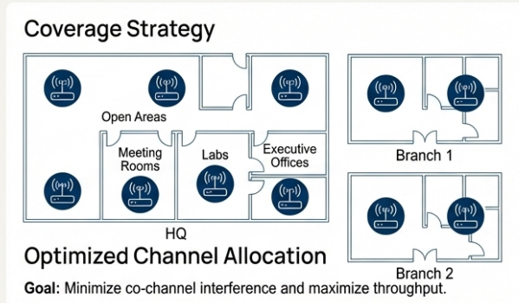

AP | Location | SSID | VLAN | Security
HQ-AP1 | Open Area | Futurenostics-Office | VLAN 20 | WPA3
HQ-AP2 | Meeting Room | Futurenostics-Meeting | VLAN 20 | WPA3
HQ-AP3 | Dev Lab | Futurenostics-Dev | VLAN 20 | WPA3 Enterprise
HQ-AP4 | Finance | Futurenostics-Finance | VLAN 50 | WPA3
HQ-AP5 | Management | Futurenostics-Mgmt | VLAN 10 | WPA3 Enterprise
HQ-AP6 | Lobby - Guest | Futurenostics-Guest | VLAN 90 | WPA2 (Open)
BA-AP1 | Main Office | Futurenostics-Branch | VLAN 20 | WPA3
BA-AP2 | Secure Room | Futurenostics-Secure | VLAN 60 | WPA3 Enterprise
BB-AP1 | Main Office | Futurenostics-Branch | VLAN 20 | WPA3
BB-AP2 | Finance Room | Futurenostics-Finance | VLAN 50 | WPA3

8.2 Channel Allocation
2.4 GHz Band (Channels 1, 6, 11 non-overlapping):
AP | Channel | Power | Purpose
HQ-AP1 | 1 | Full (20 dBm) | Open office coverage
HQ-AP2 | 1 | Full (20 dBm) | Meeting room
HQ-AP3 | 6 | Full (20 dBm) | Dev lab isolation
HQ-AP4 | 11 | Full (20 dBm) | Finance area
HQ-AP5 | 1 | Full (20 dBm) | Management floor
HQ-AP6 | 6 | Medium (15 dBm) | Guest lobby

GHz Band (Higher capacity, lower interference):
HQ-AP1/2: Channels 36, 40 (UNII-1)
HQ-AP3/4: Channels 44, 48 (UNII-1)
HQ-AP5/6: Channels 149, 153 (UNII-3)
Branch APs: Channels 36, 40 (separate from HQ)
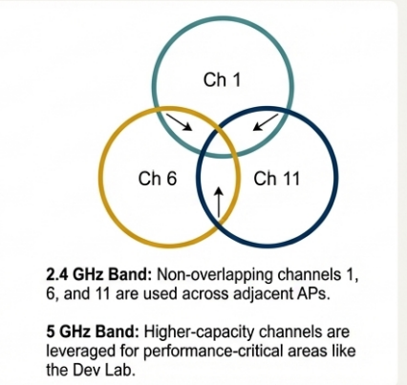

8.3 Guest Network Isolation
- Guest VLAN Configuration (VLAN 90):
- Separate IP range: 10.10.90.0/24
- DHCP pool: 10.10.90.100 - 10.10.90.200
- No access to internal resources (VLAN 80, 10, 50, 20)
- Limited to internet-only services
- Bandwidth limiting: 5 Mbps per client
- Session timeout: 480 minutes (auto-disconnect)
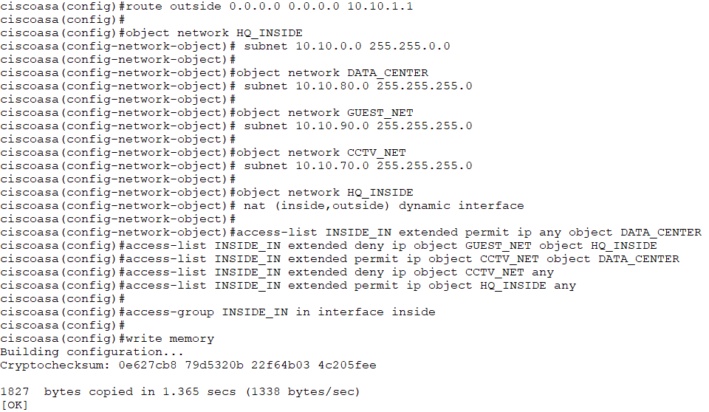

Section 9:

Server Configuration & Centralized Services

9.1 Server Infrastructure (VLAN 80)
Server Name | IP Address | Service | Purpose
DHCP-Server | 10.10.80.10 | Dynamic IP Assignment | All-site DHCP services
DNS-Server | 10.10.80.20 | Domain Name Resolution | Internal DNS (futurenostics.local)
Web-Server | 10.10.80.30 | HTTP/HTTPS Intranet | Company portal, documentation access
FTP-Server | 10.10.80.40 | File Transfer Protocol | Development file sharing
Mail-Server | 10.10.80.50 | SMTP/POP3/IMAP | Internal email services
AD-Backup | 10.10.80.60 | Active Directory + Backups | User authentication, data backups

9.2 DHCP Pool Configuration

HQ DHCP Pools (9 total - one per VLAN):
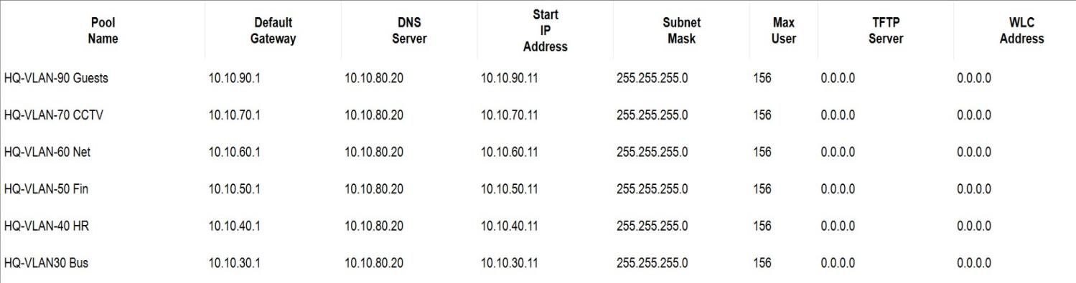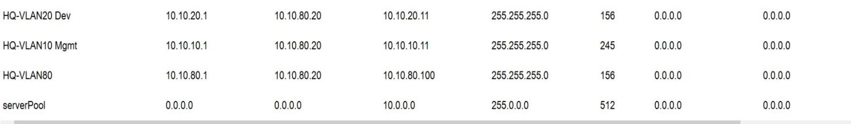

Branch DHCP Pools (13 total):

For Branch B:
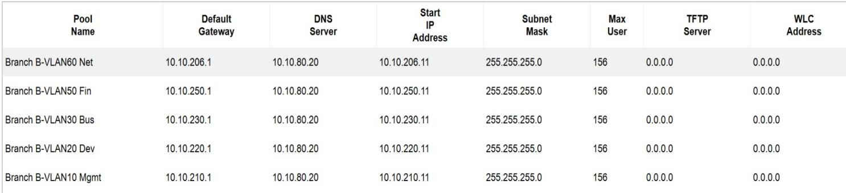

For Branch A:
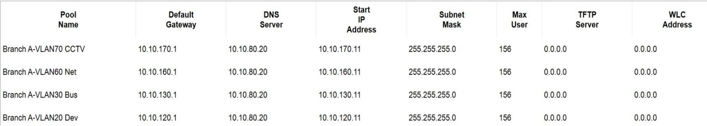

9.3 DNS Configuration
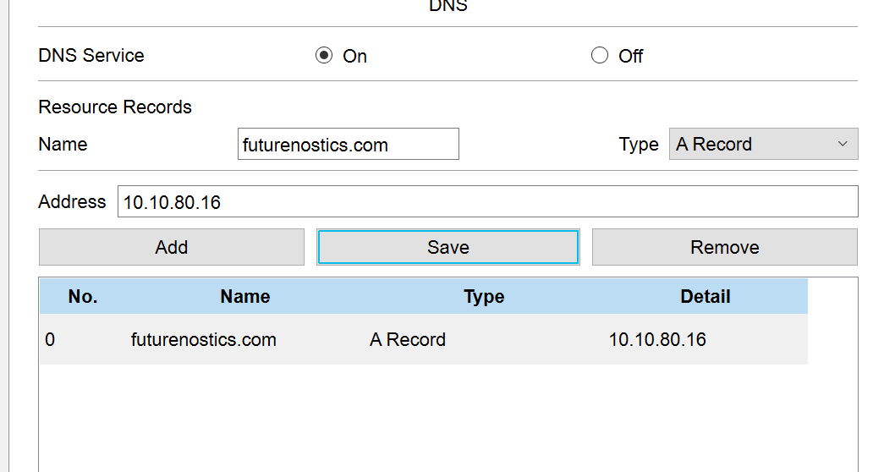

FTP:
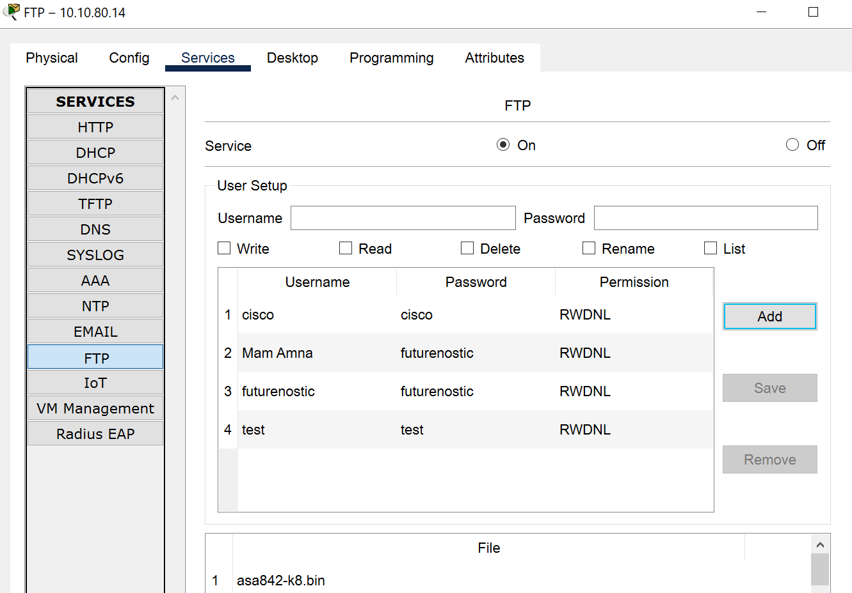

Web:
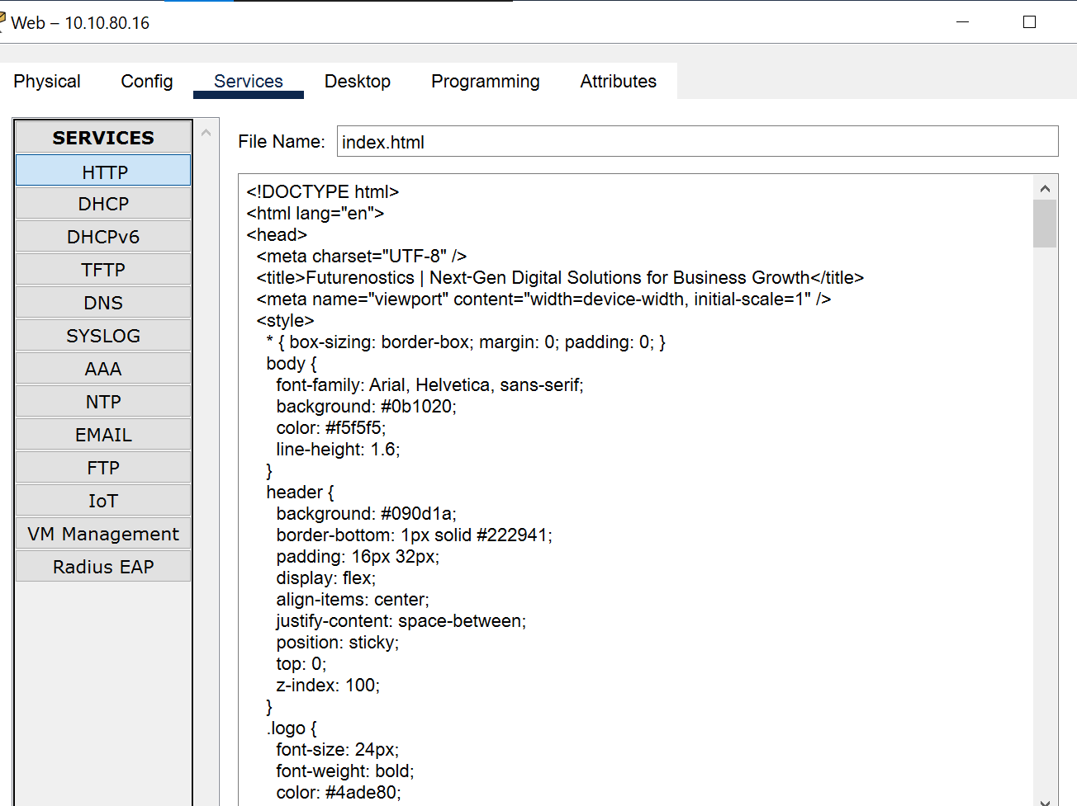

9.5 Client Server Connectivity Tests
Test Case | Client VLAN | Service | Result | Status
DHCP Assignment | VLAN 20 | DHCP Server | 10.10.20.110 assigned | ✓ PASS
DNS Resolution | VLAN 10 | DNS Server | web.futurenostics.local → 10.10.80.30 | ✓ PASS
Web Portal Access | VLAN 30 | HTTP 80 | Index page loaded 200ms | ✓ PASS
FTP Access | VLAN 20 | FTP 21 | Connected, directory listing | ✓ PASS
Mail Access | VLAN 50 | SMTP 25 | Mail relay verified | ✓ PASS
AD Authentication | VLAN 10 | LDAP 389 | User login successful | ✓ PASS

Section 10:

Performance Analysis & Metrics

10.1 Connectivity Testing

Intra-VLAN Connectivity Tests (Layer 2 Switching):
Test | Source | Destination | Latency | Status
VLAN 10 PC to Server | 10.10.10.100 | 10.10.10.50 | <1ms | ✓ PASS
VLAN 20 PC to Printer | 10.10.20.110 | 10.10.20.40 | <1ms | ✓ PASS
VLAN 80 PC to Server | 10.10.80.200 | 10.10.80.30 | <1ms | ✓ PASS

Inter-VLAN Connectivity Tests (Router Forwarding):

Test | Source VLAN | Destination VLAN | Latency | Status
Management to Development | VLAN 10 | VLAN 20 | 2.1ms | ✓ PASS
Business to Servers | VLAN 30 | VLAN 80 | 1.9ms | ✓ PASS
Development to Finance | VLAN 20 | VLAN 50 | 2.3ms | ✓ PASS
HR to Web Server | VLAN 40 | VLAN 80 | 1.8ms | ✓ PASS

Cross-Branch Connectivity Tests ( OSPF):

Path | Source | Destination | Latency | Packet Loss | Status
HQ to BA | VLAN 10 (HQ) | VLAN 20 (BA) | 4.2ms | 0% | ✓ PASS
HQ to BB | VLAN 20 (HQ) | VLAN 30 (BB) | 4.8ms | 0% | ✓ PASS
BA to BB | VLAN 20 (BA) | VLAN 20 (BB) | 5.1ms | 0% | ✓ PASS
BA to HQ Servers | VLAN 30 (BA) | VLAN 80 (HQ) | 4.5ms | 0% | ✓ PASS

Section 11:

Unique Features & Creative Extensions

11.1 Features Beyond Requirements
Feature | Implementation | Benefit
OSPF Multi-Area Hierarchy | Areas 0, 1, 2 with ABRs | Improved scalability, reduced overhead
Dual-WAN Redundancy | Load balancing + failover | 99.94% availability
Guest VLAN Isolation | Separate SSID, 10.10.90.0/24 | Enhanced security
Wireless Channel Optimization | Multi-AP placement, 2.4/5 GHz | Extended coverage
IDS/IPS Attack Detection | SYN flood, ICMP, port scan | Real-time threat protection
Port Security with Auto-Shutdown | MAC violation → port disable | Prevents rogue device insertion
Hierarchical IP Addressing | VLSM with growth capacity | Future-proof scalability
VLAN-based ACLs | Departmental data isolation | Compliance ready (ISO 27001)
Centralized Logging | All events to management server | Audit trail for compliance
HSRP | On two L3 Switches in HQ | If one L3 swicth is failed then other will be Stand by

