BraTS 2021 EDA Report
Ayesha Siddiqa BSAI-24-B 241419 Total scans: 1,251

Problems:
- 2 duplicate scans. BraTS2021_00495 and BraTS2021_00621 each show up twice
- Class Imbalance .
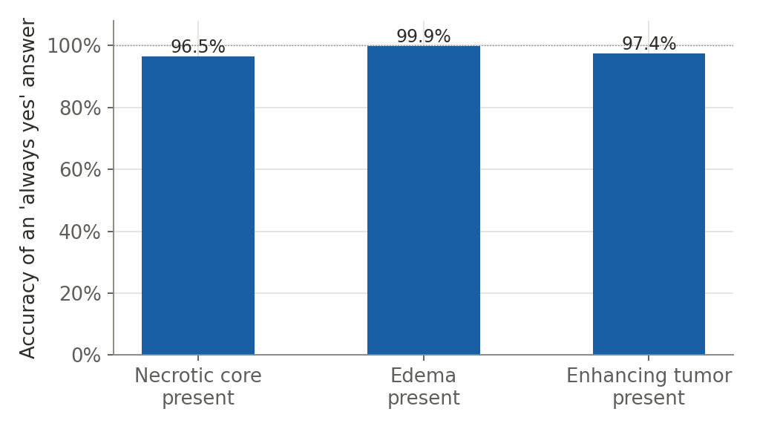
- Contradiction from literature
Multiple tumor count :59% , far more than in literature (closer to 15–20%).
- Outlier . BraTS2021_01163's brightness values are about 1,000× higher than every other scan
- "Tumor size" measures swelling. Overall tumor size tracks swelling , not actual solid tumor
Drop Cases: . BraTS2021_01163 BraTS2021_00495 and BraTS2021_00621

Information available
Available | Not Available
Where the tumor is (left/right) Location | Genetic markers (MGMT status)
How big it is Size | Whether it's getting worse over time
Which tumor parts are present Sub region space | Patient age / sex
Single vs. multiple tumor sites Multifocality | Treatment history

