Brain Tumor VLM — Architecture Specification
Expert #1 of a mixture-of-encoders medical VLM

Ayesha Siddiqa BSAI-24-B 241419

1. Purpose
It shows architecture for the first expert in a planned mixture-of-encoders medical VLM: a brain-tumor question-answering system built on BrainIAC and BraTS2021. Other experts (skin, lung, cardiac, eye, etc.) are planned but out of scope here , this document only specifies what is being built now and how it is designed to extend later.

2. System-level architecture
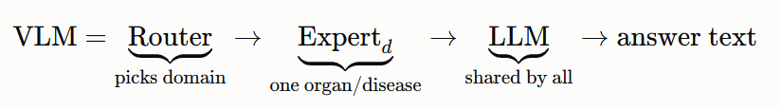
Router selects which expert handles a given (image, question) pair. With only one defined here (brain_tumor) .Every future expert adds one entry without changing anything else in the system.

3. Architecture diagram — Brain Tumor Expert
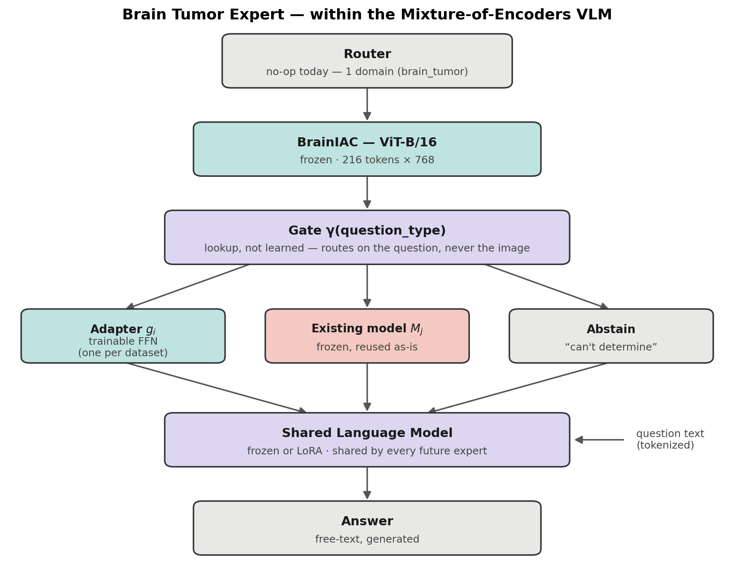

4. Routing table γ (question_type)
γ is a full lookup table, one row per question type, and each row's handler is either one of several gi​'s, one of several Mj​'s, or abstain. Nothing structurally new — just "many of each" instead of "one of each."
γ : question_type → {g1,…,gk}∪{M1,…,Mm} ∪{abstain }
The gate routes on the question type, never on the image. This is a deliberate choice: gating on the image risks learning a scanner/protocol fingerprint as a shortcut for which dataset a scan resembles, rather than reasoning about its content.
- Question types for now are: g₁ only from Brats 2021 task 1 :
- Location 2. Size 3. Sub region presence 4. Multifocality

5. Components
symbol | what it is | trainable?
x | preprocessed 96³ scan | —
f_vision | BrainIAC, ViT-B/16, 13 layers (eugenehp/brainiac port) | frozen
γ | question_type → handler lookup | not learned
gᵢ | Linear → GELU → Linear, one per dataset (k=1 today: BraTS2021) | trainable
Mⱼ | existing single-question model, if one exists (m=0 today) | frozen, reused
LLM | decoder transformer, generates the answer | frozen or LoRA

6. Data flow

