Assignment 01
Git, Gitea, GitHub, Git LFS, and GitHub Pages
Solution document
Student name | Ayesha Afifa
Registration number | FA24B1-SE-001
Section | A
Course | Cloud Computing (BSE-410)
GitHub username | ayeshaaafifa
Ubuntu prompt | ayeshaaafifa@ubuntu:~$
Deadline | 10 October 2026
Submission links
CC repository | https://github.com/ayeshaaafifa/CC
GitHub Assignment01 | https://github.com/ayeshaaafifa/Assignment01
Portfolio (GitHub Pages) | https://ayeshaaafifa.github.io/

Task 1: Install Gitea and Push a Repository from the Ubuntu Server

Step 1.1: Install and Run Gitea on the Ubuntu Server
Installed Docker and the Compose plug-in, cloned the instructor's Gitea repository, started Gitea and PostgreSQL, and confirmed Gitea answers on port 3000.
git clone https://github.com/WaqasSaleem97/Gitea.git
docker compose up -d
docker compose ps
curl -sS -o /dev/null -w "Gitea HTTP status: %{http_code}\n" http://127.0.0.1:3000/
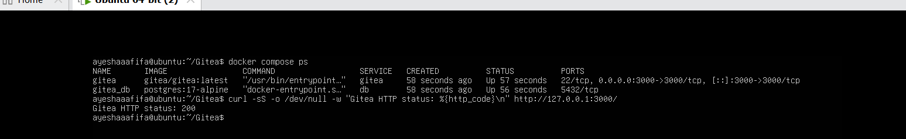
task1_gitea_running.png: both containers running and Gitea HTTP status 200
Gitea installation page, using the required PostgreSQL database settings (host db:5432, user gitea, database gitea).
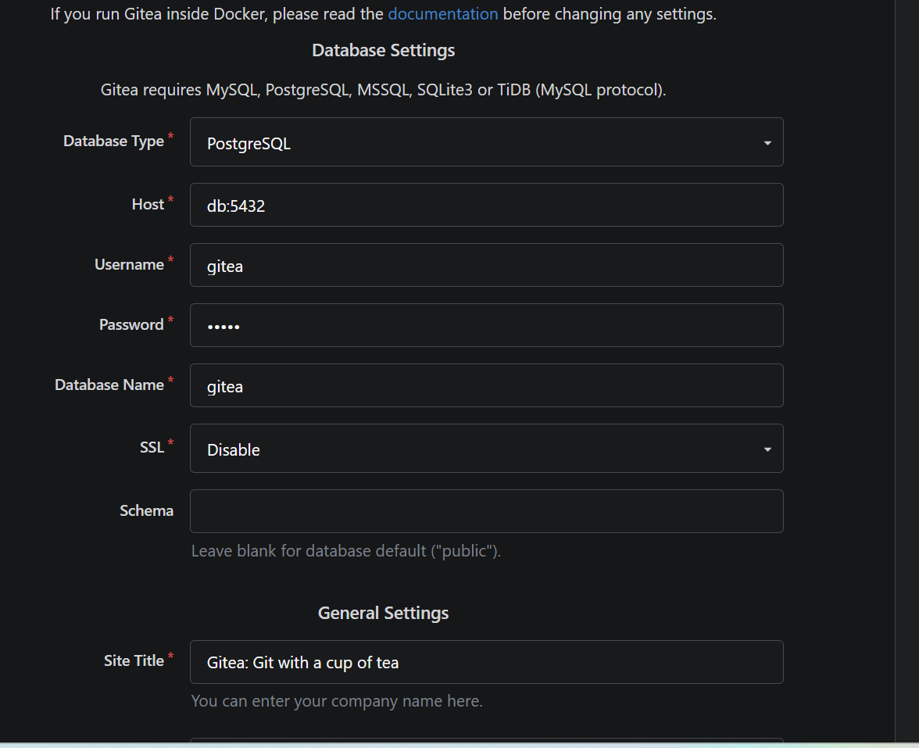
Gitea installation page: database settings
Administrator account created to complete the installation.
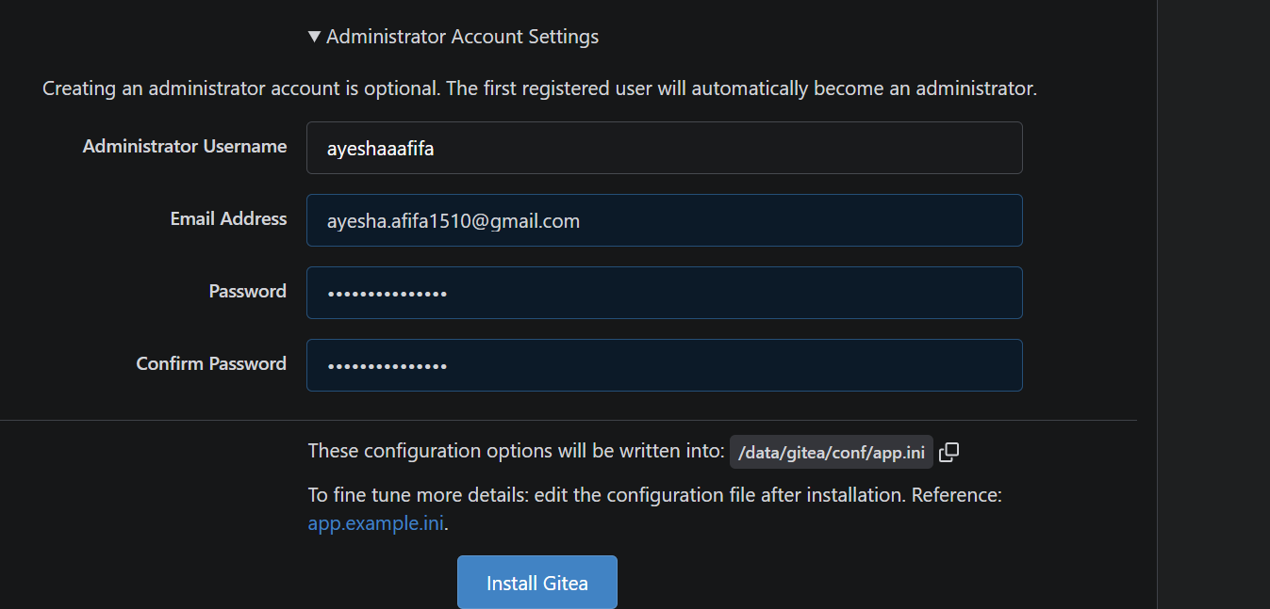
Gitea installation page: administrator account

Step 1.2: Create and Push the Initial Repository
Created an empty public Gitea repository named Assignment01. On the server, created a separate local repository with a README containing my name and registration number, added the gitea remote without a token in the URL, and pushed with a personal access token entered at the password prompt.
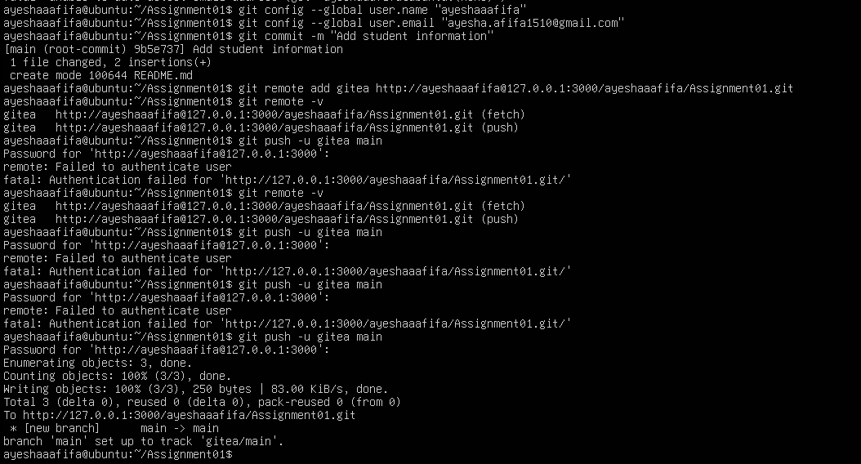
task1_gitea_push.png: gitea remote and successful push to main

Step 1.3: Verify the Gitea Repository
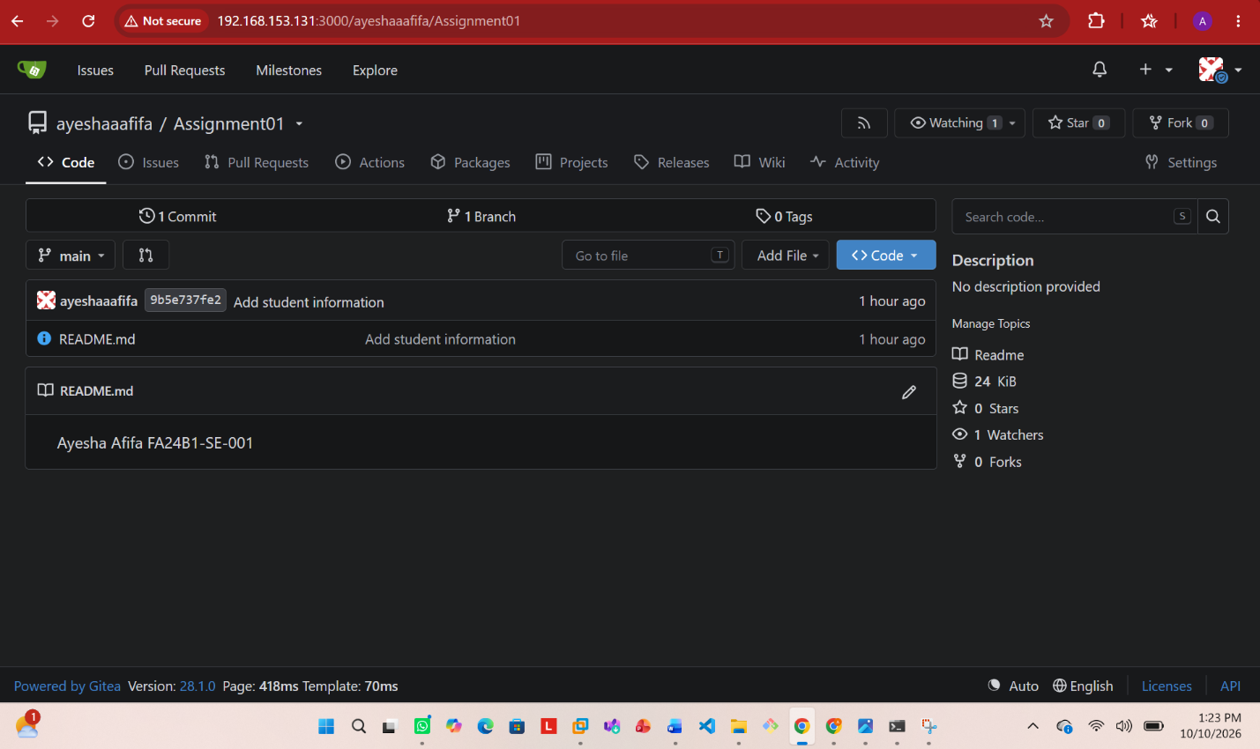
task1_gitea_repository.png: public repository ayeshaaafifa/Assignment01 with rendered README

Task 2: Push the Same Repository to GitHub

Step 2.1: Create the GitHub Repository and Verify Both Remotes
Created an empty public GitHub repository named Assignment01 and added it as the github remote.
git remote add github https://github.com/ayeshaaafifa/Assignment01.git
git remote -v
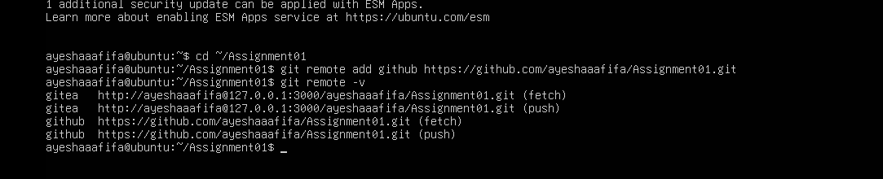
task2_remotes.png: gitea and github remotes, no token or password in the URLs

Step 2.2: Push to GitHub
git push -u github main
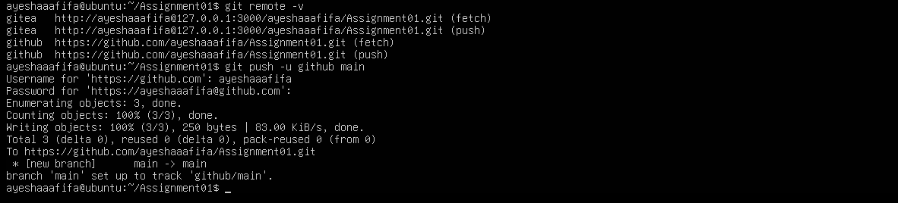
task2_github_push.png: successful push of main to GitHub

Step 2.3: Verify the GitHub Repository
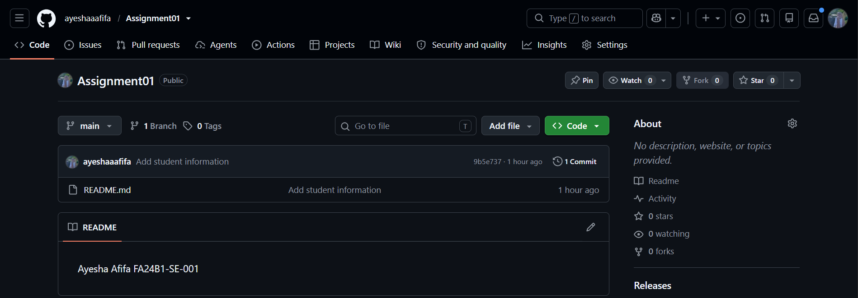
task2_github_repository.png: public repository ayeshaaafifa/Assignment01 with rendered README

Task 3: Track Three Large Files with Git LFS

Step 3.1: Configure Git LFS
git lfs install
git lfs version
git lfs track "*.bin"
cat .gitattributes
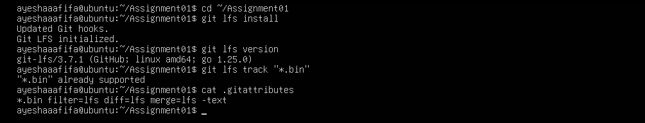
task3_lfs_setup.png: Git LFS initialized, version shown, *.bin rule in .gitattributes

Step 3.2: Create and Verify Three LFS Files
Created three files of 101 MiB, 102 MiB and 103 MiB, staged them, and listed them with Git LFS (shown as 106, 107 and 108 MB).
truncate -s 101M large-file-1.bin
truncate -s 102M large-file-2.bin
truncate -s 103M large-file-3.bin
git add .gitattributes large-file-1.bin large-file-2.bin large-file-3.bin
git lfs ls-files --size
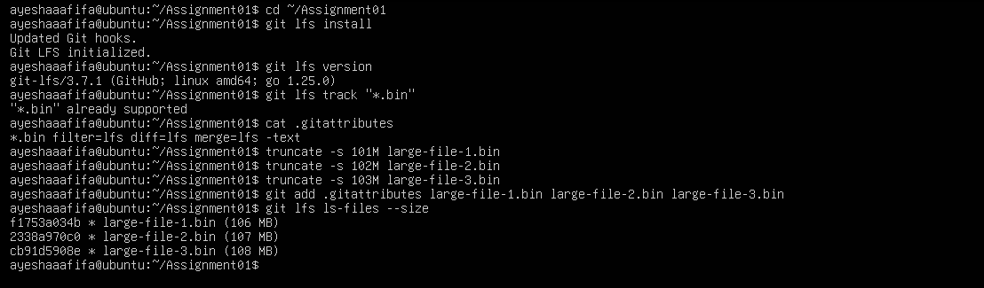
task3_lfs_files.png: three files tracked by Git LFS, each larger than 100 MiB

Step 3.3: Commit and Push the LFS Files
git commit -m "Add three files using Git LFS"
git push github main
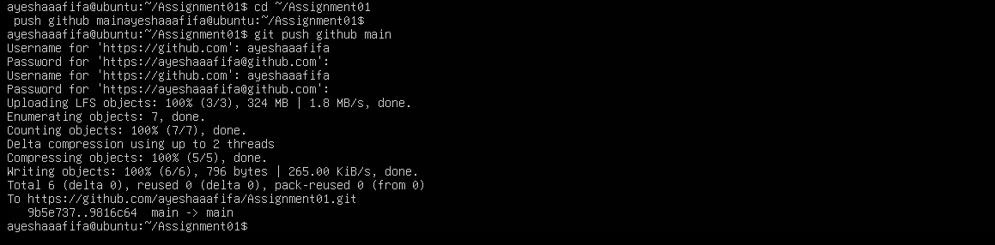
task3_lfs_push.png: LFS upload 100% (3/3) and successful push to GitHub

Task 4: Create a Portfolio or CV with GitHub Pages

Step 4.1: Create and Push the Portfolio Repository
Used the public repository ayeshaaafifa.github.io with index.html and styles.css on the main branch. The portfolio has About Me, Education, Skills and Projects sections.
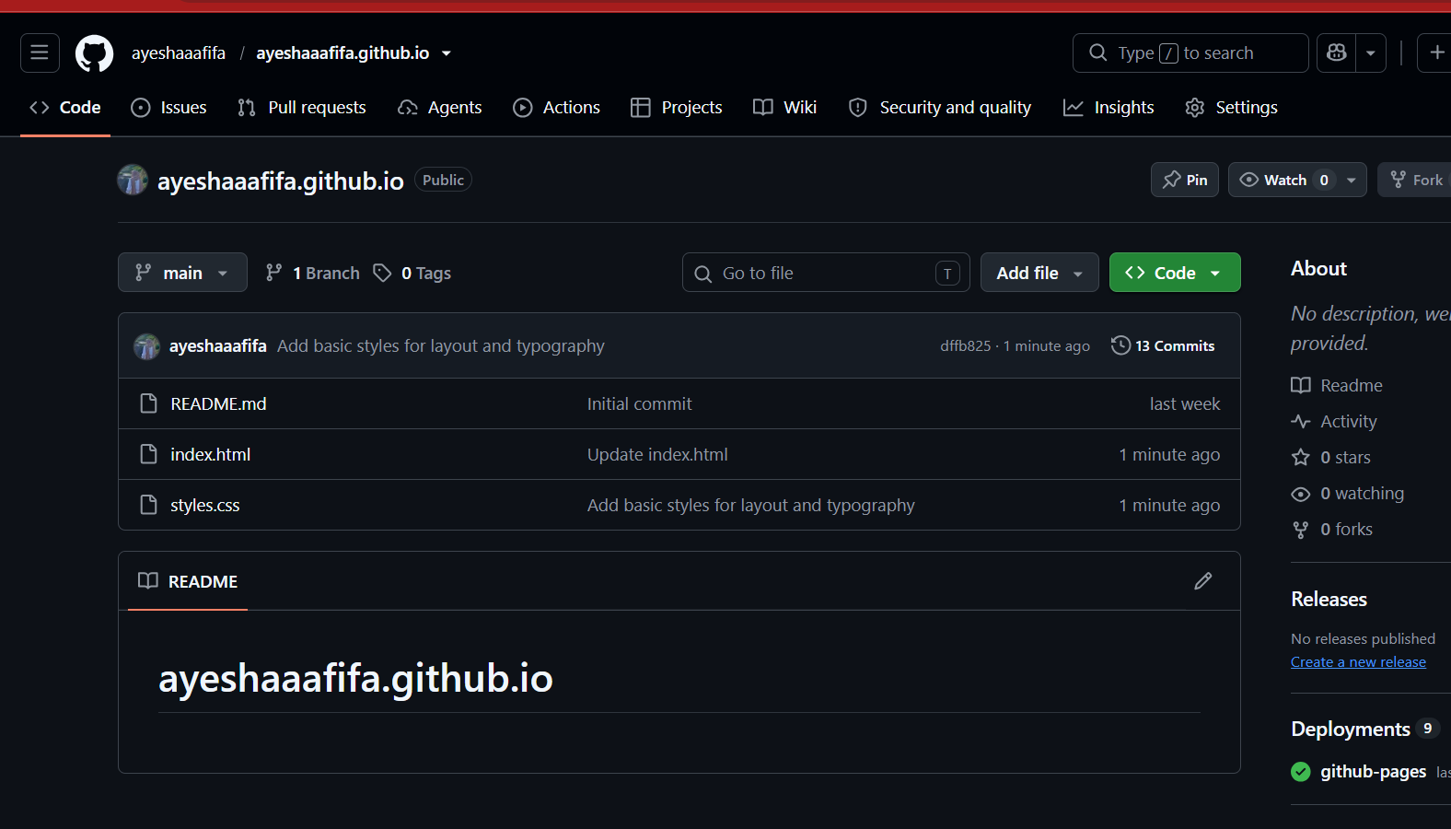
task4_pages_repository.png: repository with index.html and styles.css

Step 4.2: Publish with GitHub Pages
In Settings > Pages, selected Deploy from a branch, branch main and folder / (root).
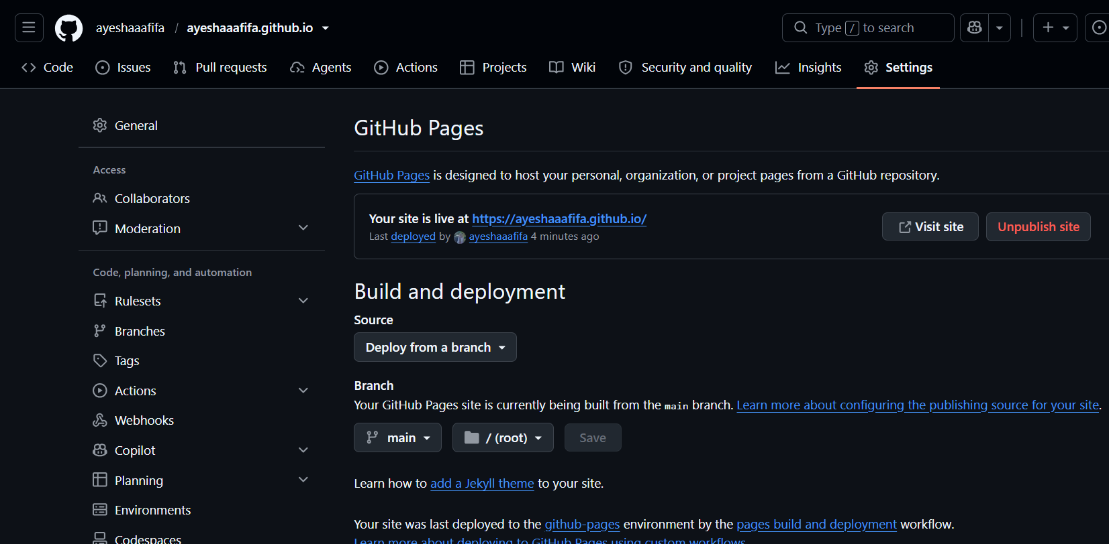
task4_pages_deployment.png: GitHub Pages live at https://ayeshaaafifa.github.io/

Step 4.3: Verify the Live Portfolio
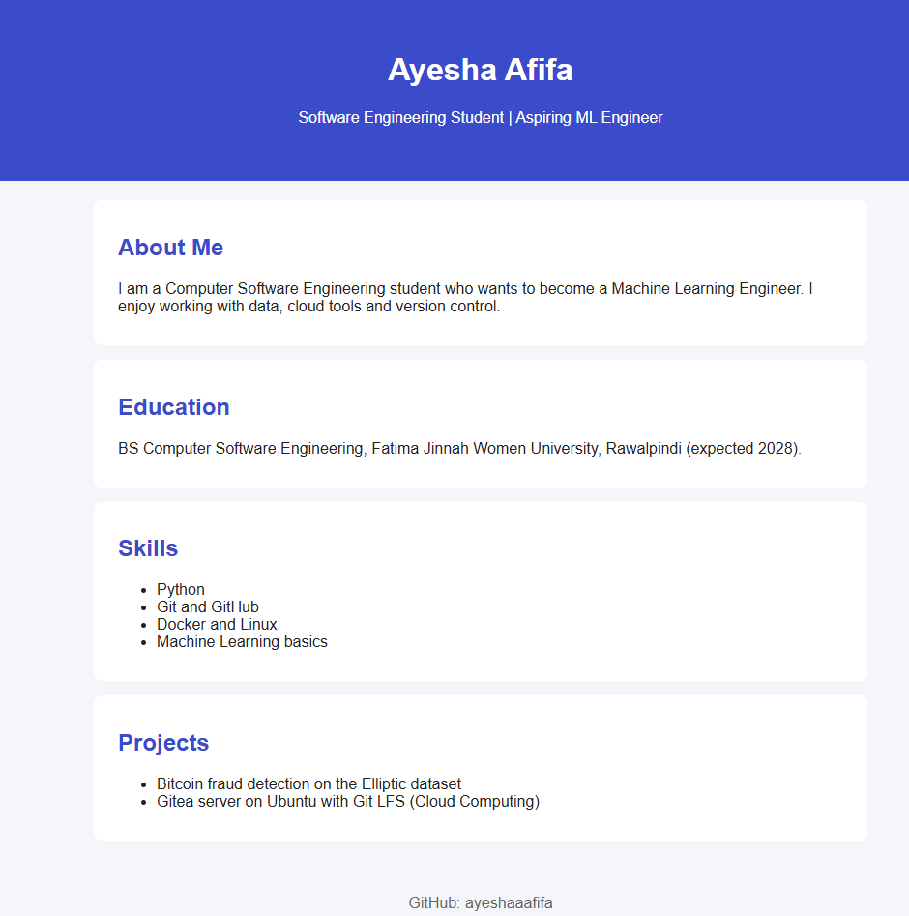
task4_portfolio_live.png: live portfolio at https://ayeshaaafifa.github.io/

