**“Assignment#1”**

**NAME: AYESHA AAMIR**

**STUDENT I.D: 63687**

**CLASS I.D: 103347**

**DATE: 28-Feb-20**

**WARSHALL’s CODE**

def Warshall(w):

assert (len(row) == len(w) for row in w)

n = len(w)

for k in range(n):

for i in range(n):

for j in range(n):

w[i][j] = w[i][j] or (w[i][k] and w[k][j])

return w

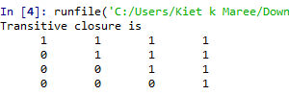

**EUCLIDEAN CODE**

def euclide(x, y):

while(y):

x, y = y, x % y

return x

a = 120

b= 38

print ("The gcd of 120 and 38 is")

print (euclide(120,38))

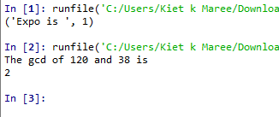

**FAST MODULAR EXPONENTATION CODE**

def expo(x, y, e) :

res = 1

x = x % e

while (y > 0) :

if ((y & 1) == 1) :

res = (res * x) % e

y = y >> 1

x = (x * x) % e

return res

x = 3; y = 6; e = 14

print("Expo is ", expo(x, y, e))

