

  

**Student1421670 Ms. SAMAN TAHIR**

**Student1399089 Ms. AYESHA AFZAL**

**Student1424062 Ms. SUNAINA**

**Group Member:**



**ONLINE COVID TEST AND VACCINATION BOOKING SYSTEM.**

**Table of Contents**

**DOCUMENTATION**

# Contents

Acknowledgement **_ _ _ _ _ _ _ _ _ _ _ _ _ _ _ _ _ _ _ _ _ _ _ _ _ _ _ _ _ _ _ _ (3)**

Certificate **_ _ _ _ _ _ _ _ _ _ _ _ _ _ _ _ _ _ _ _ _ _ _ _ _ _ _ _ _ _ _ _ _ _ _ _ _ (4)**

Problem Statement **_ _ _ _ _ _ _ _ _ _ _ _ _ _ _ _ _ _ _ _ _ _ _ _ _ _ _ _ _ _ _ _ (5)**

Our Solution **_ _ _ _ _ _ _ _ _ _ _ _ _ _ _ _ _ _ _ _ _ _ _ _ _ _ _ _ _ _ _ _ _ _ _ _ (6)**

Screenshot **_ _ _ _ _ _ _ _ _ _ _ _ _ _ _ _ _ _ _ _ _ _ _ _ _ _ _ _ _ _ _ _ _ _ _ _ (7)**

UML diagram **_ _ _ _ _ _ _ _ _ _ _ _ _ _ _ _ _ _ _ _ _ _ _ _ _ _ _ _ _ _ _ _ _ _ _ (8)**

ERD **_ _ _ _ _ _ _ _ _ _ _ _ _ _ _ _ _ _ _ _ _ _ _ _ _ _ _ _ _ _ _ _ _ _ _ _ _ _ _ _ _ (9)**

Conclusion **_ _ _ _ _ _ _ _ _ _ _ _ _ _ _ _ _ _ _ _ _ _ _ _ _ _ _ _ _ _ _ _ _ _ _ _ (10)**

ACKNOWLEDGMENT

I would like to acknowledge all those who have given moral support and helped me take a project success.

I wish to express my gratitude to the EProjects. The team at the head office guided and helped me. I would also like express my gratitude to the staff members of my center for not only providing me with the opportunity to work with them on this project. But also

I also express my sincere gratitude to the EProjects Team at the Aptech head office and my project guide at the organization, for this valuable guidance and support for the completion of this project.

And finally, I would like to offer many thanks to all my colleagues for their valuable suggestions and constructive feedback.

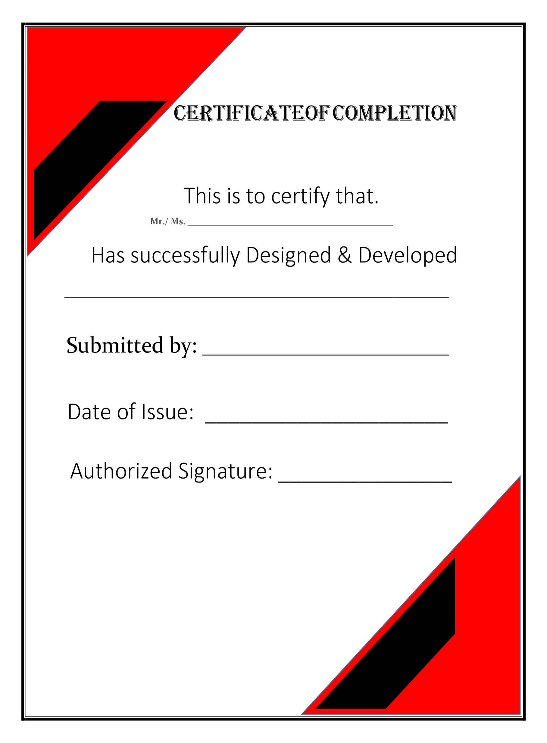

**PROBLEM STATEMENT**

Problem statement is attached separately in a file “**COVID TEST and VACCINATION System.**”

**Standards plan:**

Every code block must have comments.

The logic of the program needs to be explained. Proper documentation should be maintained.

Complete Project Report along with synopsis, code and documentation should be prepared.

**OUR SOLUTION**

***Proposed Solution:***

App will provide Online Registration System (ORS) is a framework to link various hospitals across the country for mobile number based online registration and appointment system. Portal facilitates online appointments for vaccination Detail reports showing information about test and vaccination patients taking appointment through this portal can be seen. Hospitals can come on board this platform and provide their appointment slots for online booking by patients. The system facilitates Hospitals to easily manage their registration and appointment process and monitor the flow of patients.

# **System Modules:**

## **Admin**

* All Patient details.
* Report of Covid test/vaccination
  + Test report, Vaccination (Date/week/monthly report)
* List of vaccine
  + available or unavailable
* Approval Hospital Login
* List of hospitals
* Booking Details

## **Hospital:**

* Register
* Login
* List of patient details
* Request from patient (Covid test/Vaccination)
  + Approve or Reject
* Update Covid test result
* Update Vaccination status

## **Patient:**

* Register
* Login
* Search Covid Test/Vaccination hospital
* Request for Covid Test/Vaccination for hospital
* Report of covid test/Vaccination taken
* Book Hospital appointment
* My Appointment
* View Results
* My profile

# **Modules Description**

## **Admin:**

* All patient details.
  + View all patient profile details.
* Report of COVID – 19
  + patient, COVID – 19 test report (Date wise report)
  + Admin can export the details in xls format by date, week and month wise report.
* List of vaccine
  + available or unavailable
  + Admin can view the availability of the vaccination.
* Approve Hospital Login
  + Approve or Reject
  + Once the request for appointment is from the patient’s side, it will be approved by the admin.
* List of hospitals
  + Admin can view the hospital details.
* Booking Details
  + Admin can view the booking details from patient side for booking COVID – 19 test results.

## **Hospital**

* Register & Login
  + Can register and login into the app with hospital name, address, and location details.
* List of patient details
  + Hospitals can view the patient details who are all approved for COVID – 19 tests.
* Request from patient
  + Hospitals can be request to the patient from the hospital side who are all approved / rejected for covid – 19 test / vaccination.
* Update covid – 19 results
  + Hospitals will update the patient’s covid – 19 results.
* Update vaccination status
  + Hospitals will be updated the patient’s vaccination status.

## **Patient**

* Register & Login
  + Patients can register and login into the app with patient name, address and location details.
* Search covid-19 / vaccination hospital
  + Patient Can search the covid-19 hospitals and get from the vaccination hospitals.
* Request for covid-19 test / vaccination hospital.
  + A Patient Can request to the hospital for the covid-19 test. It will approve patient can take vaccination from the hospitals.
* Report of covid test/Vaccination taken
  + A Patient can take the covid-19 test result report and their suggestion vaccination.
* Book Hospital appointment
  + A Patient will be booking the appointment from the hospitals and tested the covid-19 tests.
* My Appointment
  + A Patient will check the appointment timing and hospital details from the My Appointment module.
* View Results
  + A Patient can view their covid-19 test results and vaccination suggestions also.
* My profile
  + A patient will check the profile details and edit or delete the other information also.

**SCREENSHOTS**

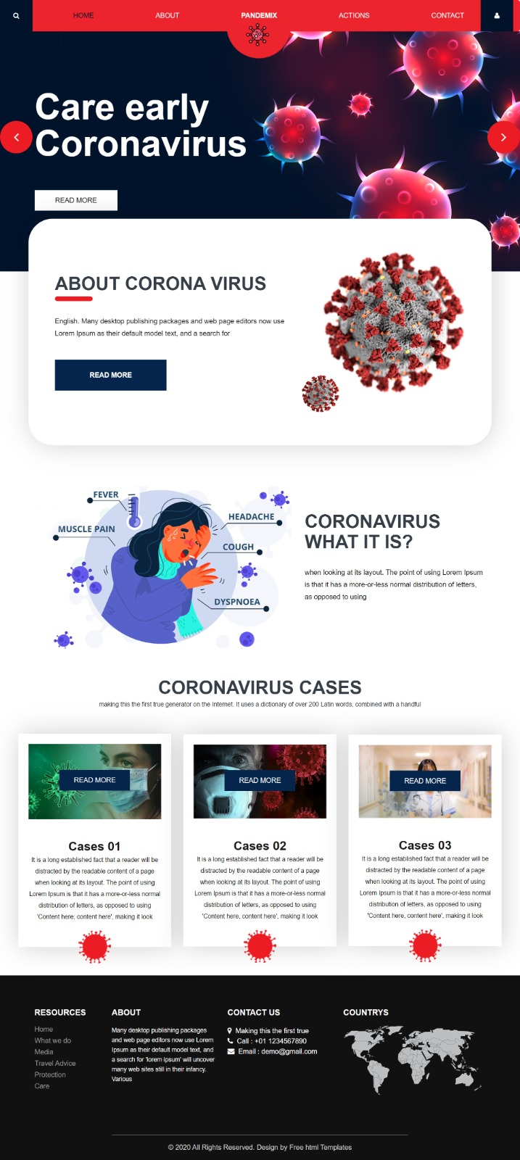

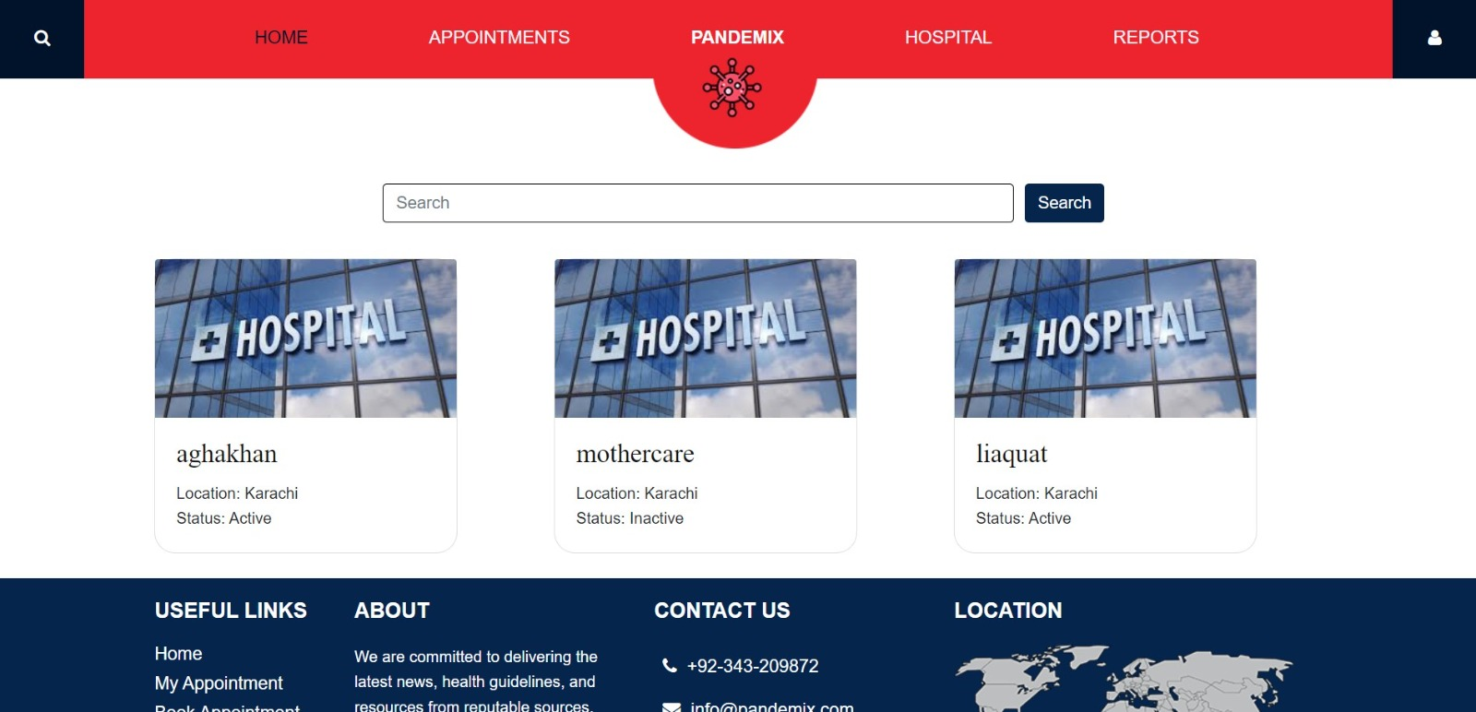

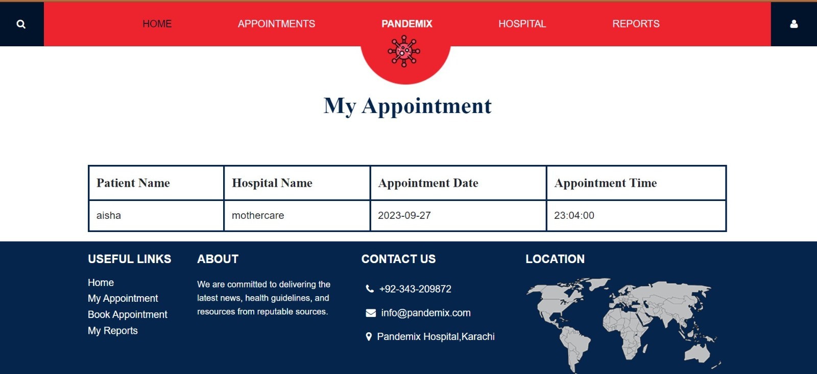

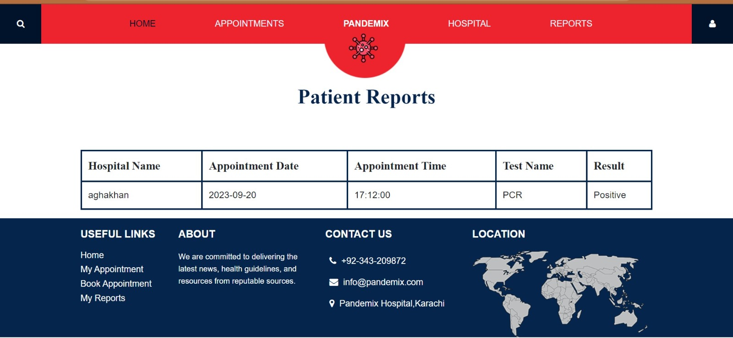

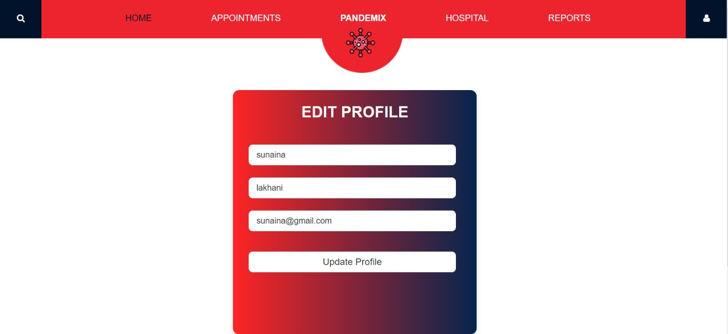

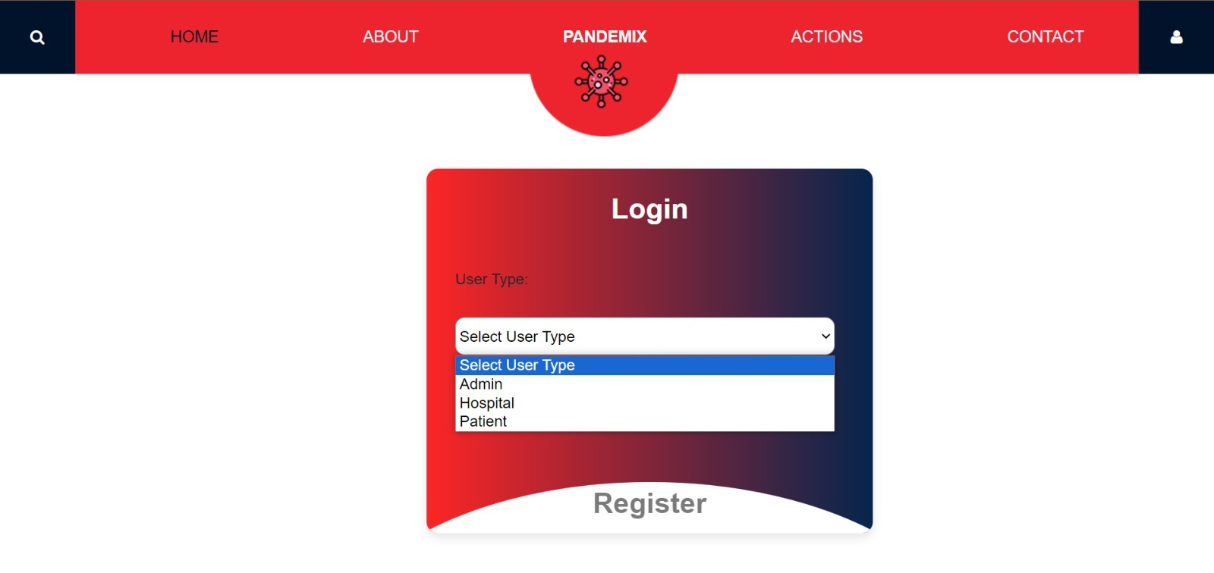

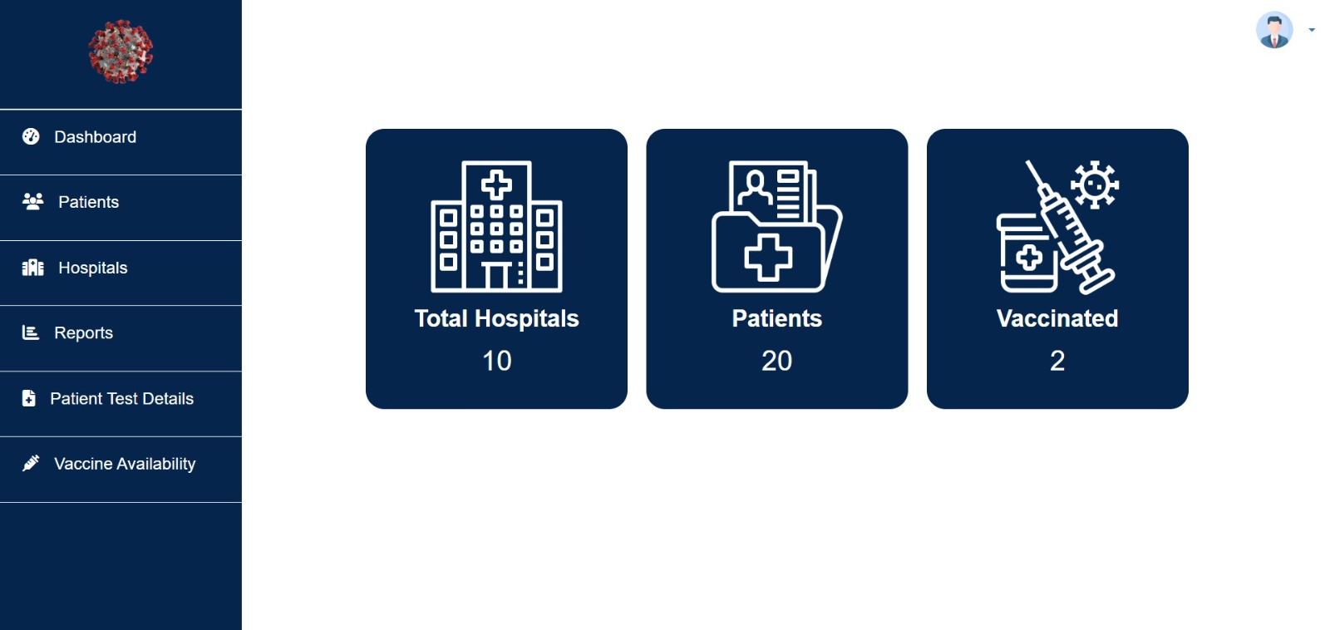

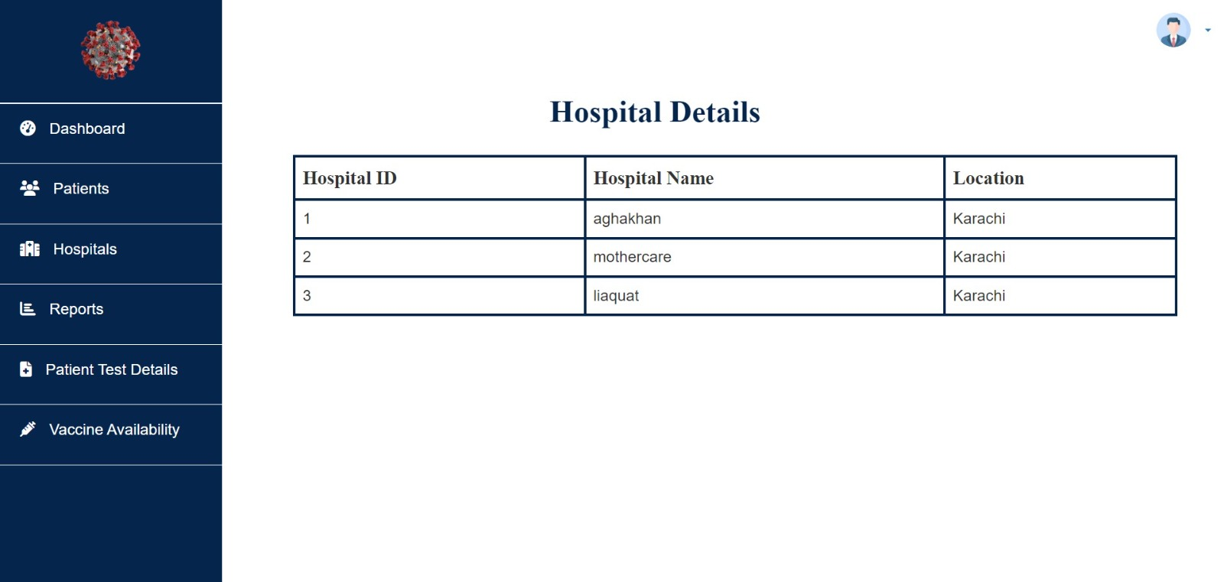

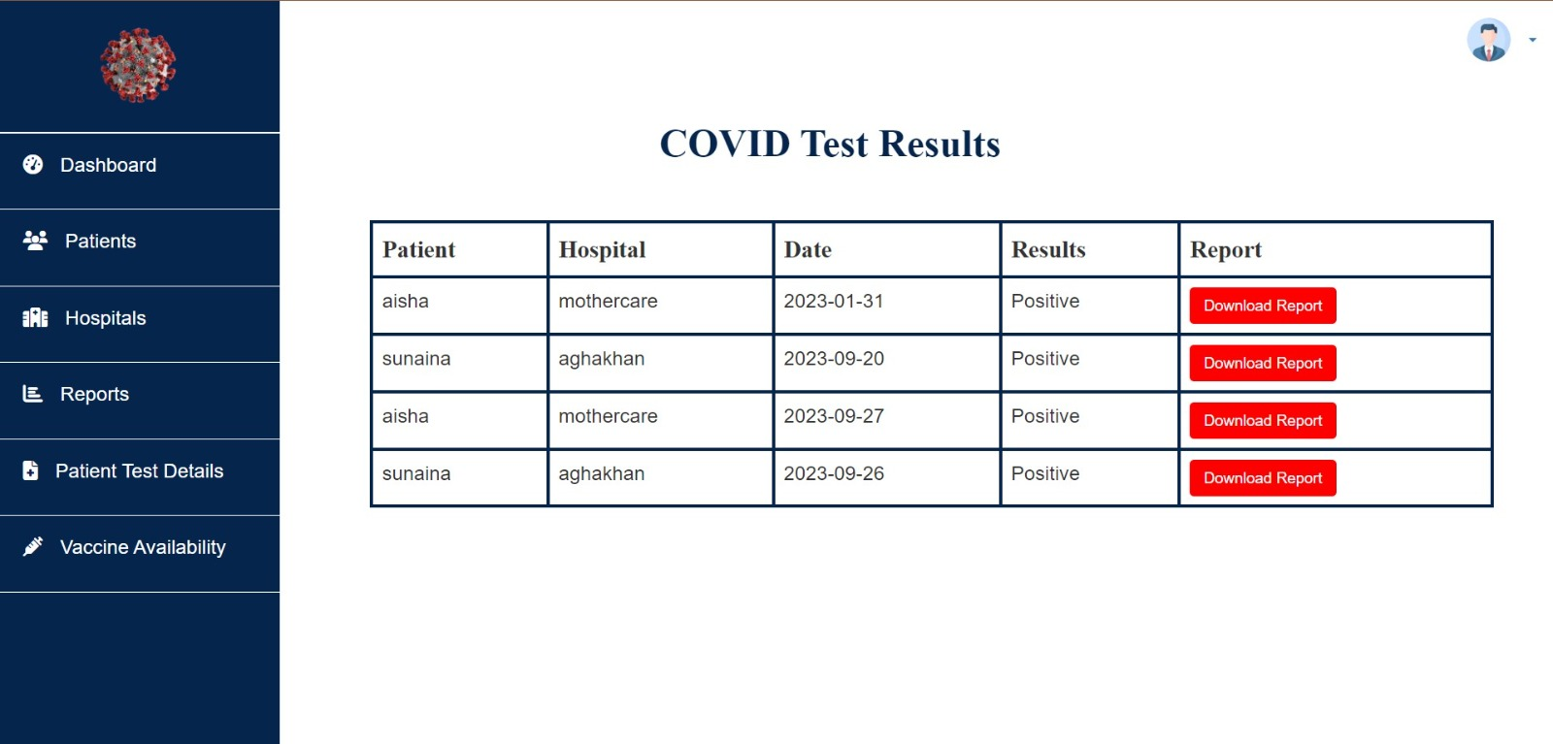

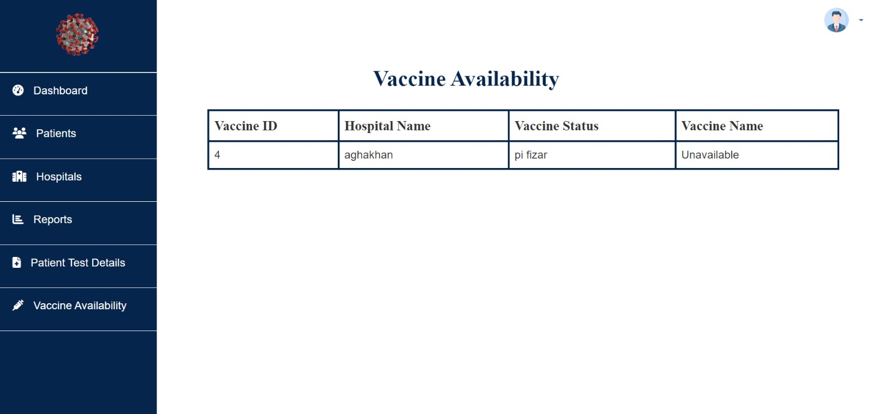

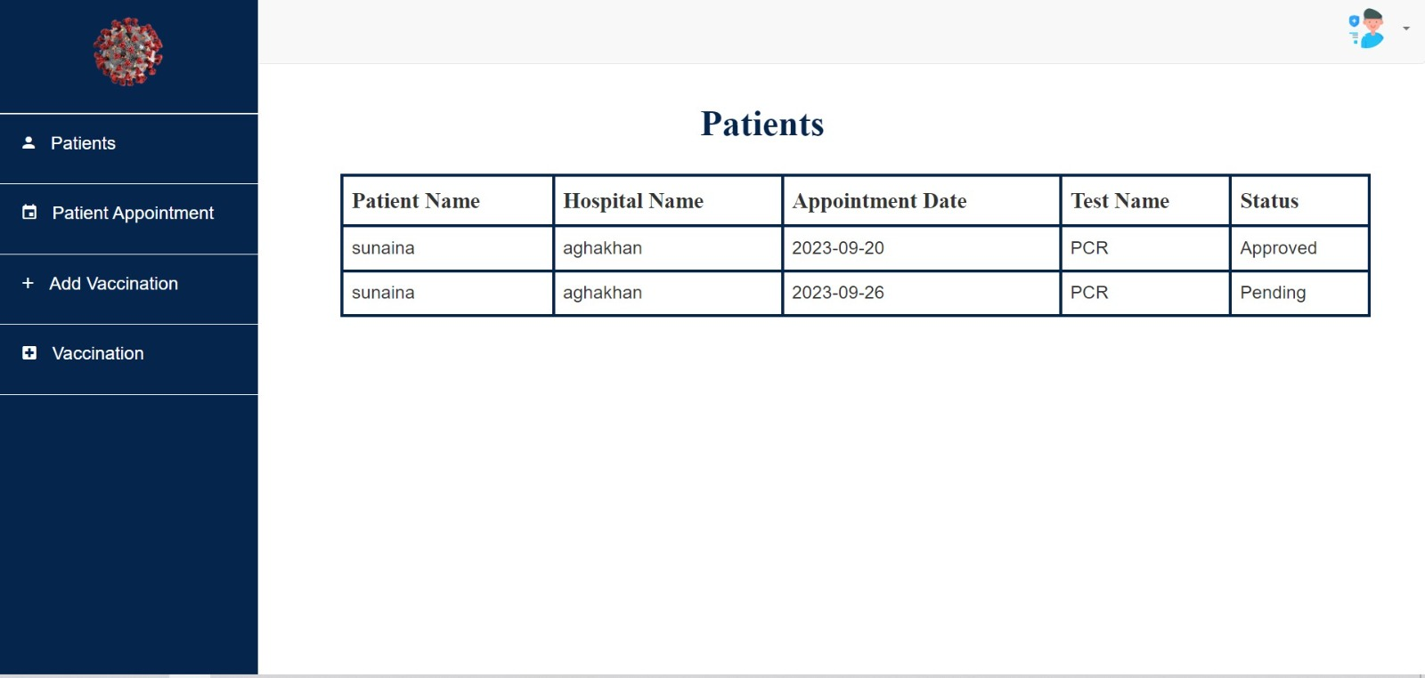

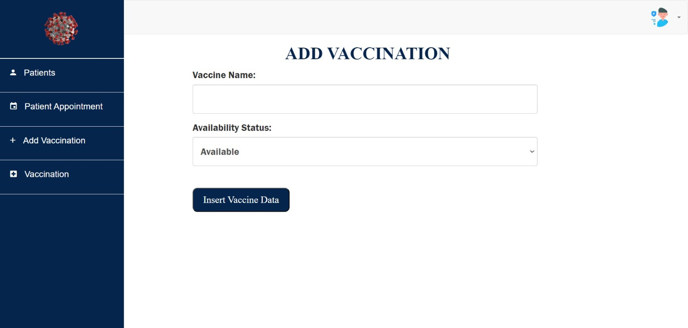

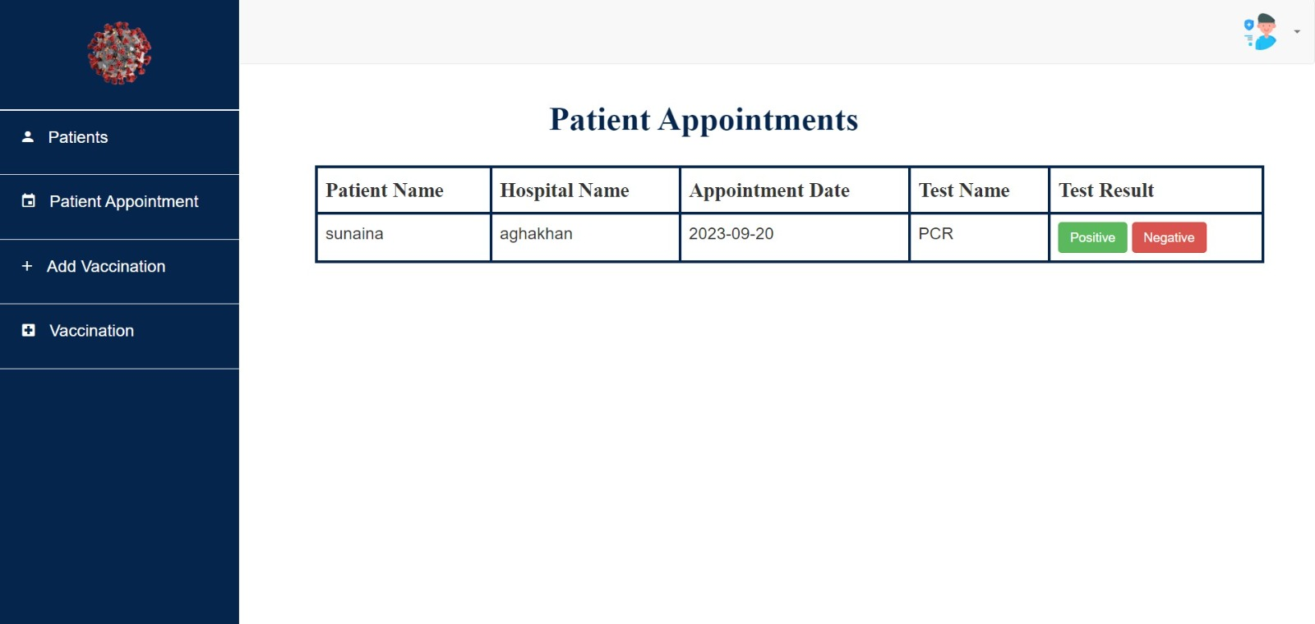

**UML DIAGRAM**

Patient Appoinment

Test result apdate

Report

Patient List

Hospital list

**Hospital**

Patient report

Vaccination status

**Admin**

Hospital/Ptients

Approved

Patients List

Appoinment

Vaccination

Available or not available

**User**

**ERD DIAGRAM**

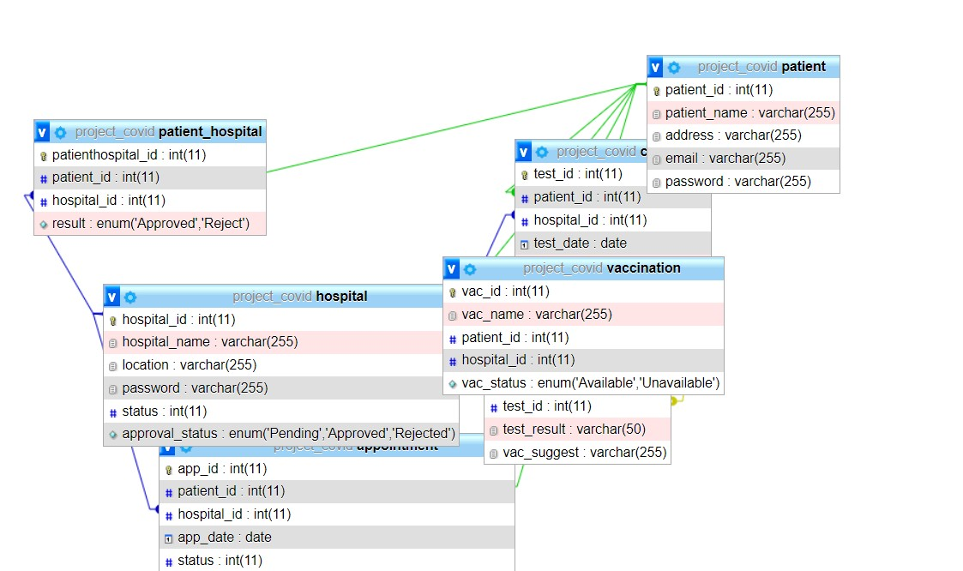

CONCLUSION

Our Website “ONLINE COVID TEST AND VACCINATION BOOKING SYSTEM”. This ORS can significantly improve the efficiency and accessibility of healthcare services, making it easier for patients to schedule appointments, especially for vaccinations, and for hospitals to manage their resources effectively. By facilitating seamless online interactions between patients and healthcare providers, this system has the potential to enhance the overall healthcare experience and contribute to more efficient healthcare delivery on a national scale.