Lab Session 14: Deadlock Avoidance and Detection Algorithms

Lab Exercise:

                - Compare and contrast deadlock avoidance and deadlock detection. When would you prefer to use one over the other in a real-world operating system?

Deadlock Avoidance
Deadlock avoidance is a technique in which the operating system checks every resource request before allocation. The system only grants the request if it keeps the system in a safe state. Banker’s Algorithm is the most common deadlock avoidance algorithm.

Deadlock Detection
Deadlock detection is a technique where the operating system allows processes to request resources freely and periodically checks whether a deadlock has occurred. If deadlock is detected, recovery methods such as process termination or resource preemption are used.
Feature | Deadlock Avoidance | Deadlock Detection
Goal | Prevent deadlock before it occurs | Detect deadlock after it occurs
Resource Allocation | Checked before allocation | Resources allocated directly
Safe State Check | Required | Not required
Overhead | High | Lower
Recovery Needed | No | Yes
Example | Banker’s Algorithm | Deadlock Detection Algorithm
Best Use | Safety-critical systems | Large general-purpose systems

Use Deadlock Avoidance When:
- System safety is very important
- Deadlocks cannot be tolerated
- Example:
  - Banking systems
  - Air traffic control
  - Medical systems

Use Deadlock Detection When:
- Deadlocks are rare
- System performance is more important
- Example:
  - Operating systems
  - Database systems
  - Distributed systems
                - Analyze the time and space complexity of the Banker’s Algorithm and Deadlock Detection Algorithm. Which algorithm is more efficient for large systems with many processes and resources?

Banker’s Algorithm

Time Complexity
The algorithm repeatedly checks all processes and resources.
Time Complexity:
O(n² × m)
Reason:
- Outer loop may run n times
- Each loop checks n processes
- Each process checks m resources

Space Complexity
The algorithm stores:
- Allocation Matrix
- Maximum Matrix
- Need Matrix
Space Complexity:
O(n × m)

Deadlock Detection Algorithm

Time Complexity
Similar repeated checking occurs.
Time Complexity:
O(n² × m)

Space Complexity
Stores:
- Allocation Matrix
- Need Matrix
- Work Vector
- Finish Vector
Space Complexity:
O(n × m)

Efficient
Deadlock Detection Algorithm is generally more efficient for large systems because:
- It does not check safe state before every allocation
- Lower runtime overhead
- Simpler implementation
Banker’s Algorithm is more expensive because:
- Every request requires safety checking
- Future maximum resource requirements must be known
                - Consider a system with multiple resource types and multiple processes. Each process has made some resource requests, and you need to verify if those requests will lead to a deadlock or if it is safe to grant them. Implement the Banker’s Algorithm by first accepting the allocation and maximum matrices as input, and then determining if it is safe to allocate resources to each process based on its needs. The system contains four processes and three types of resources, and you are provided with the following data:
Allocation matrix: [[2, 1, 1], [3, 2, 2], [2, 2, 1], [1, 0, 2]]
Maximum matrix: [[3, 2, 2], [4, 3, 3], [3, 3, 2], [2, 1, 3]]
Available resources: [3, 2, 1]
Using the Banker’s Algorithm, calculate the Need matrix and determine if the system can grant any resource requests safely without risking a deadlock. If no safe sequence exists, the algorithm should terminate and declare that the system is in an unsafe state.

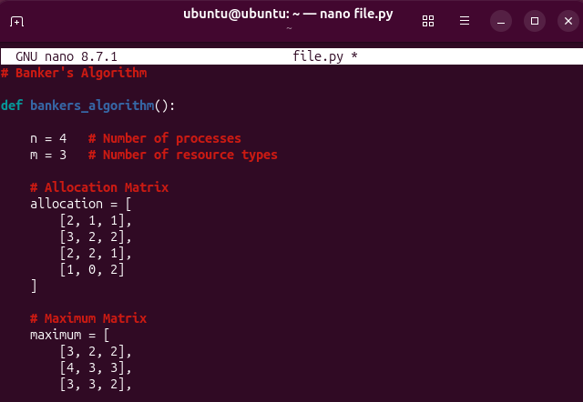

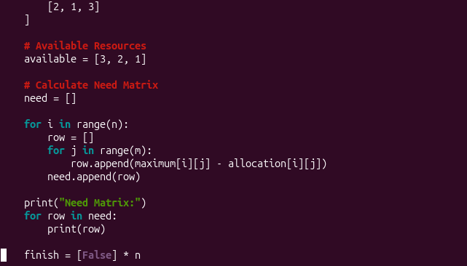

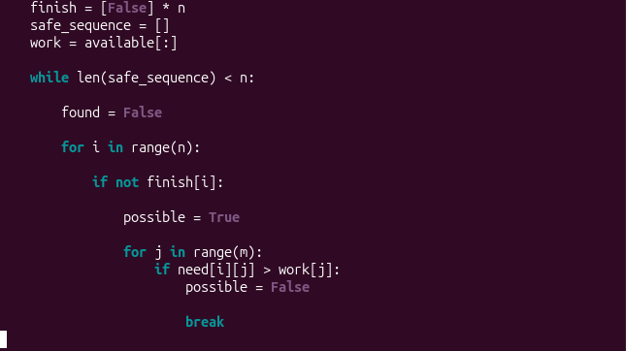

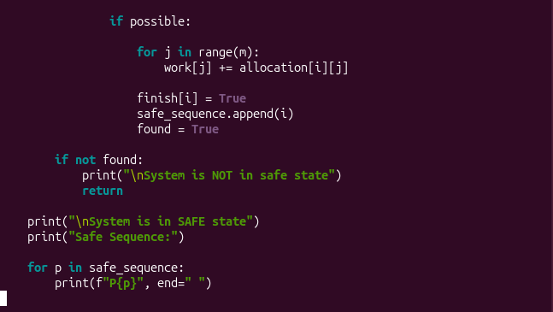

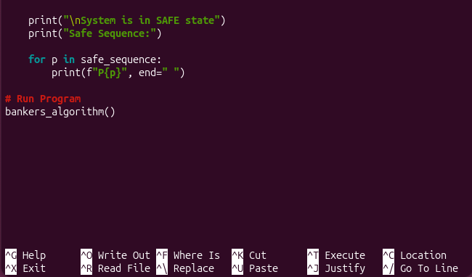

OUTPUT
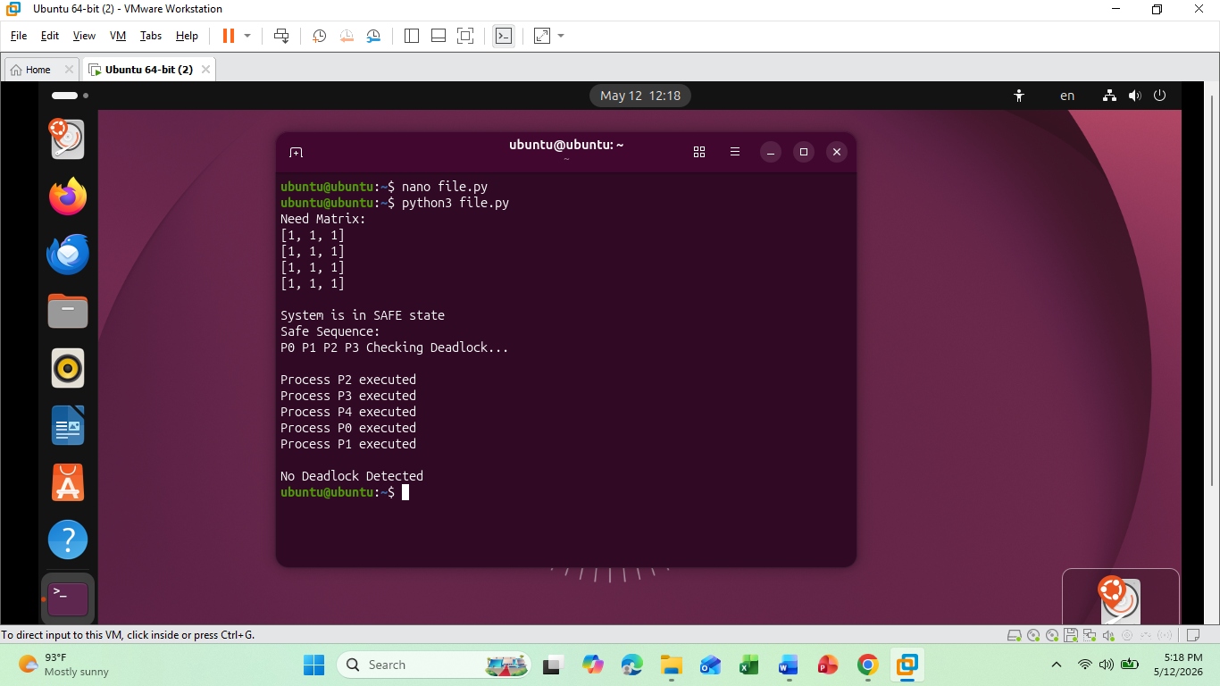

                - You are developing a system that requires periodic checks to identify if any deadlock exists among processes. Implement the deadlock detection algorithm to check if any processes are blocked due to the circular wait condition. The system has five processes and three types of resources. Each process has been allocated a certain number of resources, and the need matrix has been calculated. Given the Allocation, Need, and Available matrices:
Allocation matrix: [[2, 1, 0], [2, 2, 2], [3, 2, 2], [2, 1, 2], [1, 2, 1]]
Need matrix: [[1, 2, 2], [2, 0, 0], [0, 1, 1], [2, 1, 1], [3, 0, 2]]
Available resources: [1, 1, 1]
The deadlock detection algorithm will check for processes that are unable to proceed because their resource needs exceed the available resources. Identify if any deadlocked processes exist and return their indices.

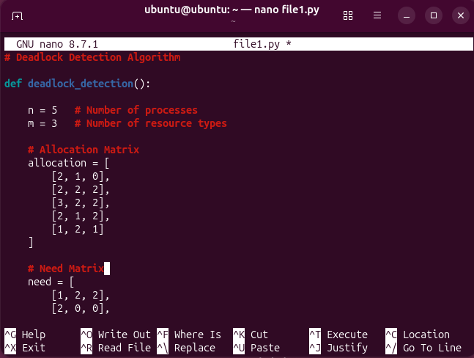

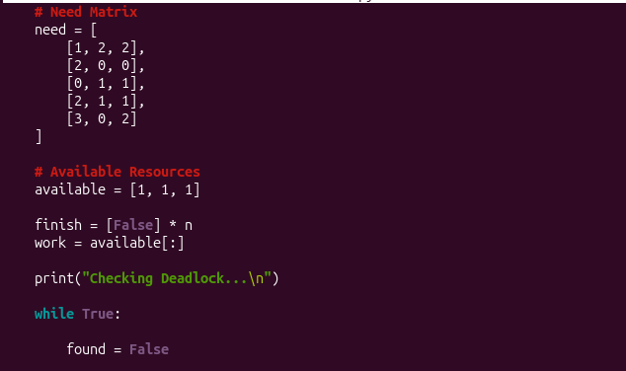

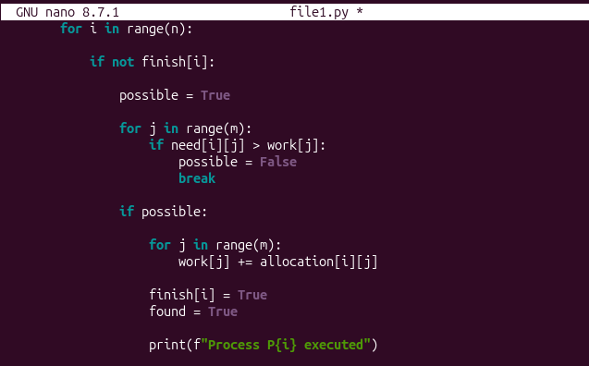

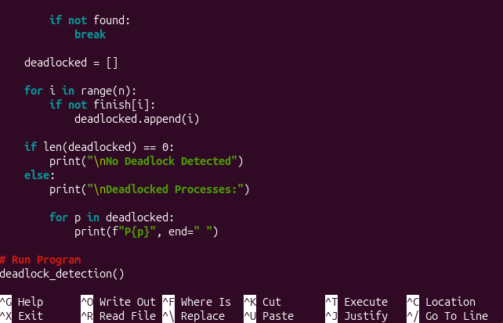

OUTPUT

