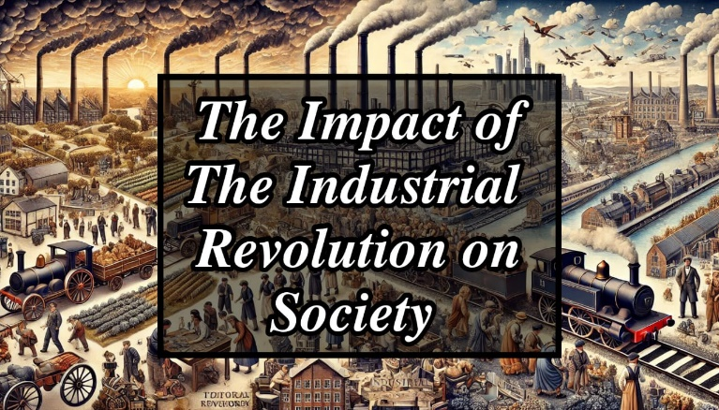

**Title: The Impact of the Industrial Revolution on Society**

**Group – 1**

**Member 1 : Md Ferdous Mahmud Noor**

**Member 2 : Tamanna Rahman Dristy**

**Member 3 : Ayesha Akter**

**Member 4 : Sadman Hossen Sifat**

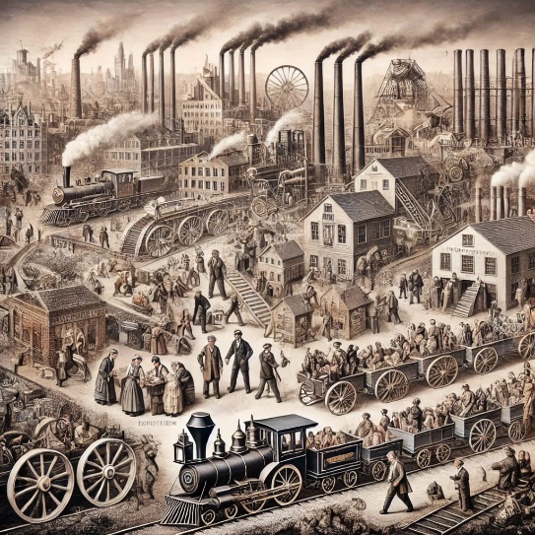

**Introduction :**

**Definition : The Industrial Revolution was a period between the late 1700s and mid-1800s when major changes occurred in manufacturing, transportation, and society. It began in Britain and soon spread across Europe, the United States, and the rest of the world.**

**Main Idea: This period marked the shift from hand-made goods to machine-based production, leading to significant changes in economic, social, and cultural life.**

**Key Factors: It was driven by innovations such as the steam engine, the spinning jenny, and the power loom. These developments allowed factories to produce goods on a massive scale, transforming how people worked, lived, and interacted.**

**Economic Impact :**



**Factories & Mass Production :**

**Before the Industrial Revolution, goods were made by hand in small workshops or at home, often taking a long time to produce and at a high cost. The development of factories allowed for the centralization of production. Machines could operate much faster than human labor, which drastically increased production rates and lowered costs.**

**The textile industry was one of the first to industrialize, leading to the mass production of cloth and clothing. Other industries, like iron and steel, followed suit.**

**Job Creation & Capitalism:**

**The rise of factories led to a surge in job creation, as people were needed to operate the machinery. This led to a large migration of workers from rural areas to urban centers, where factories were concentrated.**

**Entrepreneurs invested in these new industries, leading to the rise of capitalism. The concept of private ownership and profit-making became central to the economy. Investors and business owners grew wealthy, while workers earned low wages.**

**Urbanization:**

**As factories expanded, more people moved to cities in search of work. This led to rapid urbanization, with cities like Manchester, London, and Birmingham growing in size and population.**

**However, the rapid growth of cities led to overcrowding, poor sanitation, and the spread of diseases. Housing was often cramped, and the infrastructure struggled to keep up with the growing population.**

**Global Trade: The increase in production and improvements in transportation, such as the expansion of railways and the development of steamships, allowed for the growth of global trade. Countries began to exchange goods at a faster rate, leading to the spread of industrial products worldwide.**

**Britain, in particular, became the "workshop of the world," exporting manufactured goods to its colonies and other countries.**

**Social Impact Class Structure:**

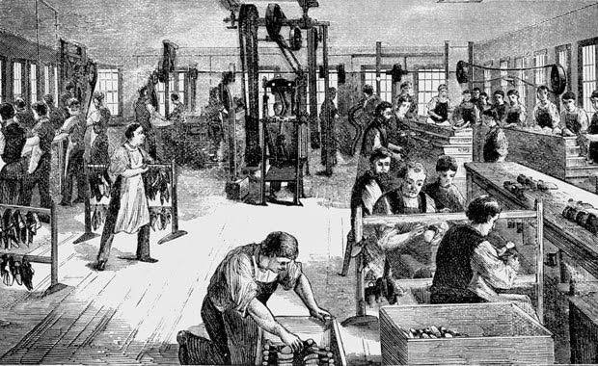

**The Industrial Revolution created a new social hierarchy. At the top were the factory owners and industrialists who accumulated vast wealth. This group became the new upper class.**

**Below them was the emerging middle class, which included professionals such as doctors, lawyers, teachers, and managers. This group benefited from the new opportunities created by industrialization.**

**The working class, however, lived in much harsher conditions. These were the laborers who worked long hours in factories, mines, and workshops for very low wages. The rise of factories led to a significant increase in the number of working-class people, but their living conditions were poor, and they had little social mobility.**

**Working Conditions:**

**Factory workers, including women and children, often worked 12-16 hours a day, six days a week. The work was repetitive, dangerous, and exhausting. Workers had few rights and no job security.**

**Children as young as five were employed in factories and mines. They worked in unsafe conditions, handling machinery that could easily injure or kill them.**

**There were no regulations to protect workers from exploitation. Employers could fire workers for any reason, and the concept of health and safety at work was virtually non-existent.**

**City Life:**

**As people moved to cities for factory work, the population in urban areas surged. Housing was built quickly and cheaply to accommodate the influx of workers, resulting in overcrowded and unsanitary living conditions.**

**Many workers lived in slums, with little access to clean water, proper sanitation, or medical care. Diseases such as cholera and typhoid spread rapidly in these environments, causing high mortality rates.**

**Technological Advancements**

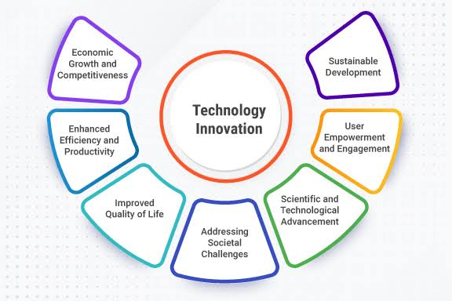

**Steam Engine:**

**Invented by James Watt in the late 1700s, the steam engine became the driving force of the Industrial Revolution. It powered factories, trains, and ships, enabling goods to be produced and transported at unprecedented speeds. The steam engine's impact on transportation was revolutionary. It led to the development of railroads, which connected cities and regions, allowing for faster and more efficient movement of people and goods.**

**Spinning Jenny:**

**Developed by James Hargreaves in 1764, the spinning jenny was one of the key inventions in the textile industry. It allowed a single worker to spin multiple spools of thread at once, greatly increasing productivity in the production of cloth.**

**This innovation was a critical factor in the growth of the textile industry, one of the largest sectors during the Industrial Revolution.**

**Railways & Transportation:**

**The expansion of railways in the 19th century was a game changer. It made it easier to transport raw materials to factories and finished goods to markets. Railroads also facilitated the movement of people, enabling cities to expand and industries to grow.**

**The first railway line, from Manchester to Liverpool, opened in 1830. Soon, railroads crisscrossed Europe and North America, playing a vital role in the spread of industrialization.**

**Iron & Steel Production:**

**Advances in metallurgy, especially the development of the Bessemer process in the 1850s, allowed for the mass production of steel. Steel became the backbone of industrialization, used in everything from machinery and railways to bridges and ships.**

**The iron and steel industries were critical to the growth of other sectors, as they provided the raw materials needed for building the infrastructure of the modern world.**

**Cultural Changes**

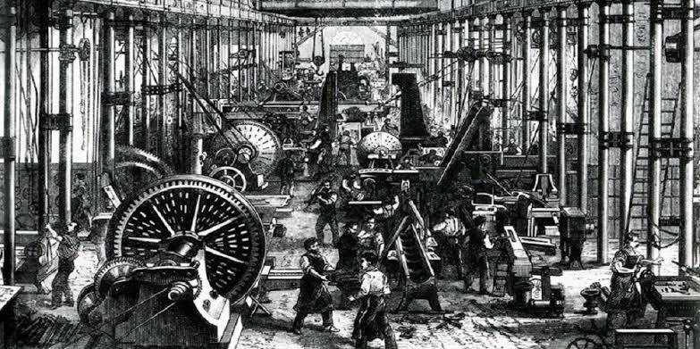

**Family Roles:**

**Industrialization fundamentally changed family structures. In pre-industrial societies, families often worked together in agriculture or small-scale craft production. With the rise of factories, families were split up, as men, women, and children worked in separate factories.**

**Women and children were often employed in low-skilled, low-paying jobs, which provided an additional source of income for the family but also placed them in dangerous working conditions.**

**Education:**

**The need for a more skilled workforce led to the development of public education systems. Governments began to invest in schools, and literacy rates gradually increased.**

**However, education was still largely inaccessible to the working class, as children were often required to work to help support their families. It wasn’t until later in the 19th century that reforms were introduced to improve access to education for all.**

**Social Movements:**

**The poor working conditions and the inequality between the rich and the working class led to the rise of social movements. Labor unions formed to protect workers’ rights, and strikes became a common way for workers to demand better wages, shorter hours, and safer conditions. Reformers also called for improvements in public health, education, and housing. The social reforms of the 19th century laid the groundwork for the modern welfare state.**

**Environmental Impact**

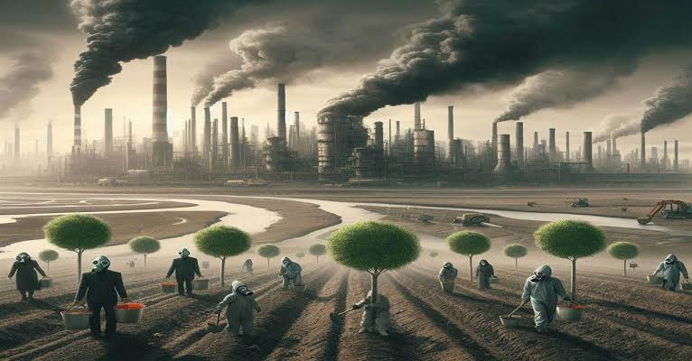

**Pollution:**

**The Industrial Revolution had a devastating impact on the environment. Factories released large amounts of smoke, soot, and other pollutants into the air. Rivers and lakes were contaminated with industrial waste, harming wildlife and polluting water supplies.**

**The widespread use of coal as a source of energy contributed to air pollution and the degradation of the atmosphere. The smog in industrial cities like London became so thick that it caused respiratory illnesses and premature death among the population. Resource Depletion:**

**The demand for raw materials such as coal, iron, and timber led to the over-exploitation of natural resources. Forests were cleared, and mines were dug deeper to keep up with the needs of industry.**

**This overuse of resources had long-term environmental consequences, including deforestation, soil erosion, and the destruction of ecosystems.**

**Conclusion**

**Key Points:**

**The Industrial Revolution was a transformative period in history that reshaped economies, societies, and cultures. It brought about significant technological advancements that laid the foundation for the modern world.**

**However, the benefits of industrialization were not evenly distributed. While factory owners and investors grew rich, many workers lived in poverty and suffered from poor working conditions. The environmental consequences of industrialization are still felt today, as pollution and resource depletion continue to be major global issues.**

**Legacy:**

**The Industrial Revolution’s impact is still visible in today’s world, influencing how we live, work, and interact with technology. It set the stage for the technological advancements of the 20th and 21st centuries and continues to shape global economies and societies.**