

CLOUD COMPUTING
Assignment 01: Git, Gitea, GitHub, Git LFS, and GitHub Pages

Submitted to: Sir Waqas Saleem

Submitted by: Ayesha Asif
Registration no: FA24B1-SE-046
Submission date: Oct 14, 2026
Submission day: Wednesday
Semester: 5th (B)
GitHub Username: ayeshaasif46

DEPARTMENT OF SOFTWARE ENGINEERING
SESSION: 2024-2028
Task 1
Install Gitea and Push Repository from Ubuntu Server
1.1: Gitea Running Status:
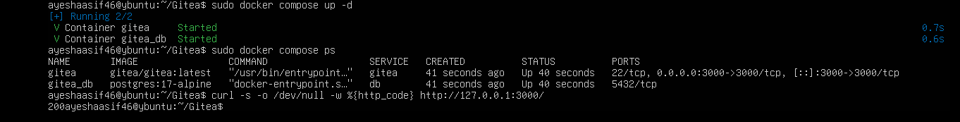
task1_gitea_running.png
1.2: Terminal Push to Gitea:
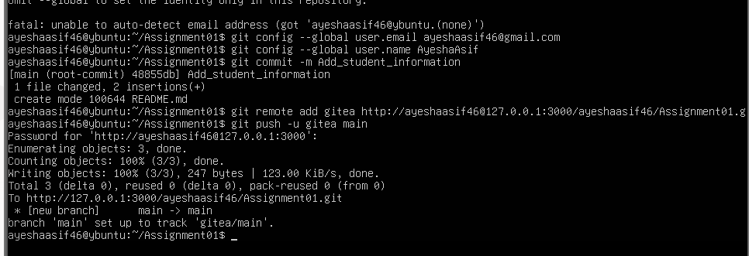
task1_gitea_push.png
1.3: Gitea Web Repository:
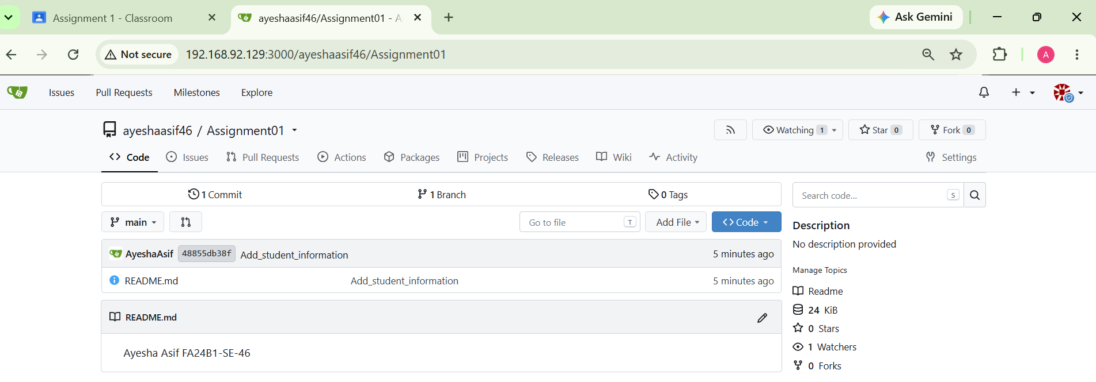
task1_gitea_repository.png

Task 2
GitHub Remote Configuration:
2.1: Verify Remotes:
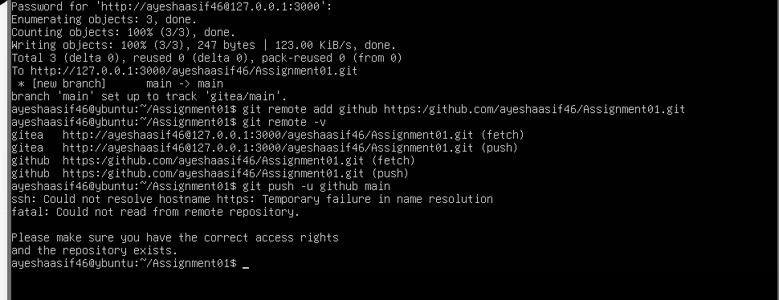
task2_remotes.png
2.2: Terminal Push to GitHub:
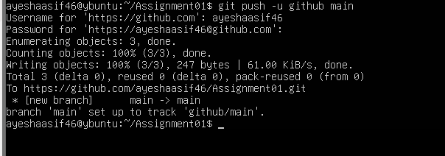
task2_github_push.png
2.3: GitHub Web Repository:
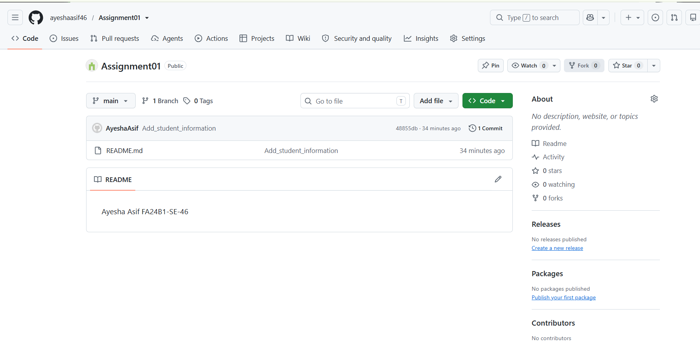
task2_github_repository.png

Task 3
Track Three Large Files with Git LFS
3.1: Git LFS Setup:
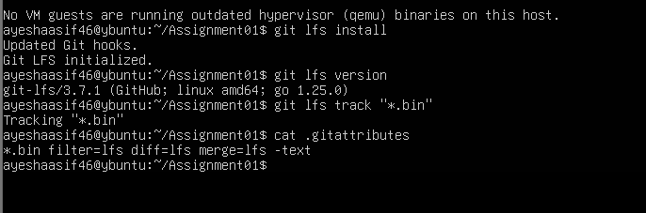
task3_lfs_setup.png
3.2: LFS Files Listing:
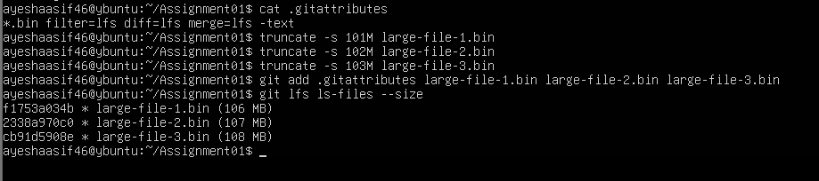
task3_lfs_files.png
3.3: Push LFS Files:
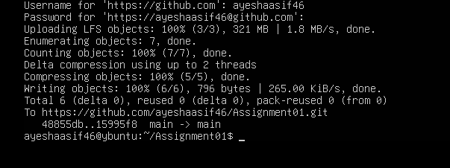
task3_lfs_push.png

Task 4
GitHub Pages Portfolio Setup
task4_pages_repository.png

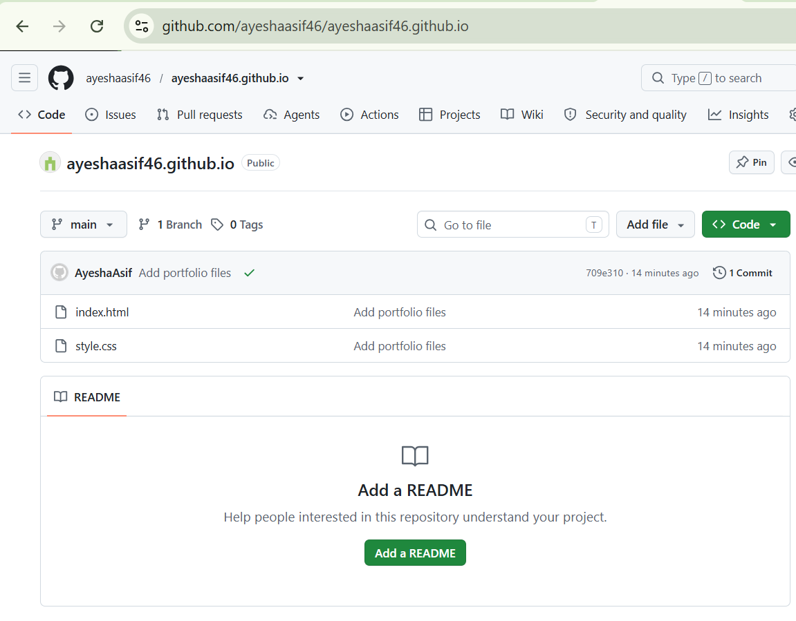
task4_pages_repository.png
4.2: GitHub Pages Settings:
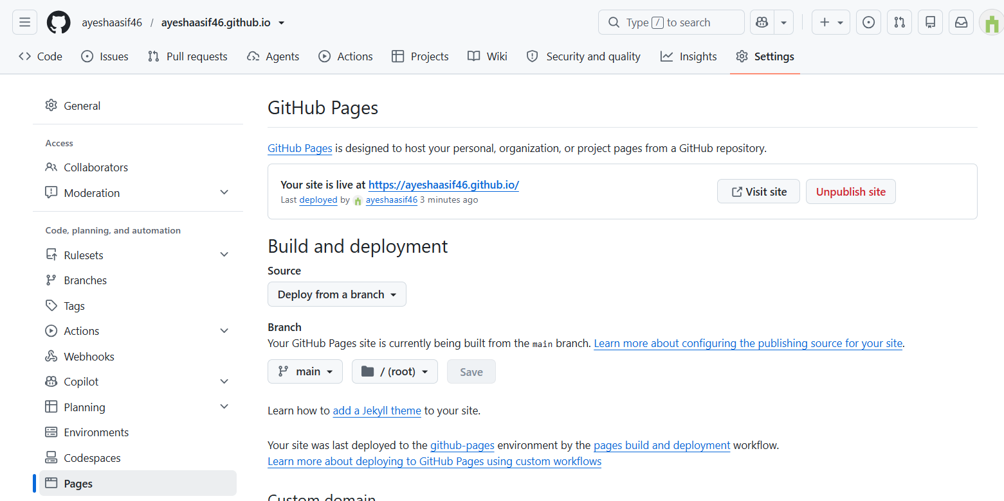
task4_pages_deployment.png

4.3: Live Portfolio Site:
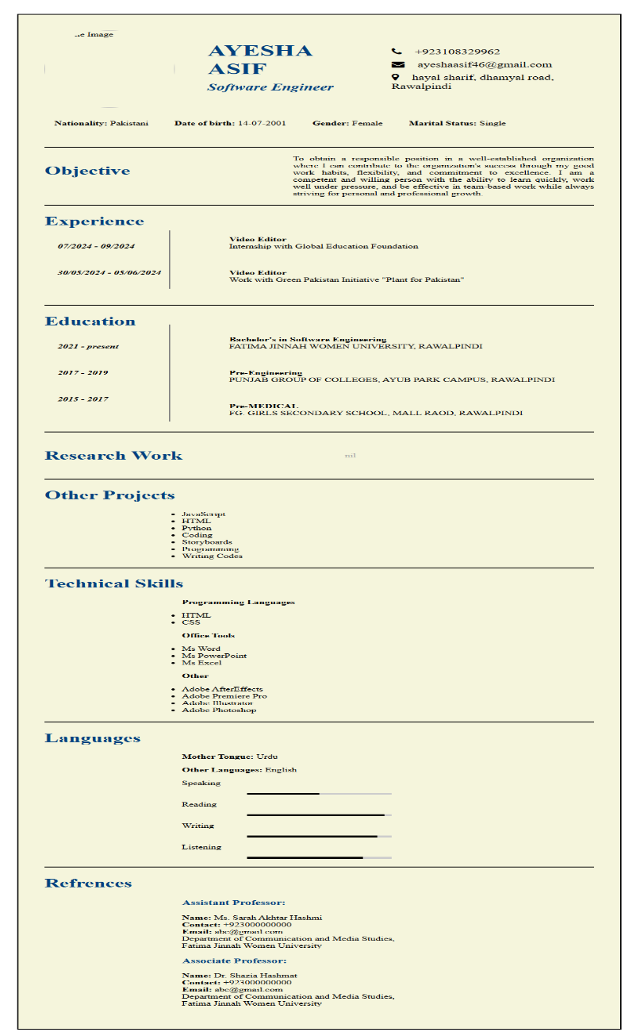
task4_portfolio_live.png

