HELICOPTER SHOOTER GAME
An OOP-Based Windows Forms Game Project Report
by
Ayesha Batool
2025-CS-404
Research Supervisor:
Ms. Rimsha Afzal
2026
Department of Computer Science
University of Engineering and Technology, Lahore
Instructor Signature: ____________________
Date: ____________________

ACKNOWLEDGEMENT
First and foremost, I am thankful to Allah Almighty for granting me the knowledge, patience, and ability to complete this project successfully.
I would like to express my heartfelt gratitude to my parents for their constant support, encouragement, and prayers throughout my academic journey, without which this work would not have been possible.
I am sincerely grateful to my instructor, Ms. Rimsha Afzal, for her invaluable guidance, feedback, and patience while teaching the concepts of Object-Oriented Programming that form the foundation of this project. Her support helped me understand how theoretical OOP concepts translate into a working, interactive application.
Finally, I extend my appreciation to the Department of Computer Science, University of Engineering and Technology, Lahore, for providing the resources, environment, and opportunity to undertake and complete this project.

ABSTRACT
This project presents the design and implementation of a 2D side-scrolling arcade game, the “Helicopter Shooter Game”, developed in C# using the Windows Forms (.NET Framework 4.7.2) platform. The player controls a helicopter that must navigate between scrolling pillars (obstacles) while shooting down enemy UFOs to score points. The game features two difficulty levels: Level 1 introduces basic obstacle avoidance and shooting, while Level 2 increases the speed of obstacles and enemies and introduces enemy UFOs that fire back at the player.
The primary objective of this project was to apply the four major pillars of Object-Oriented Programming — Encapsulation, Inheritance, Polymorphism, and Abstraction — along with supporting concepts such as Interfaces and Composition, to build a maintainable and extensible game architecture.
Technologies used include C# (.NET Framework 4.7.2), Windows Forms for the graphical user interface, and the System.Drawing namespace for rendering sprites and animations. A central GameManager class coordinates gameplay using a Timer-driven game loop, while individual game entities (Player, UFO, FastUFO, Bullet, Pillar) are modeled as classes derived from a common abstract GameObject base class.
Key OOP concepts implemented include: encapsulated properties for controlled access to game-object state; an abstract GameObject class defining a contract (Update method) that all game entities must implement; inheritance, where FastUFO extends UFO to reuse and extend its behaviour; runtime polymorphism, where each object's overridden Update() method is invoked through a common base-class reference inside the main game loop; and the ICollidable interface, implemented by Player, UFO, and Pillar to provide object-specific collision responses.
Major features of the application include smooth keyboard-controlled player movement, a bullet-firing mechanism, real-time collision detection, a scrolling background using pillar objects, a scoring system with a live HUD, level progression based on score, and dedicated start and game-over screens. The resulting application demonstrates a clean separation of concerns between game logic, rendering, and user interface, and serves as a practical example of applying core OOP principles to interactive software development.

TABLE OF CONTENTS
ACKNOWLEDGEMENT 2
ABSTRACT 3
TABLE OF CONTENTS 4
LIST OF FIGURES 6
CHAPTER 1: INTRODUCTION 7
1.1 Introduction 7
1.2 Project Overview 7
1.3 Problem Statement 7
1.4 Objectives 7
1.5 Scope 7
CHAPTER 2: REQUIREMENT ANALYSIS 9
2.1 Functional Requirements 9
2.2 Non-Functional Requirements 9
2.3 Software Requirements 9
2.4 Hardware Requirements 9
CHAPTER 3: SYSTEM DESIGN 10
3.1 Development Workflow 10
3.2 System Architecture 10
3.3 Class Diagram 10
3.4 OOP Relationship Diagram 11
3.5 Game Flow Diagram 11
CHAPTER 4: IMPLEMENTATION 12
4.1 Project Structure 12
4.2 Resource Management 12
4.3 Main Classes 12
GameObject 12
Player 13
UFO 13
FastUFO 13
Bullet 13
Pillar 14
CollisionManager 14
ScoreManager 14
GameManager 14
CHAPTER 5: OOP CONCEPTS IMPLEMENTED 16
5.1 Classes and Objects 16
5.2 Encapsulation 16
5.3 Inheritance 16
5.4 Abstraction 16
5.5 Polymorphism 17
5.6 Interface 17
5.7 Composition 17
CHAPTER 6: RESULTS AND TESTING 18
6.1 Screenshots 18
6.2 Test Cases 18
CHAPTER 7: CHALLENGES AND SOLUTIONS 20
Collision Detection Issues 20
Resource Loading Problems 20
Timer Synchronization Issues 20
Object Management 20
CHAPTER 8: CONCLUSION AND FUTURE WORK 21
Conclusion 21
Future Enhancements 21
REFERENCES 22

LIST OF FIGURES
Figure 3.1: System Architecture Diagram
Figure 3.2: Game Flow Diagram
Figure 3.3: Class Diagram (Inheritance and Interface Relationships)
Figure 3.4: OOP Relationship Diagram
Figure 6.1: Start Menu Screen
Figure 6.2: Gameplay Screen – Level 1
Figure 6.3: Collision / Score Update Example
Figure 6.4: Level 2 Gameplay (Enemy UFOs Firing Back)
Figure 6.5: Game Over Screen

CHAPTER 1: INTRODUCTION

1.1 Introduction
Game development is one of the most engaging and effective ways to learn and apply Object-Oriented Programming (OOP) concepts, as games naturally model the real world through interacting objects with their own properties and behaviours. In this project, OOP principles are used to design a 2D arcade-style “Helicopter Shooter” game, where every visual element on screen — the player's helicopter, enemy UFOs, bullets, and obstacles — is represented as an object derived from a common base class. This approach mirrors how OOP is used in professional game engines, where entities share a common interface but behave differently at runtime.

1.2 Project Overview
The Helicopter Shooter Game is a single-player, side-scrolling arcade game built with C# Windows Forms. The player controls a helicopter using the Up and Down arrow keys and fires bullets using the Space bar. The helicopter must avoid colliding with scrolling pillar obstacles and enemy UFOs while shooting down UFOs to earn points. Reaching a score of 10 points completes Level 1 and transitions the player into Level 2, where obstacles and enemies move faster and UFOs fire bullets back at the player. The game ends when the player's helicopter collides with an obstacle, an enemy, or an enemy bullet, after which a Game Over screen displays the final score and level reached, with options to restart or exit.

1.3 Problem Statement
Many beginner-level programming projects demonstrate OOP concepts using abstract, non-visual examples (e.g., bank accounts, employee records) that do not clearly show how polymorphism and abstraction affect program behaviour at runtime. This project addresses that gap by implementing OOP concepts in a visual, interactive game where the effects of inheritance, polymorphism, abstraction, encapsulation, and interfaces can be directly observed through gameplay — for example, watching a FastUFO move differently from a regular UFO even though both are updated through the same line of code in the game loop.

1.4 Objectives
- Develop a fully functional 2D arcade game using Windows Forms (.NET Framework).
- Apply all four major OOP concepts — Encapsulation, Inheritance, Abstraction, and Polymorphism — in a meaningful, demonstrable way.
- Design and implement an interface (ICollidable) to standardize collision handling across different object types.
- Create an interactive, responsive user interface with real-time keyboard input handling.
- Implement core game logic including movement, shooting, collision detection, scoring, and level progression.
- Demonstrate composition by having the Form (UI layer) own and coordinate a GameManager (logic layer).

1.5 Scope
The scope of this project is limited to a two-level, single-player arcade game intended primarily as an educational demonstration of OOP concepts in C#. The game does not include sound effects, persistent high-score storage, multiplayer functionality, or advanced graphics/animation beyond simple sprite movement using GIF images. The game is built and tested for desktop execution on Windows using the .NET Framework 4.7.2 runtime and is not intended for deployment on mobile or web platforms.

CHAPTER 2: REQUIREMENT ANALYSIS

2.1 Functional Requirements
- The system shall display a Start Menu with options to Play or Exit the game.
- The system shall allow the player to move the helicopter up and down using the Up and Down arrow keys.
- The system shall allow the player to fire bullets using the Space bar.
- The system shall move pillars (obstacles) and UFOs (enemies) continuously across the screen.
- The system shall detect collisions between the player, bullets, UFOs, and pillars.
- The system shall destroy a UFO and increase the player's score when it is hit by a player bullet.
- The system shall end the game when the player collides with a pillar, a UFO, or an enemy bullet.
- The system shall display the current score and level on a heads-up display (HUD) during gameplay.
- The system shall transition the player to Level 2 once a score of 10 is reached, increasing object speeds and enabling enemy UFOs to fire bullets.
- The system shall display a Game Over screen showing the final score and level reached, with options to restart or exit.

2.2 Non-Functional Requirements
- Performance: The game loop shall update game objects and redraw the screen at a consistent rate (driven by a Windows Forms Timer) to provide smooth animation.
- Reliability: The game shall correctly detect collisions and update game state without crashing during extended play sessions.
- Usability: Controls shall be simple and intuitive (arrow keys for movement, Space for shooting), and on-screen feedback (HUD, dialogs) shall be clear.
- Maintainability: The codebase shall be organized into clearly separated classes (GameObjects, Managers, Interfaces, Enums, Forms) following OOP principles, making it easy to extend with new object types or levels.

2.3 Software Requirements
- Microsoft Visual Studio (2019 or later) with .NET Desktop Development workload.
- .NET Framework 4.7.2
- C# Programming Language
- Windows Operating System (for running and testing the Windows Forms application)

2.4 Hardware Requirements
- Processor: Intel Core i3 or equivalent (minimum)
- RAM: 4 GB minimum (8 GB recommended for smooth Visual Studio operation)
- Storage: At least 500 MB free disk space for project files, build output, and Visual Studio components

CHAPTER 3: SYSTEM DESIGN

3.1 Development Workflow
The development of the Helicopter Shooter Game followed an incremental workflow: first, the abstract GameObject base class and the ICollidable interface were designed to define a common contract for all game entities. Next, concrete entity classes (Player, UFO, Pillar, Bullet) were implemented, followed by the FastUFO subclass to demonstrate inheritance and polymorphism. The GameManager class was then developed to coordinate object creation, the update loop, collision detection, and scoring. Finally, the Windows Forms UI (Start Form, main Game Form, and Game-Over Form) was built to tie the logic together and provide user interaction.
Design abstract GameObject + ICollidable
|
v
Implement Player, UFO, Pillar, Bullet
|
v
Implement FastUFO (extends UFO)
|
v
Implement GameManager (game loop, scoring, collisions)
|
v
Build UI Forms (frmStart, Form1, frmGameEnd)
|
v
Integrate, test, and refine gameplay

3.2 System Architecture
The architecture follows a layered design where the Windows Forms UI layer (Form1) is composed with a logic layer (GameManager), which in turn manages a collection of GameObject-derived entities and two helper managers for scoring and collision detection.
frmStart
|
v
Form1 (UI Layer)
|
| (Composition)
v
GameManager (Game Logic / Controller)
|
|--> Player
|--> List<GameObject> (UFO, FastUFO, Bullet, Pillar)
|--> ScoreManager
|--> CollisionManager
|
v
frmGameEnd (Result Screen)

3.3 Class Diagram
The class diagram below shows the inheritance hierarchy rooted at the abstract GameObject class, the ICollidable interface implemented by collidable entities, and the relationship of FastUFO as a specialization of UFO.
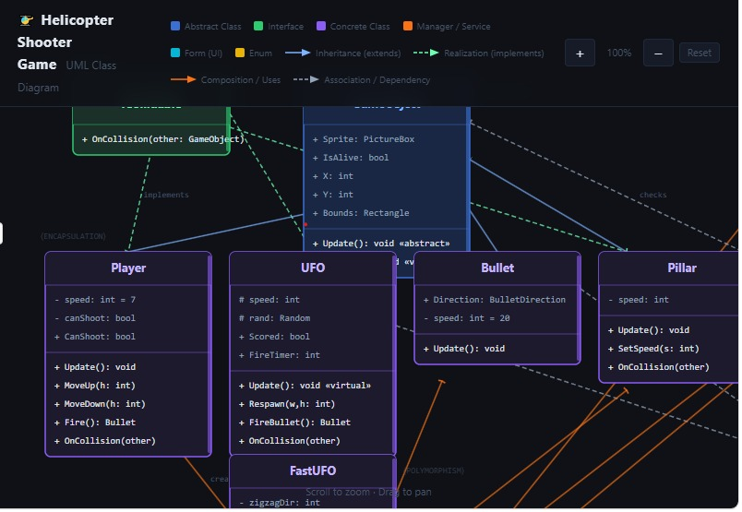

3.4 OOP Relationship Diagram
- Inheritance: Player, Bullet, UFO, and Pillar all inherit from the abstract class GameObject. FastUFO further inherits from UFO.
- Composition: Form1 “has-a” GameManager; GameManager “has-a” ScoreManager, a CollisionManager, a Player, and a List<GameObject>.
- Interface Relationships: Player, UFO, and Pillar each implement the ICollidable interface, providing their own version of OnCollision().

3.5 Game Flow Diagram
Start Menu (frmStart)
|
v
Initialize GameManager -> StartLevel1()
|
v
+------------------------------------+
| Game Loop (Timer Tick): |
| 1. Read keyboard input |
| 2. Move player |
| 3. Update all GameObjects |
| 4. Handle enemy fire (Level 2) |
| 5. Check collisions |
| 6. Remove offscreen bullets |
| 7. Update score & HUD |
| 8. Check level-up / game-over |
+------------------------------------+
| |
| score>=10 | player destroyed
v v
StartLevel2() Show frmGameEnd
| |
v (Restart / Exit)
Continue loop

CHAPTER 4: IMPLEMENTATION

4.1 Project Structure
The project is organized into folders that group related classes by responsibility, which improves readability and maintainability:
Helicopter Shooter Game/
|-- Game/
| `-- GameManager.cs
|-- GameObjects/
| |-- GameObject.cs (abstract base class)
| |-- Player.cs
| |-- UFO.cs
| |-- FastUFO.cs
| |-- Bullet.cs
| `-- Pillar.cs
|-- Managers/
| |-- ScoreManager.cs
| `-- CollisionManager.cs
|-- Interfaces/
| `-- ICollidable.cs
|-- Enums/
| `-- BulletDirection.cs
|-- Forms/ (Form1, frmStart, frmGameEnd)
|-- Resources/ (sprite images: Halicopter, alien1-3, pillar)
`-- Program.cs

4.2 Resource Management
All visual assets used in the game are stored as embedded resources in the Resources folder and accessed through the auto-generated Properties.Resources class. The player's helicopter is represented by Halicopter.gif, enemy UFOs cycle through alien1.gif, alien2.gif, and alien3.gif each time they respawn (giving visual variety), and obstacles use pillar.gif. Each game object's Sprite is a PictureBox control whose Image property is set to the corresponding resource. Background colours of objects are set to Color.Transparent so that sprites blend naturally with the form's background, and SizeMode is set to AutoSize or StretchImage depending on whether the original image dimensions should be preserved.

4.3 Main Classes

GameObject
Purpose: Abstract base class that defines the common structure and contract shared by every visual entity in the game (player, enemies, bullets, obstacles).
Attributes: Sprite (PictureBox), IsAlive (bool), X and Y (computed from Sprite position), Bounds (Rectangle).
Methods: abstract Update() — must be implemented by every subclass; virtual Destroy() — hides the sprite and marks the object as not alive, can be overridden for extra cleanup.
Code Explanation: By declaring Update() as abstract, GameObject guarantees that any class derived from it (Player, UFO, Bullet, Pillar, FastUFO) must define its own movement/update logic. This allows the GameManager to treat all objects uniformly as a List<GameObject> and call go.Update() on each — the correct, type-specific behaviour runs automatically (runtime polymorphism).
internal abstract class GameObject
{
public PictureBox Sprite { get; set; }
public bool IsAlive { get; set; } = true;
public int X { get { return Sprite.Left; } set { Sprite.Left = value; } }
public int Y { get { return Sprite.Top; } set { Sprite.Top = value; } }
public abstract void Update();
public virtual void Destroy() { IsAlive = false; Sprite.Hide(); }
}

Player
Purpose: Represents the helicopter controlled by the user.
Attributes: speed (private), CanShoot (bool property).
Methods: MoveUp(), MoveDown(), Fire() — creates and returns a new Bullet travelling right, OnCollision() — implements ICollidable, Update() — implements the abstract method (empty, since movement is driven by keyboard input in the game loop).
Code Explanation: Player inherits from GameObject (gaining Sprite, X, Y, IsAlive) and implements ICollidable so that when the CollisionManager detects the player has hit a UFO or Pillar, it can call player.OnCollision(other), which calls Destroy() to end the game.

UFO
Purpose: Represents an enemy flying object that moves from right to left across the screen and can be shot down for points.
Attributes: speed (protected, so FastUFO can use it), Scored (bool, prevents double-counting score), FireTimer (int, used for Level 2 enemy fire).
Methods: Update() — moves the UFO left and respawns it on the right edge when it exits the screen; Respawn() — repositions the UFO at a random height; FireBullet() — creates a bullet travelling left toward the player; OnCollision() — destroys the UFO if hit by a player bullet.
Code Explanation: speed is declared protected (rather than private) specifically so that the derived class FastUFO can be constructed with a different speed value while reusing the same field.

FastUFO
Purpose: A faster, more challenging variant of UFO that moves in a zig-zag pattern, used in Level 2.
Attributes: zigzagDir, zigzagTimer (private, control the up/down zig-zag motion).
Methods: Overrides Update() to move left faster and add vertical zig-zag movement; reuses UFO's constructor via base(...) to set a higher speed.
Code Explanation: FastUFO demonstrates inheritance (it reuses Respawn(), OnCollision(), FireBullet(), and all properties from UFO without rewriting them) and polymorphism (its overridden Update() runs automatically when the GameManager calls go.Update() on a GameObject reference, even though the underlying object is actually a FastUFO).

Bullet
Purpose: Represents a projectile fired either by the player (rightward) or by a UFO (leftward, in Level 2).
Attributes: Direction (BulletDirection enum, read-only outside the class), speed (private).
Methods: Update() — moves the bullet left or right depending on Direction.
Code Explanation: The Direction property uses a private setter (public BulletDirection Direction { get; private set; }) so that once a bullet is created with a direction, no other class can change it — a clear example of encapsulation protecting object state.

Pillar
Purpose: Represents a static obstacle that scrolls from right to left, which the player must avoid.
Attributes: speed (private).
Methods: Update() — scrolls the pillar left and loops it back to the right edge of the screen; SetSpeed() — allows GameManager to increase scroll speed for Level 2; OnCollision() — implements ICollidable (no special action; the Player's OnCollision handles game-over).

CollisionManager
Purpose: Centralizes all collision-detection logic so that GameObject classes do not need to know about each other directly.
Attributes: None (stateless helper class).
Methods: CheckCollisions(List<GameObject> objects, Player player) — iterates through all game objects and checks for: player vs UFO/Pillar collisions, player bullets vs UFOs, and enemy bullets vs player.
Code Explanation: When a collision is detected, CollisionManager does not directly destroy objects itself — instead it calls the relevant object's OnCollision() method (defined via the ICollidable interface), letting each object decide how to respond to a collision.

ScoreManager
Purpose: Tracks and manages the player's score.
Attributes: score (private int, exposed via a read-only Score property).
Methods: AddPoints(int points), Reset().
Code Explanation: The private score field combined with a get-only Score property is a simple example of encapsulation — external classes can read the score but cannot directly overwrite it; they must use AddPoints() or Reset().

GameManager
Purpose: Acts as the central controller (“game engine”) that creates, updates, and removes game objects, manages levels, and coordinates the ScoreManager and CollisionManager.
Attributes: form (reference to the hosting Form), player, gameObjects (List<GameObject>), scoreManager, collisionManager, level, pillarSpeed, ufoSpeed, and HUD labels.
Methods: StartLevel1(), StartLevel2(), Update(goUp, goDown) — the main per-frame update method, PlayerFire(), and several private helpers (CreatePlayer, CreatePillars, CreateUFO, CreateFastUFO, HandleEnemyFire, RemoveOffscreenBullets, UpdateScore, RespawnUFO).
Code Explanation: The Update() method's main loop is the clearest demonstration of polymorphism in the project — it calls go.Update() on every object in gameObjects without checking what specific type each object is:
foreach (GameObject go in gameObjects)
{
if (go.IsAlive)
go.Update(); // Player, UFO, FastUFO, Bullet, Pillar
// each run their own version
}

CHAPTER 5: OOP CONCEPTS IMPLEMENTED

5.1 Classes and Objects
The project defines several classes representing real game entities: GameObject (abstract base), Player, UFO, FastUFO, Bullet, and Pillar, as well as supporting classes GameManager, ScoreManager, and CollisionManager. At runtime, the GameManager creates concrete objects of these classes — for example, two Pillar objects, one UFO object (and a second FastUFO object in Level 2), and a Player object — and stores the moving entities together in a single List<GameObject>, demonstrating how multiple distinct classes can be managed uniformly through their shared base type.

5.2 Encapsulation
Encapsulation is used throughout the project to protect internal object state and expose it only through controlled properties. For example, ScoreManager keeps its score field private and only allows it to be read through a get-only property, while modification is only possible through the AddPoints() and Reset() methods:
private int score = 0;
public int Score
{
get { return score; }
}
public void AddPoints(int points)
{
score += points;
}
Similarly, in Bullet, the Direction property has a private setter so it can only be assigned once, inside the constructor, and never changed afterward by other classes:
public BulletDirection Direction { get; private set; }

5.3 Inheritance
All movable game entities inherit from the abstract GameObject class, gaining its Sprite, X, Y, IsAlive properties and Destroy() method without re-declaring them. FastUFO further inherits from UFO, reusing UFO's Respawn(), FireBullet(), OnCollision(), and Scored property while only adding zig-zag movement logic.
GameObject (abstract)
|-- Player
|-- Bullet
|-- Pillar
`-- UFO
`-- FastUFO

5.4 Abstraction
The abstract class GameObject hides the implementation details of how each object updates itself behind a single abstract method, Update(). Code that works with GameObject (such as GameManager's main loop) does not need to know how a Player moves differently from a Pillar or a UFO — it only needs to know that every GameObject can be updated:
internal abstract class GameObject
{
...
public abstract void Update();
}

5.5 Polymorphism
Polymorphism is demonstrated in two ways in this project:
- Method Overriding (runtime polymorphism): UFO, FastUFO, Player, Bullet, and Pillar each provide their own implementation of Update(). When GameManager iterates over gameObjects (typed as List<GameObject>) and calls go.Update(), the .NET runtime automatically executes the correct overridden version based on the object's actual type.
- Virtual method overriding for Destroy(): GameObject provides a virtual Destroy() method (sets IsAlive = false and hides the sprite); subclasses can override it if extra cleanup is required, while still being callable through the base GameObject reference.
foreach (GameObject obj in gameObjects)
{
obj.Update();
// Could be UFO.Update(), FastUFO.Update(),
// Player.Update(), Bullet.Update(), or Pillar.Update()
// — the correct one runs automatically.
}

5.6 Interface
The ICollidable interface defines a single method, OnCollision(GameObject other), which is implemented by Player, UFO, and Pillar — each providing its own collision response (the player is destroyed, the UFO is destroyed if hit by a player bullet, and the pillar takes no special action). This allows CollisionManager to treat all collidable objects the same way, simply calling obj.OnCollision(other) without needing to know the object's concrete type.
internal interface ICollidable
{
void OnCollision(GameObject other);
}

5.7 Composition
Composition (a “has-a” relationship) is used extensively to build the overall game structure. Form1 “has-a” GameManager, which it creates and controls. In turn, GameManager “has-a” Player, a List<GameObject> (containing Pillars, UFOs, FastUFOs, and Bullets), a ScoreManager, and a CollisionManager. None of these relationships are inheritance — GameManager is not a type of ScoreManager — rather, GameManager is built by composing these smaller, focused objects together, each responsible for one part of the game's behaviour.
internal class GameManager
{
private Player player;
private List<GameObject> gameObjects;
private ScoreManager scoreManager;
private CollisionManager collisionManager;
...
}

CHAPTER 6: RESULTS AND TESTING

6.1 Screenshots
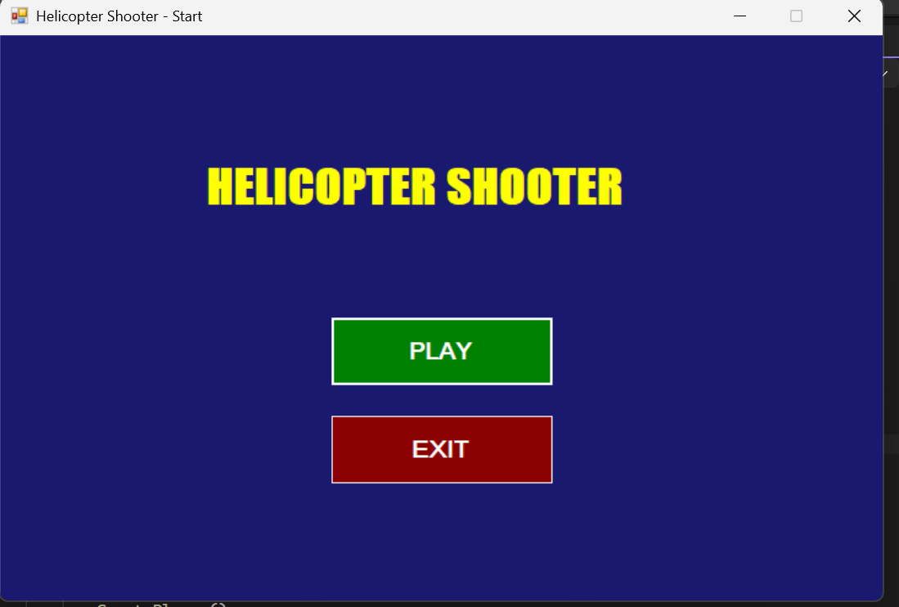
Figure 6.1: Main Menu – the Start screen showing Play and Exit buttons.
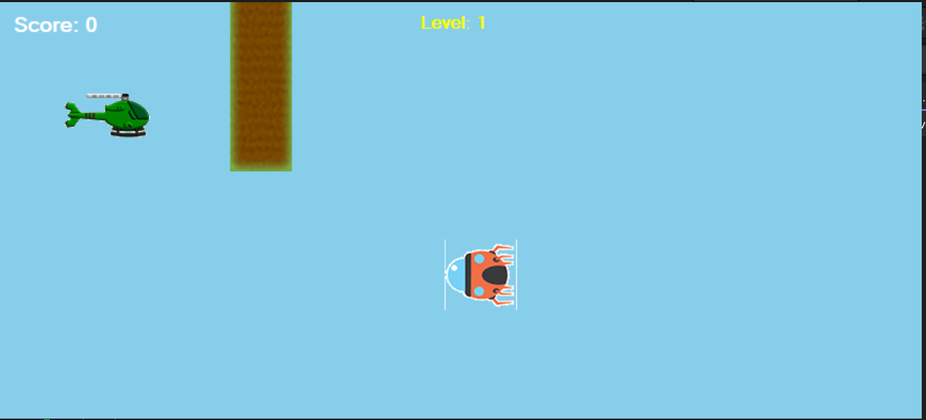
In Figure 6.4: Gameplay – two UFOs (including the faster zig-zagging FastUFO) on screen, with enemy bullets travelling toward the player.
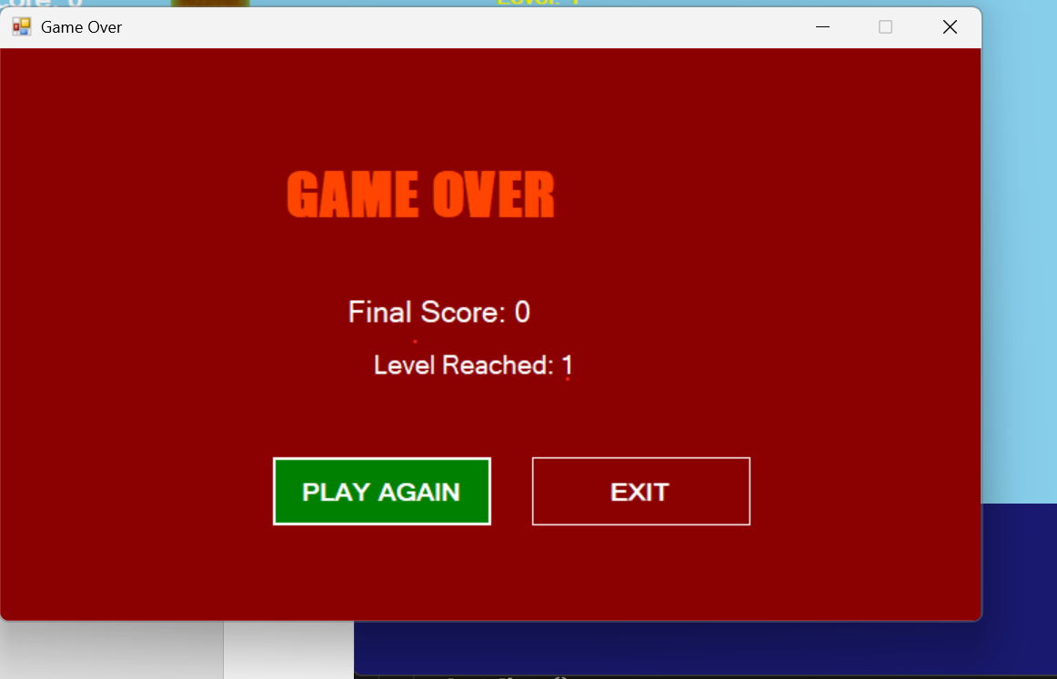
Figure 6.5: Game Over Screen – frmGameEnd showing the final score, level reached, and Restart/Exit options.

6.2 Test Cases
Test Case | Expected Result | Actual Result | Status
Start Game (frmStart → Play) | Form1 opens and Level 1 begins, player and pillars appear | Game starts as expected | Pass
Move Player (Up/Down arrow keys) | Helicopter moves up/down within form bounds | Player moves correctly | Pass
Fire Bullets (Space bar) | A bullet is created at the helicopter's nose and moves right | Bullet fires and travels right | Pass
Player vs Pillar Collision | Player is destroyed and Game Over screen appears | Game ends as expected | Pass
Bullet vs UFO Collision | UFO is destroyed, bullet is removed, score increases by 10 | UFO destroyed and score updated | Pass
UFO Respawn | Destroyed UFO reappears on the right at a new random height with a new image | UFO respawns correctly | Pass
Level Up (score >= 10) | Level 2 starts: speeds increase and a FastUFO appears | Level transition occurs correctly | Pass
Enemy Fire (Level 2) | UFOs periodically fire bullets toward the player | Enemy bullets fire as expected | Pass
Enemy Bullet vs Player | Player is destroyed and Game Over screen appears | Game ends correctly | Pass
Restart Game | Game resets to Level 1 with score 0 after clicking Restart | Game restarts successfully | Pass

CHAPTER 7: CHALLENGES AND SOLUTIONS

Collision Detection Issues
Initially, checking every object against every other object for collisions on each frame was inefficient and occasionally caused a bullet to be checked against itself or an already-destroyed object. This was solved by centralizing all collision logic inside a dedicated CollisionManager class, which first checks IsAlive before testing bounds, and uses the ICollidable interface so each object responds to collisions in its own way (e.g., a UFO destroys itself, while a Pillar does nothing) without the manager needing type-specific if-else chains.

Resource Loading Problems
Early on, enemy sprites all looked identical, making the game visually repetitive. This was resolved by cycling through three different UFO images (alien1, alien2, alien3) each time a UFO respawns, using a simple index counter (GetNextUFOImage()) in GameManager, giving visual variety without adding new classes.

Timer Synchronization Issues
During level transitions (Level 1 to Level 2), the game loop occasionally continued running while old objects were still being removed and new ones created, causing brief visual glitches. This was fixed by stopping the GameTimer before performing the transition (StartLevel2()) and using a levelTransitioning flag to skip Update() calls until setup was complete, then restarting the timer.

Object Management
Removing destroyed bullets from both the gameObjects list and the form's Controls collection while iterating could cause index errors. This was solved by iterating the gameObjects list backwards (from the last index to 0) inside RemoveOffscreenBullets(), so that removing an item does not affect the indices of items not yet processed.

CHAPTER 8: CONCLUSION AND FUTURE WORK

Conclusion
This project successfully demonstrates how the four major pillars of Object-Oriented Programming — Encapsulation, Inheritance, Abstraction, and Polymorphism — along with interfaces and composition, can be applied to build a working, interactive 2D game in C# using Windows Forms. By modeling every game entity as a class derived from a common abstract GameObject, the project achieves a clean, extensible architecture where new enemy types (such as FastUFO) can be added with minimal changes to existing code. Through this project, key learning outcomes were achieved, including a deeper practical understanding of how abstract classes and interfaces define contracts that concrete classes must fulfill, how runtime polymorphism allows a single line of code (go.Update()) to produce different behaviour for different object types, and how composition can be used to build complex systems (GameManager) out of smaller, focused, single-responsibility classes (ScoreManager, CollisionManager).

Future Enhancements
- Multiple Levels: Extend the level system beyond Level 2, with progressively increasing difficulty.
- Sound Effects: Add audio feedback for shooting, collisions, and level transitions.
- Power-Ups: Introduce collectible items (e.g., shields, rapid-fire) as new GameObject subclasses.
- Multiplayer Support: Allow a second player to control a separate helicopter.
- Better Graphics: Replace static GIF sprites with animated sprite sheets for smoother visuals.
- AI Opponents: Give UFOs simple AI behaviours (e.g., tracking the player's vertical position before firing).

REFERENCES

