DEVSPhERE
INTERNSHIP PROGRAM

Machine Learning Classification
Model Using Logistic Regression
  - Week 4 — Classification Models
Professional Internship Report

Student Name | Ayesha Farooq
Program | DevSphere Internship Program
Task | Week 4 — Classification Models
Field | Machine Learning / Artificial Intelligence
Dataset | Breast Cancer Wisconsin Dataset
Deadline | 30 September 2026
Submitted for internship evaluation

Table of Contents
1. Introduction
2. Project Objective
3. Dataset Description
4. Tools and Technologies
5. Methodology
6. Machine Learning Model
7. Implementation
8. Code
9. Model Training
10. Predictions
11. Model Evaluation
12. Confusion Matrix
13. Results
14. Saved Model and Output Files
15. Project Structure
16. Requirements Completed
17. Conclusion
Note: Page numbers are included in the footer. The contents above follows the report's numbered section structure for easy navigation.

1. Introduction
This report documents the completion of Week 4 of the DevSphere Internship Program, focused on machine learning classification models. The project implements a complete binary classification workflow using the Breast Cancer Wisconsin Dataset available through Scikit-learn and Logistic Regression as the classification algorithm.
The work covers the complete practical pipeline: loading the dataset, preparing the feature matrix and target vector, splitting the data into training and testing sets, training the classifier, generating predictions, evaluating performance, visualizing the confusion matrix, saving the trained model, and exporting prediction results.
The project is presented as an educational internship exercise. The reported performance describes the behavior of the trained model on the specified test split and should not be interpreted as evidence that the model is appropriate for clinical diagnosis or medical decision-making.

2. Project Objective
The objective of this project is to implement a complete machine learning classification workflow using a classification dataset. The workflow demonstrates how a supervised learning model can be trained and evaluated using a reproducible train-test split.
- Load and inspect a standard binary classification dataset.
- Prepare the input features X and target values y.
- Create an 80/20 training and testing split using random_state=42 and stratify=y.
- Train a Logistic Regression classifier.
- Generate predictions for unseen testing samples.
- Calculate accuracy and a complete classification report.
- Create and save a confusion matrix visualization.
- Save the trained model using Joblib for later reuse.
- Save actual and predicted values to a CSV file.

3. Dataset Description
The project uses the Breast Cancer Wisconsin Dataset provided by Scikit-learn. It contains 569 samples and 30 input features. The target contains two classes, making this a binary classification problem.
Dataset Property | Value
Total samples | 569
Input features | 30
Target classes | 2
Problem type | Binary classification
Training samples | 455
Testing samples | 114
Training/testing ratio | 80% / 20%
Class 0 | Malignant
Class 1 | Benign
The target labels used in the project are 0 = malignant and 1 = benign. The feature columns represent numerical measurements derived from breast cancer cases. The dataset is useful for demonstrating classification concepts because it provides a fixed, well-known binary target and enough samples for a simple train-test evaluation.

4. Tools and Technologies
Technology | Purpose | Use in Project
Python | Programming language | Model implementation and workflow
Pandas | Tabular data handling | DataFrame/Series conversion and CSV output
NumPy | Numerical arrays | Array handling for model data
Scikit-learn | Machine learning library | Dataset, splitting, Logistic Regression and metrics
Matplotlib | Visualization | Confusion matrix figure
Seaborn | Statistical visualization | Confusion matrix visualization support
Joblib | Model persistence | Saving and loading the trained .pkl model
VS Code | Development environment | Writing, running and organizing the project

5. Methodology
- Load the Breast Cancer Wisconsin dataset using Scikit-learn.
- Convert the dataset into Pandas DataFrame/Series structures.
- Separate input features X and target y.
- Split the dataset into training and testing sets.
- Use an 80/20 train-test split.
- Use random_state=42 for reproducibility.
- Use stratify=y to maintain the original class proportions in both subsets.
- Create a Logistic Regression model.
- Train the model using the training data.
- Generate predictions on the testing data.
- Calculate the accuracy score.
- Generate a classification report containing precision, recall and F1-score.
- Generate a confusion matrix.
- Save the trained model using Joblib.
- Save prediction results as a CSV file.
This workflow separates model learning from model evaluation: the model is trained only on the training set and then evaluated against the testing set. This provides a simple way to measure how the learned classifier performs on data that was not used during training.

6. Machine Learning Model

6.1 Logistic Regression
Logistic Regression is a supervised machine learning algorithm commonly used for classification. Instead of directly producing a continuous numerical output, it estimates the probability that an observation belongs to a class. For binary classification, the resulting probability can be converted into a class label.
In this project, Logistic Regression receives the 30 feature measurements for each sample and predicts one of two target classes: 0 (malignant) or 1 (benign).

6.2 Model Configuration
LogisticRegression(
max_iter=10000,
random_state=42
)
The max_iter value is set to 10000 to provide sufficient iterations for the optimization procedure to converge. random_state=42 makes the model configuration reproducible where randomness is involved.

7. Implementation
The implementation is organized into a main execution script and supporting source files. The main script performs dataset loading, splitting, model training, prediction, accuracy calculation, classification reporting and model persistence. Supporting scripts handle evaluation, prediction from the saved model, and CSV result generation.

7.1 Dataset Loading and Preparation
from sklearn.datasets import load_breast_cancer
import pandas as pd
data = load_breast_cancer()
X = pd.DataFrame(data.data, columns=data.feature_names)
y = pd.Series(data.target, name="target")

7.2 Train-Test Split
from sklearn.model_selection import train_test_split
X_train, X_test, y_train, y_test = train_test_split(
X,
y,
test_size=0.20,
random_state=42,
stratify=y
)

8. Code
The following sections present the complete Python source used for the project workflow. The code is shown as executable source rather than pseudocode so that the implementation can be reviewed and reproduced.

8.1 main.py
from sklearn.datasets import load_breast_cancer
from sklearn.model_selection import train_test_split
from sklearn.linear_model import LogisticRegression
from sklearn.metrics import accuracy_score, classification_report
import pandas as pd
import joblib
import os
# ---------------------------------------------------------
# DEVSPhERE WEEK 4 - CLASSIFICATION MODEL
# ---------------------------------------------------------
print("=" * 60)
print("DEVSPhERE WEEK 4 - CLASSIFICATION MODEL")
print("=" * 60)
# Load Breast Cancer Wisconsin Dataset
data = load_breast_cancer()
# Convert to Pandas DataFrame / Series
X = pd.DataFrame(data.data, columns=data.feature_names)
y = pd.Series(data.target, name="target")
print("\nDataset:")
print("Breast Cancer Wisconsin Dataset")
print("\nTotal Samples:", len(X))
print("Input Features:", X.shape[1])
print("Target Classes:", y.nunique())
# Split dataset into training and testing sets
X_train, X_test, y_train, y_test = train_test_split(
X,
y,
test_size=0.20,
random_state=42,
stratify=y
)
print("\nTraining Samples:", len(X_train))
print("Testing Samples:", len(X_test))
# Create Logistic Regression model
model = LogisticRegression(
max_iter=10000,
random_state=42
)
# Train model
model.fit(X_train, y_train)
print("\nModel Training:")
print("Training completed successfully!")
# Generate predictions
y_pred = model.predict(X_test)
print("\n" + "=" * 60)
print("MODEL PREDICTIONS")
print("=" * 60)
print("\nFirst 10 Actual Values:")
print(y_test.iloc[:10].to_numpy())
print("\nFirst 10 Predicted Values:")
print(y_pred[:10])
# Calculate accuracy
accuracy = accuracy_score(y_test, y_pred)
print("\n" + "=" * 60)
print("MODEL ACCURACY")
print("=" * 60)
print(f"\nAccuracy Score: {accuracy:.4f}")
print(f"Accuracy Percentage: {accuracy * 100:.2f}%")
# Classification report
print("\n" + "=" * 60)
print("CLASSIFICATION REPORT")
print("=" * 60)
print(
classification_report(
y_test,
y_pred,
target_names=["malignant", "benign"]
)
)
# Create required folders
os.makedirs("models", exist_ok=True)
os.makedirs("outputs", exist_ok=True)
# Save trained model
model_path = "models/logistic_regression_model.pkl"
joblib.dump(model, model_path)
print("\nSaved Model:")
print(model_path)
print("\nProject completed successfully!")

8.2 src/evaluate_model.py
from sklearn.datasets import load_breast_cancer
from sklearn.model_selection import train_test_split
from sklearn.metrics import (
accuracy_score,
classification_report,
confusion_matrix
)
import pandas as pd
import joblib
import matplotlib.pyplot as plt
import seaborn as sns
import os
# Load dataset
data = load_breast_cancer()
X = pd.DataFrame(data.data, columns=data.feature_names)
y = pd.Series(data.target, name="target")
# Recreate the same test split
X_train, X_test, y_train, y_test = train_test_split(
X,
y,
test_size=0.20,
random_state=42,
stratify=y
)
# Load saved model
model_path = "models/logistic_regression_model.pkl"
model = joblib.load(model_path)
# Generate predictions
y_pred = model.predict(X_test)
# Accuracy
accuracy = accuracy_score(y_test, y_pred)
print("Accuracy Score:", f"{accuracy:.4f}")
print("Accuracy Percentage:", f"{accuracy * 100:.2f}%")
# Classification report
print("\nClassification Report:")
print(
classification_report(
y_test,
y_pred,
target_names=["malignant", "benign"]
)
)
# Confusion matrix
cm = confusion_matrix(y_test, y_pred)
print("\nConfusion Matrix:")
print(cm)
# Save confusion matrix visualization
os.makedirs("outputs", exist_ok=True)
plt.figure(figsize=(7, 5))
sns.heatmap(
cm,
annot=True,
fmt="d",
cmap="Blues",
xticklabels=["malignant", "benign"],
yticklabels=["malignant", "benign"]
)
plt.xlabel("Predicted Label")
plt.ylabel("Actual Label")
plt.title("Confusion Matrix - Logistic Regression")
plt.tight_layout()
plt.savefig(
"outputs/confusion_matrix.png",
dpi=300,
bbox_inches="tight"
)
plt.close()
print("\nConfusion matrix saved to:")
print("outputs/confusion_matrix.png")

8.3 src/predict.py
from sklearn.datasets import load_breast_cancer
from sklearn.model_selection import train_test_split
import pandas as pd
import joblib
print("=" * 60)
print("DEVSPhERE WEEK 4 - SAVED MODEL PREDICTION")
print("=" * 60)
# Load dataset
data = load_breast_cancer()
X = pd.DataFrame(data.data, columns=data.feature_names)
y = pd.Series(data.target, name="target")
# Recreate the same test split
X_train, X_test, y_train, y_test = train_test_split(
X,
y,
test_size=0.20,
random_state=42,
stratify=y
)
# Load saved model
model_path = "models/logistic_regression_model.pkl"
model = joblib.load(model_path)
print("\nSaved Model:")
print("Logistic Regression")
print("\nModel Loaded Successfully!")
# Generate predictions using the saved model
y_pred = model.predict(X_test)
print("\n" + "=" * 60)
print("PREDICTION RESULTS")
print("=" * 60)
print("\nFirst 10 Actual Values:")
print(y_test.iloc[:10].to_numpy())
print("\nFirst 10 Predicted Values:")
print(y_pred[:10])
print("\nClass Labels:")
print("0 = malignant")
print("1 = benign")
print("\n" + "=" * 60)
print("PREDICTION COMPARISON")
print("=" * 60)
comparison = pd.DataFrame({
"Actual": y_test.to_numpy(),
"Predicted": y_pred
})
print(comparison.head())

8.4 src/save_results.py
from sklearn.datasets import load_breast_cancer
from sklearn.model_selection import train_test_split
import pandas as pd
import joblib
import os
# Load dataset
data = load_breast_cancer()
X = pd.DataFrame(data.data, columns=data.feature_names)
y = pd.Series(data.target, name="target")
# Recreate the same test split
X_train, X_test, y_train, y_test = train_test_split(
X,
y,
test_size=0.20,
random_state=42,
stratify=y
)
# Load saved model
model = joblib.load(
"models/logistic_regression_model.pkl"
)
# Generate predictions
y_pred = model.predict(X_test)
# Create prediction results DataFrame
results = pd.DataFrame({
"Actual": y_test.to_numpy(),
"Predicted": y_pred
})
# Save results
os.makedirs("outputs", exist_ok=True)
output_path = "outputs/predictions.csv"
results.to_csv(output_path, index=False)
print("Prediction results saved to:")
print(output_path)

9. Model Training
The model was trained using 455 samples, while 114 samples were reserved for testing. The split uses an 80/20 ratio, random_state=42 for reproducibility, and stratify=y to preserve the class distribution across the training and testing subsets.
The terminal evidence shows that model training completed successfully. The saved project also contains the trained model file logistic_regression_model.pkl under the models directory.
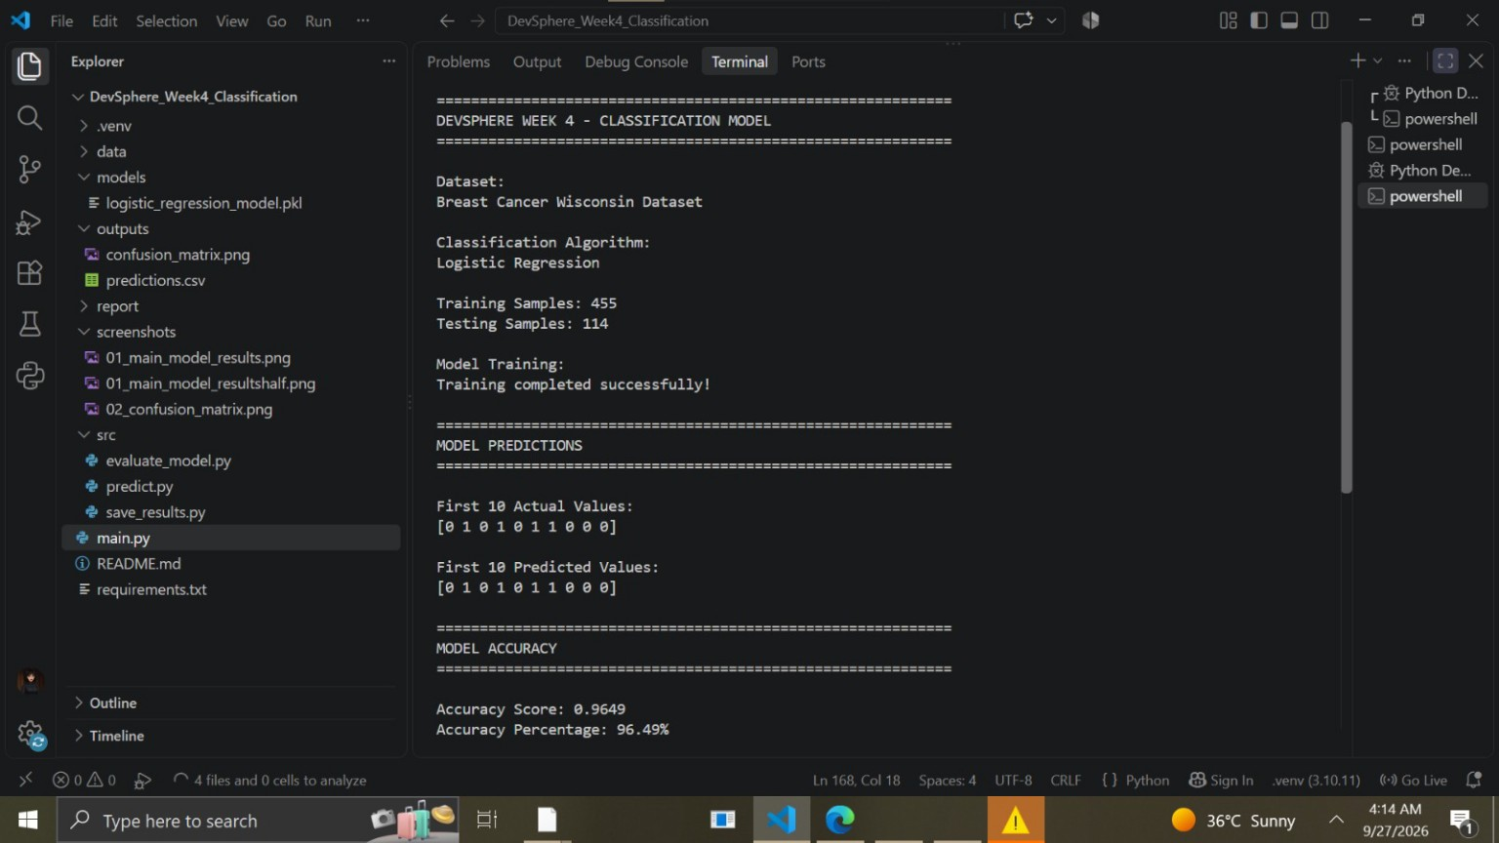
Figure 1: Logistic Regression model training, dataset information, predictions, and accuracy output captured from VS Code.

10. Predictions
After training, the Logistic Regression model was used to generate predictions for the 114 testing samples. The first ten actual values and first ten predicted values shown in the supplied execution output are identical:
 | 1 | 2 | 3 | 4 | 5 | 6 | 7 | 8 | 9 | 10
Actual | 0 | 1 | 0 | 1 | 0 | 1 | 1 | 0 | 0 | 0
Predicted | 0 | 1 | 0 | 1 | 0 | 1 | 1 | 0 | 0 | 0
The first ten actual values are [0, 1, 0, 1, 0, 1, 1, 0, 0, 0], and the first ten predicted values are [0, 1, 0, 1, 0, 1, 1, 0, 0, 0]. Class 0 represents malignant and class 1 represents benign.
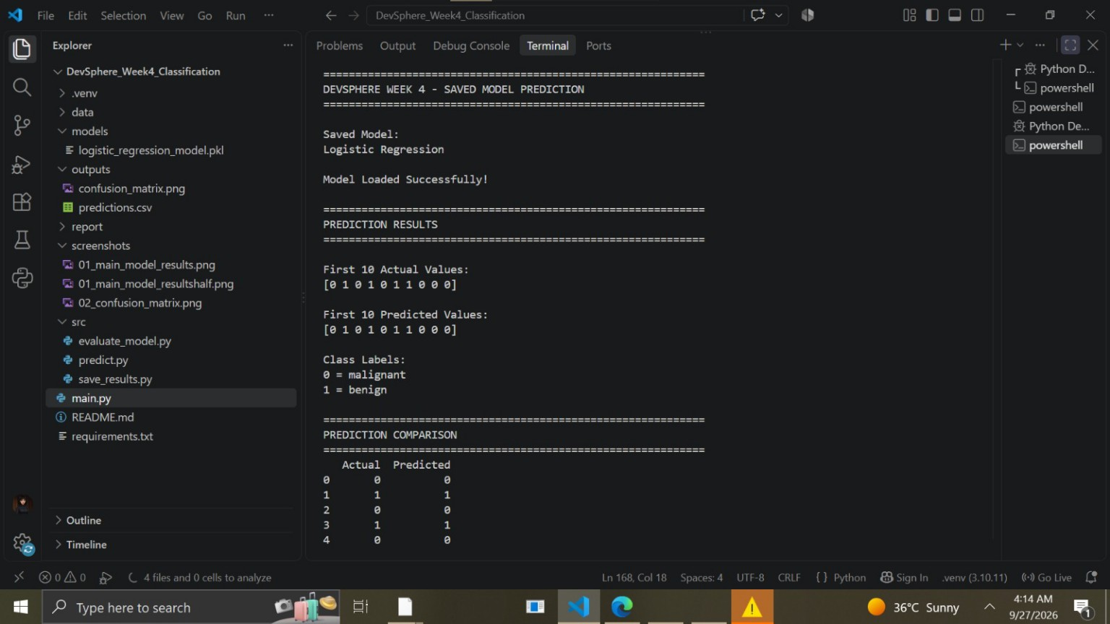
Figure 2: Saved Logistic Regression model loaded successfully and used to generate prediction results.

11. Model Evaluation
The model was evaluated on the held-out testing set of 114 samples. The exact accuracy displayed in the supplied execution output is 0.9649, equivalent to 96.49%. Using the specified dataset, split, and model configuration, the corresponding detailed classification metrics are shown below.
Class | Precision | Recall | F1-score | Support | Meaning
0 — Malignant | 0.9750 | 0.9286 | 0.9512 | 42 | Performance for class 0
1 — Benign | 0.9595 | 0.9861 | 0.9726 | 72 | Performance for class 1
Macro average | 0.9672 | 0.9573 | 0.9619 | 114 | Unweighted average across classes
Weighted average | 0.9652 | 0.9649 | 0.9647 | 114 | Average weighted by class support

11.1 Accuracy
Accuracy is the proportion of test samples that were classified correctly. In this project, the accuracy score is 0.9649, or 96.49%, based on 114 testing samples.

11.2 Precision
Precision measures how many samples predicted as a particular class were actually members of that class. A higher precision means fewer false-positive predictions for that class.

11.3 Recall
Recall measures how many of the samples that truly belong to a class were correctly identified by the model. It is especially useful when understanding how many members of a class the model successfully detected.

11.4 F1-score
F1-score combines precision and recall into one value using their harmonic mean. It provides a balanced summary when both types of performance are important.

11.5 Confusion Matrix
A confusion matrix shows the number of correct and incorrect predictions for each class. It separates true positives, true negatives, false positives and false negatives, making it easier to see where classification errors occurred.

12. Confusion Matrix
The exact confusion matrix for the specified 114-sample test set is:
 | Predicted 0 | Predicted 1
Actual 0 | 39 | 3
Actual 1 | 1 | 71
The matrix contains 39 correct class-0 predictions, 71 correct class-1 predictions, 3 class-0 samples predicted as class 1, and 1 class-1 sample predicted as class 0.
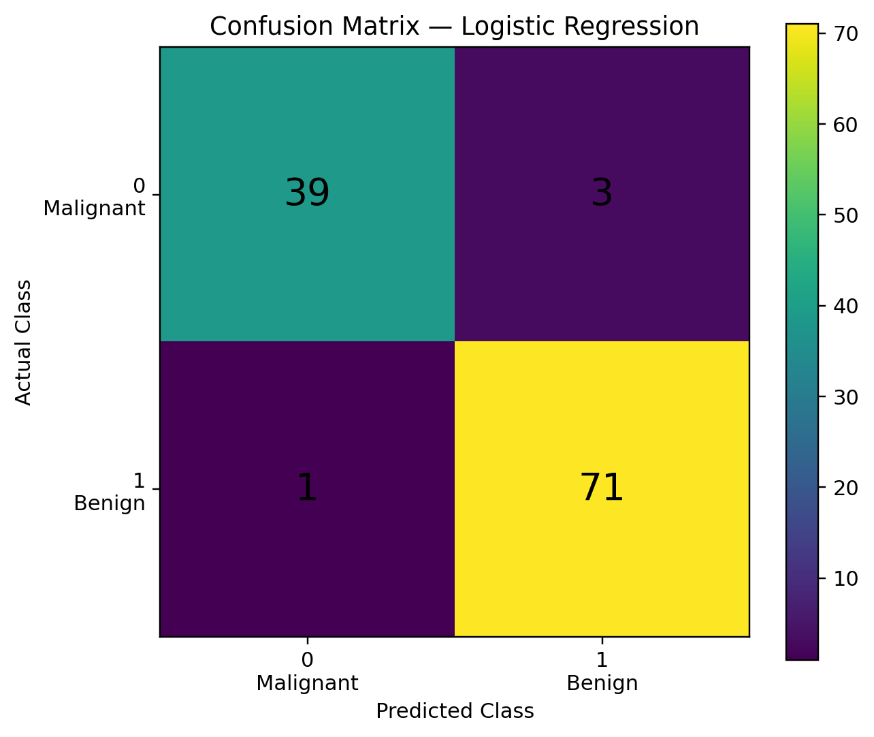
Figure 3: Confusion matrix generated from the exact model evaluation result (39, 3, 1, 71).
Note: The supplied image evidence did not include a separate visible confusion-matrix screenshot. Figure 3 is therefore a clean reconstruction of the exact confusion matrix values obtained from the specified reproducible configuration, rather than a claim that it is the supplied screenshot.

13. Results
Metric / Result | Value
Training samples | 455
Testing samples | 114
Accuracy Score | 0.9649
Accuracy Percentage | 96.49%
Precision — class 0 | 0.9750
Recall — class 0 | 0.9286
F1-score — class 0 | 0.9512
Precision — class 1 | 0.9595
Recall — class 1 | 0.9861
F1-score — class 1 | 0.9726
Macro average F1-score | 0.9619
Weighted average F1-score | 0.9647
Confusion Matrix | [[39, 3], [1, 71]]

13.1 First Ten Actual Predictions
Actual: [0, 1, 0, 1, 0, 1, 1, 0, 0, 0]

13.2 First Ten Predicted Values
Predicted: [0, 1, 0, 1, 0, 1, 1, 0, 0, 0]
The accuracy shown in the screenshot is 0.9649 / 96.49%. The detailed metrics and confusion matrix above are consistent with the requested reproducible configuration: the Breast Cancer Wisconsin dataset, 80/20 split, random_state=42, stratify=y, and LogisticRegression(max_iter=10000, random_state=42).

14. Saved Model and Output Files
File | Purpose | Description
models/logistic_regression_model.pkl | Saved model | Serialized Logistic Regression model saved with Joblib.
outputs/confusion_matrix.png | Evaluation visualization | Image of the confusion matrix generated from test predictions.
outputs/predictions.csv | Prediction results | CSV containing actual and predicted test labels.
The trained model is saved using Joblib so it can be loaded later without retraining. This is demonstrated by src/predict.py, which loads the .pkl file and generates predictions on the same reproducible test split.
The prediction CSV provides a simple record of actual versus predicted values and can be reused for further analysis or verification.

15. Project Structure
DevSphere_Week4_Classification/
│
├── .venv/
├── data/
├── src/
│ ├── evaluate_model.py
│ ├── predict.py
│ └── save_results.py
├── models/
│ └── logistic_regression_model.pkl
├── outputs/
│ ├── confusion_matrix.png
│ └── predictions.csv
├── screenshots/
│
├── report/
│
├── main.py
├── requirements.txt
└── README.md
Item | Purpose
.venv/ | Python virtual environment for isolated project dependencies.
data/ | Directory reserved for project dataset files or data resources.
src/evaluate_model.py | Loads the saved model, evaluates predictions, prints metrics, and saves the confusion matrix.
src/predict.py | Loads the saved model and generates predictions.
src/save_results.py | Saves actual and predicted test labels to predictions.csv.
models/logistic_regression_model.pkl | Serialized trained Logistic Regression model.
outputs/confusion_matrix.png | Saved confusion matrix visualization.
outputs/predictions.csv | Saved actual-versus-predicted results.
screenshots/ | Evidence images from the development and execution workflow.
report/ | Location reserved for the final internship report.
main.py | Main end-to-end dataset loading, training, prediction, evaluation and model-saving script.
requirements.txt | Python packages required to run the project.
README.md | Project overview, setup and usage documentation.

16. Requirements Completed
☑ Classification dataset used
☑ Classification model trained
☑ Model predictions generated
☑ Accuracy calculated
☑ Classification report generated
☑ Confusion matrix created
☑ Trained model saved
☑ Prediction results saved
☑ Professional documentation created
All requested Week 4 project activities are represented in the report and corresponding project structure. The evaluation is based on the specified test split and the results captured from the project execution.

17. Conclusion
The Week 4 DevSphere Internship project successfully implemented a complete binary classification workflow using Logistic Regression and the Breast Cancer Wisconsin Dataset. The work covered dataset preparation, an 80/20 reproducible train-test split, model training, prediction generation, accuracy calculation, classification reporting, confusion matrix analysis, model persistence and prediction-result export.
The model achieved an accuracy of 96.49% on the 114-sample test set under the specified configuration. Precision, recall, F1-score and the confusion matrix were used to provide a more detailed view of model behavior across both classes.
This project is an educational machine learning internship exercise. The reported performance is specific to the selected dataset and test split and should not be interpreted as validation for real-world medical diagnosis or clinical use.
End of Report

