DEVSPHERE INTERNSHIP – WEEK 5
Model Evaluation + Tuning
Breast Cancer Classification – Model Comparison and Hyperparameter Optimization

Prepared by: Ayesha Farooq
Machine Learning Internship
Week 5 Task

1. Objective
The objective of this Week 5 task was to optimize a machine learning classification model by training multiple models, comparing their performance using evaluation metrics, applying hyperparameter tuning, and presenting the results through charts and an evaluation report.

2. Dataset
The Breast Cancer Wisconsin dataset available through scikit-learn was used. No external Kaggle download was required because the dataset is included directly in the scikit-learn library.
- Samples: 569
- Features: 30 numerical features
- Target: Binary classification
- Training samples: 455
- Testing samples: 114
- Test split: 20%

3. Libraries and Tools
- Python – implementation language
- NumPy – numerical operations
- Pandas – data handling and result tables
- Scikit-learn – machine learning, preprocessing, model selection and evaluation
- Matplotlib – visualization
- Seaborn – confusion matrix visualization
- Joblib – saving the optimized machine learning model
- VS Code – development environment

4. Models Trained
Three classification algorithms were trained and compared:
- Logistic Regression
- Random Forest
- Support Vector Machine (SVM)

5. Evaluation Metrics
The models were evaluated using accuracy, precision, recall, F1 score, and ROC-AUC. F1 score was used as the main criterion for selecting the model for tuning because it balances precision and recall.

6. Model Comparison Results
Model | Accuracy | Precision | Recall | F1 Score | ROC-AUC
Logistic Regression | 0.9825 | 0.9861 | 0.9861 | 0.9861 | 0.9954
Random Forest | 0.9561 | 0.9589 | 0.9722 | 0.9655 | 0.9931
SVM | 0.9825 | 0.9861 | 0.9861 | 0.9861 | 0.9950
Logistic Regression and SVM achieved the highest F1 score of 0.9861. Logistic Regression was selected for tuning based on the model-selection process.

7. Model Training Output
The terminal output below shows the dataset split and the evaluation results for all three models.
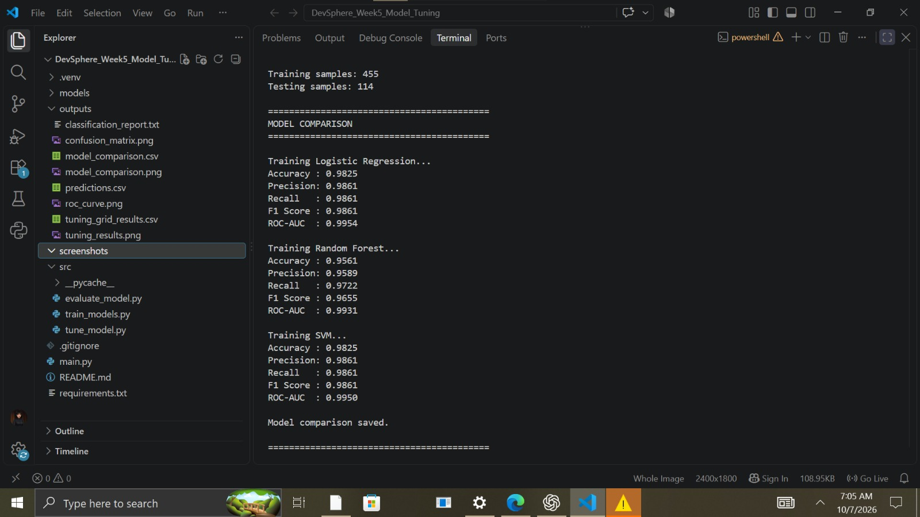
Figure 1. Model comparison results shown in the VS Code terminal.

8. Model Comparison Visualization
The comparison chart provides a visual comparison of accuracy, precision, recall, F1 score, and ROC-AUC across the three trained models.
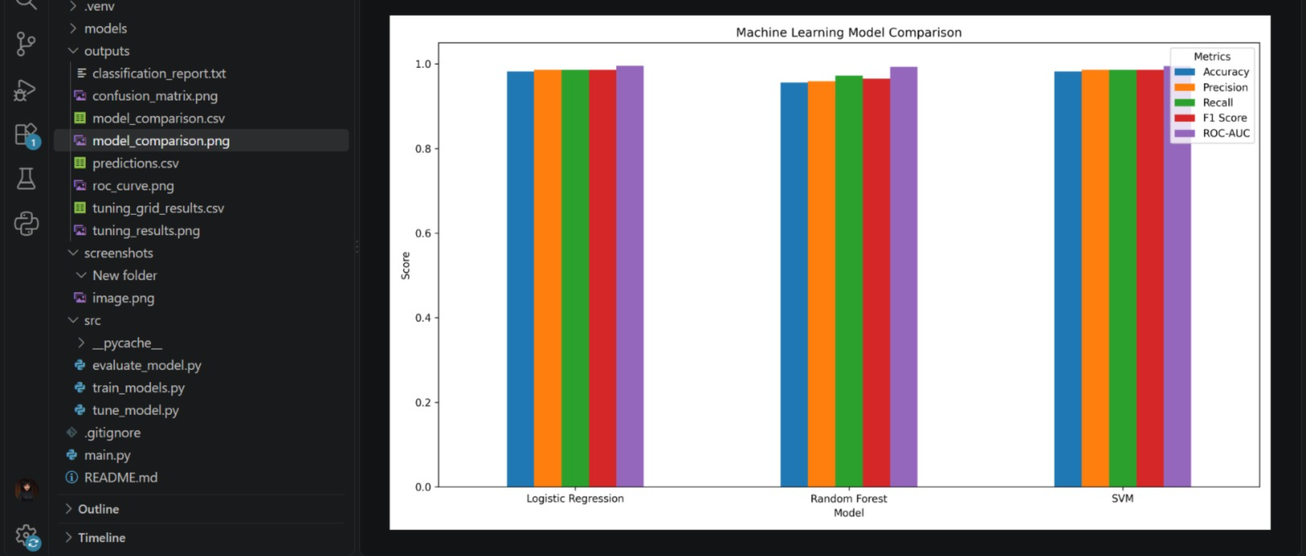
Figure 2. Performance comparison of Logistic Regression, Random Forest, and SVM.

9. Hyperparameter Tuning
GridSearchCV with 5-fold cross-validation was applied to the selected Logistic Regression model. The search evaluated different values of the regularization parameter C and solver options.
- Tuning method: GridSearchCV
- Cross-validation: 5-fold
- Scoring metric: F1 score
- Best C: 0.1
- Best solver: lbfgs
- Best cross-validation F1 score: 0.9845
The optimized model was saved as models/optimized_model.pkl for reuse.

10. Optimized Model Evaluation
Metric | Optimized Logistic Regression
Accuracy | 0.9737
Precision | 0.9726
Recall | 0.9861
F1 Score | 0.9793
ROC-AUC | 0.9957
The final optimized model achieved an F1 score of 0.9793 and ROC-AUC of 0.9957 on the held-out test set. The tuned model therefore provides strong classification performance while using hyperparameters selected through cross-validation.

11. Confusion Matrix
The confusion matrix shows the actual and predicted classes of the evaluated Logistic Regression model. The matrix contains 40 correctly classified malignant cases, 71 correctly classified benign cases, 2 malignant cases predicted as benign, and 1 benign case predicted as malignant.
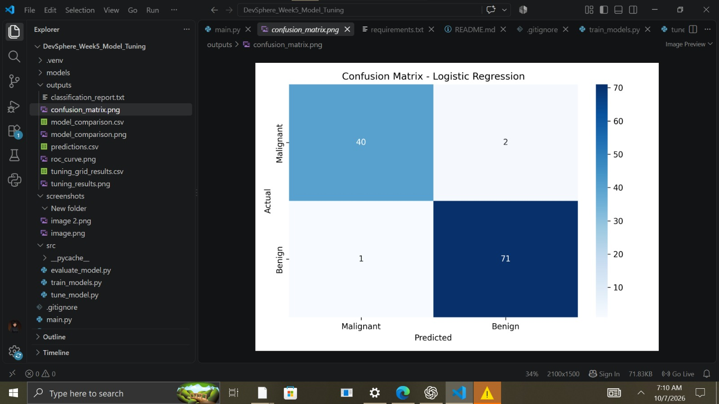
Figure 3. Confusion matrix for Logistic Regression.

12. Additional Visualizations
The project also generated a ROC curve and a hyperparameter tuning results chart. The ROC-AUC value of 0.9957 for the optimized model indicates excellent separation between the two classes. The tuning chart summarizes the highest-performing parameter combinations identified during GridSearchCV.
- outputs/roc_curve.png – ROC curve for the optimized model
- outputs/tuning_results.png – top hyperparameter tuning results

13. Project Outputs
- models/optimized_model.pkl – saved optimized model
- outputs/model_comparison.csv – model comparison metrics
- outputs/predictions.csv – test predictions and probabilities
- outputs/tuning_grid_results.csv – GridSearchCV results
- outputs/classification_report.txt – detailed classification report
- outputs/model_comparison.png – model comparison chart
- outputs/confusion_matrix.png – confusion matrix
- outputs/roc_curve.png – ROC curve
- outputs/tuning_results.png – tuning visualization

14. Conclusion
This Week 5 task successfully demonstrated model evaluation and tuning. Three machine learning classification models were trained and compared using multiple evaluation metrics. Logistic Regression was selected for further optimization based on F1 score. GridSearchCV with 5-fold cross-validation identified C=0.1 and the lbfgs solver as the best parameters. The optimized model achieved strong performance on the held-out test set, including an ROC-AUC of 0.9957. The project also generated evaluation charts, predictions, tuning results, and a reusable serialized model.

15. Internship Requirements Checklist
Requirement | Completed
Train multiple models | Yes – 3 models
Compare performance | Yes
Apply model tuning | Yes – GridSearchCV
Use evaluation metrics | Yes
Show graphs/charts | Yes
Optimized ML model | Yes
Evaluation report | Yes

