Lab-04


Session 2025 - 2029

Submitted by:
Ayesha Fatima 2025-CS-341

Submitted to:
Sir Ashir

Course:
Data Structures and Algorithms

Department of Computer Science
University of Engineering and Technology Lahore Pakistan
Lab-04
Part 1: Data Plot using Graphs: 2
Task-1: 3
Task-2: 3
Task-3: 4
Task-4: 4
Part 2: Differentiating the Disease Category: 5
Task-1: Load data using pandas 5
Task-2: Draw scattered graph between each symptom and the label. Discuss how each symptom is dependent on the label. 5
Task-3,4: Calculating the distance of each entry in test data with main data file and assigning the distance to labels 7
Task-5 : Analyzing the time complexity: 8
Task-6: Splitting the main data in two parts 8
Task-7: Increase the percentage of ratio of correctly classified instances. 10
Task-8: Recursive algorithm: 10
Task-9: Improvement in Algorithm: 11

Part 1: Data Plot using Graphs:
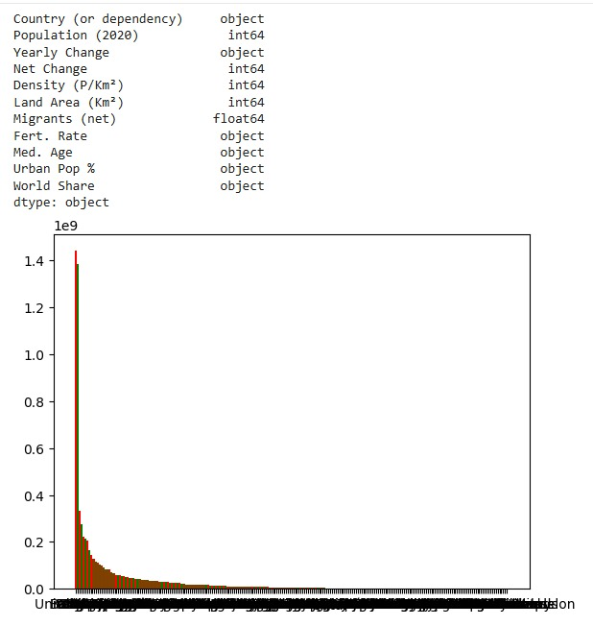

Task-1:
Draw the line chart for the total number of steps on daily basis.
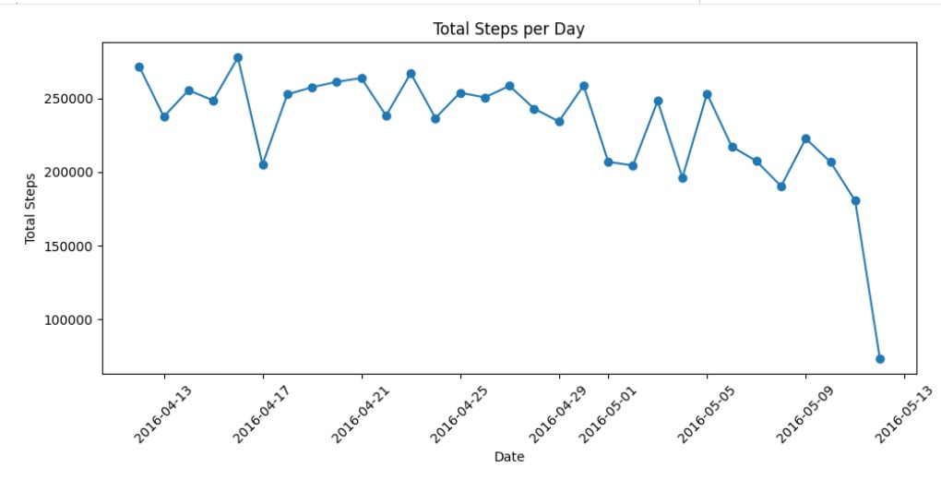

Task-2:
Draw the bar chart for the daily distance covered.
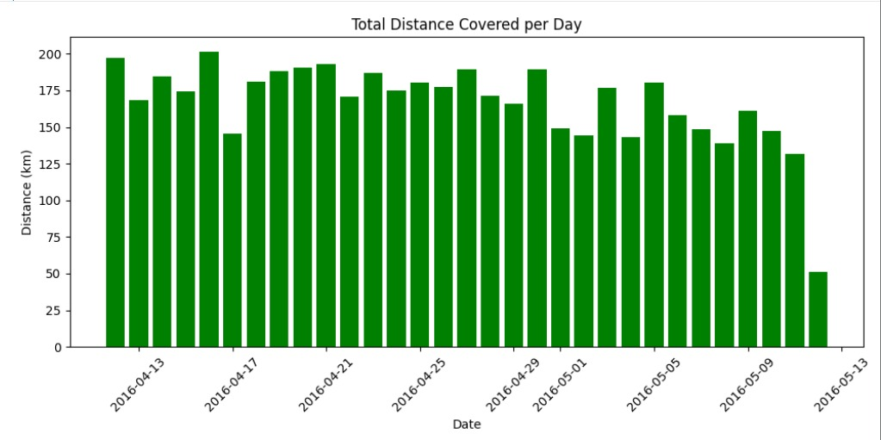

Task-3:
Draw the scatter chart for the total time in the bed.
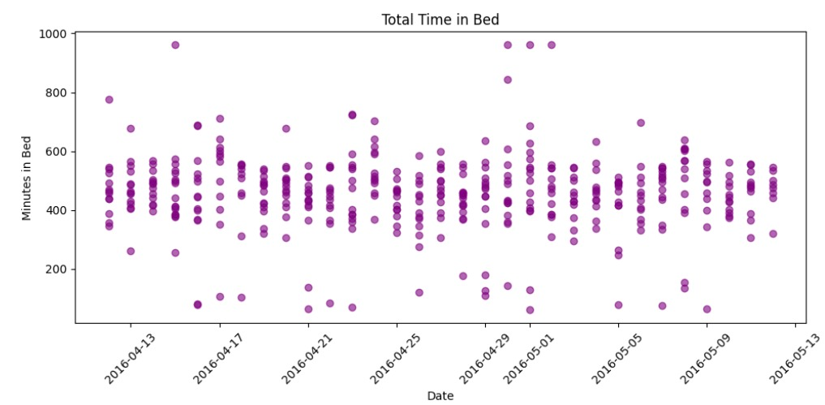

Task-4:
Draw the Pie chart for the hourly steps on the 12th April 2016.
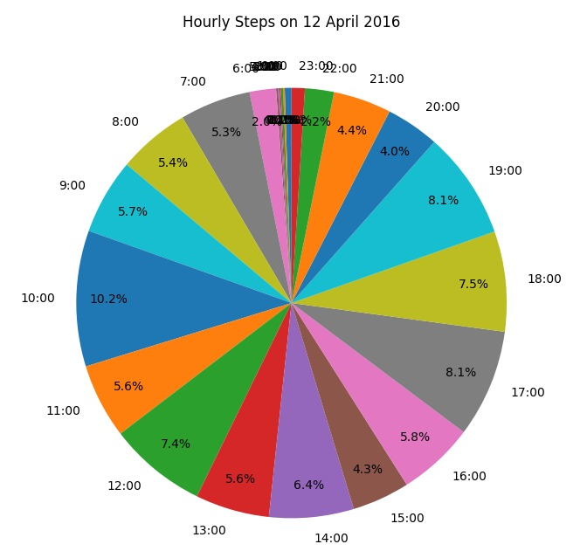

Part 2: Differentiating the Disease Category:

Task-1: Load data using pandas
In lab-04 folder we run this command after downloading the 2 files
python -c "import pandas as pd; a=pd.read_csv('Train.csv'); b=pd.read_csv('Test.csv'); print(a.shape, b.shape); print(list(a.columns)); print(a.head(3)); print(a.iloc[:,-1].unique()); print(list(b.columns)[-3:])"

Output:
['COUGH', 'MUSCLE_ACHES', 'TIREDNESS', 'SORE_THROAT', 'RUNNY_NOSE', 'STUFFY_NOSE', 'FEVER', 'NAUSEA', 'VOMITING', 'DIARRHEA', 'SHORTNESS_OF_BREATH', 'DIFFICULTY_BREATHING', 'LOSS_OF_TASTE', 'LOSS_OF_SMELL', 'ITCHY_NOSE', 'ITCHY_EYES', 'ITCHY_MOUTH', 'ITCHY_INNER_EAR', 'SNEEZING', 'PINK_EYE', 'TYPE']
COUGH MUSCLE_ACHES TIREDNESS SORE_THROAT RUNNY_NOSE ... ITCHY_MOUTH ITCHY_INNER_EAR SNEEZING PINK_EYE TYPE
0 0 0 1 0 1 ... 0 1 0 1 ALLERGY
1 0 0 1 0 0 ... 1 1 1 1 ALLERGY
2 0 1 1 1 0 ... 0 0 0 1 ALLERGY
[3 rows x 21 columns]
<StringArray>
['ALLERGY', 'COLD', 'COVID', 'FLU']
Length: 4, dtype: str
['ITCHY_INNER_EAR', 'SNEEZING', 'PINK_EYE']

Task-2: Draw scattered graph between each symptom and the label. Discuss how each symptom is dependent on the label.
Wrote a function in Part2.py and here is the output
The table shows the percentage of cases in each disease where a symptom is present. A value of 0% means the disease never shows that symptom. A value near 50% means the symptom appears randomly, so it does not help separate that disease from the others. The label is decided by combinations of symptoms. The symptoms with 0% in some classes are the most useful for classification, and the ones near 50% everywhere are the least useful.
Output:
TYPE ALLERGY COLD COVID FLU
COUGH 50.0 50.0 50.0 53.7
MUSCLE_ACHES 50.0 50.0 50.0 53.5
TIREDNESS 50.0 50.0 50.0 53.5
SORE_THROAT 50.0 50.0 50.0 53.4
RUNNY_NOSE 50.0 50.0 0.0 53.4
STUFFY_NOSE 50.0 50.0 0.0 53.4
FEVER 0.0 50.0 50.0 51.7
NAUSEA 0.0 0.0 50.0 53.6
VOMITING 0.0 0.0 50.0 53.6
DIARRHEA 0.0 0.0 50.0 53.4
SHORTNESS_OF_BREATH 0.0 0.0 50.0 53.5
DIFFICULTY_BREATHING 0.0 0.0 50.0 53.6
LOSS_OF_TASTE 50.0 50.0 0.0 40.4
LOSS_OF_SMELL 50.0 50.0 0.0 40.4
ITCHY_NOSE 50.0 0.0 0.0 0.0
ITCHY_EYES 50.0 0.0 0.0 0.0
ITCHY_MOUTH 50.0 0.0 0.0 0.0
ITCHY_INNER_EAR 50.0 0.0 0.0 0.0
SNEEZING 50.0 50.0 50.0 53.4
PINK_EYE 50.0 0.0 0.0 0.0
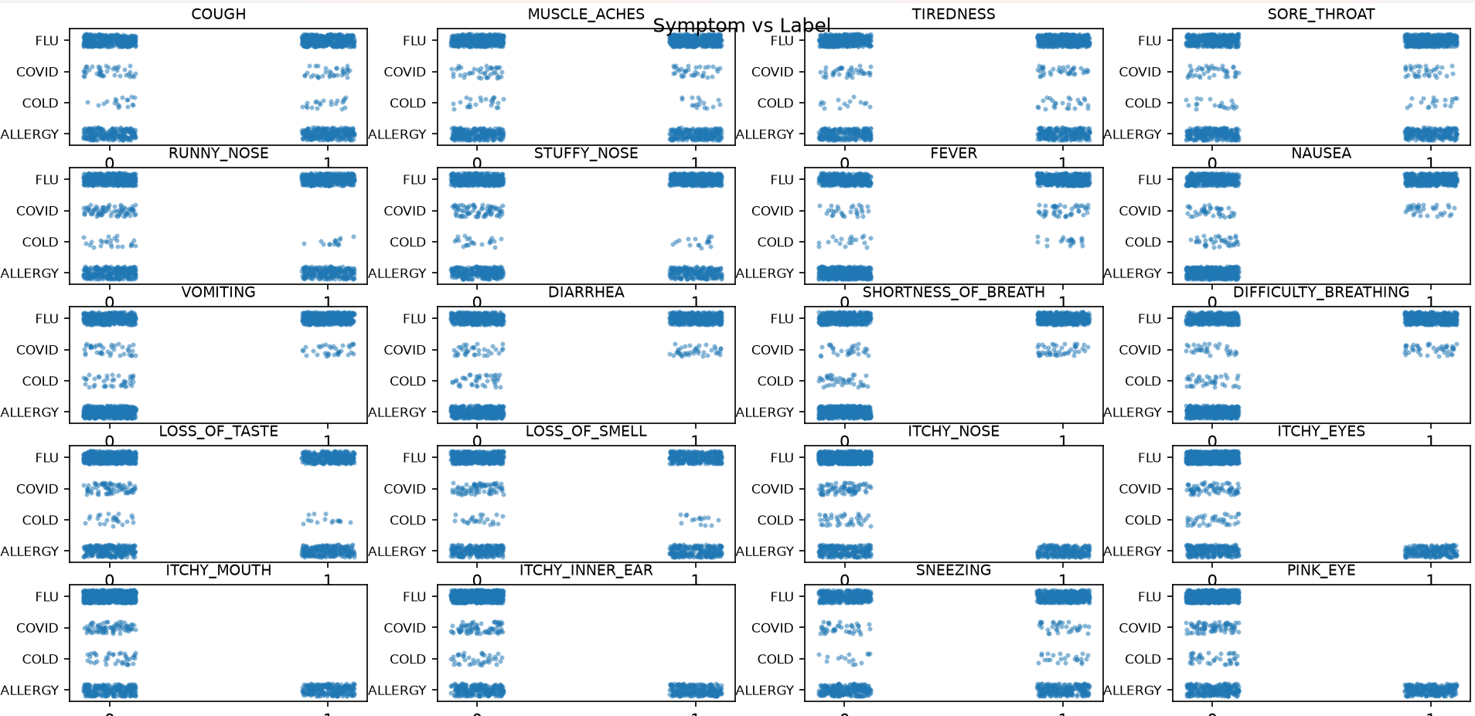

Task-3,4: Calculating the distance of each entry in test data with main data file and assigning the distance to labels
euclidean_distance(x, y):Formula to find the distance between 2 entries manually
classify_entry(entry): For the test entry, the distance is calculated from every training row using loops (so that the complexity can be analyzed), and the label of the row with the smallest distance is returned.
classify_test():Assigns all the 19 values a label and then prints it.
Output:
TYPE
0 FLU
1 FLU
2 FLU
3 FLU
4 FLU
5 FLU
6 FLU
7 FLU
8 FLU
9 FLU
10 FLU
11 FLU
12 FLU
13 FLU
14 COVID
15 FLU
16 FLU
17 FLU
18 FLU

Task-5 : Analyzing the time complexity:
Let n = number of rows in the main (Train) data (44,453), m = number of test entries (19), and d = number of symptoms (20).
euclidean_distance(x, y) runs one loop over the d symptoms, so it takes O(d).
classify_entry(entry) first converts the data to lists, which takes O(n·d). It then loops over all n rows and calls euclidean_distance for each, which is n × O(d) = O(n·d). Total: O(n·d) per test entry.
classify_test() calls classify_entry for each of the m test entries, so the total is O(m·n·d).
Since d is a fixed constant (20), the time complexity is O(m·n). In numbers, this is about 19 × 44,453 × 20 ≈ 16.9 million basic operations.
Space complexity: O(n·d), because each call creates a list copy of the training data.
The algorithm compares every test entry with every training row (brute force), so it gets slower linearly as the data grows. The repeated conversion of the data to a list inside each call is wasted work and can be improved.

Task-6: Splitting the main data in two parts
Part1: Contain the data with no change
Output:
TYPE
0 FLU
1 FLU
2 FLU
3 FLU
4 FLU
5 FLU
6 FLU
7 FLU
8 FLU
9 FLU
10 FLU
11 FLU
12 FLU
13 FLU
14 COVID
15 FLU
16 FLU
17 FLU
18 FLU
Part1: (43953, 21) Part2: (500, 20)
Part 2: contains the data without label.
Output:
Part2: (500, 20)
COUGH MUSCLE_ACHES TIREDNESS SORE_THROAT ... ITCHY_MOUTH ITCHY_INNER_EAR SNEEZING PINK_EYE
20482 1 1 1 0 ... 0 0 1 0
41460 1 0 1 0 ... 0 0 1 0
42984 0 1 1 1 ... 0 0 0 0
20258 0 1 1 0 ... 0 0 1 0
29117 1 0 1 1 ... 0 0 0 0
13625 1 1 0 0 ... 0 1 1 0
7094 0 0 1 0 ... 1 1 1 0
33442 1 0 0 1 ... 0 0 1 0
31001 0 0 1 0 ... 0 0 0 0
4157 1 1 0 0 ... 1 1 0 1
[10 rows x 20 columns]
Accuracy: 71.20%
Time taken: 36.1 seconds

Task-7: Increase the percentage of ratio of correctly classified instances.
Part 1 (43,953 rows with labels) was used as the reference data, and Part 2 (500 rows, labels removed) was classified by assigning each entry the label of its closest Part 1 entry (Euclidean distance). The predicted labels were compared with the original labels. Accuracy = 71.20% (correctly classified / total × 100).
Yes it can be increased by:
- Use k nearest neighbours (k > 1) with majority voting instead of only the single closest entry. This reduces the effect of noisy or unusual rows.
- Use more reference data (a larger Part 1 relative to Part 2), so more symptom combinations are covered.
- Give more weight to important symptoms. From the dependence table, symptoms such as ITCHY_*, PINK_EYE, NAUSEA and VOMITING separate the classes strongly, while COUGH and SNEEZING (about 50% everywhere) carry little information.
- Break ties better. Currently the first closest row wins. Choosing the most common label among tied rows is more reliable.
The accuracy cannot reach 100% because different diseases share overlapping symptom patterns (for example, FLU overlaps with the other three), so identical symptom combinations can appear under different labels.

Task-8: Recursive algorithm:
The recursive algorithm uses divide and conquer. The function recursive_nearest(entry, X, labels, lo, hi) works on the rows from lo to hi:
- Base case: if only one row is left, return its distance to the test entry and its label.
- Recursive case: split the rows into two halves, find the nearest row in each half recursively, and return the closer one. On a tie, the left one is kept, as in the iterative version.
The label of the closest row is assigned to the test entry.
Complexity analysis. Let n = number of rows, d = number of symptoms (20), m = number of test entries.
- Recurrence: T(n) = 2T(n/2) + O(d) for n > 1, and T(1) = O(d).
- Every row is visited exactly once, and there are n − 1 merge steps, so T(n) = O(n·d) per test entry.
- For m test entries: O(m·n·d), the same as the iterative version.
- Space: the recursion depth is log₂(n) ≈ 16 for n = 43,953, so the stack uses O(log n). The list copy of the data is O(n·d).
A simple one-row-at-a-time recursion would be as slow and would need depth n, which exceeds Python's recursion limit (1000), so the halving approach is used.
Output: Recursive matches iterative on test data: True

Task-9: Improvement in Algorithm:
Efficient algorithm accuracy: 71.20%
Efficient algorithm time: 1.114 seconds
Previous algorithm: 71.20% in 36.3 seconds
(n = rows, u = unique patterns, d = 20, m = test entries)
Previous algorithm: distance for one pair is O(d). Per test entry it takes O(n·d). Total time is O(m·n·d). Extra space is O(n·d).
Efficient algorithm: distance for one pair is O(1). Per test entry it takes O(1) on an exact match, otherwise O(u). Total time is O(n·d) once to build the index, plus O(m·u). Extra space is O(u).
Results on the same Part 1 / Part 2 split:
Previous algorithm: accuracy 71.20%, time 36.3 seconds.
Efficient algorithm: accuracy 71.20%, time 1.1 seconds.
The accuracy is the same, because ties are resolved the same way (first occurrence wins), but the efficient algorithm is about 33 times faster (36.3 / 1.114 ≈ 32.6).
Improvement 1: Change of data storage: each row of 20 binary symptoms is stored as a single integer (bitmask). Duplicate rows are stored only once in a dictionary (pattern → label of its first occurrence).
Improvement 2:Cheaper distance: since all values are 0 or 1, the squared Euclidean distance equals the Hamming distance, which is the bit count of a XOR b. This is one machine operation instead of a 20-step loop, and it gives the same ranking of closest entries, so the labels are the same.
Improvement 3: Exact-match shortcut: if the test entry's pattern is already in the dictionary, its label is returned in O(1) (distance 0).

