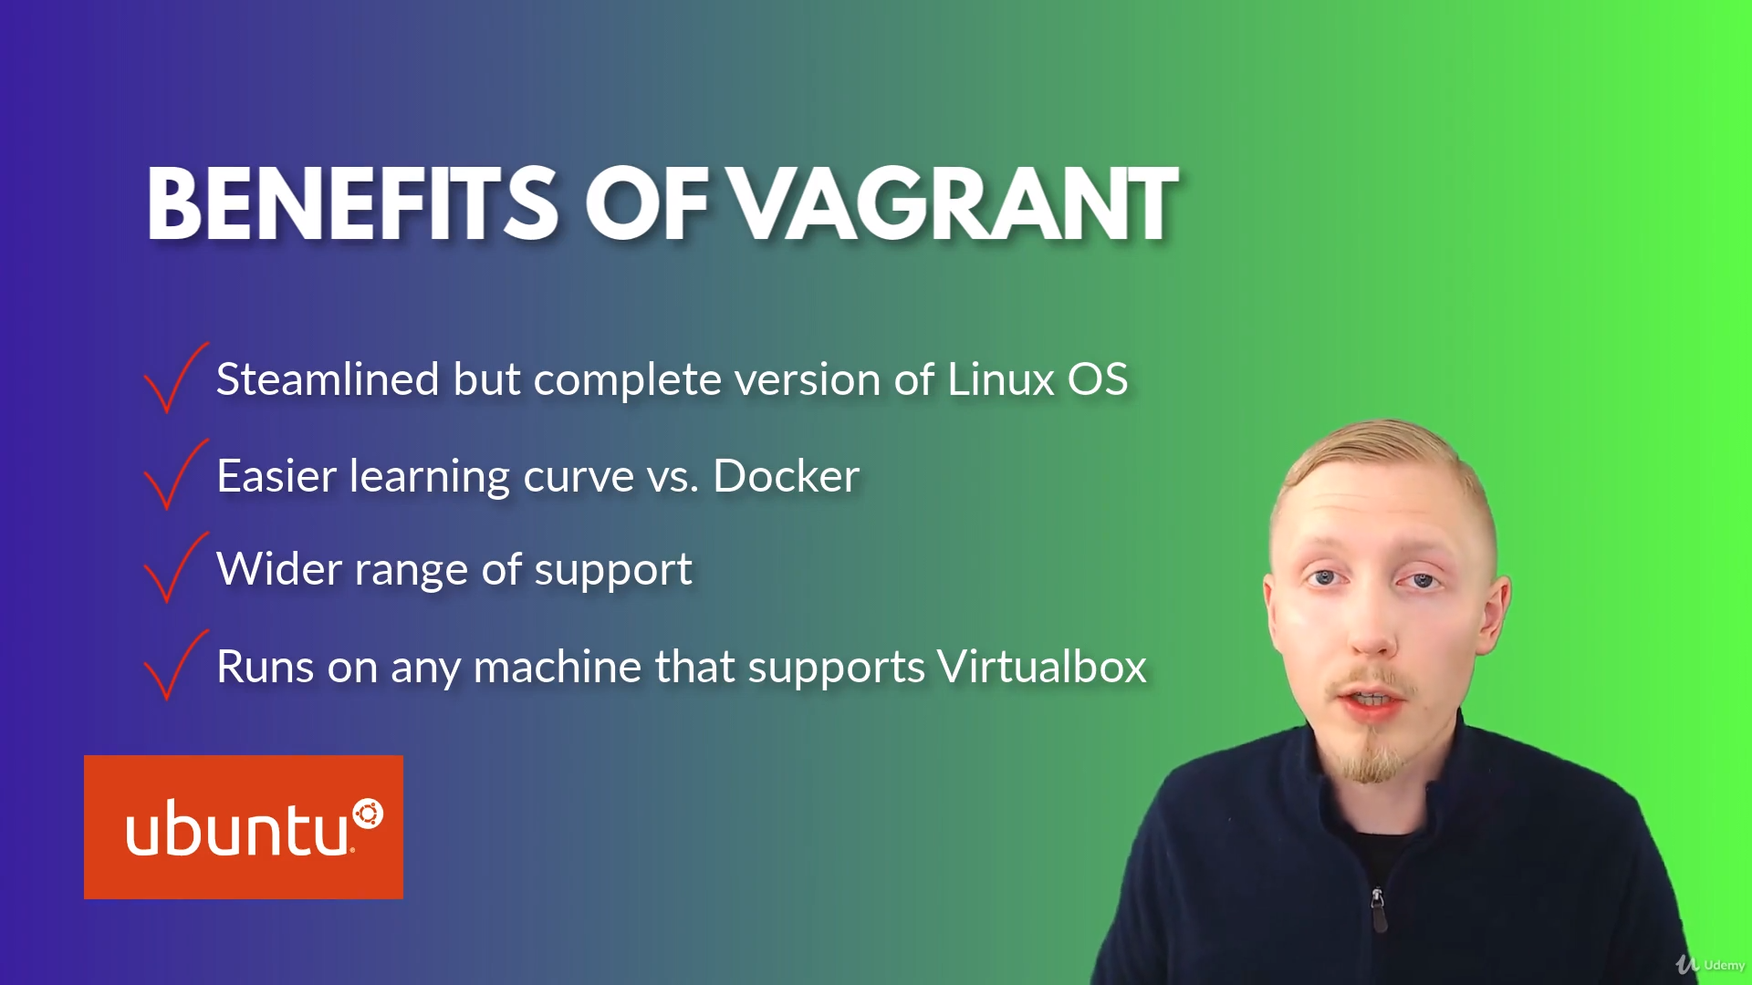

But isn’t designed to run on production – hence easier learning curve

Supports no of hypervisors, hence support wide range of OS.

Vagrant vs Docker:

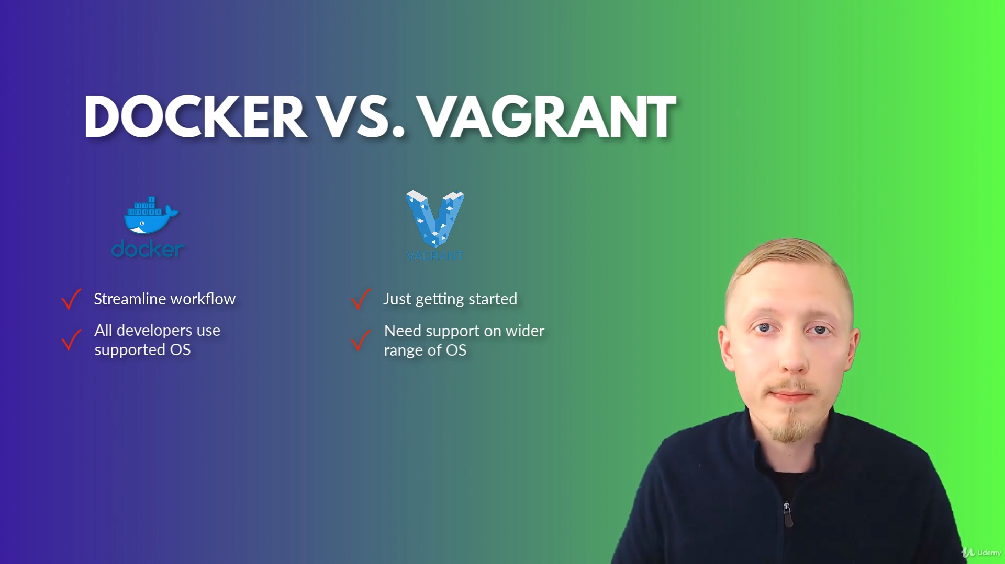

\*streamline workflow from development to production.