**Running a Hello World script:**

Vagrant creates a synchronized directory on our vagrant server that updates itself with all of the files of our local project every time we make changes.

1. Connect to the vagrant server using ‘vagrant ssh’

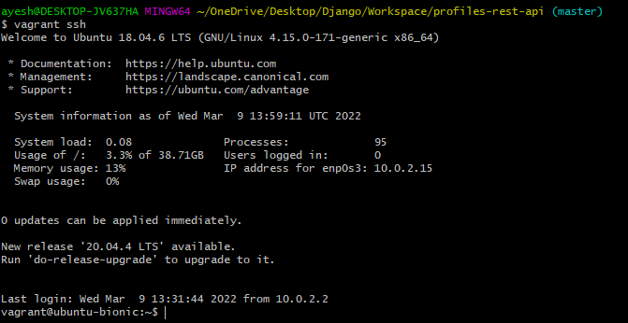

2. Switch to vagrant directory.

cd /vagrant



Everything in our vagrant directory is synchronized with our project folder (Atom)

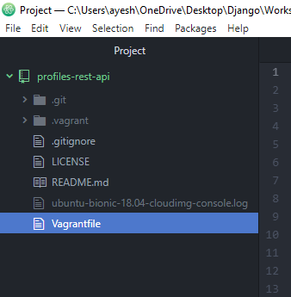

3. Create a new file using vagrant using command ‘touch test.txt’

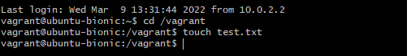

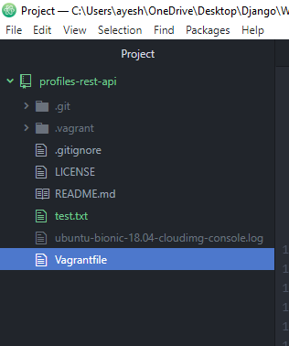

test.txt is created on our local machine. So all of the files are synchronized. (vagrant directory and local machine)

4. Run ‘ls’ command to check

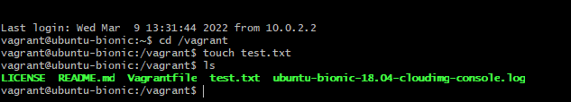

By default hidden files are not shown using ‘ls’ command.

5. Now, delete the ‘test.txt’ file from project folder (in Atom) and run ls command again.

Synchronization works both ways server to host and host to server.

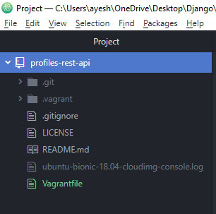

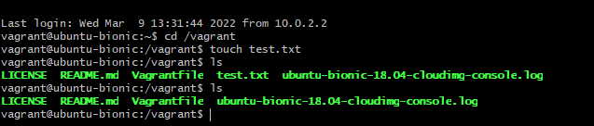

6. Run the hello world script

a. create a new .py file ‘hello_world.py’ and Save it.

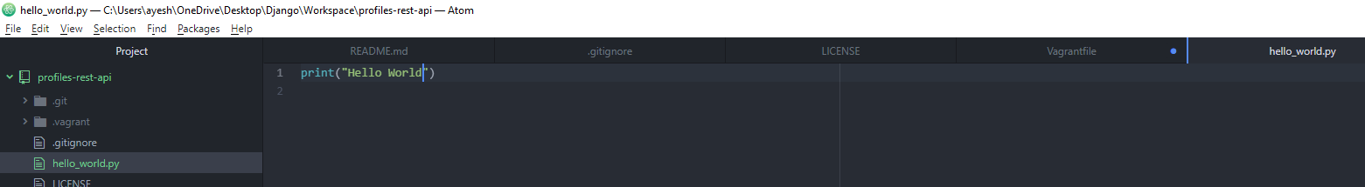

b. run the file.



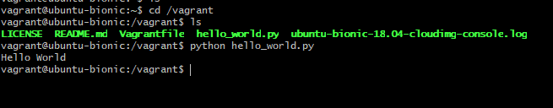

7. Commit and push the changes to git hub

Open a new git bash window and run commands as below.

