**Creating a Vagrant File:**

1. Go to git bash in your project folder ‘profile-rest-api’ and run the below command

vagrant init ubuntu/bionic64

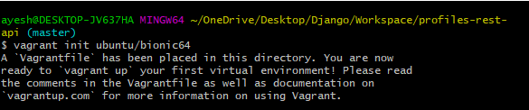

**Configuring our Vagrant Box:**

Customize the vagrant file as per the requirements for our development server.

1. Copy the custom vagrant file from resource link in the course.

2. In Atom, paste the custom vagrant file in the vanilla version of the file.

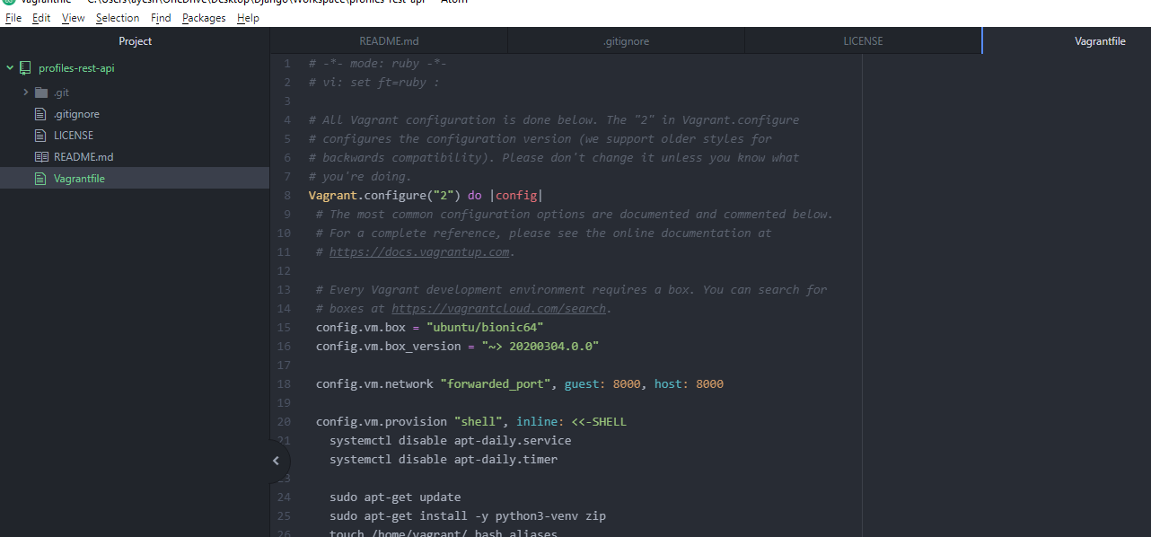

**Running and connecting to our Dev Server:**

Start our vagrant box on our machine.

*We use vagrant using git bash.

1. Start the vagrant server of our project – run command ‘vagrant up’

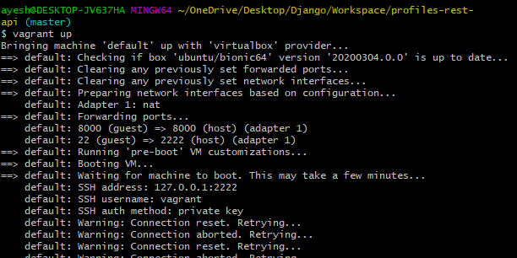

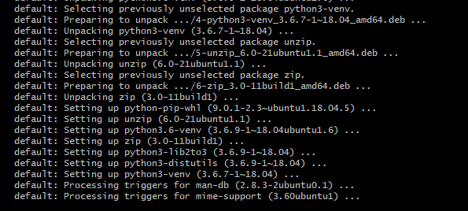

2. Connect to the vagrant server. – run command ‘vagrant ssh’

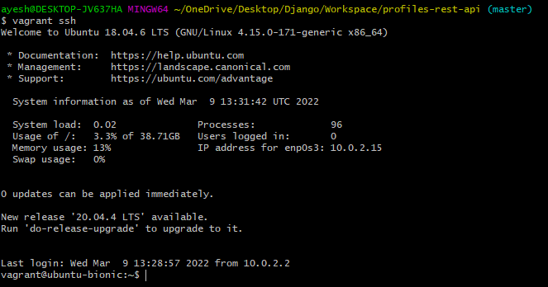

Now we can run our commands in the guest operating system/development server instead of our local machine.

3. To disconnect from the machine, type ‘exit’ command

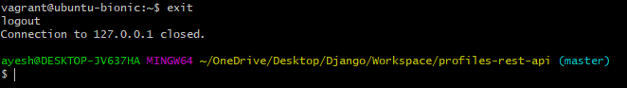

***Errors I got while setting up our vagrant box/server***

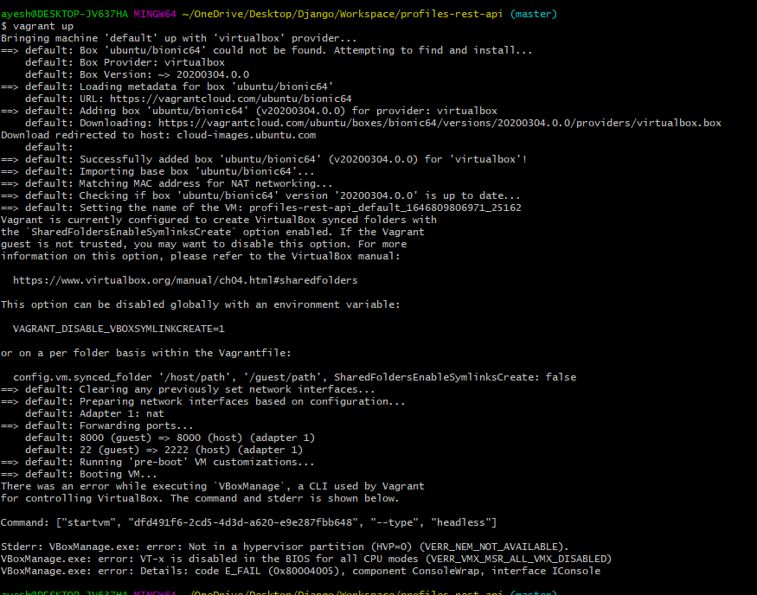

Search in Google with ‘how to enable virtualization in bios on windows 10’ or search with the error message ‘VT-x is disabled in the BIOS…’

Then check for changes based on your computer model (HP in this case)

<https://2nwiki.2n.cz/pages/viewpage.action?pageId=75202968#:~:text=ON%20the%20System.-,Press%20F2%20key%20at%20startup%20BIOS%20Setup.,changes%20and%20Reboot%20into%20Windows>.

Once rebooted, rerun the command.