**Creating Python Virtual Environment on Vagrant Server:**

1. Open git for our project profiles-rest-api directly or using cd command.

2. Connect to the vagrant server using ‘vagrant ssh’

3. Change directory to vagrant using ‘cd /vagrant’

4. Create python virtual environment

Run command ‘python –m venv ~/env’



5. Activate the virtual environment

Run command ‘source ~/env/bin/activate’

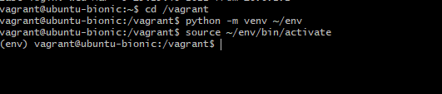

6. Switch Off/ deactivate the virtual environment.

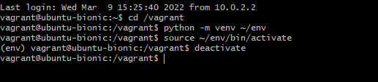

**Install Required Python Packages:**

Best practice is to list all of the required packages in a separate file.

1. Create a file called ‘requirements.txt’ (in Atom)

- Specify all the required python packages and versions we need.

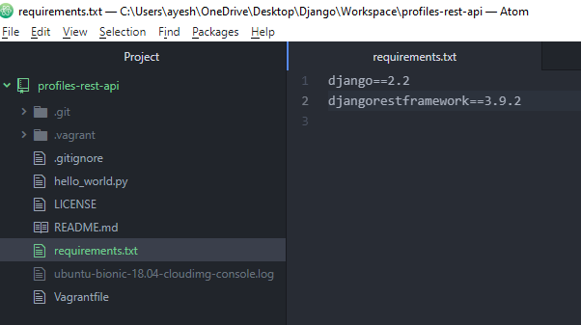

Save

2. Check the following.

a. Connected to vagrant server

‘vagrant up’

b. Use local ssh and access to shell

‘vagrant ssh’

c. Should be in vagrant directory

‘cd /vagrant’

d. Activate virtual environment

‘source ~/env/bin/activate’

3. Run ‘pip install –r requirements.txt’

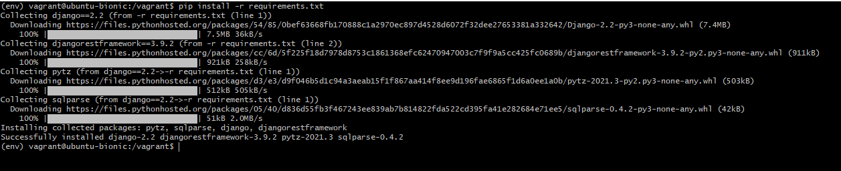

***Initially I was getting error while running command ‘pip install –r requirements.txt’***

Ran ‘pip install --default-timeout=1000 ...’

-this also errored out.

Reran ‘pip install –r requirements.txt’

And it got installed this time.

Similar error:

https://github.com/pypa/pypi-support/issues/175