**Creating Django Project and App:**

1. Make sure of the following.

a. Connected to vagrant server

‘vagrant up’

b. Use local ssh and access to shell

‘vagrant ssh’

c. Should be in vagrant directory

‘cd /vagrant’

d. Activate virtual environment

‘source ~/env/bin/activate’

2. Start/create a Django Project

Run command ‘django-admin.py startproject profiles_project .’



profiles_project – name of the project

. – to create the project folder under main directory/folder

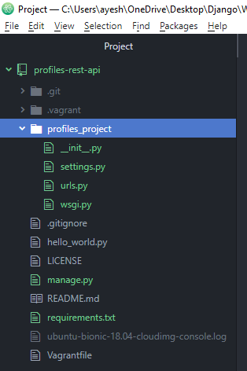

It created the profiles_project folder and manage.py file.

3. Create a Django App within our Project for our profiles api.

Run command ‘python manage.py startapp profiles_api’



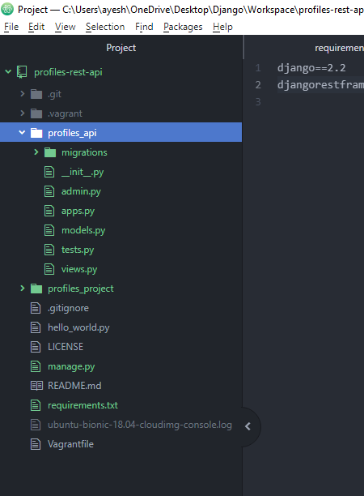

It created profiles_api.

**Enabling our App in Django settings file:**

Enable the App in our Project

1. Under profiles_project open settings.py

Under INSTALLED_APPS add all the apps that are installed either through external dependencies such as ‘requirements.txt’ or by creating other apps such as ‘profiles_api’

