**Test and Commit the changes:**

We will test it using Django Development server.

1. Start Django development server

a. Check the initial setups:

- start vagrant box and connect to it

vagrant up

vagrant ssh

cd /vagrant

- Activate it

source ~/env/bin/activate

b. Run command ‘python manage.py runserver 0.0.0.0:8000’

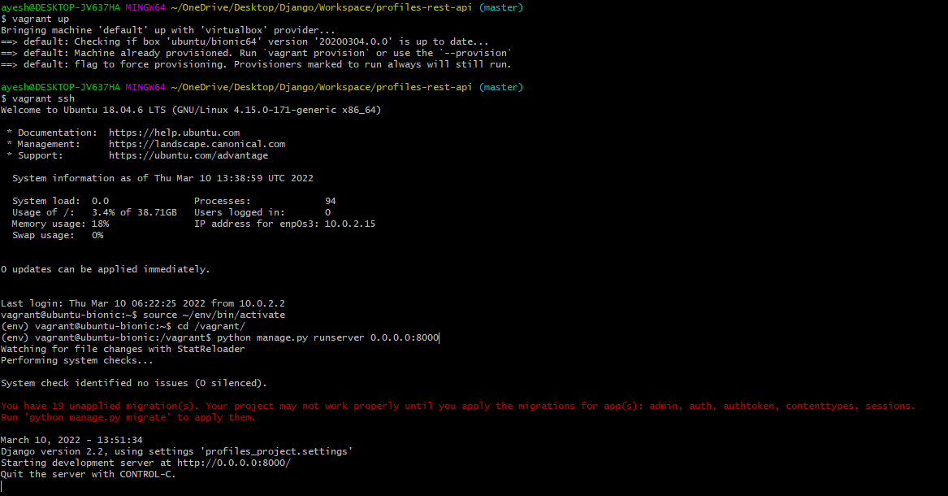

0.0.0.0 – make it available on all network adapters on our dev server

8000 – start it in port 8000

2. In the browser open

127.0.0.1 – local host address

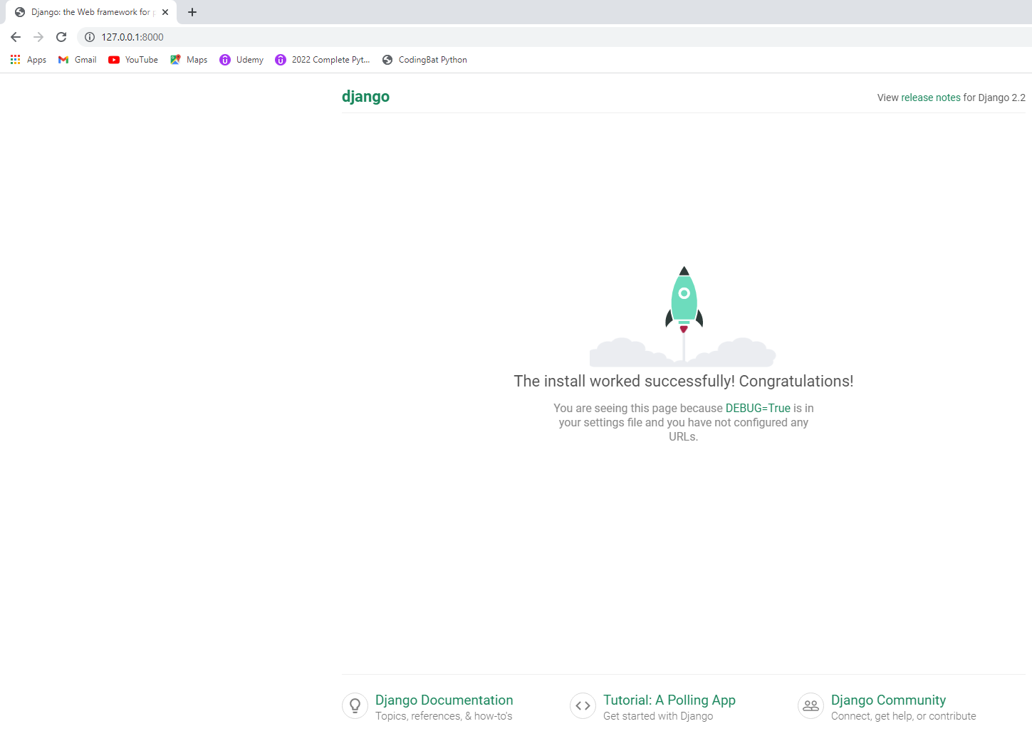

* Click Ctrl+c to stop the server

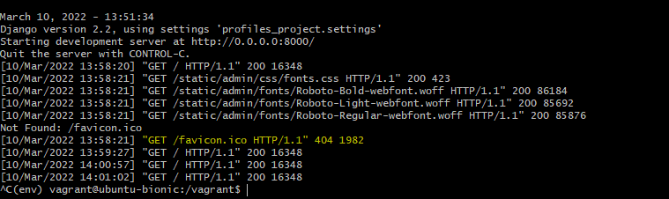

Refresh page.

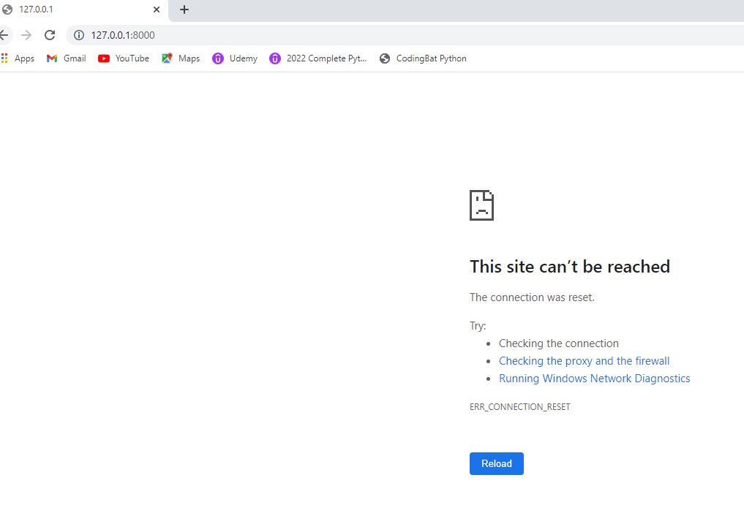

3. Add and commit our changes to git

Git bash here in folder Workspace/profiles-rest-api

(i.e. it should be at profiles-rest-api and not under vagrant server)

