**Create our user database model:**

1. Create user profile model

Django comes with default user model that is used for standard authentication system and for Django Admin.

We will override the standard model with custom model that will allow us to use an email address instead of the standard username.

**Best Practice

Keep all the database model file in a file named models.py within our app.

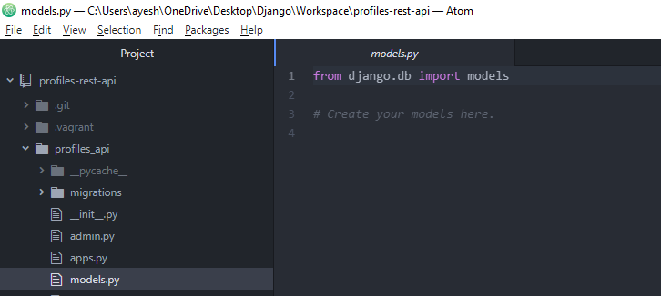

a. Include our user profile model.

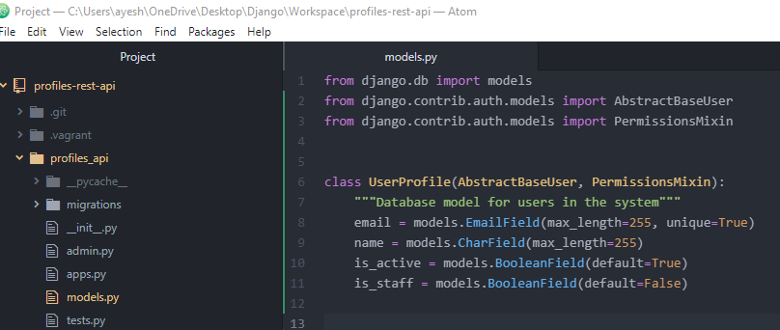

Included the column names (e.g. email), datatype and constraints

b. Need to include the model manager for our object

(required because we will use our custom user model with the Django CLI so Django needs to have a custom model manager for the user model so it knows how to create users and control users using Django command line tools)

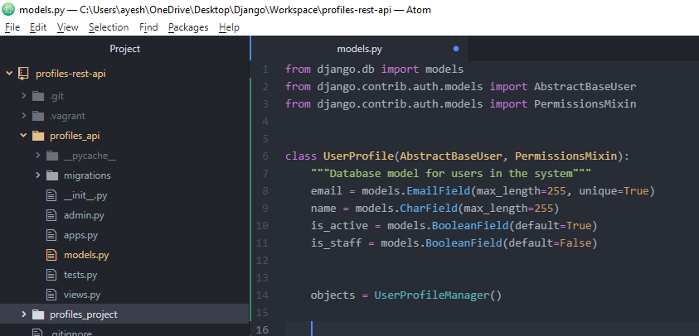

c. Adding few more fields to our class

overriding default USERNAME_FIELD which is called username with email so now when we authenticate our users, so instead of them providing username and password, now they would provide email and password for authentication.

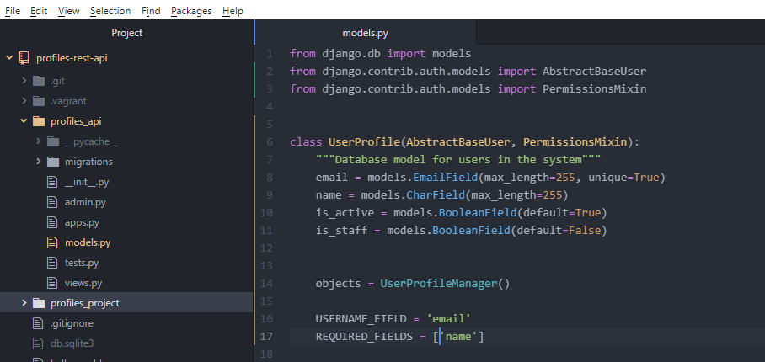

USERNAME_FIELD is required by default.

In REQUIRED_FIELDS include all those fields which we want to mark as required.

d. Include some functions which Django uses to interact with the custom user model

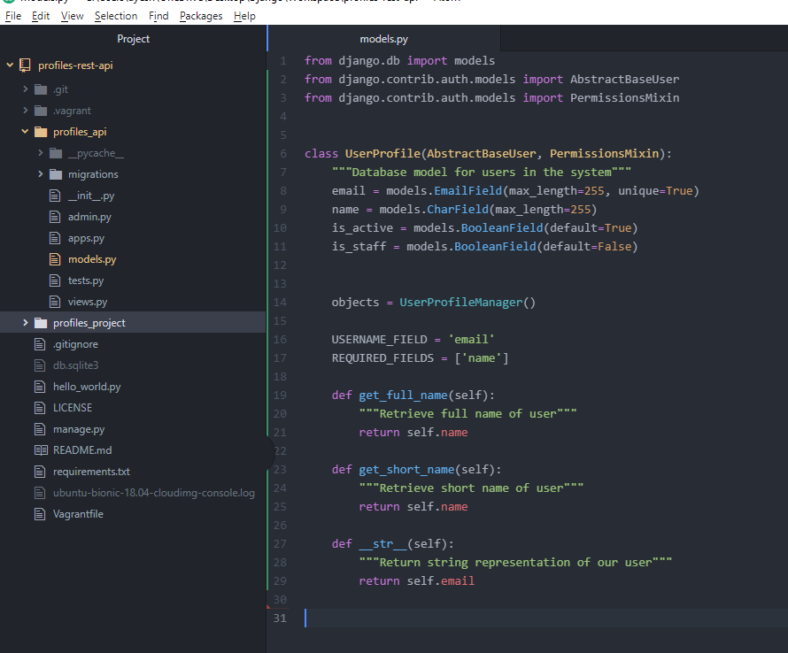

Save all the changes.

Hence added first model to our project.