**Set our custom user model:**

Configure our Django project to use custom model as the default user model.

Set the user model:

We need to set it in the settings.py file of our project(profiles_project).

Go to the end of the file and include a new setting as below.

AUTH_USER_MODEL = 'profiles_api.UserProfile'

Set this to a string which represents the model which we want to user as Django user model.

Specify the app from which we want to retrieve the model followed by the name of the model that we want to use.

So this will be used for all of our authentication and user registration in our project.

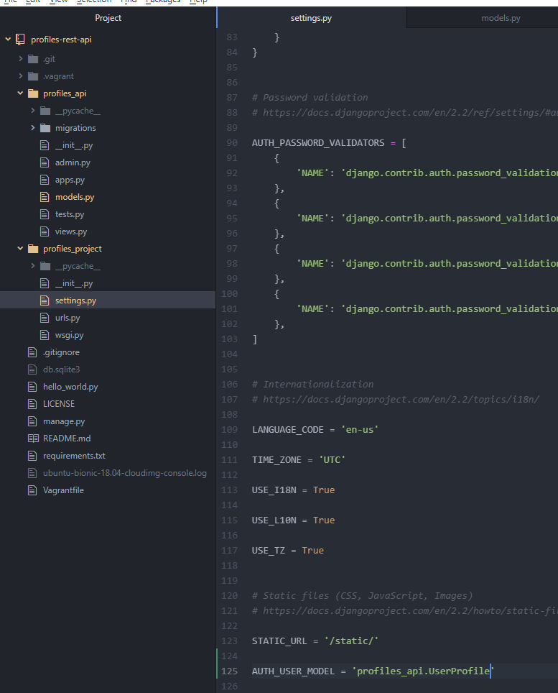

Save the changes.

**Create migrations and sync DB:**

Create migration files for our models that we have added to our project.

Create a migration file that stores all the steps required to make our database match our Django models.

So every time we change our model or add additional model to our project we need to create a new migration file. Migration file will contain the steps required to modify the database to match our updated models.

For e.g. if we add a new model to our project we need be able to create a new table in our database using migrations.

1. Open git bash

2. Change directory to our workspace.

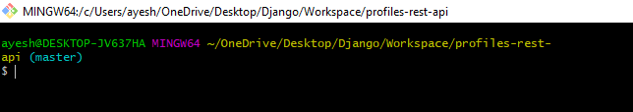

3. Connect to vagrant server.

Run command ‘vagrant ssh’

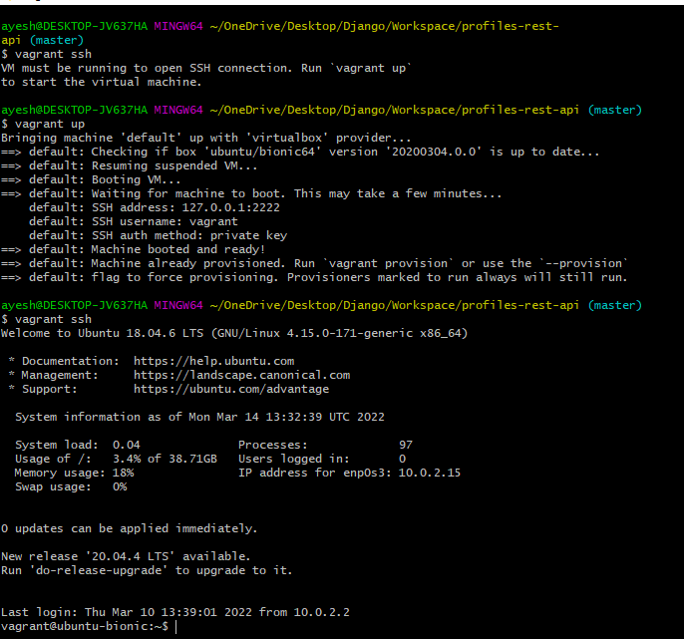

*Run vagrant up (to start VM) before running vagrant ssh.

4. Switch to vagrant directory.

‘cd /vagrant’

5. Run ‘source ~/env/bin/activate’ to activate our virtual environment.



6. We will use manage.py file to create migrations for our project.

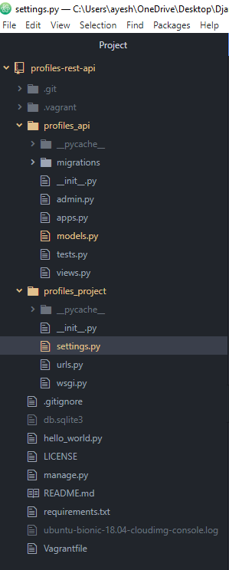

Run command ‘python manage.py makemigrations profile_api’

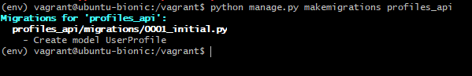

It creates a new file 0001_initial.py

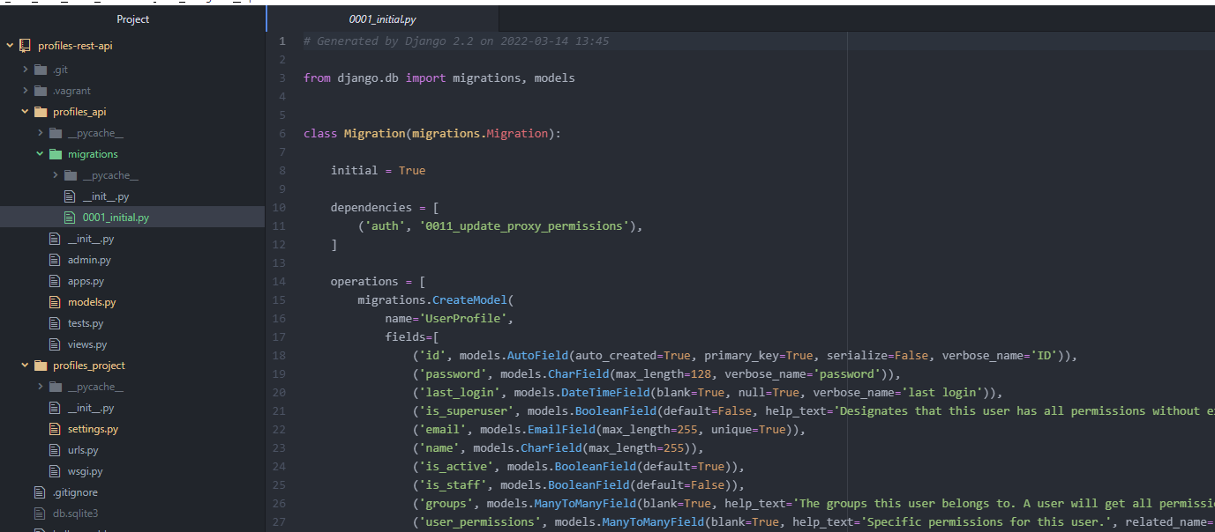

This contains all the steps required to create our model.

7. Run our migration.

It will make all the changes required to setup the db for our Django project.

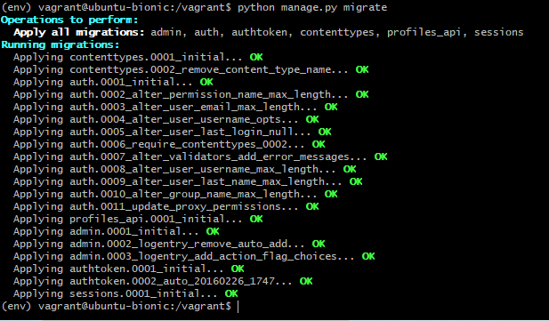

It creates all the required models and all the required tables in the database for our models and dependencies.

8. Commit our changes to git hub.

