**Django REST Framework Views**

DRF provides some helper classes that we can use to create our API endpoints.

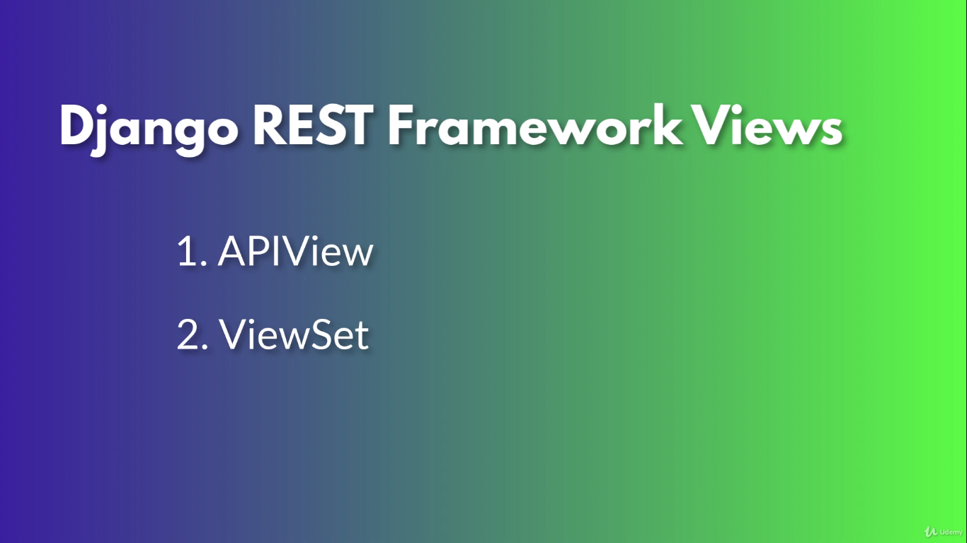

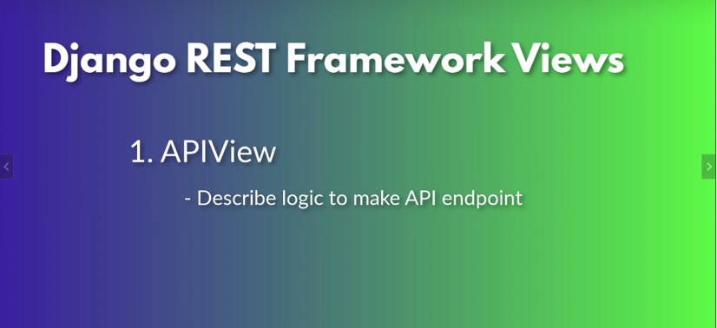

API View: View which helps to build our API.

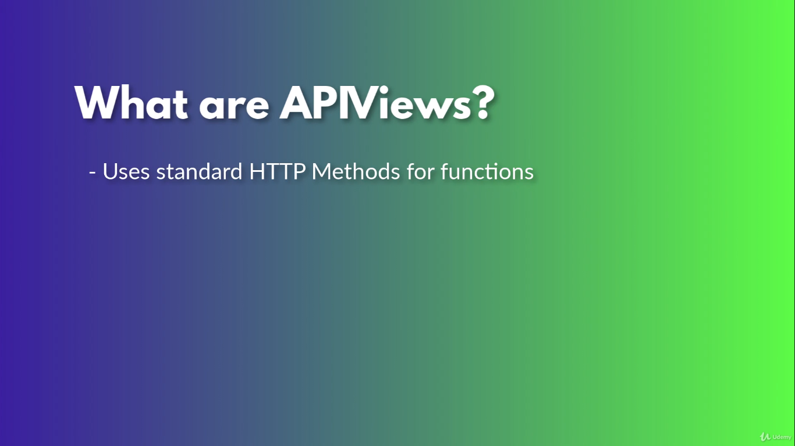

API Views allows to define functions that match the standard HTTP methods.

For e.g.

HTTP GET

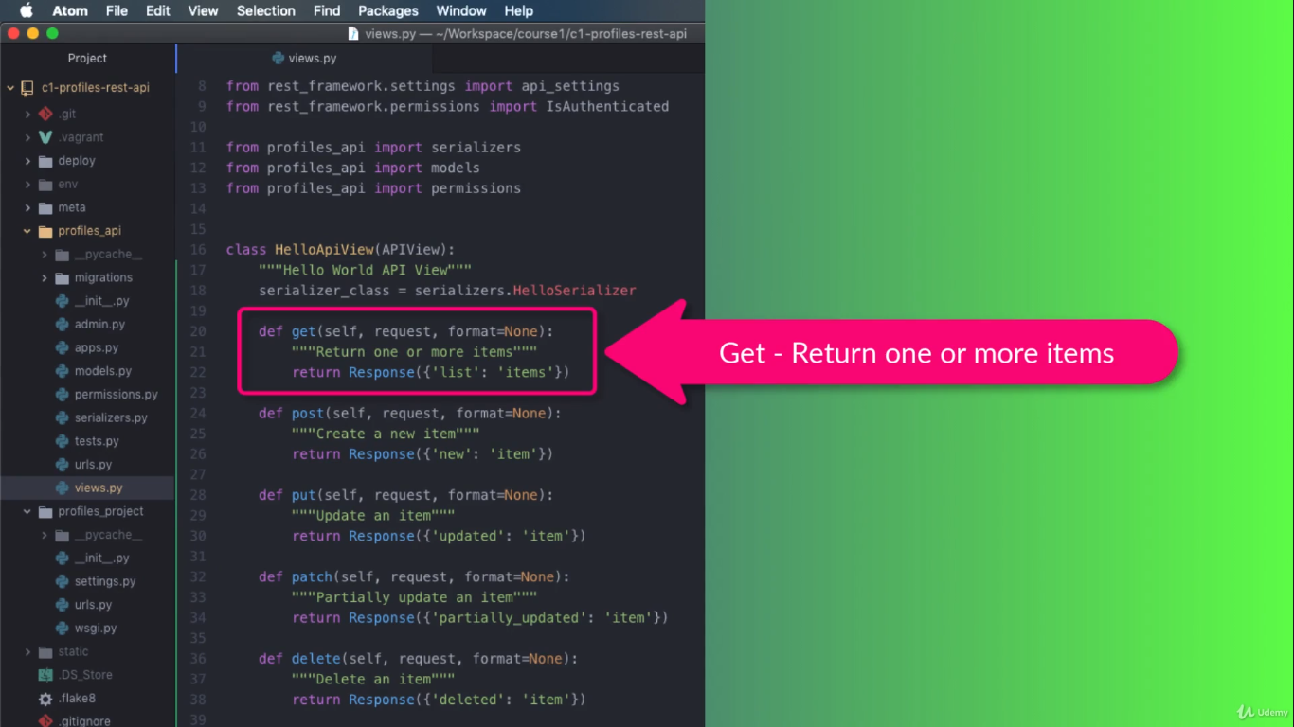

HTTP POST

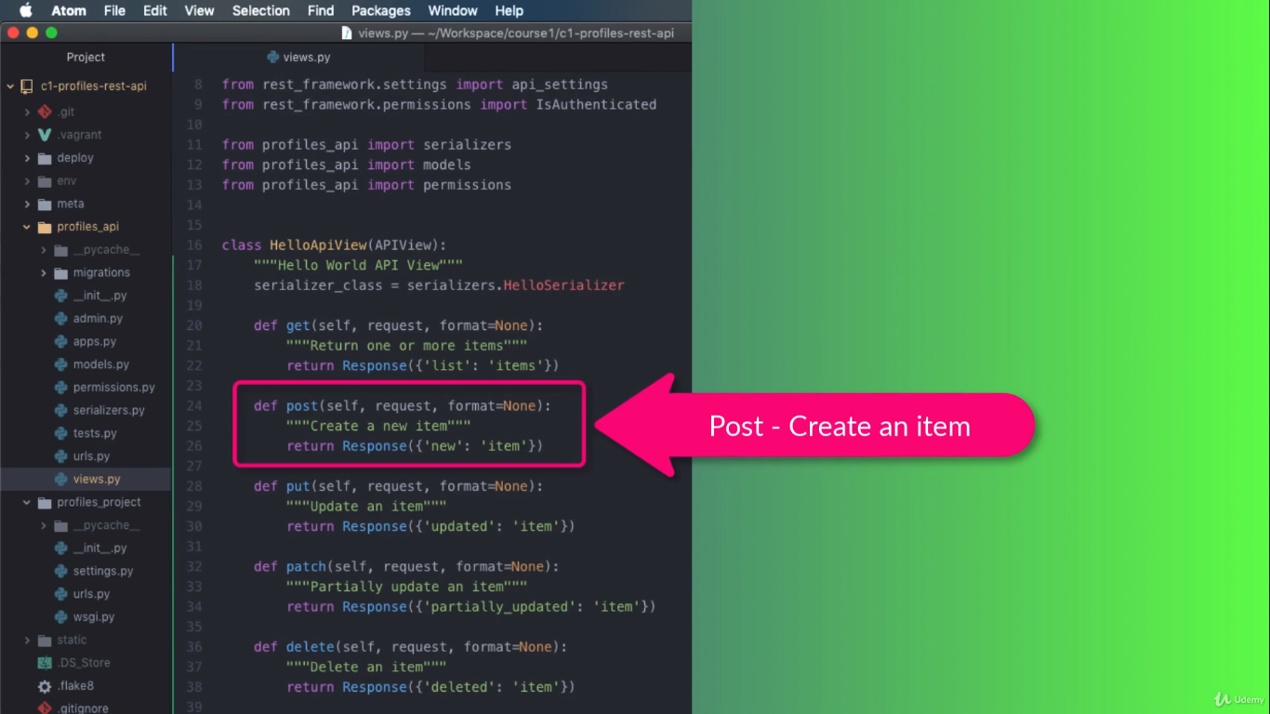

HTTP PUT

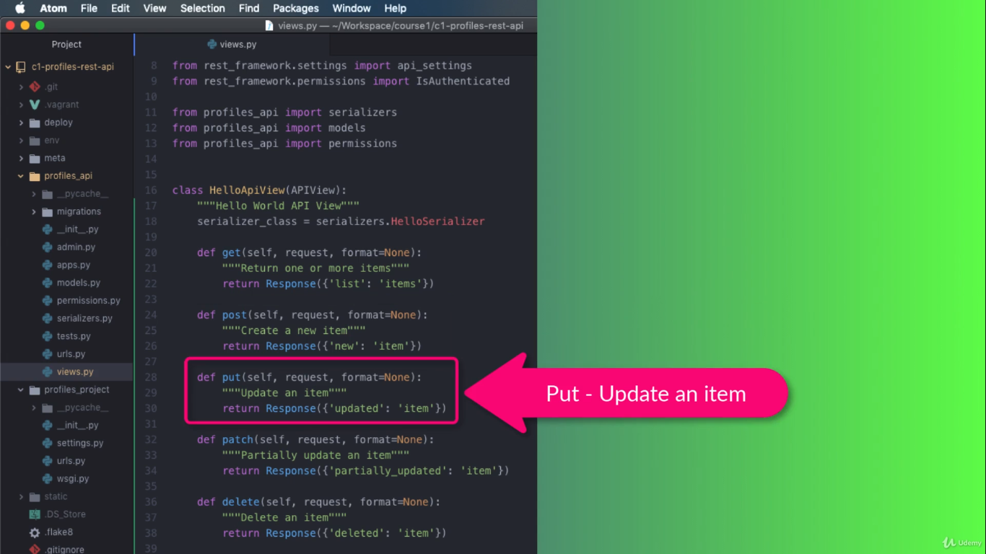

HTTP PATCH

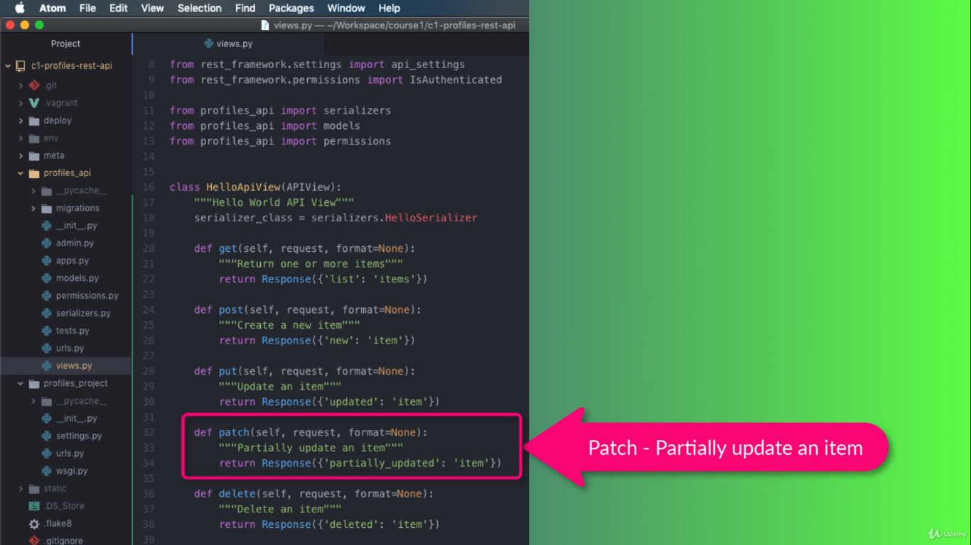

HTTP DELETE

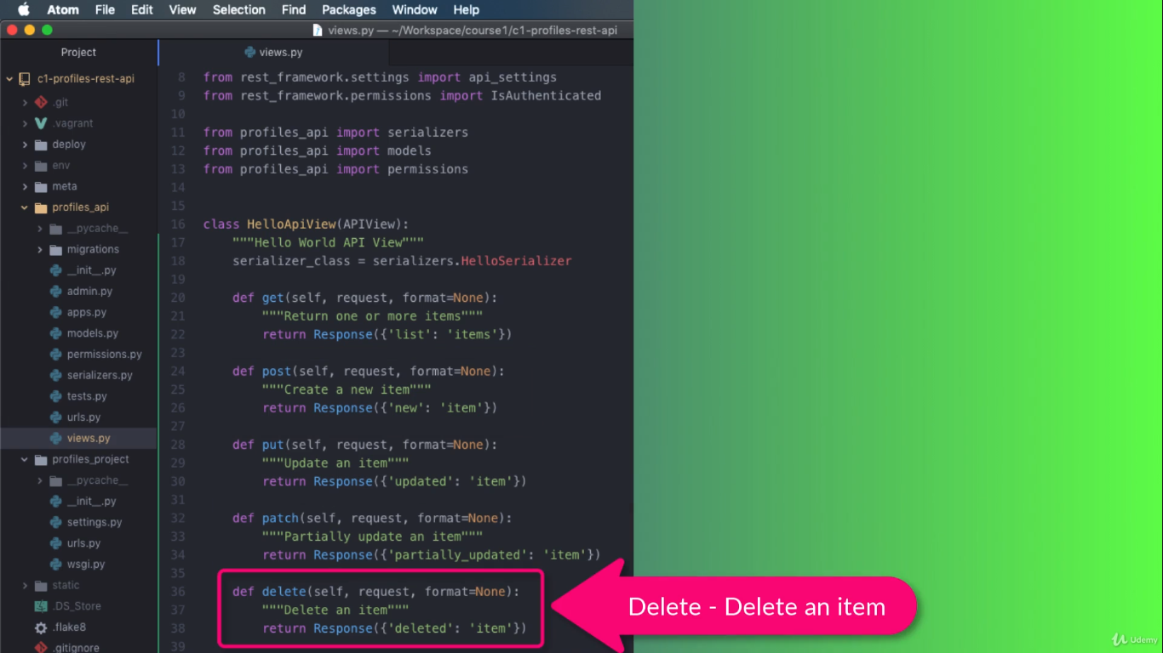

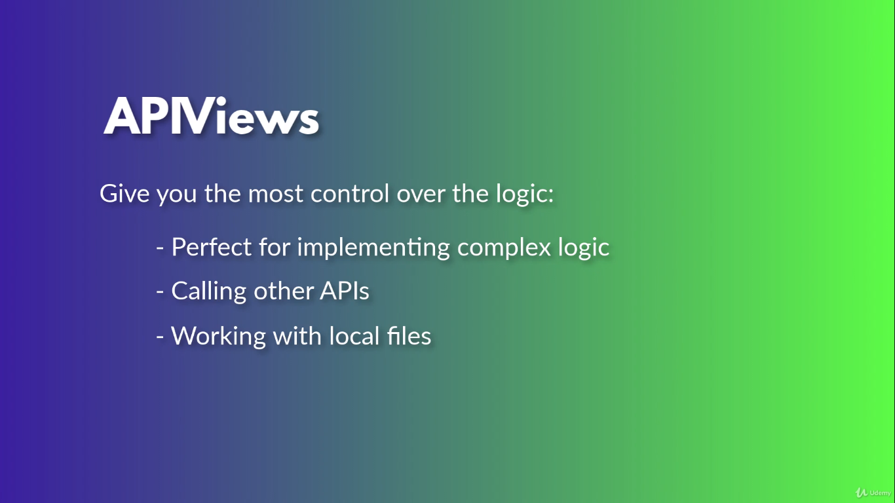

By allowing us to customize functions for each HTTP method on API URL, API views give us the control of our application logic.

