DRF offers 2 classes that help us write the logic for our API.

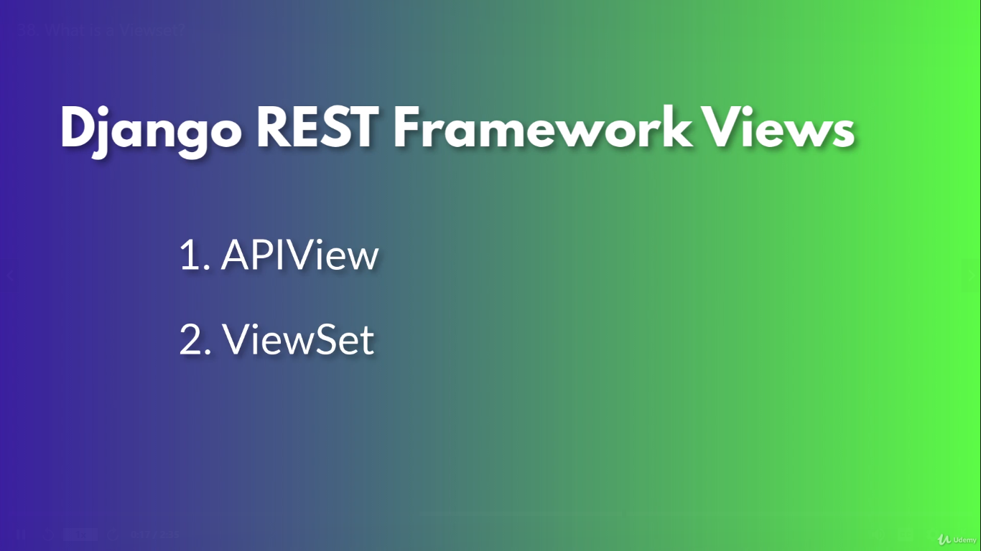

What are ViewSet?

1. Just like APIView, ViewSets allows us to write the logic for our endpoints.

However, instead of defining functions which map to HTTP methods, ViewSet accepts functions that map to common API object actions such as

list – for getting a list of objects

create – for creating new objects

retrieve – for getting a specific object

update – updating an object

partial update – updating part of an object

destroy – deleting an object

2,3,4

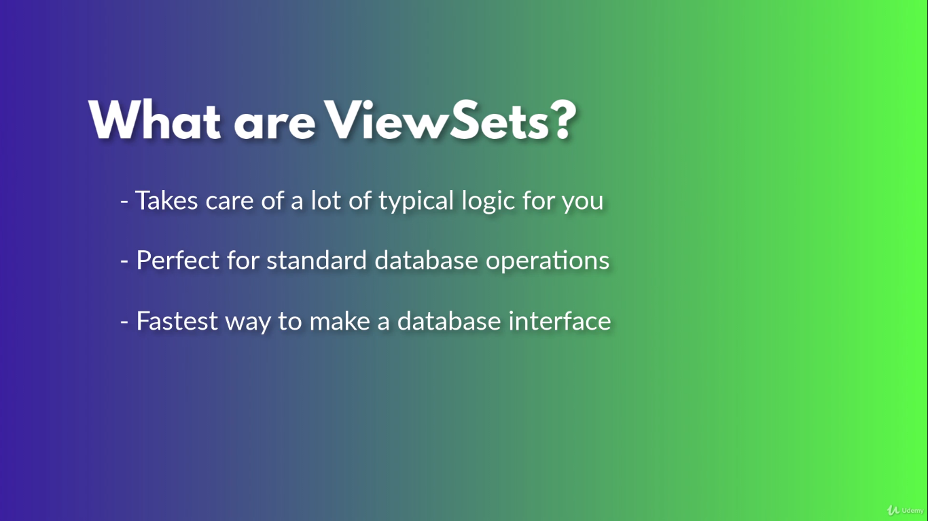

When to use ViewSets?

