**Notification Teask_Lecture14**

Notifications are mostly used for reminders.

* Heads-up notification
* Lock screen
* App icon badge
* Notification actions
* Notification updates & groups

This is first main activity xml file screenshot :

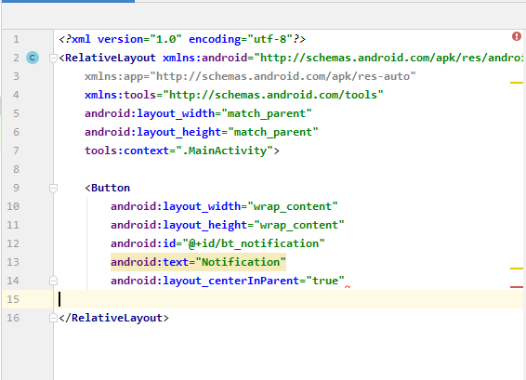

This is first main activity java file befor adding the notification activity

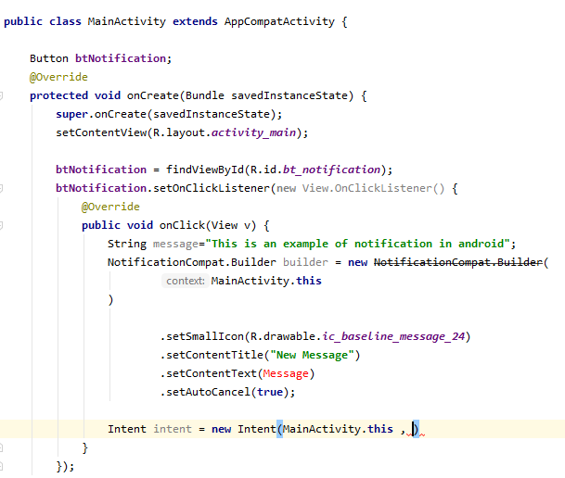

Then, I add the new activity for notification purpose.

and after adding activity, we do changings in main java activity:

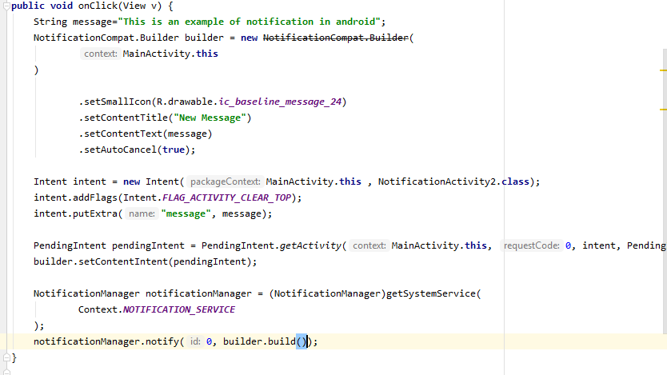

And in the last step,

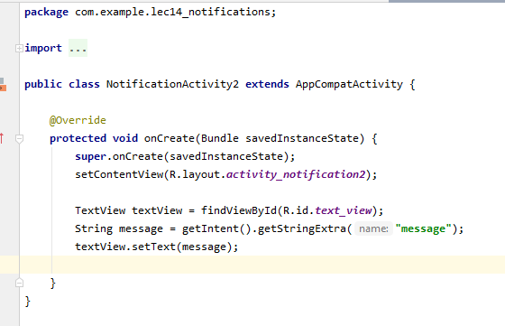\

Hence, output is: