**Mobile Computing - Lecture 1&2**

Here is the attached screenshots of how to add files in github through gitbash. First open gitbash in the folder which we want to add in the repository or by using cd command.

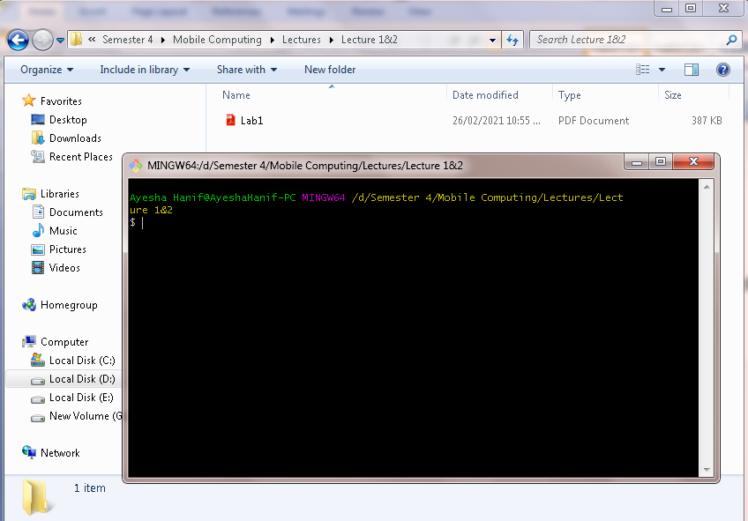

Ls command is used in order to view the files that are present in that directory.

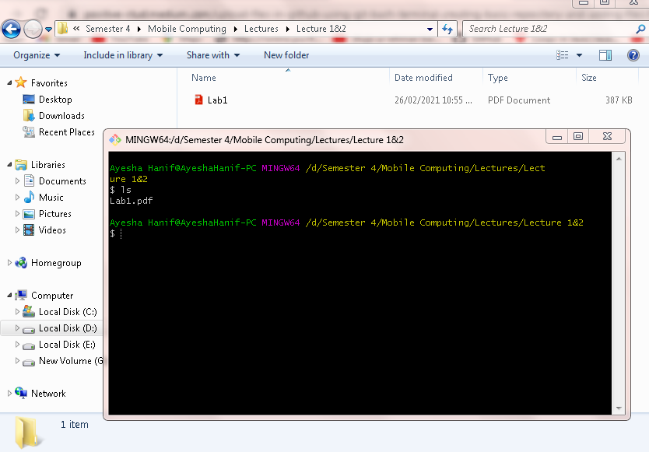

 Enter command as ‘’git init”, in order to initialize an empty git repository.

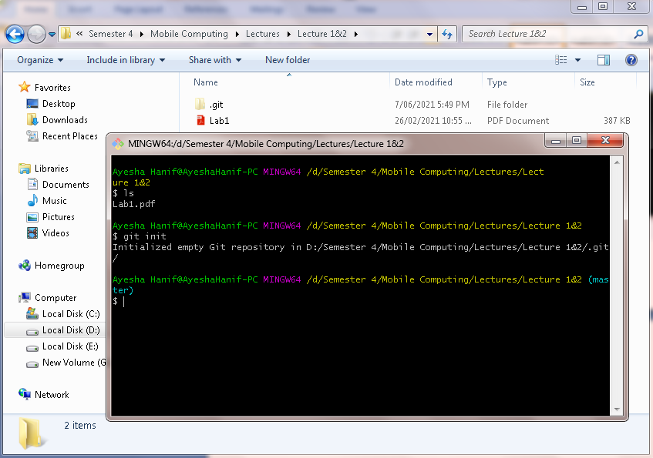

Now, I go to my repository and got link of repository.

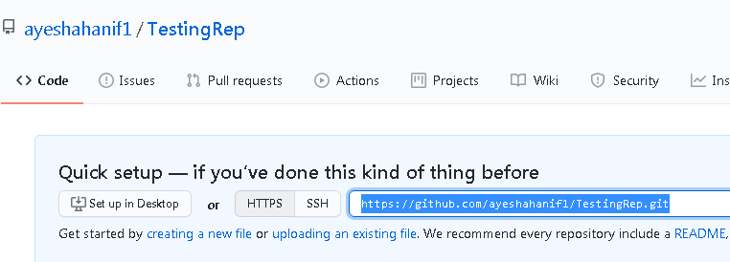

Provide command as “git remote add origin “ then paste the HTTPS link of my repository. git remote add origin is used to add a new remote.

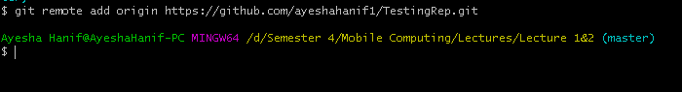

Enter command as “git remote -v” to check if fetching and pushing is working or not.

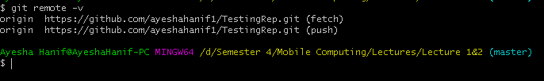

Give command as “git add .” to take all files from my directory and push it to my repository.



Provide command as “git commit -m “First commit” ” to make the first commit in the GitHub repository.

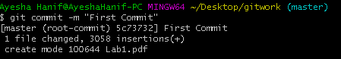

Finally, enter command as “git push origin master” to push the master directory to the origin.

