**Phase 1: Problem Understanding & Industry Analysis**

**1. Requirement Gathering**

**Functional:** Patients can book appointments, receive reminders, doctors view history, auto follow-ups, dashboards for admin, and chatbot for triage.  
**Non-Functional:** Secure patient data, fast performance, simple UI, scalable for multiple doctors.

**2. Stakeholder Analysis**

* **Patients:** Easy booking, reminders, chatbot guidance.
* **Doctors:** Access to records, notifications for schedule updates.
* **Receptionists:** Simple scheduling tools.
* **Admins:** Dashboards for utilization & patient retention.

**3. Business Process Mapping**

1. Patient books appointment.
2. System sends confirmation & notifications.
3. Doctor conducts appointment & records notes.
4. Follow-up auto-created.
5. Reminders sent.
6. Admin reviews dashboards.

**4. Industry-Specific Use Case**

Clinics face no-shows, poor scheduling, and scattered records. A Salesforce CRM adds value with automation, dashboards, and AI chatbots, improving efficiency and patient care.

**5. AppExchange Exploration**

* Health Cloud: Powerful but costly for small clinics.
* Appointment apps: Limited customization.
* Chatbots: Generic, not healthcare-focused.

**Phase 2: Org Setup & Configuration**

**1. Company Profile Setup**

* Updated organization details to reflect *Healthcare Clinic CRM*.
* Verified default time zone, currency, and language for clinic operations.

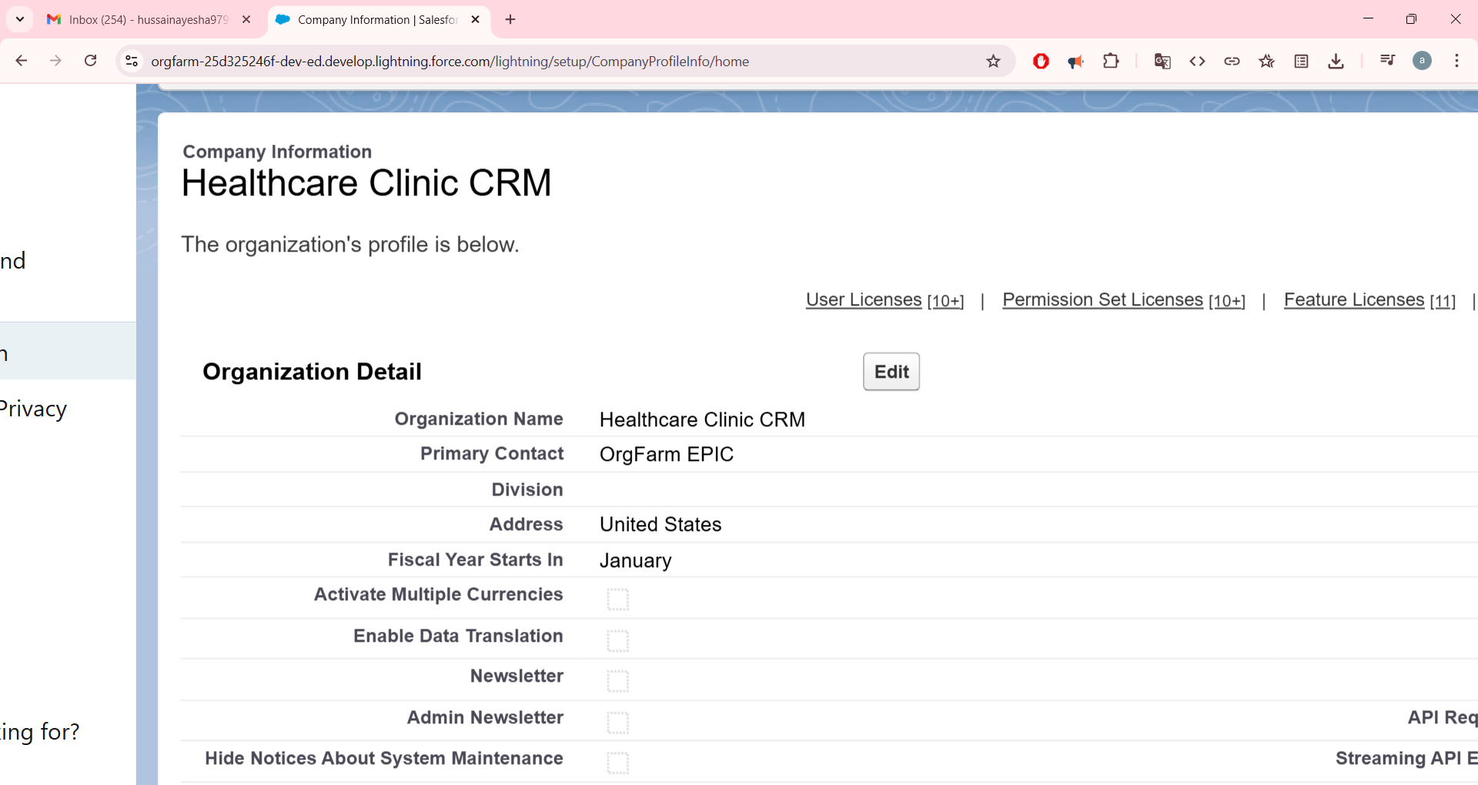

**2. Business Hours & Holidays**

* Defined business hours: Monday–Saturday, 9:00 AM to 6:00 PM.
* Added official holidays (e.g., Independence Day, Christmas).

**3. User Setup & Licenses**

* Created users for **System Admin, Doctor, and Receptionist** with appropriate licenses.
* Assigned roles based on hierarchy: Admin > Doctor > Receptionist.

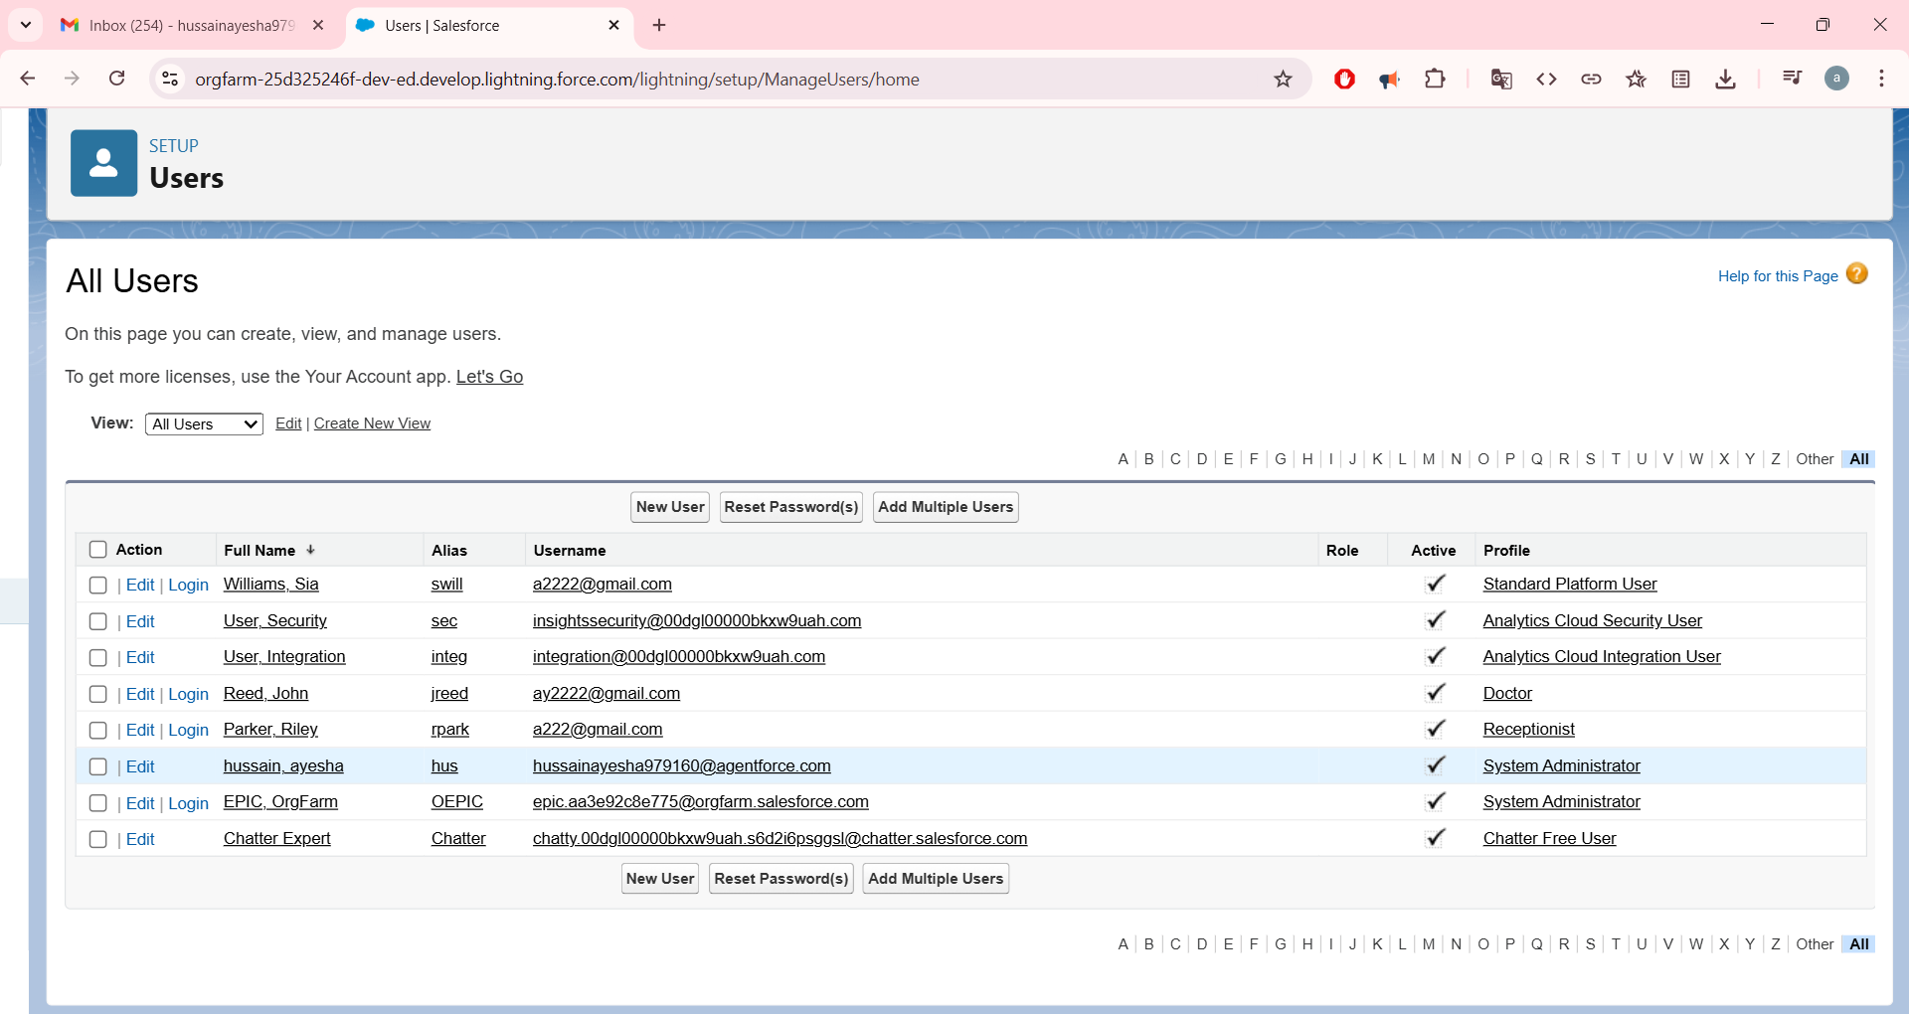

**4. Profiles**

* Cloned standard profiles to create **Doctor Profile** and **Receptionist Profile**.
* Configured object-level permissions:
  + Doctors: Read/Write Patients & Appointments, Read Prescriptions.
  + Receptionists: Full CRUD on Patients & Appointments.

**5. Organization-Wide Defaults (OWD)**

* Set sharing model to **Private** for Patients and Appointments.
* Prescriptions controlled by parent Appointment.
* Sharing rules allow Receptionists full access and Doctors access to their assigned records.

**6. Login Access Policies**

* Enabled "Administrators Can Log in as Any User" for testing.
* Session timeout set to 30 minutes for demo purposes.
* Password policies simplified for Developer Org testing.