**Section 0 -Use GIT as local VCS. Steps to follow:**

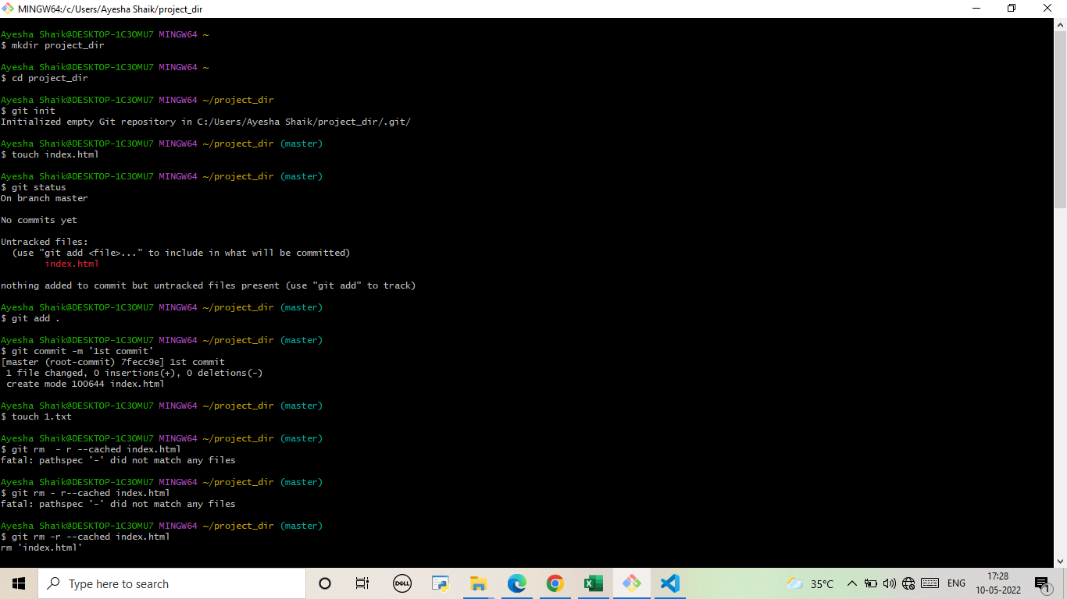

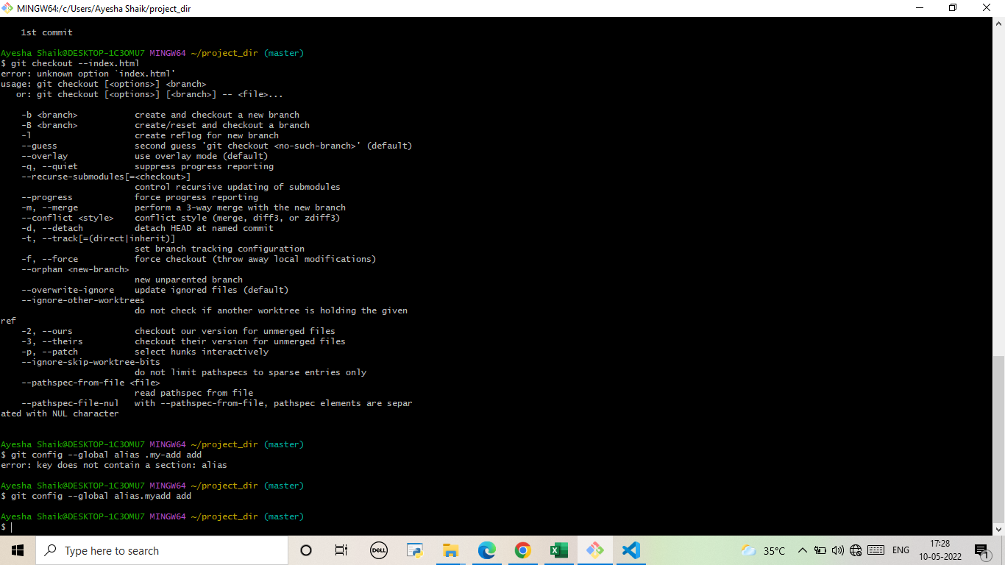

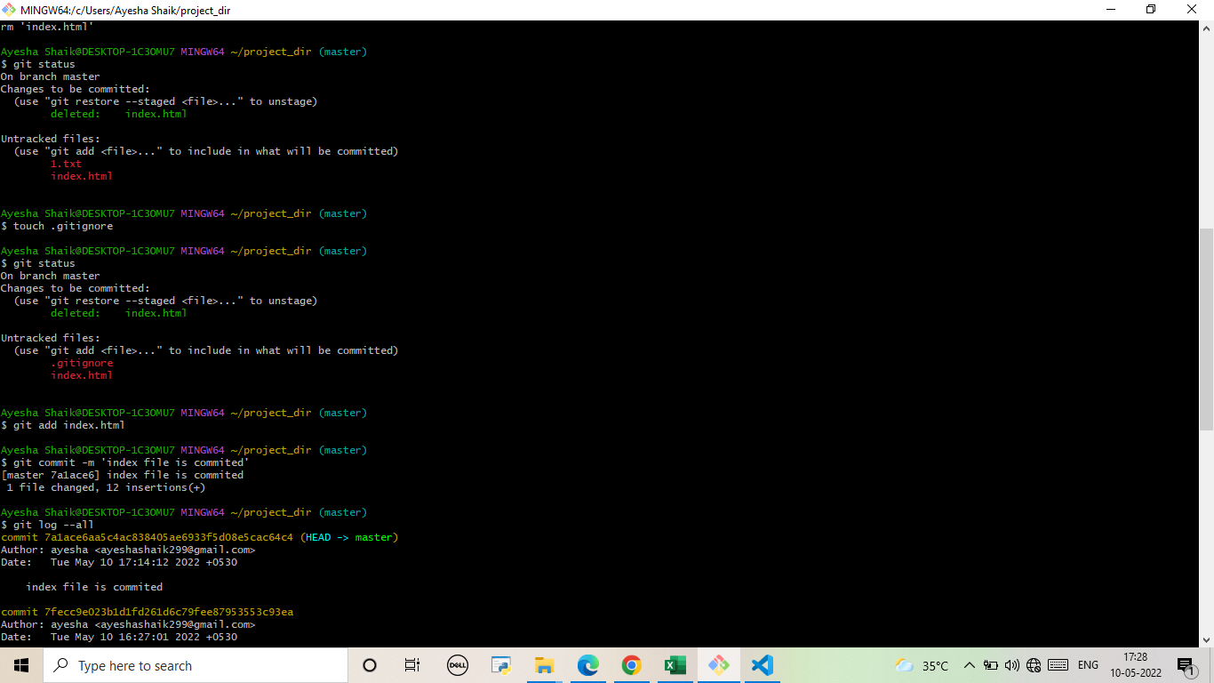

**SECTION-1 (HTML assignments) - Steps to follow:**

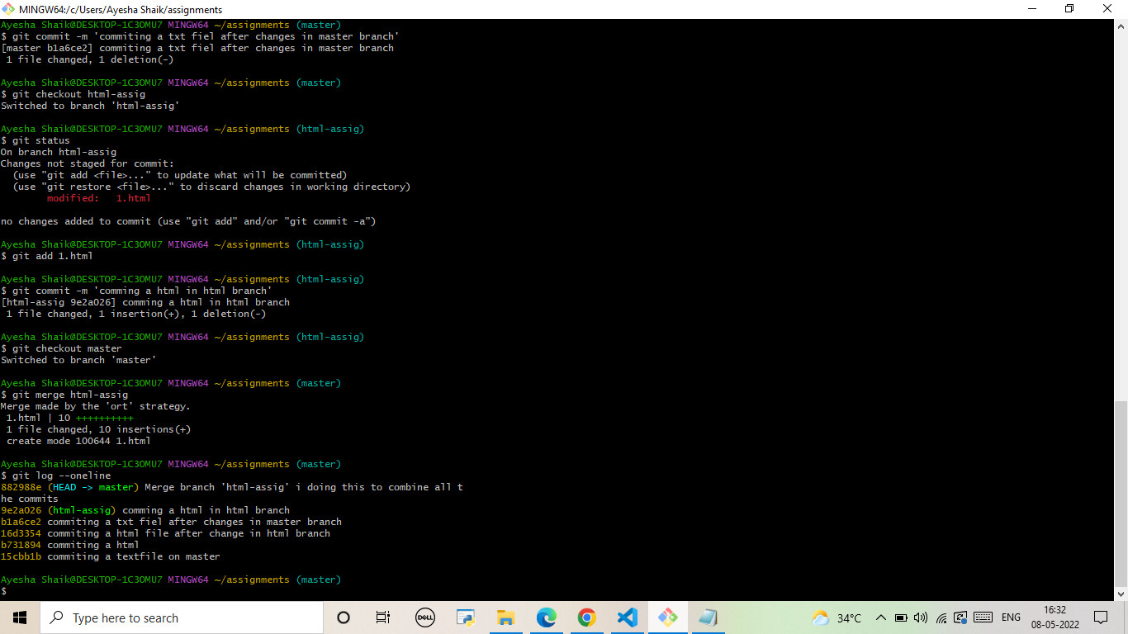

**SECTION-2 - (CSS assignments) Steps to follow:**

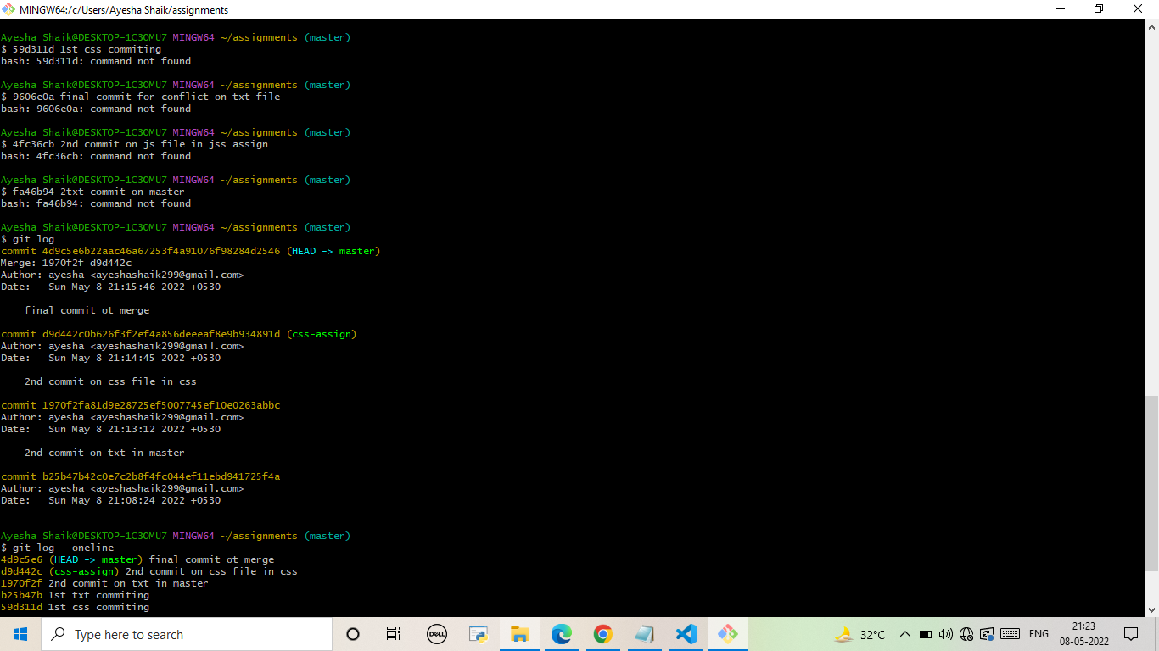

**SECTION-3 - (JavaScript assignments) Steps to follow:**

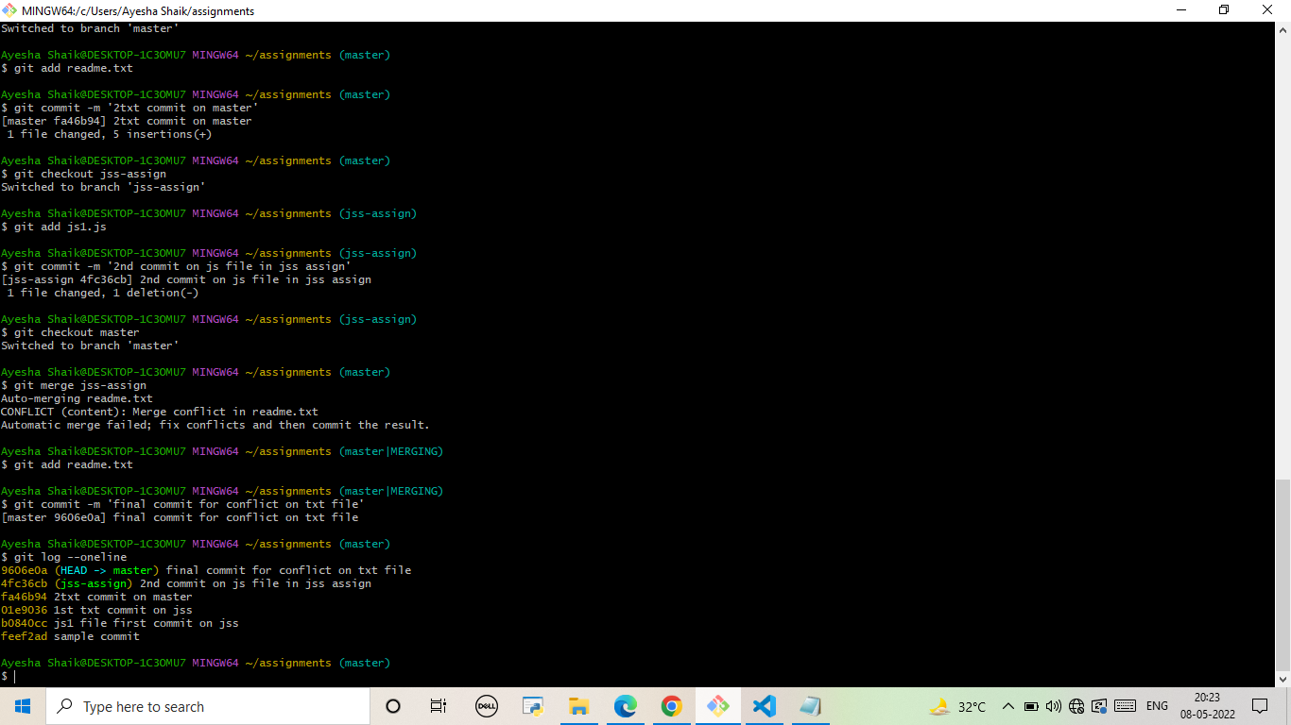

**SECTION-3 (Pushing assignments to remote repository) - Steps to follow:**

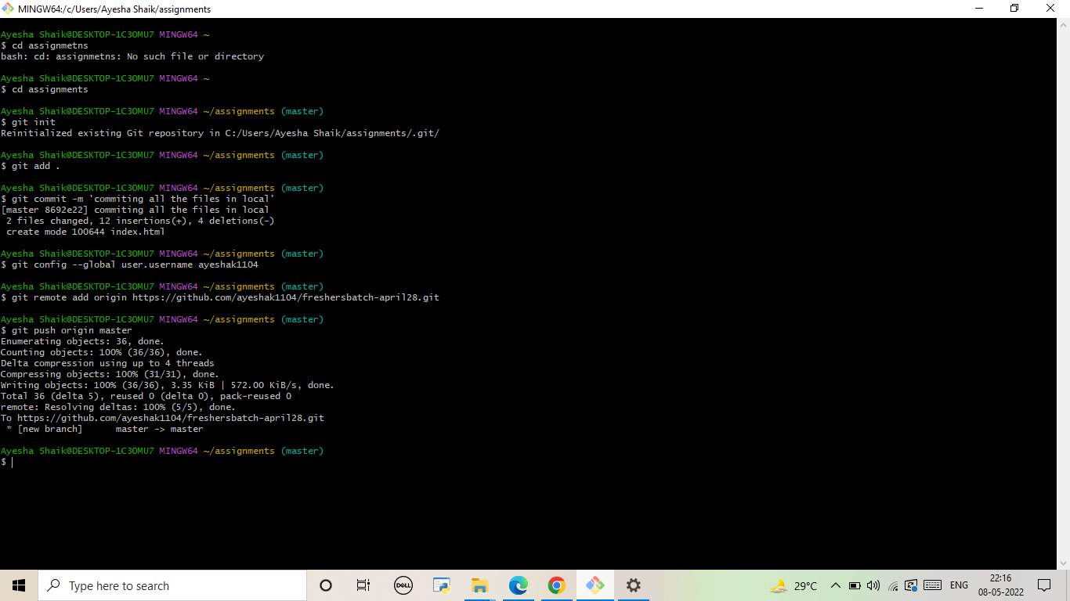

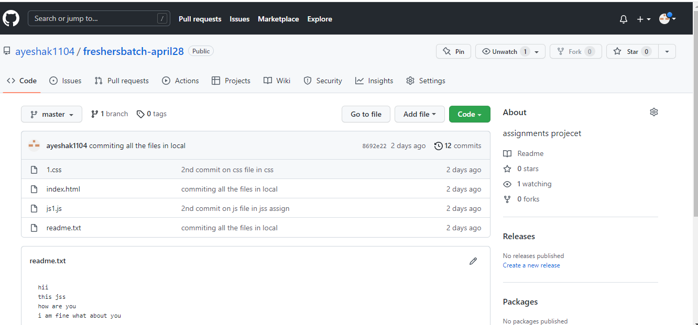

**SECTION-4 (Pushing source code to remote repository using Eclipse GIT plugin) - Steps to follow:**

