
Fatima Jinnah Women University
Department of Software Engineering

Assignment 01
Git, Gitea, GitHub, Git LFS, and GitHub Pages
Name | Ayesha Kanwal
Registration No | fa24b1-se-077
Course | Cloud Computing (BSE-410)
Class | BS(SE)-V
Submitted To | Sir Waqas
Submission Date | 10 October 2026

Task 1: Install Gitea and Push a Repository from the Ubuntu Server
In this task I installed Docker Engine and the Docker Compose plug-in on my Ubuntu server, cloned the instructor-provided Gitea setup repository, and started Gitea together with PostgreSQL using the supplied compose.yaml without changing any settings. After that I created a separate local repository, committed a README.md containing my name and registration number, and pushed it to my Gitea server over the local loopback address.

Step 1.1: Install and Run Gitea
Commands used:
git --version
docker --version
docker compose version
cd ~
git clone https://github.com/WaqasSaleem97/Gitea.git
cd Gitea
docker compose up -d
docker compose ps
curl -sS -o /dev/null -w "Gitea HTTP status: %{http_code}\n" http://127.0.0.1:3000/
Both the gitea and gitea_db containers are running and Gitea returned HTTP status 200.
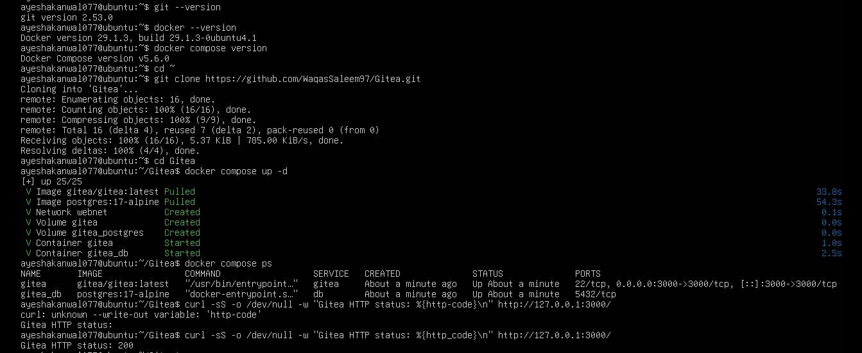
task1_gitea_running.png

Step 1.2: Create and Push the Initial Repository
Commands used:
cd ~
mkdir Assignment01 && cd Assignment01
git init
git branch -M main
git add README.md
git commit -m "Add student information"
git remote add gitea http://ayeshakanwal077@127.0.0.1:3000/ayeshakanwal077/Assignment01.git
git remote -v
git push -u gitea main
The personal access token was entered only at the password prompt, so it is not stored in the remote URL.
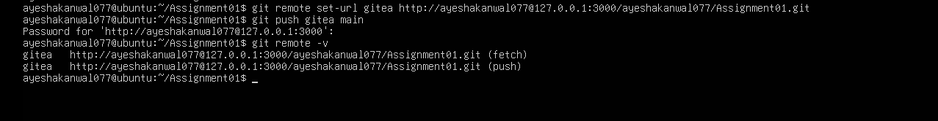
task1_gitea_push.png

Step 1.3: Verify the Gitea Repository
The public Assignment01 repository in Gitea shows the owner (ayeshakanwal077), the repository name, and the rendered README.md with my full name and registration number.
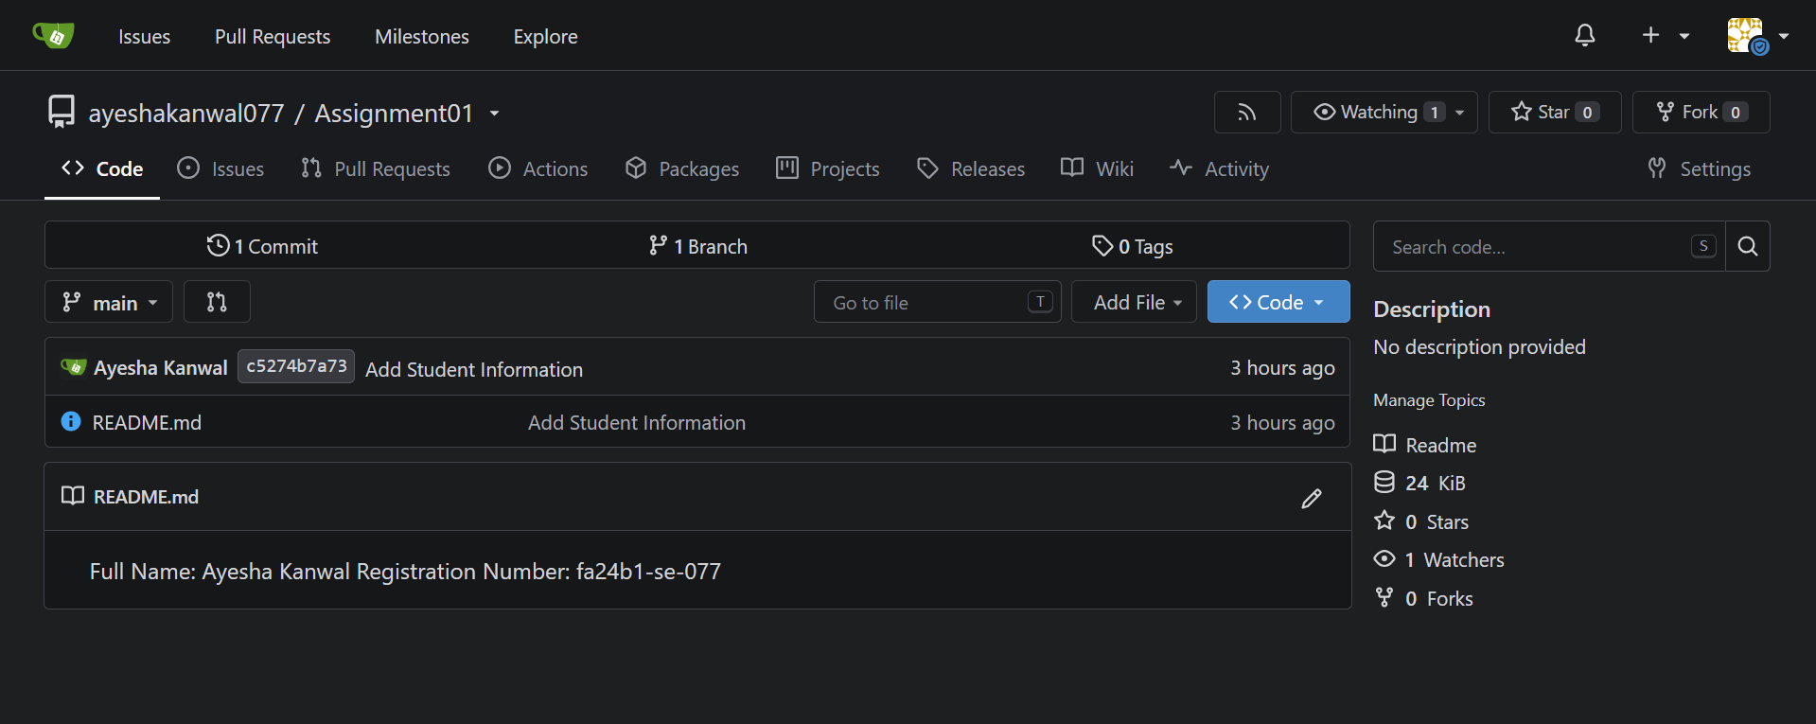
task1_gitea_repository.png

Task 2: Push the Same Repository to GitHub
I created an empty public GitHub repository named Assignment01 and added it as a second remote called github to the same local repository. Both remotes (gitea and github) are now connected to one local repository, and the main branch was pushed to GitHub.

Step 2.1: Add the GitHub Remote
cd ~/Assignment01
git remote add github https://github.com/ayeshakanwal077/Assignment01.git
git remote -v
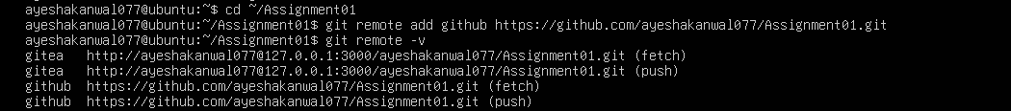
task2_remotes.png

Step 2.2: Push to GitHub
git push -u github main
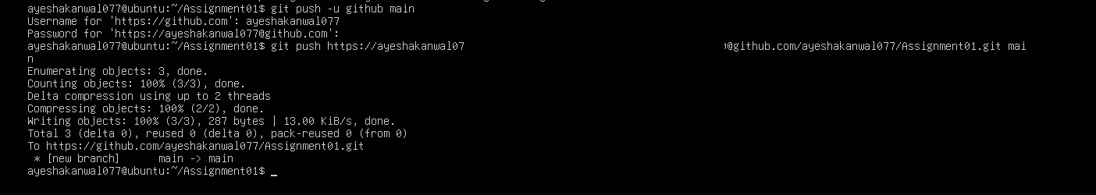
task2_github_push.png

Step 2.3: Verify the GitHub Repository
The public repository at github.com/ayeshakanwal077/Assignment01 shows the README.md with my full name and registration number.
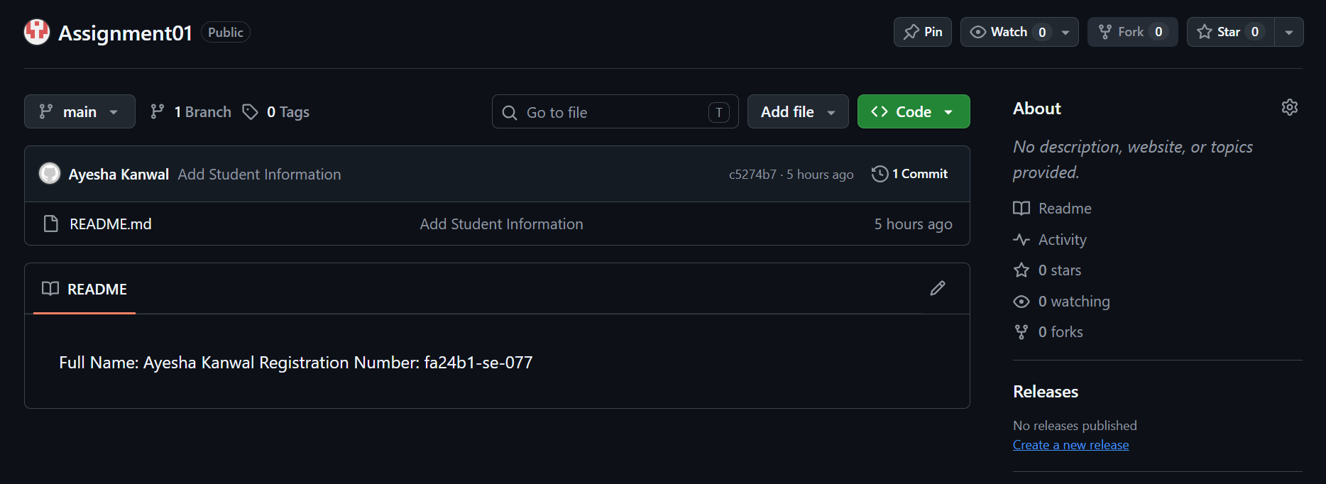
task2_github_repository.png

Task 3: Track Three Large Files with Git LFS
Git LFS was installed and initialised, and all *.bin files were tracked. I then created three files, each larger than 100 MiB, staged them, verified them with git lfs ls-files, and pushed them to GitHub.

Step 3.1: Configure Git LFS
cd ~/Assignment01
git lfs install
git lfs version
git lfs track "*.bin"
cat .gitattributes
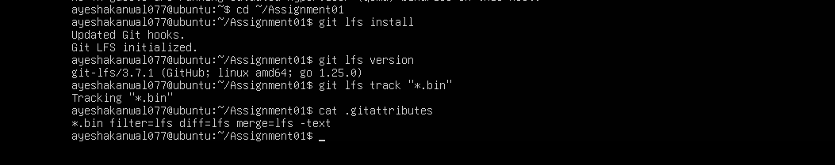
task3_lfs_setup.png

Step 3.2: Create and Verify Three LFS Files
truncate -s 101M large-file-1.bin
truncate -s 102M large-file-2.bin
truncate -s 103M large-file-3.bin
git add .gitattributes large-file-1.bin large-file-2.bin large-file-3.bin
git lfs ls-files --size
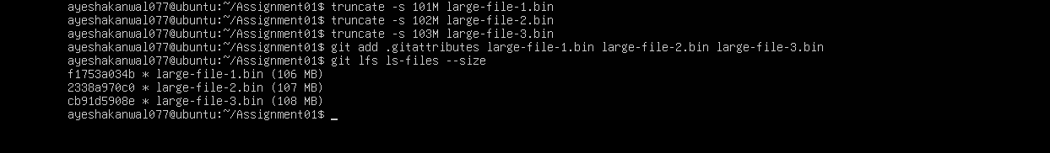
task3_lfs_files.png

Step 3.3: Commit and Push the LFS Files
git commit -m "Add three files using Git LFS"
git push github main
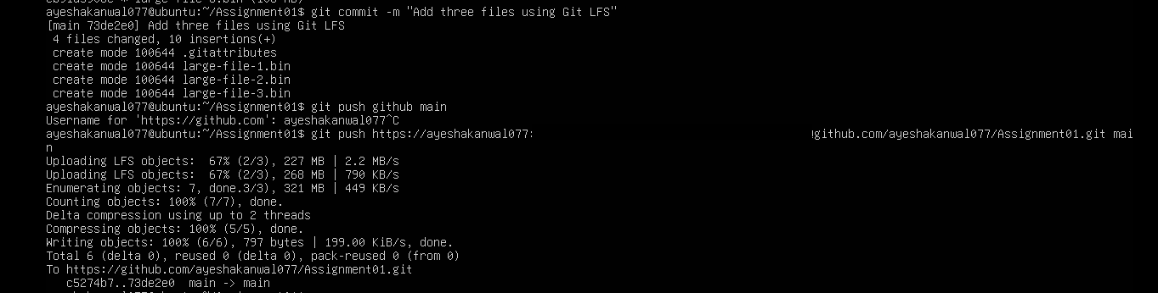
task3_lfs_push.png

Task 4: Create a Portfolio with GitHub Pages
I created a public repository named ayeshakanwal077.github.io containing index.html and styles.css. The portfolio includes the About Me, Education, Skills, and Projects sections. It was published with GitHub Pages using Deploy from a branch (main, / root).

Step 4.1: Portfolio Repository
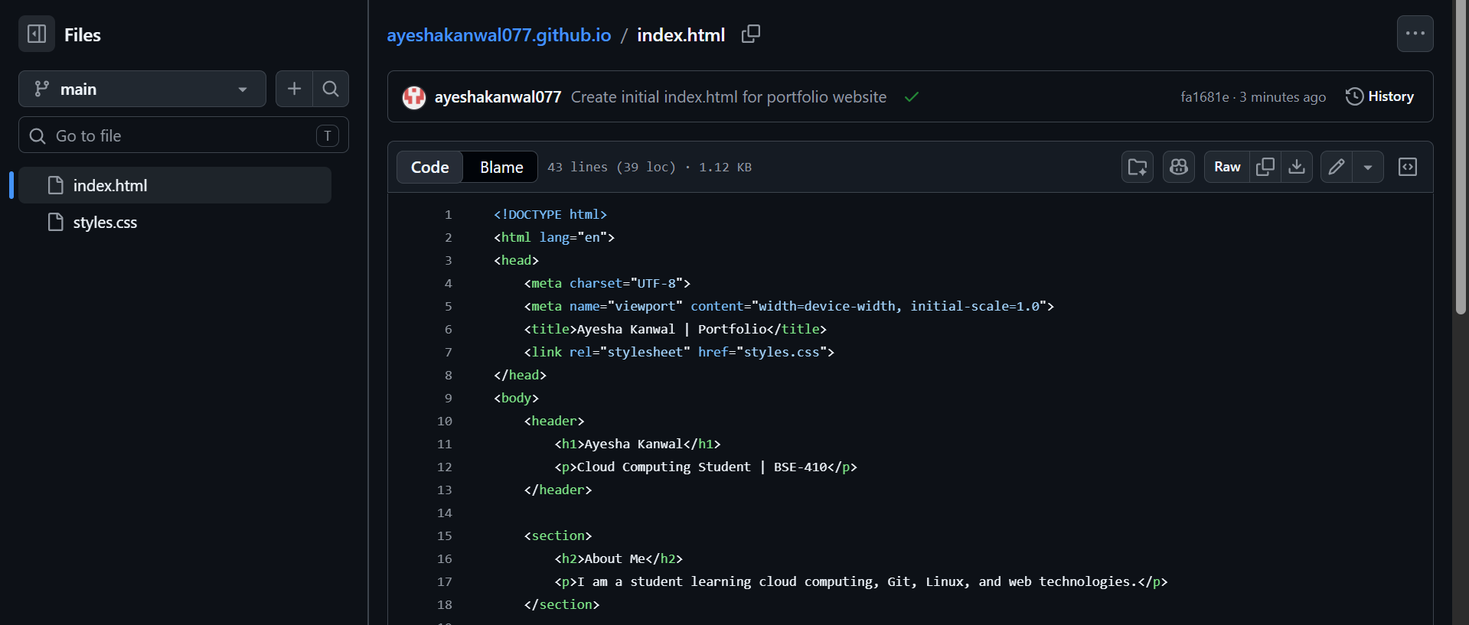
task4_pages_repository.png

Step 4.2: Publish with GitHub Pages
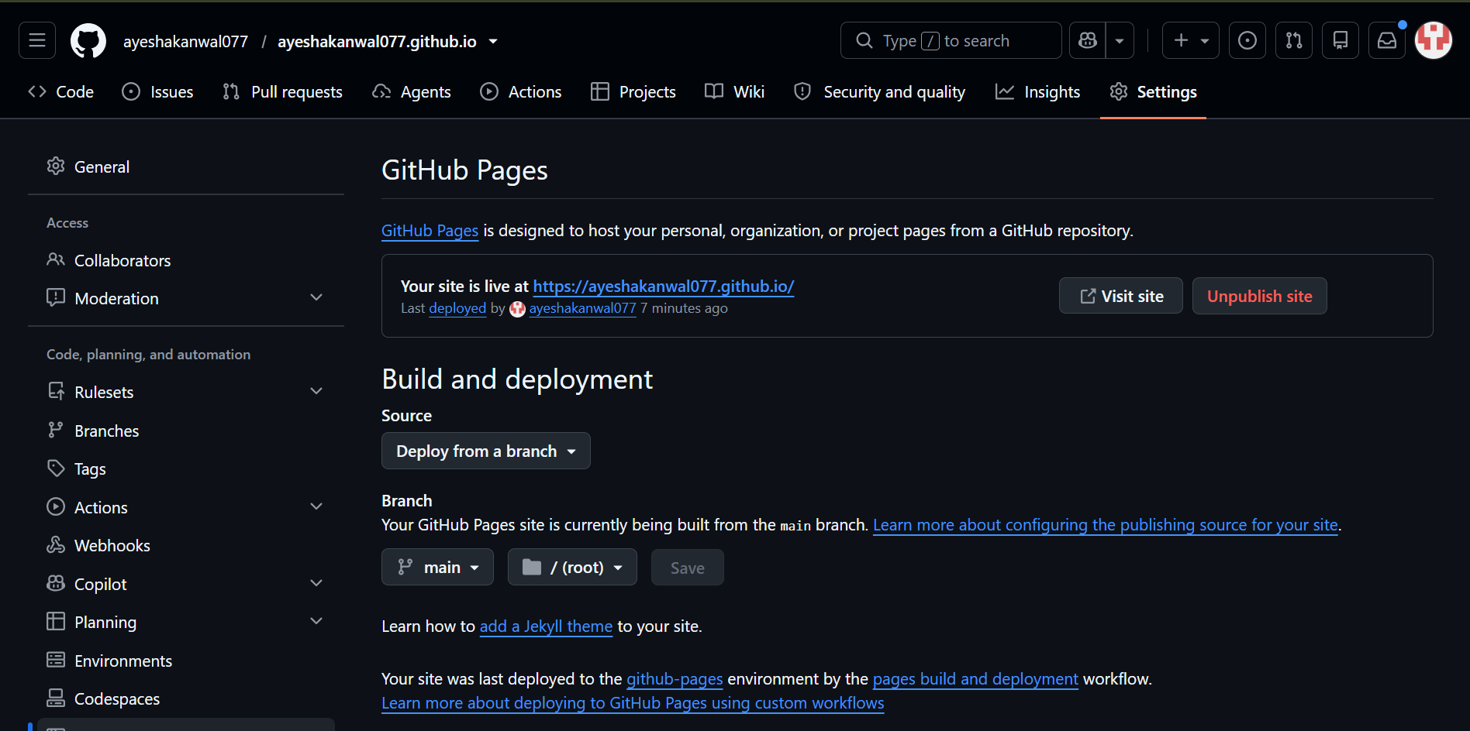
task4_pages_deployment.png

Step 4.3: Verify the Live Portfolio
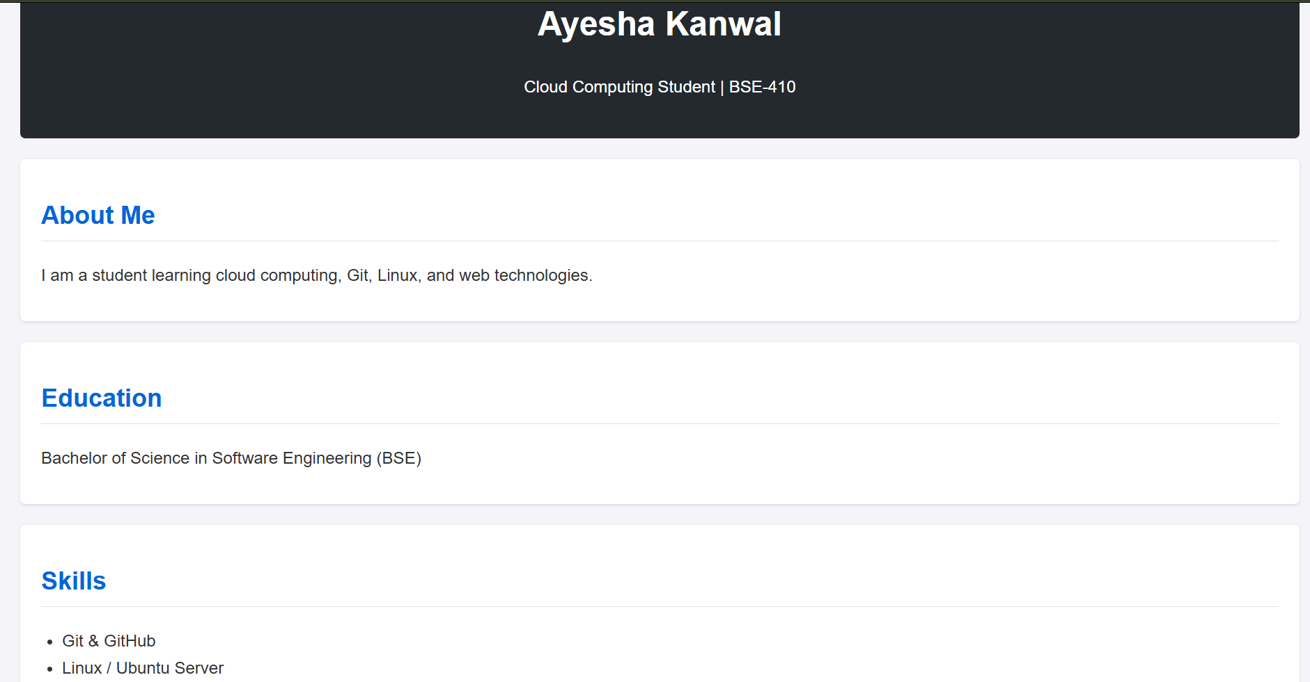
task4_portfolio_live.png

Repositories and Portfolio Links
CC Repository: https://github.com/ayeshakanwal077/CC
Assignment01 Repository: https://github.com/ayeshakanwal077/Assignment01
Live Portfolio: https://ayeshakanwal077.github.io/

----------------------------------------------------

