**University of the Punjab**

**Gujranwala Campus**

**Department of Information Technology**



**Project  
Title: Leaf Disease Detection and Health Grading system**

**Submitted By:**

Hafiza Amber Ijaz- BIT21001

Ayesha Khalid - BIT21011 **(Group Leader)**

Arooj Rashid - BIT21045

**Submitted to:**

**Miss Fouqia Zafeer**

**Plant Disease Detection Using Deep Learning**

**Abstract**

Plant diseases can significantly affect crop yield and quality, leading to severe economic losses. Traditional disease detection methods rely on human expertise, which can be time-consuming and prone to errors. This project presents a deep learning-based approach for plant disease detection using Convolutional Neural Networks (CNNs). The model is trained on a dataset consisting of images of healthy and diseased plants. The system aims to automate and enhance the accuracy of disease detection, providing farmers with a reliable tool for monitoring plant health.

**Introduction**

Plant health is a crucial factor in agricultural productivity. Various plant diseases, such as early blight and late blight in potatoes, can cause significant crop damage if not detected early. The advent of deep learning and computer vision offers an opportunity to automate the identification of plant diseases using image classification techniques. This project utilizes a dataset containing images categorized into healthy and diseased plants and applies a CNN model to classify them effectively.

**Dataset Description**

The dataset used in this project is derived from the PlantVillage dataset and consists of three categories:

1. **Healthy Plants** - 1000 images
2. **Early Blight** - 1000 images
3. **Late Blight** - 1000 images

These images are preprocessed and fed into the CNN model for training and evaluation.

**Methodology**

1. **Data Preprocessing**
   * Image resizing and normalization
   * Data augmentation techniques to enhance model robustness
2. **Model Architecture**
   * Convolutional Neural Network (CNN)
   * Multiple convolutional layers followed by pooling layers
   * Fully connected layers for classification
3. **Training and Evaluation**
   * The model is trained on the dataset using GPU acceleration
   * Performance is evaluated using accuracy, precision, and recall metrics

**Results and Discussion**

The trained CNN model achieves high accuracy in detecting plant diseases. The system can classify images into healthy or diseased categories effectively. The use of deep learning provides a scalable and efficient method for plant disease identification compared to traditional methods.

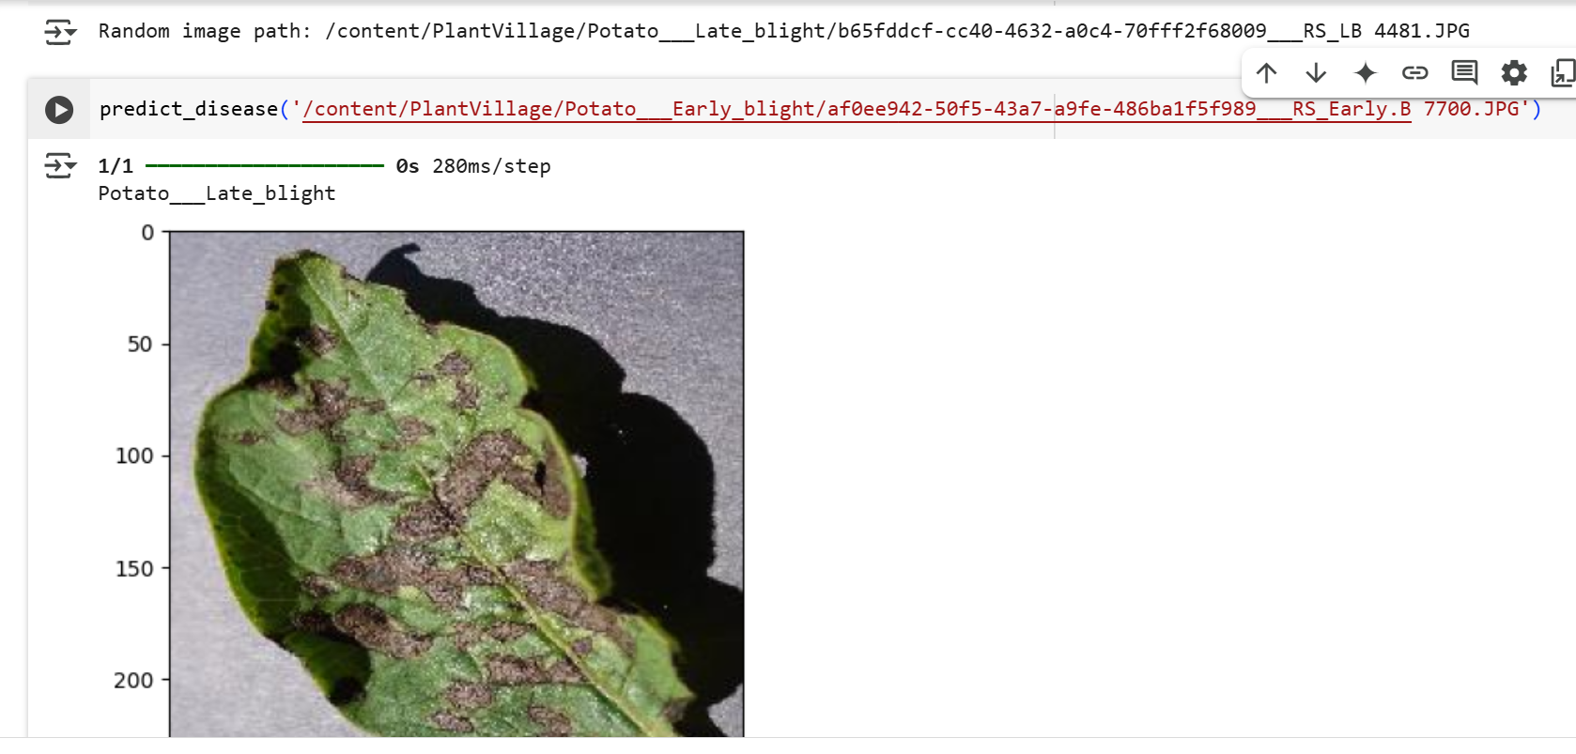

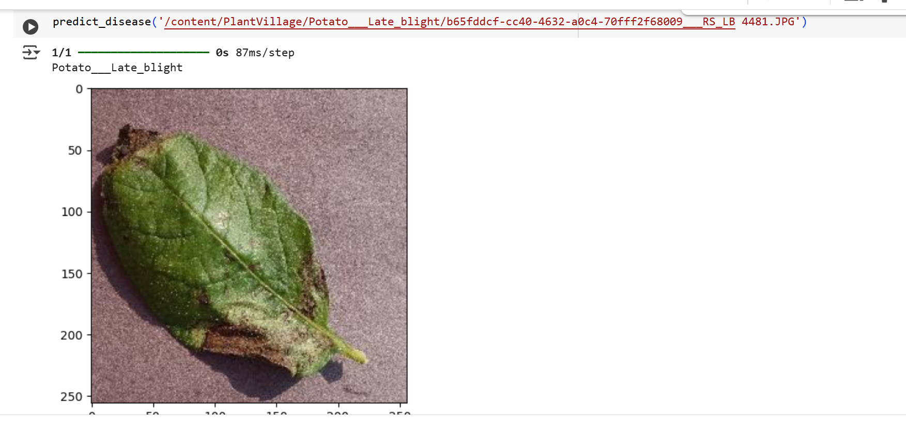

**Conclusion**

This project demonstrates the effectiveness of deep learning for plant disease detection. By utilizing a CNN model, the system automates the classification of plant diseases, enabling early diagnosis and better crop management. Future improvements could include integrating this model into a mobile application for real-time disease detection in the field.

**References**

* Kaggle PlantVillage Dataset
* Research papers on deep learning in agriculture
* PyTorch documentation

## **Objective:**

Developed an algorithm using deep learning, Image Processing and Fuzzy Inference system that allows the user to identify a disease caused by a particular micro-organism that is infested on the leaf of a plant and also successfully shows estimated health severity of the leaf based on how much of a leaf is infected.

[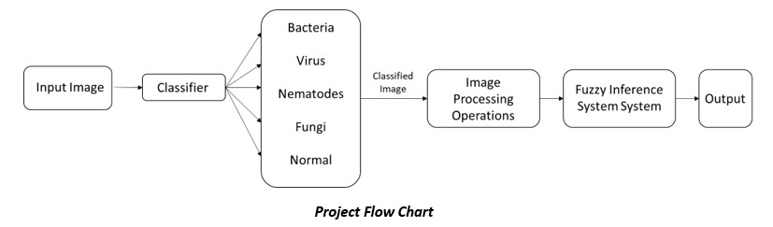](https://youtu.be/N7Jr5pAZFg8)

## **Methodology:**

### I. Neural Network Classifier

The deep learning algorithm studies the different dataset images and classifies into one of the 5 categories: Bacteria, Fungi, Virus, Nematode and Normal Leaf (Not infected at all)

[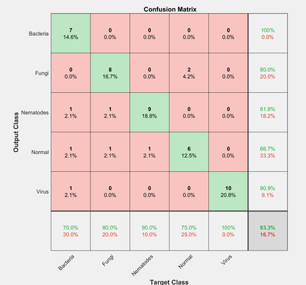](https://user-images.githubusercontent.com/73630123/119844591-3132b000-bf26-11eb-8151-0c4dc690b854.png)

After classifying feature extraction of the infected leaf has been done using Digital Image Processing technique.

### II. Image processing

Studied the images in the dataset and understanding the different patterns in which the organisms infect the leaf. Thus, the main objective of the technique of image processing is to extract the infected area of the leaf and isolating the background and the green part of the leaf. This would help us to highlight the only the infected area.

[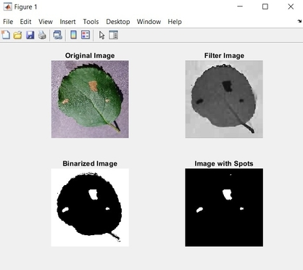](https://user-images.githubusercontent.com/73630123/119844877-6ccd7a00-bf26-11eb-94ed-bf3a323f05ee.jpg)

### III. Fuzzy Rule Base System

Finally after the feature extraction , to determine the health severity of the leaf in terms of percentage, a set of rules have been aggregated by using Fuzzy Inference System in MATLAB

[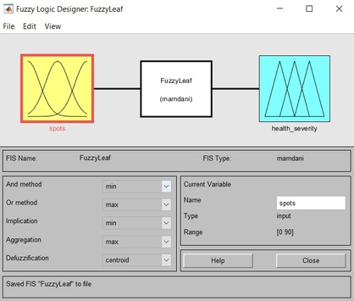](https://user-images.githubusercontent.com/73630123/119845058-95ee0a80-bf26-11eb-93ee-cfed52f258bd.jpg)

## **Result:**

[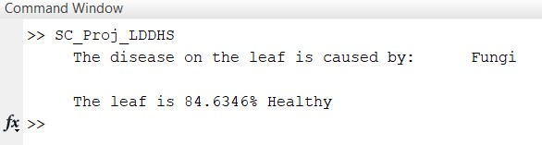](https://user-images.githubusercontent.com/73630123/119840931-04c96480-bf23-11eb-957d-14e49c01d3d9.jpg)