

Assignment 1

BY

AYESHA MAQSOOD
DEPARTMENT OF SOFTWARE ENGINEERING

Reg No. : FA24B1-SE-042
Submitted to : Sir Waqas Salim
Subject : Cloud Computing

Getting Started:
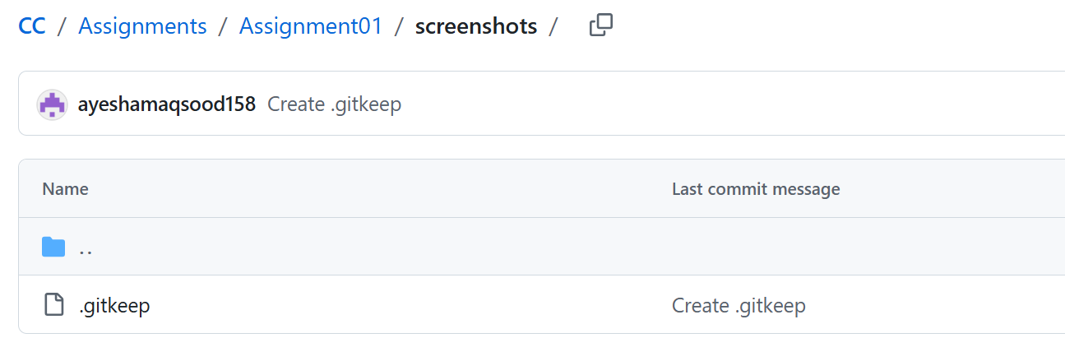
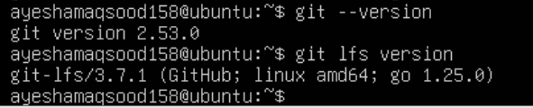

Task 1: Install Gitea and Push a Repository from the Ubuntu Server

Step 1.1: Install and Run Gitea on the Ubuntu Server
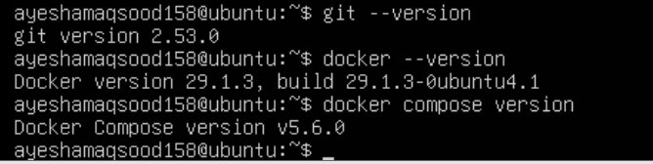
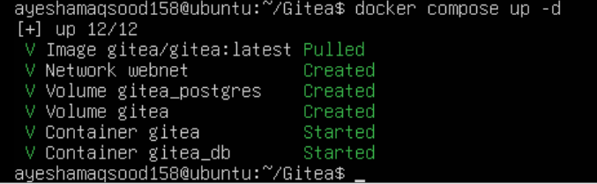
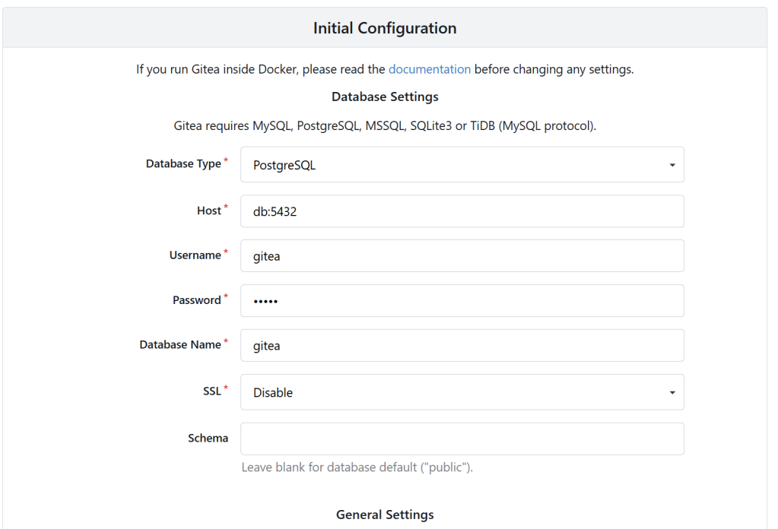
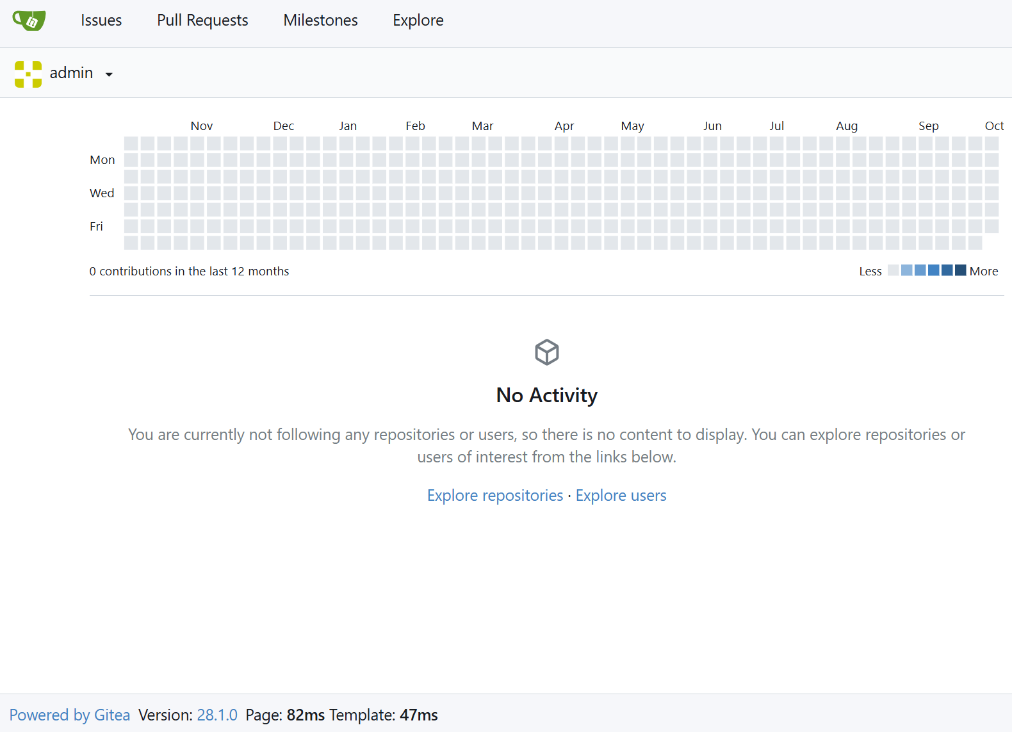
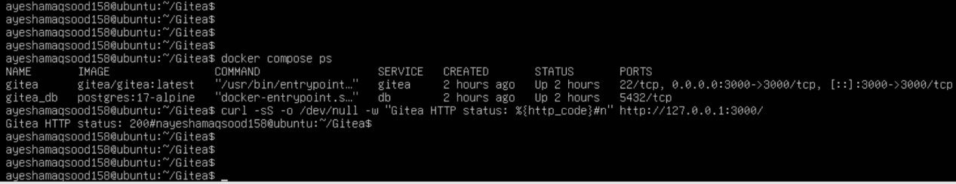

Step 1.2: Create and Push the Initial Repository
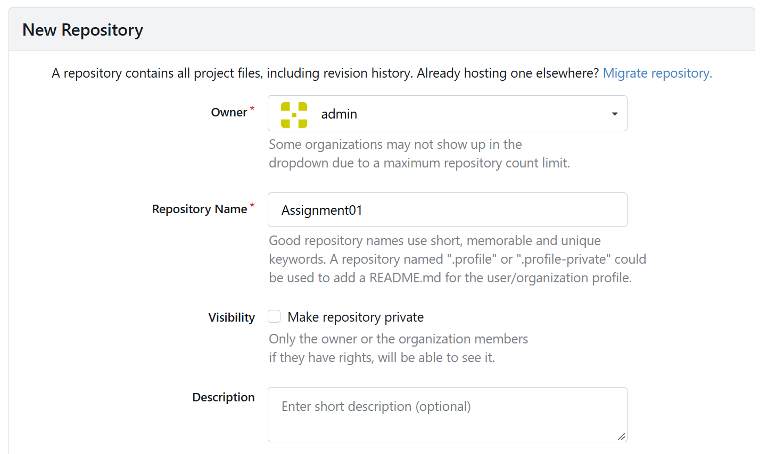
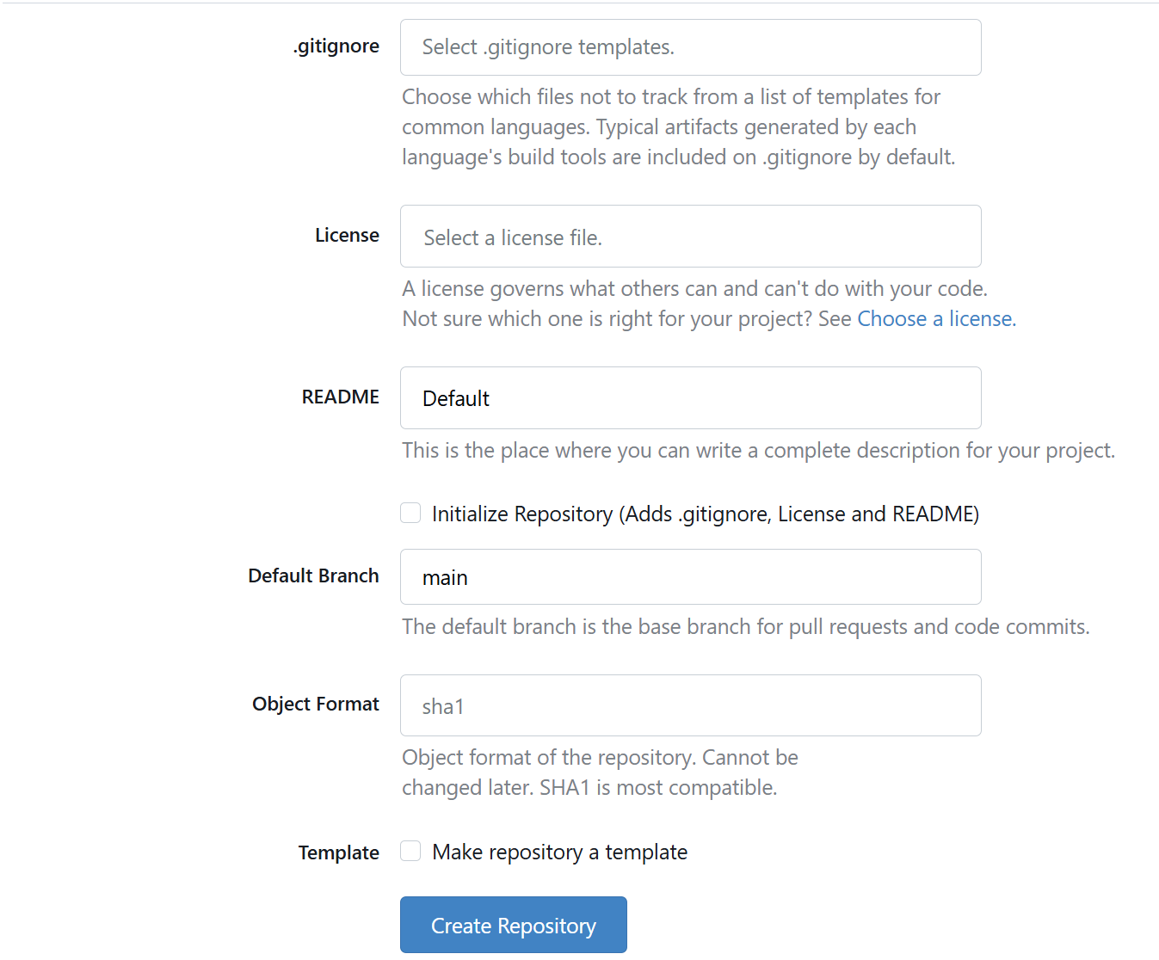
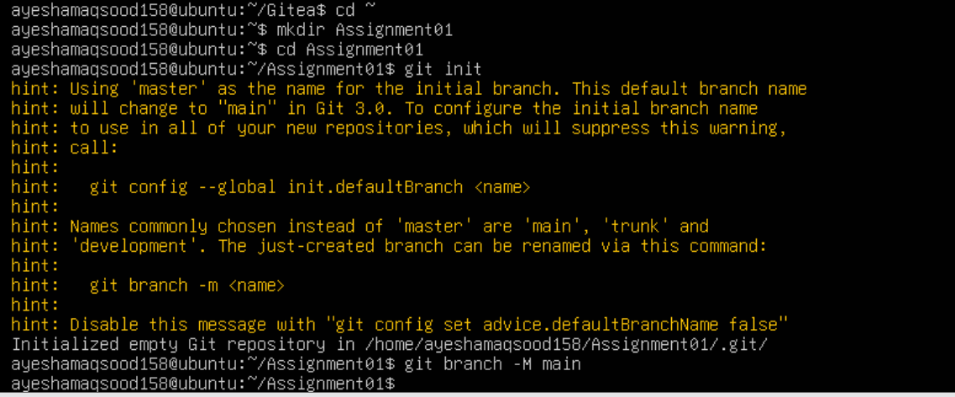
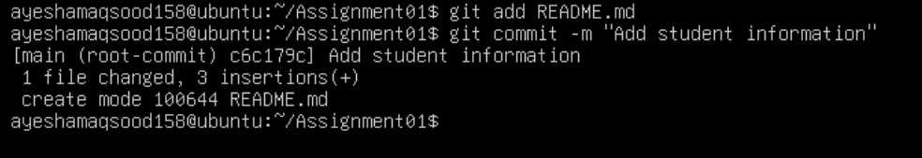
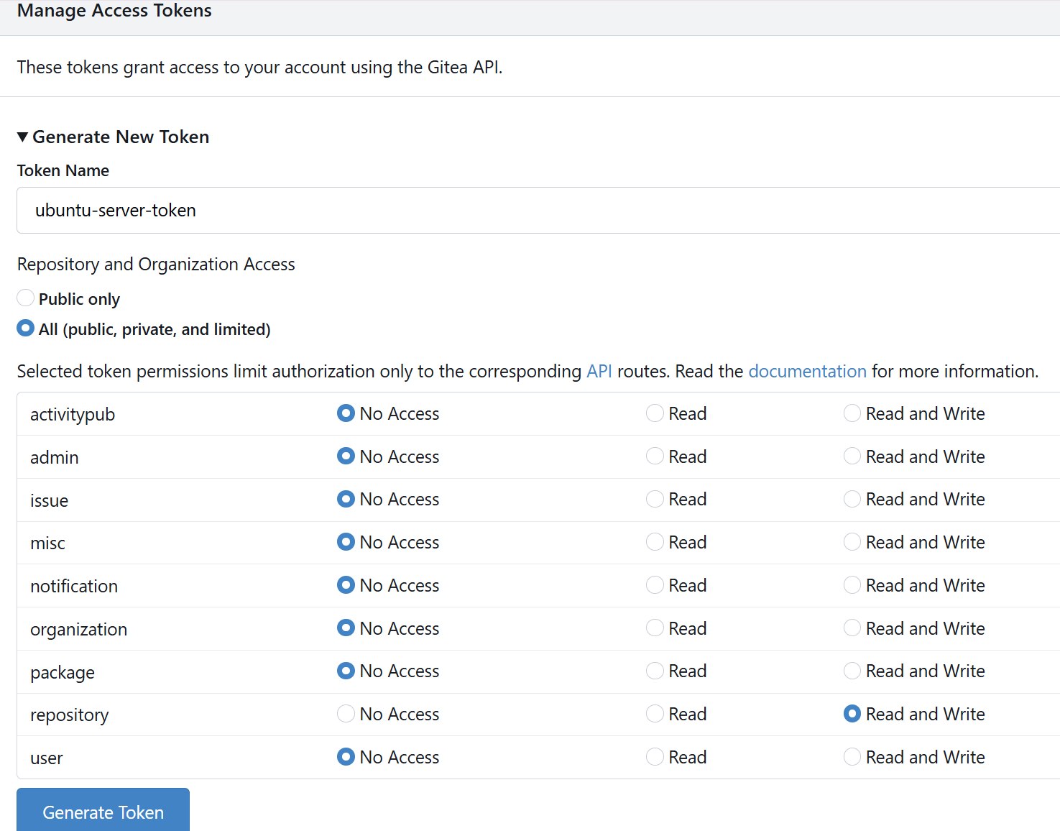
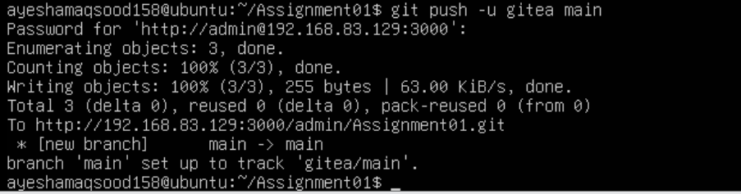

Step 1.3: Verify the Gitea Repository
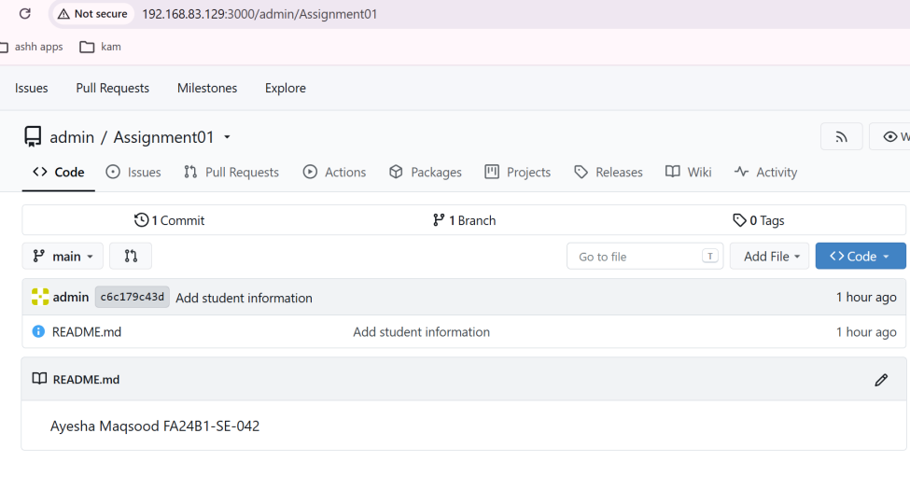

Task 2: Push the Same Repository to GitHub

Step 1.2: Create and Push the Initial Repository
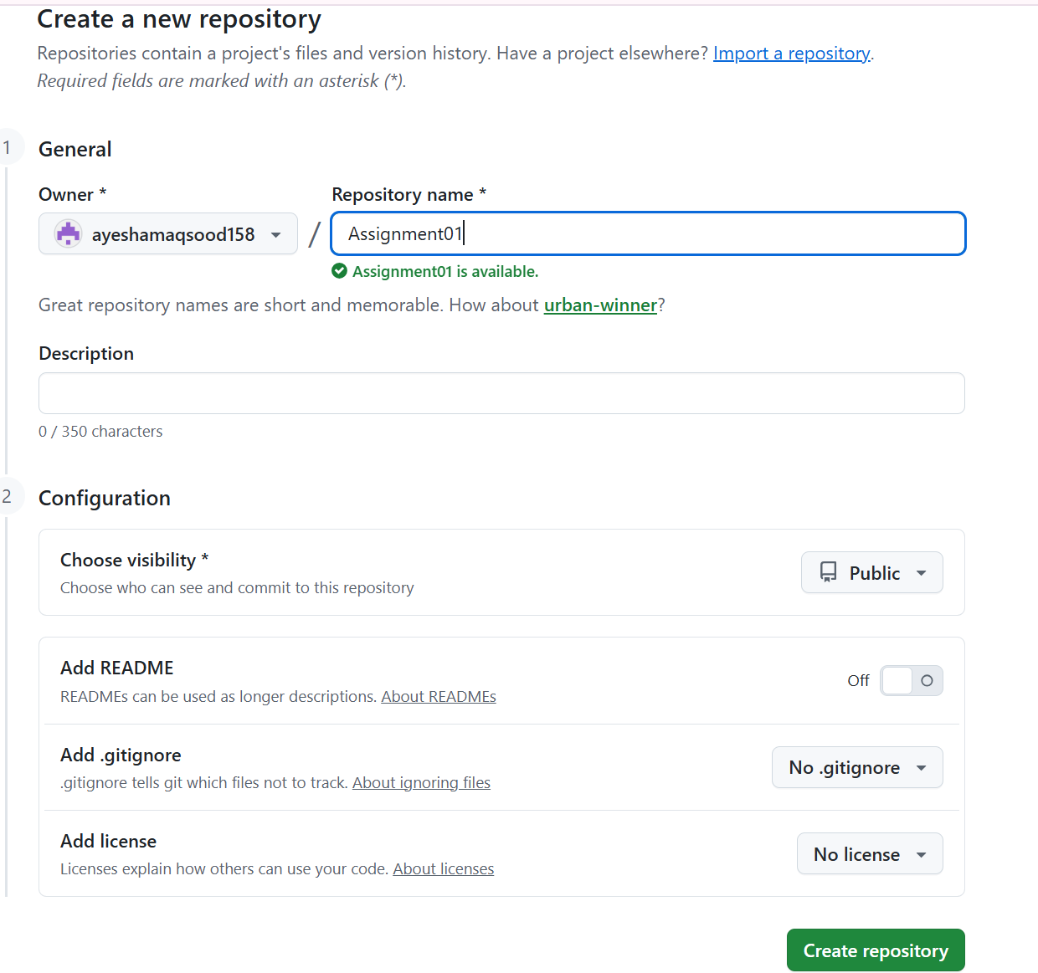

Step 2.1: Create the GitHub Repository and Verify Both Remotes
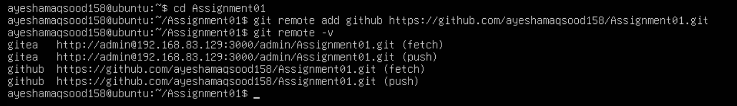

Step 2.2: Push to GitHub
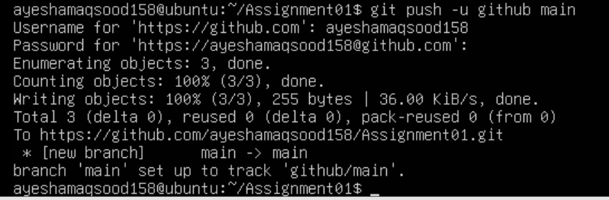

Step 2.3: Verify the GitHub Repository
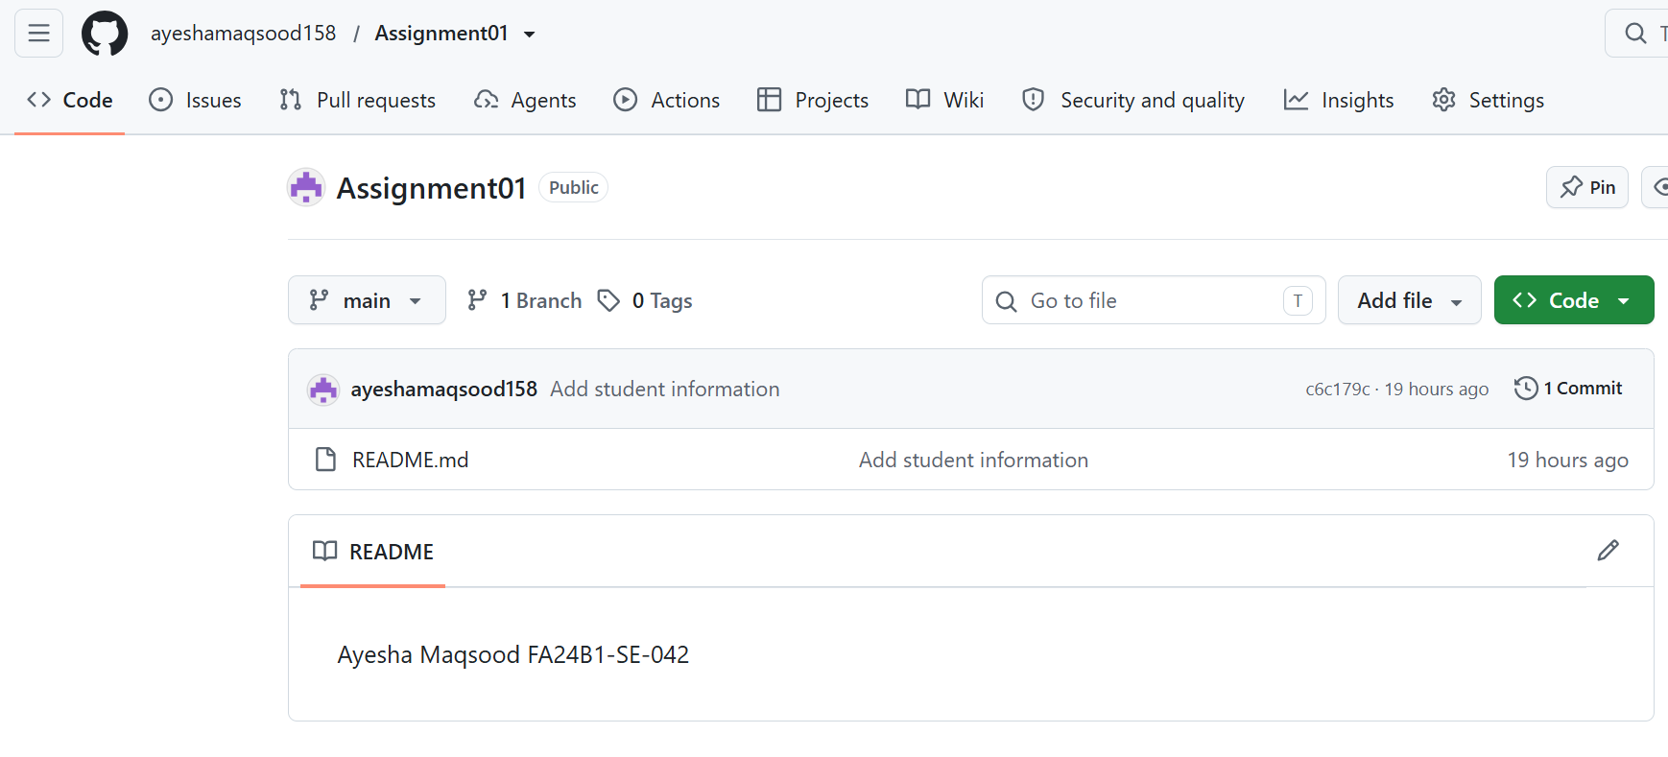

Task 3: Track Three Large Files with Git LFS

Step 3.1: Configure Git LFS
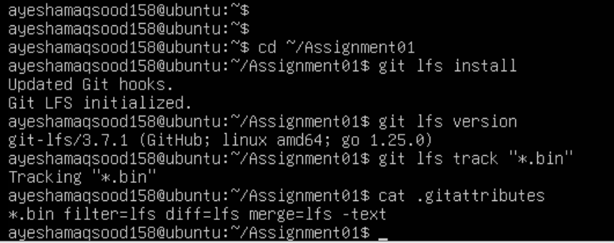

Step 3.2: Create and Verify Three LFS Files
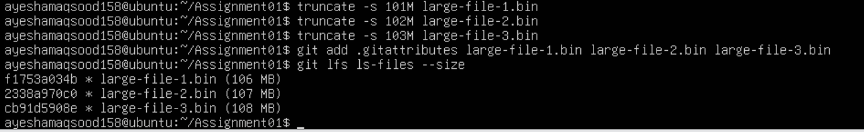

Step 3.3: Commit and Push the LFS Files
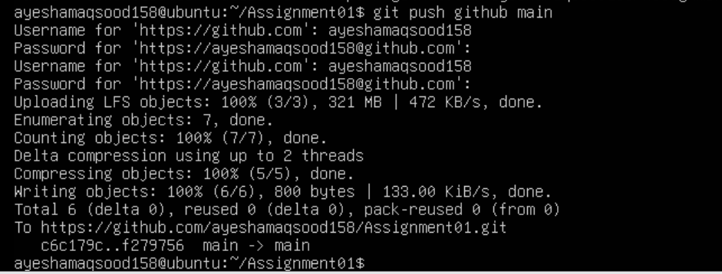

Task 4: Create a Portfolio or CV with GitHub Pages

Step 4.1: Create and Push the Portfolio Repository
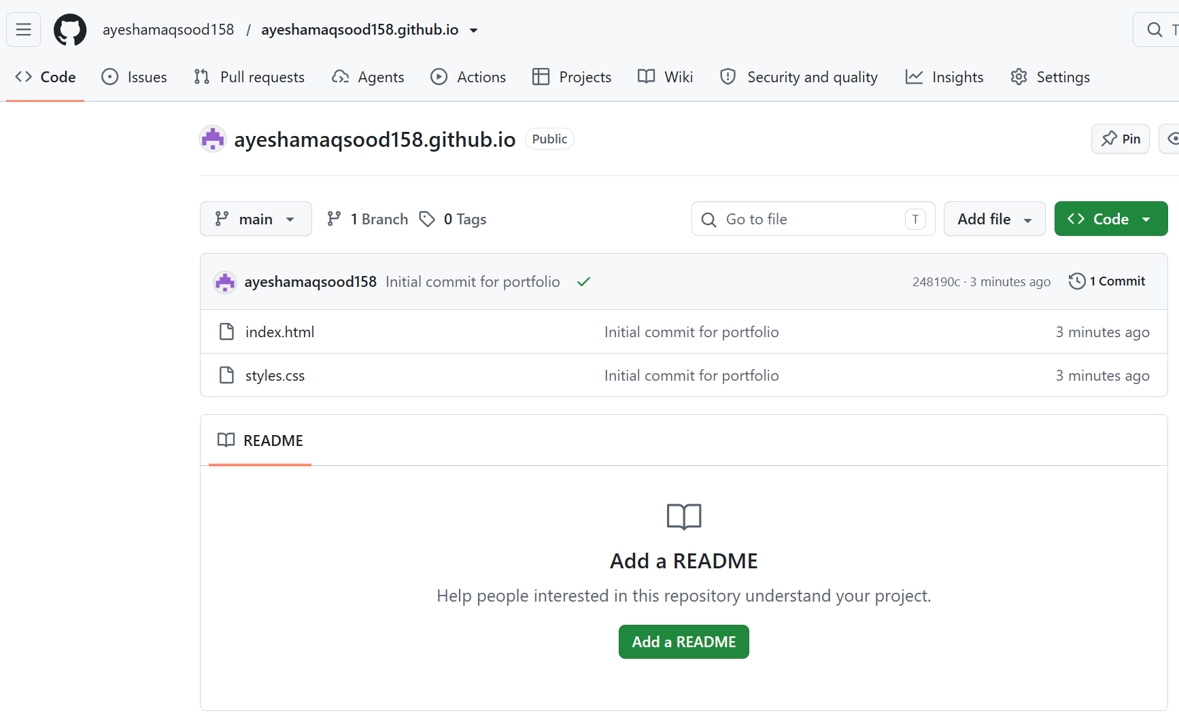

Step 4.2: Publish with GitHub Pages
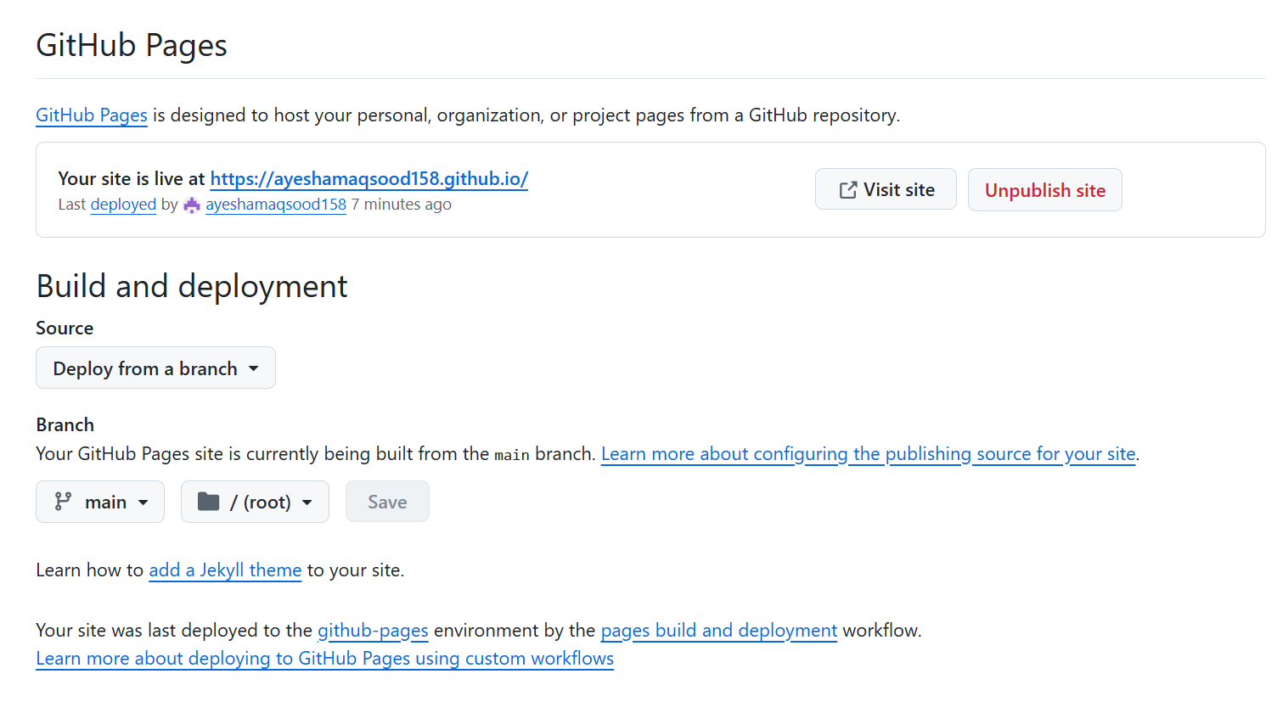

Step 4.3: Verify the Live Portfolio
