Name : Ayesha Maqsood Awan
Reg no: Fa24b1-se-070
Assignment: Assignment 01
Section: B
Course: Cloud Computing
Topic: Git, Gitea, GitHub, Git LFS, and GitHub Pages

Task 1 – Gitea

Gitea Installation
- Used Ubuntu Server as the working environment.
- Installed Docker and Docker Compose.
- Started the Gitea and PostgreSQL containers.
- Verified that both services were running successfully.
- Verified Gitea using the local HTTP request.
- Accessed Gitea through the Ubuntu server IP.
- Configured PostgreSQL as the database.
- Completed the Gitea installation and created the administrator account.

Figure 1 – Gitea running on Ubuntu Server
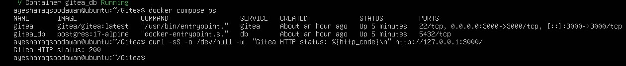 task1_gitea_running.png

Push Repository to Gitea
- Created a public Gitea repository named Assignment01.
- Created a local Git repository on Ubuntu.
- Initialized the repository with the main branch.
- Created README.md containing: o Full Name o Registration Number
- Committed the README file.
- Added Gitea as a remote named gitea.
- Successfully pushed the main branch to Gitea.

Figure 2 – Successful push to Gitea
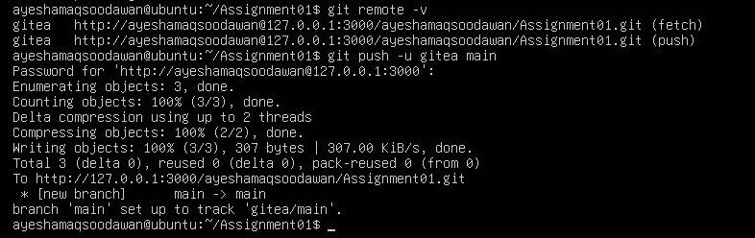 task1_gitea_push.png

Gitea Repository Verification
- Opened the Assignment01 repository in Gitea.
- Verified:
- Repository name o Owner
- Public visibility o README file o Student information

Figure 3 – Gitea Assignment01 repository
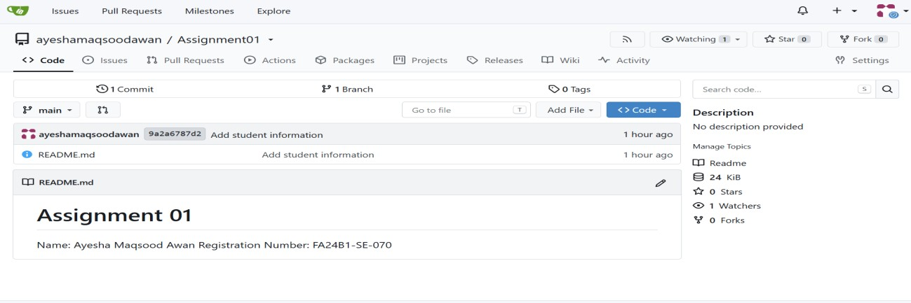 task1_gitea_repository.png

Result
- Gitea was successfully installed.
- Repository was successfully created and pushed.

Task 2 – GitHub

Configure Git Remotes
- Created a public GitHub repository named Assignment01.
- Used the same local repository from Task 1.
- Added GitHub as a second remote named github.
- Verified both remotes using git remote -v.
- The repository now had:
o gitea remote o github remote

Figure 4 – Gitea and GitHub remotes
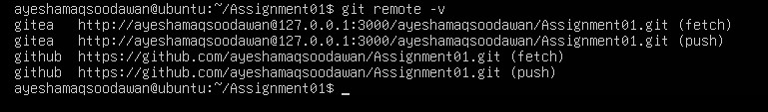

Push to GitHub
- Pushed the main branch to GitHub.
- GitHub authentication was completed successfully.
- Push completed without errors.

Figure 5 – Successful GitHub pushtask2_remotes.png

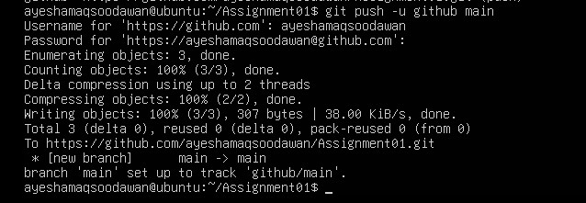 task2_github_push.png

GitHub Repository Verification
- Opened the GitHub Assignment01 repository.
- Verified:
- Repository name o Owner
- Public visibility o README file o Student information

Figure 6 – GitHub Assignment01 repository

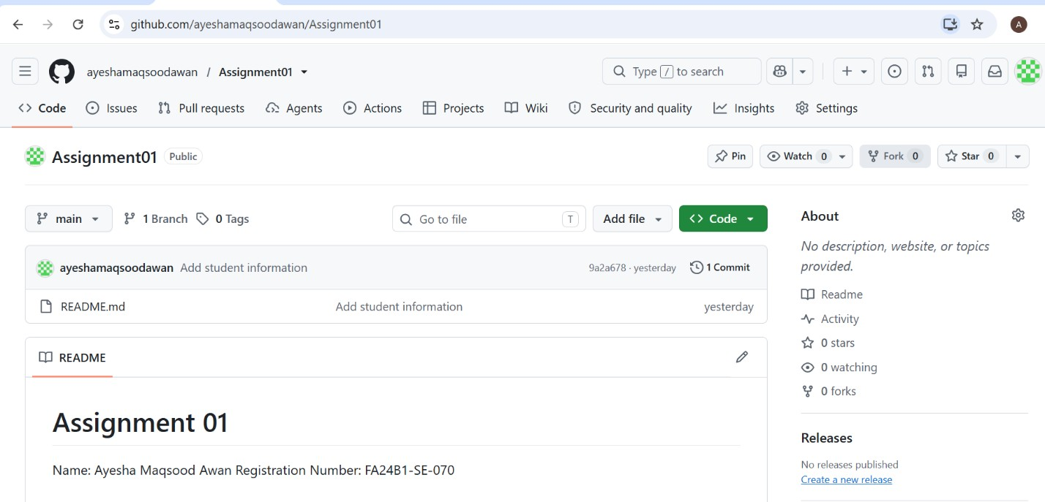 task2_github_repository.png
Result
• The same local repository was successfully pushed to both Gitea and GitHub.

Task 3 – Git LFS

Git LFS Setup
- Initialized Git LFS in the Assignment01 repository.
- Verified the installed Git LFS version.
- Configured .bin files to be tracked using Git LFS.
- Verified the .gitattributes file.

Figure 7 – Git LFS setup
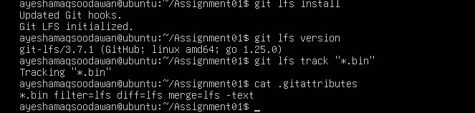 task3_lfs_setup.png

Large File Creation
• Created three binary files:

o large-file-1.bin – 101 MiB o large-file-2.bin – 102 MiB o large-file-3.bin – 103 MiB
- Added the files to Git.
- Verified that all three files were tracked by Git LFS.

Figure 8 – Git LFS tracked files
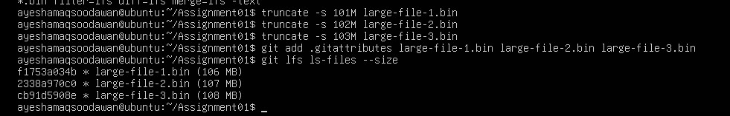 task3_lfs_files.png

Git LFS Push
- Committed the three large files.
- Pushed the commit to GitHub.
- Git LFS uploaded the large file objects successfully.
- Push completed successfully.

Figure 9 – Successful Git LFS push
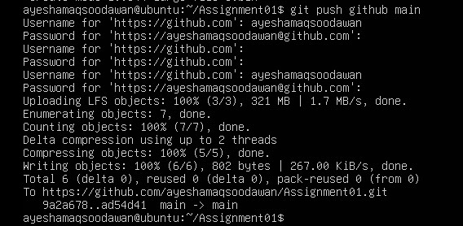 task3_lfs_push.png

Result
• Three files larger than 100 MiB were successfully managed and pushed using Git LFS.

Task 4 – GitHub Pages Portfolio

Portfolio Creation
- Created a personal portfolio website using HTML and CSS.
- Created the following files:
o index.html o styles.css
• Added the following sections:
o About Me o Education o Skills o Projects
- Used a green, white, and black design.
- Created a GitHub repository named salehataj.github.io.
- Pushed the portfolio to the main branch.

Figure 10 – Portfolio GitHub repository
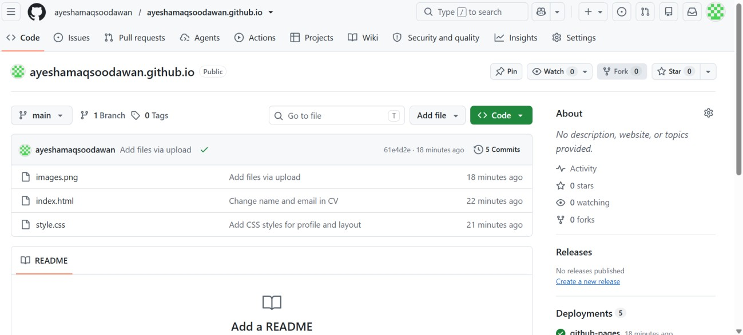

GitHub Pages Deployment
- Opened the repository's Settings → Pages.
- Selected deployment from the main branch.
- Selected the root directory / (root).
- Saved the configuration.
- GitHub Pages successfully deployed the website.
- Generated live website URL: https://salehataj.github.io/

Figure 11 – GitHub Pages deployment
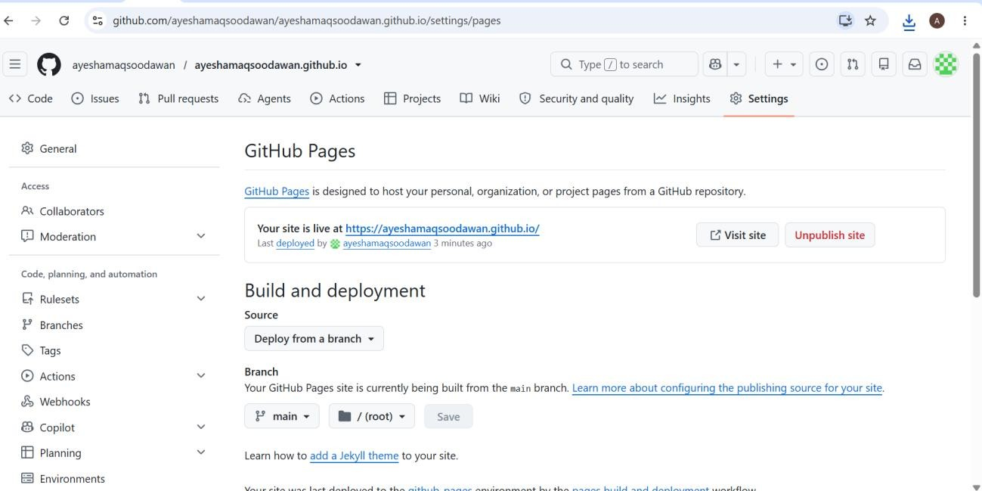 task4_pages_repository.png

Live Portfolio
- Opened the GitHub Pages URL in the browser.
- Verified that the website was publicly accessible.
- Confirmed that the portfolio content was displayed correctly.

Figure 12 – Live portfolio website


Result
• The portfolio website was successfully created and published using GitHub Pages.

