AYESHA MAQSOOD AWAN
FA24B1-SE-070
CLOUD COMPUTING
LAB 01
SUBMITTED TO: SIR SHOAIB

Task 1: Create and Configure your github account
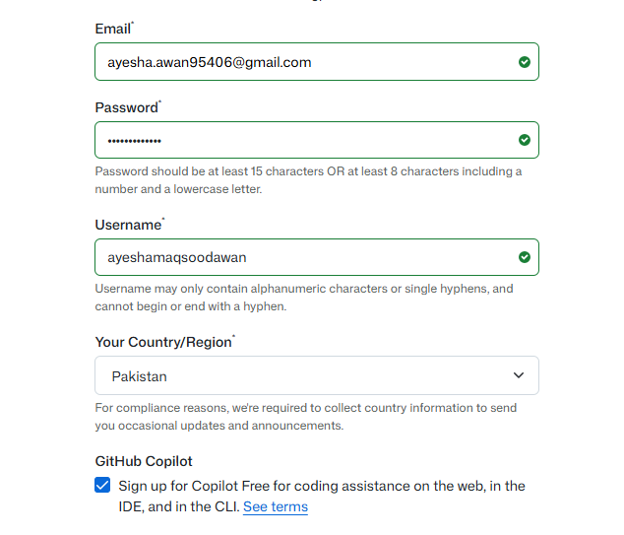

github_ayeshamaqsoodawan.png

Screenshot 1:
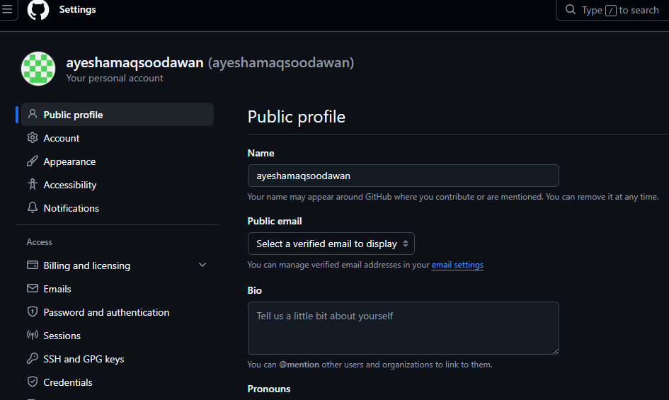
Github profile showing my profile name and username
Screenshot 2:
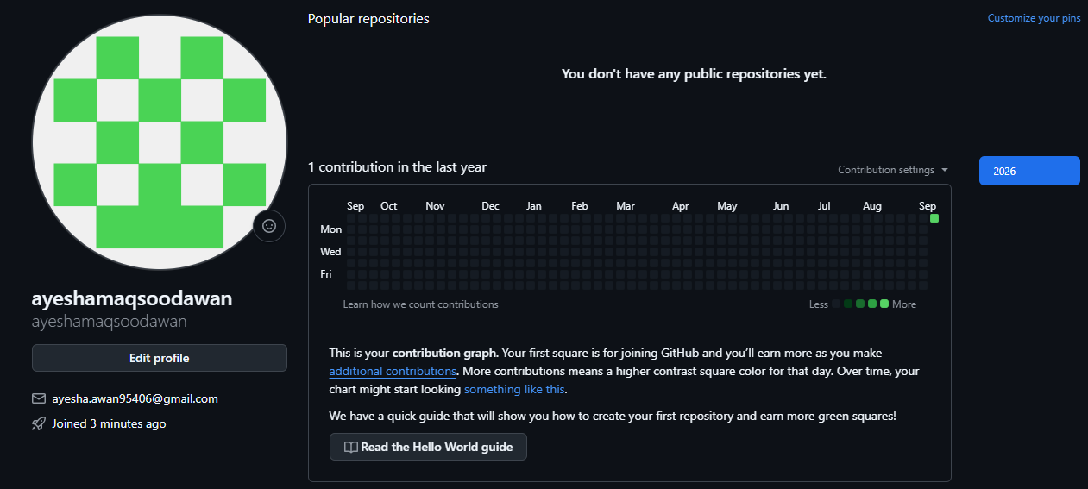
github_ayeshamaqsoodawan.png

Task 2: Register in student marks portal
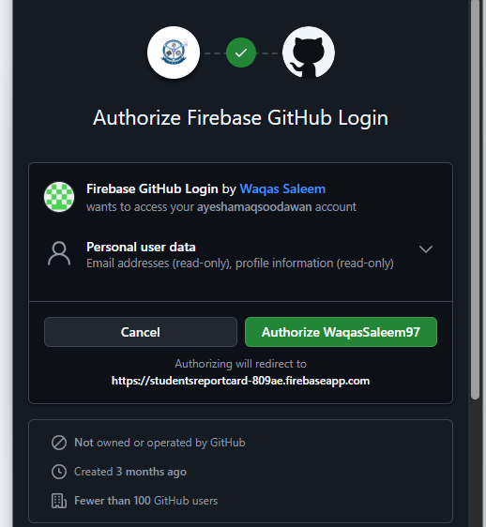
Portal_login_page.png

Screenshot 1:
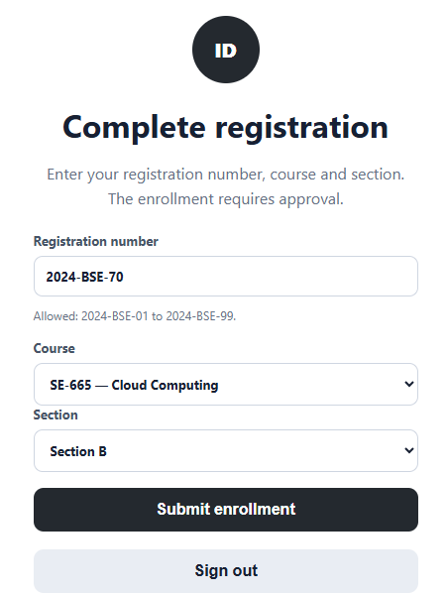
Portal_github_profile.png

Screenshot 2/3:
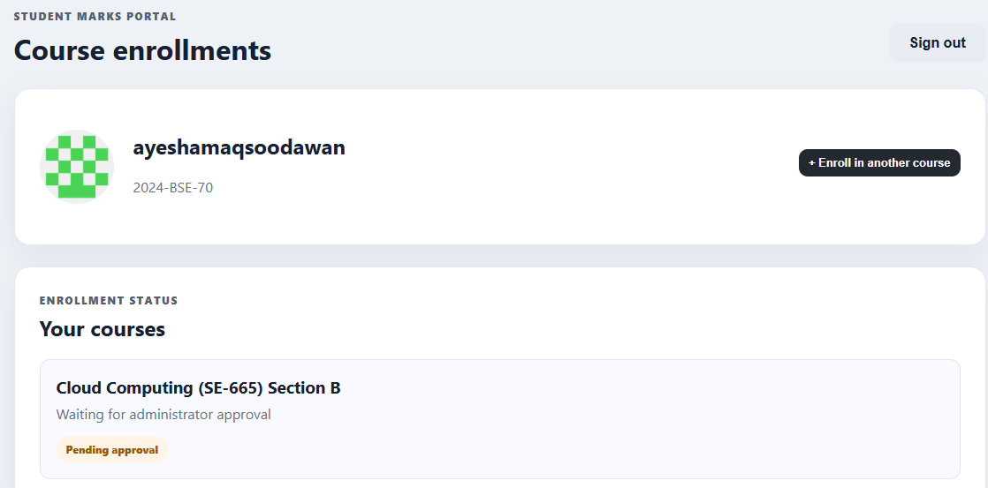
Portal_enrollment_submitted.png

Task 3: Download VMware Workstation Pro and Ubuntu Server
Screenshot 1:
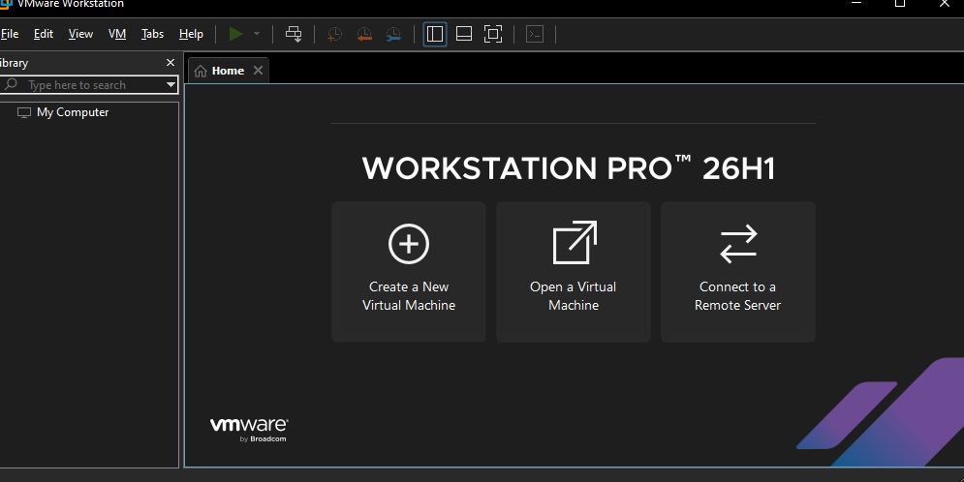
vmware_workstation.png
Screenshot 2:
Ubuntu server ISO filename.

Screenshot 3:
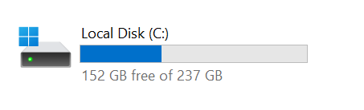
Available storage showing atleast 20 GB free space.

Task 4: Create the ubuntu server virtual machine
Screenshot 1:New VM Wizard
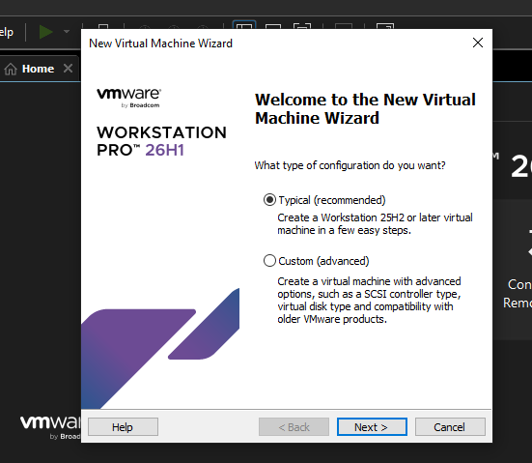
vm_creation_wizard.png

Screenshot 2: Typical configuration
vm_typical_configuration.png

Screenshot 3:Ubuntu ISO selected
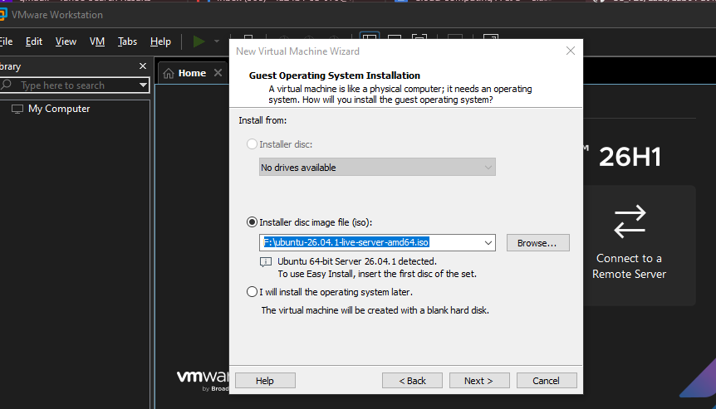
vm_ubuntu_iso_selected.png

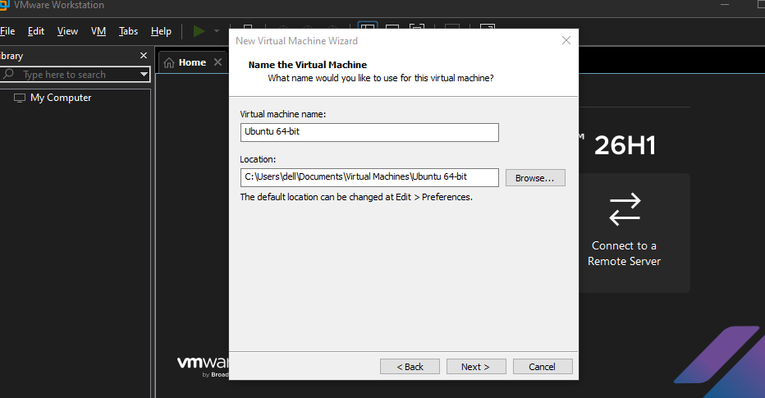

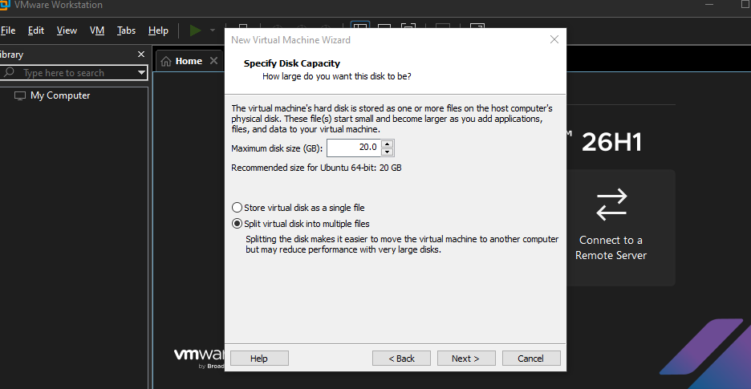

Screenshot 4: VM configuration summary
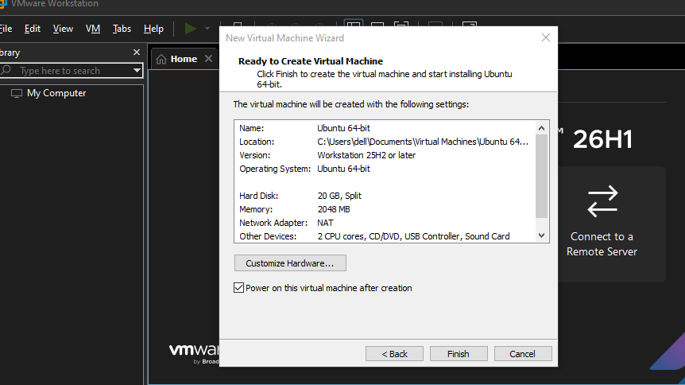vm_configuration_summary.png

Screenshot 5:Ubuntu boot server
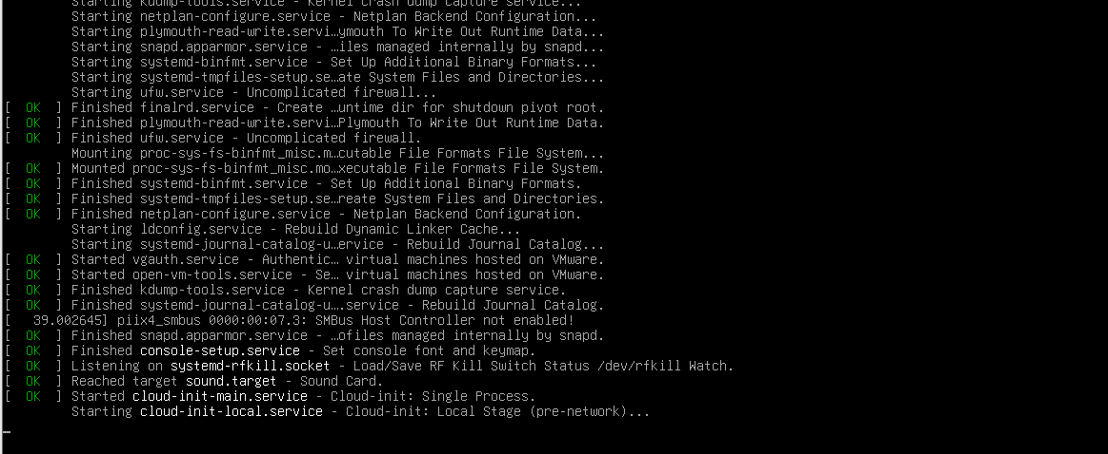
ubuntu_installer_boot.png

Task 5: Choose the Installation Language.
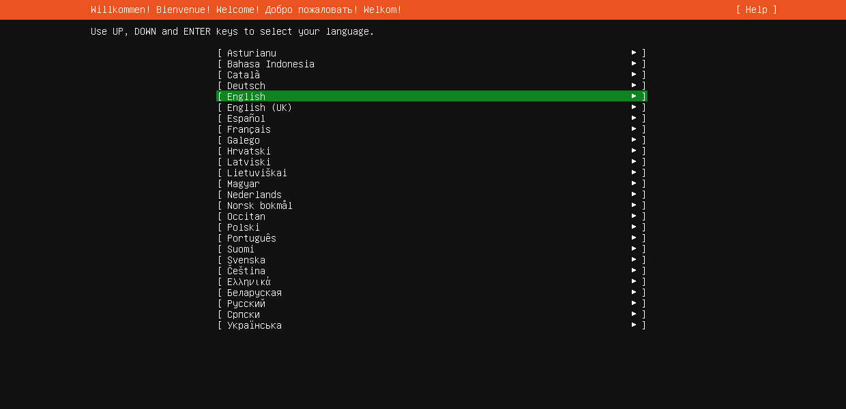
ubuntu_language.png

Task 6:Configure keyboard layout
Screenshot 1:
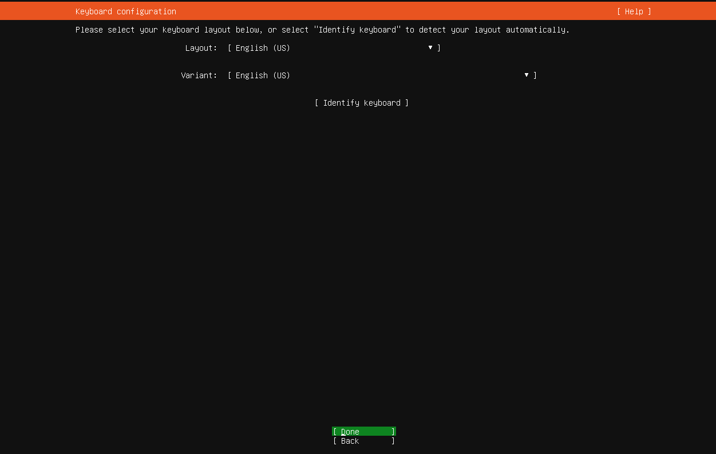

Screenshot 2:
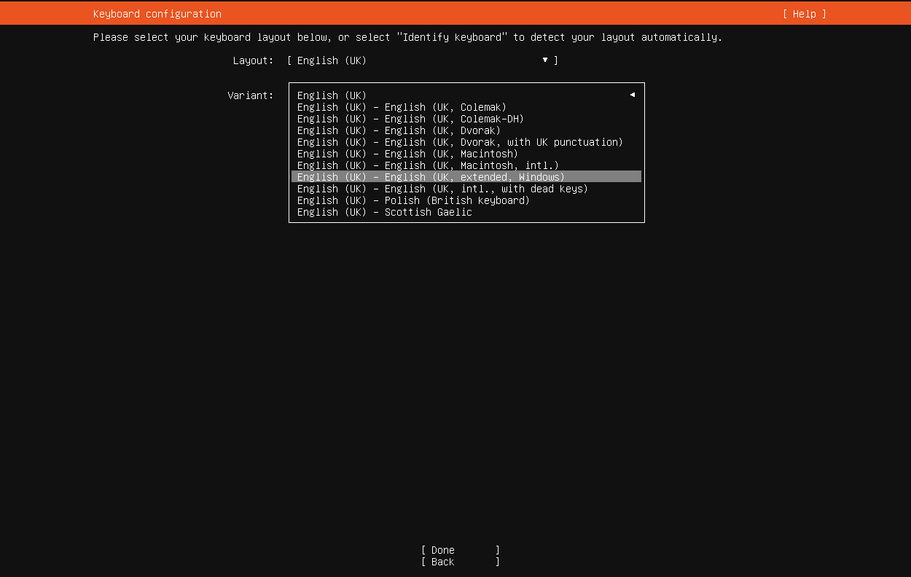
ubuntu_keyboard_variant.png

Task 7: Choose the Ubuntu Server Installation Type
Screenshot 1:
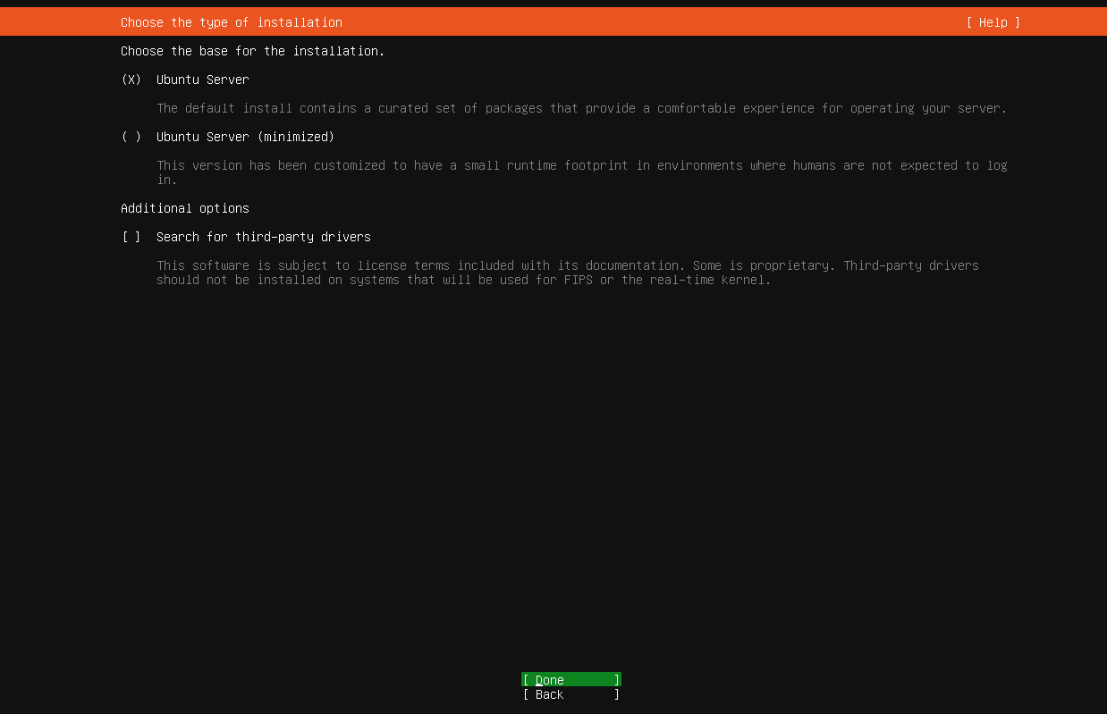
Normal Ubuntu Server installation option selected.

Task 8: Configure the network
Screenshot 1:
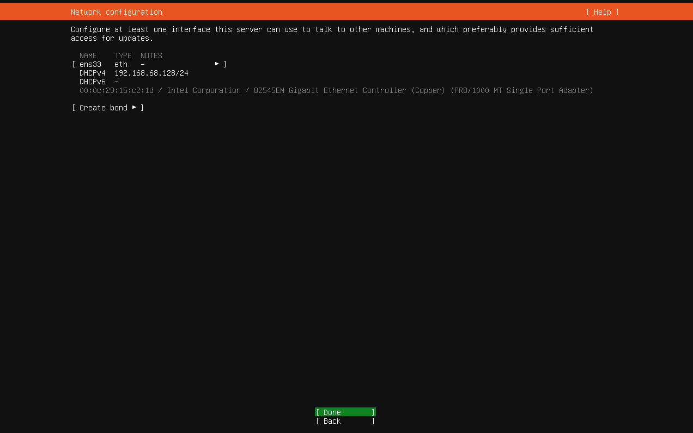

Screenshot 2:

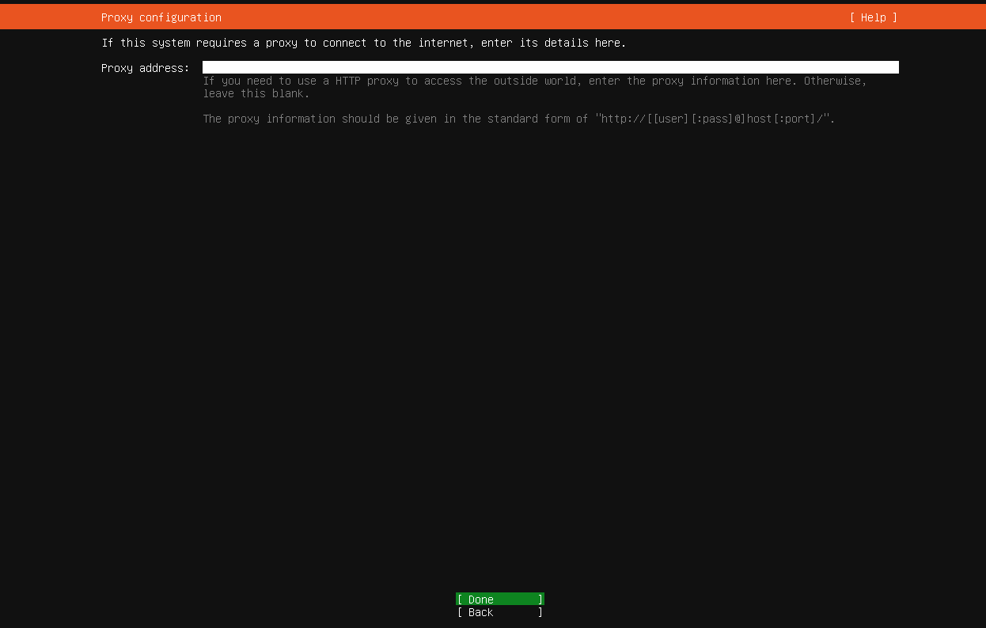
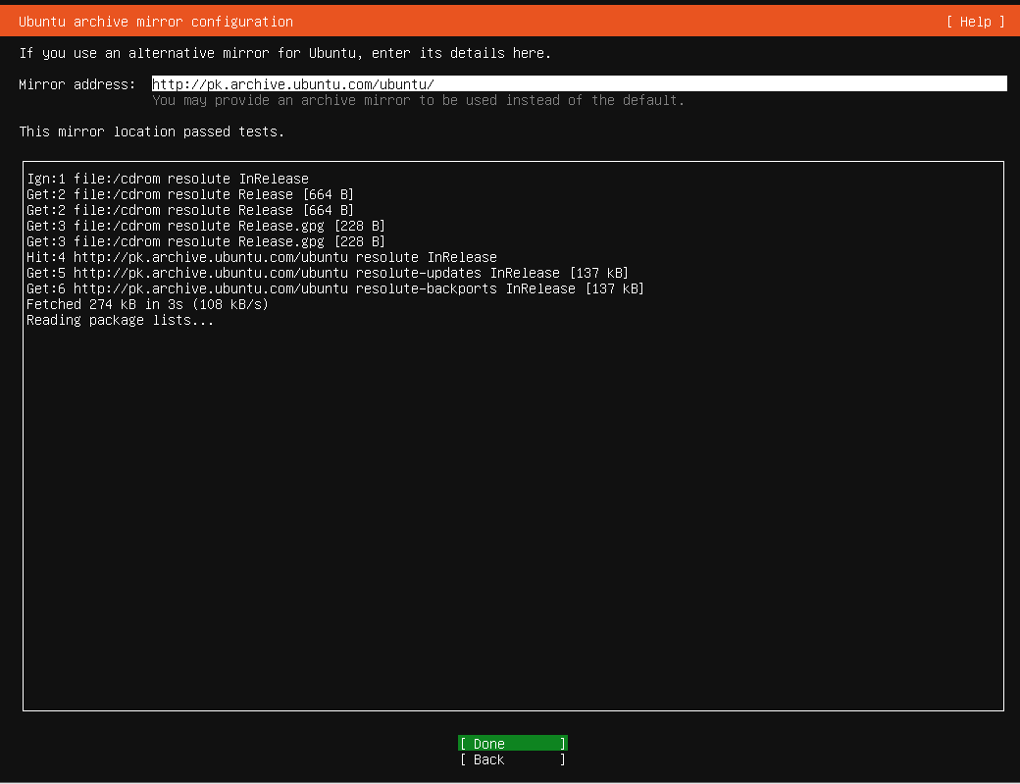

Task 9: Configure Storage
Screenshot 1:

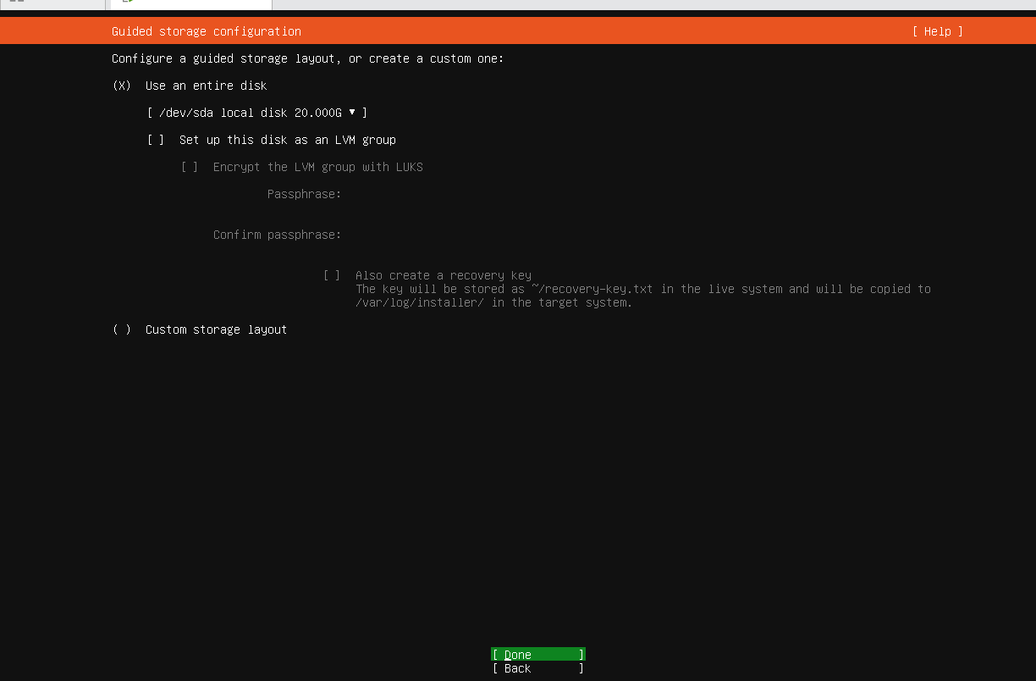

Screenshot 2:
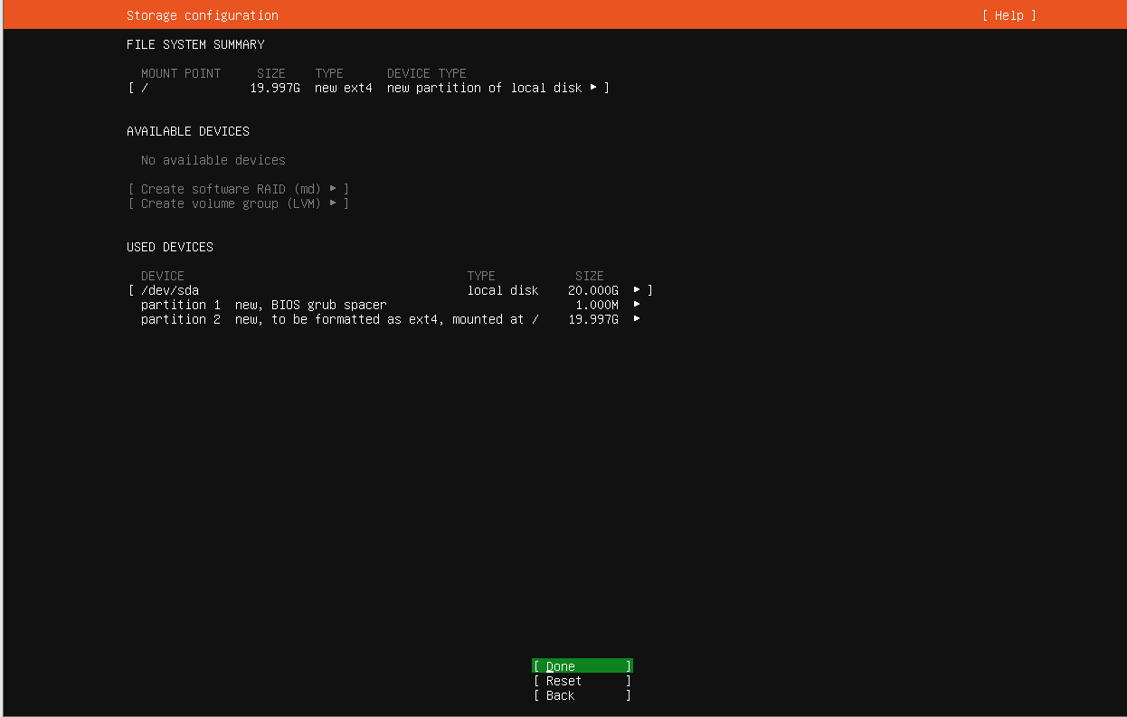

Task 10: Select the installation Disk
Screenshot 1:
Screenshot 2:
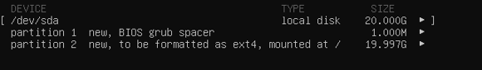

Task 11: Review the partitions
Screenshot 1:
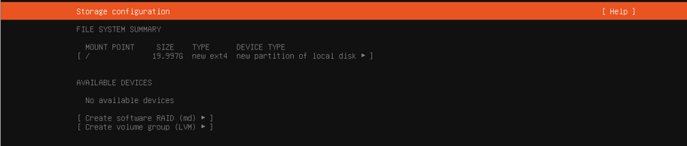

Task 12: Configure the storage changes
Screenshot1: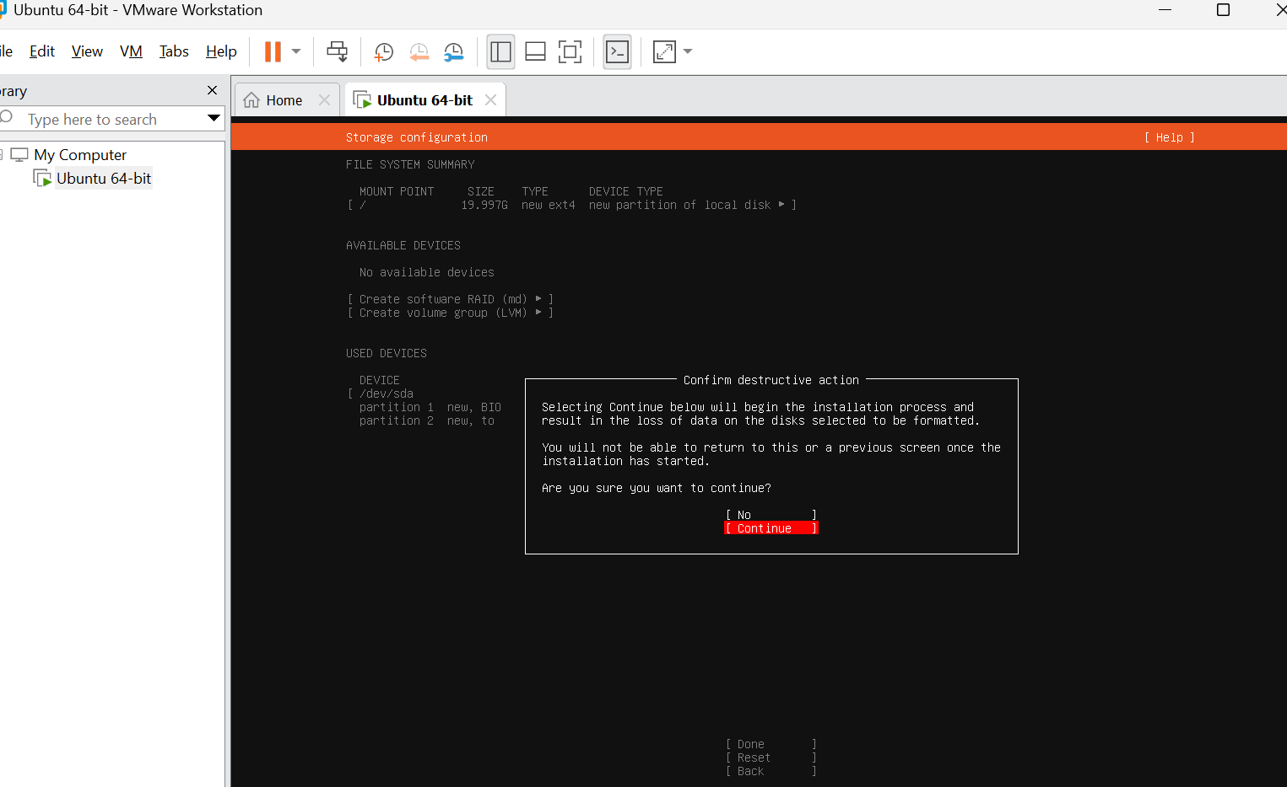

Screenshot 2: Storage changes confirmation.
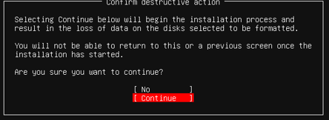

Task 13: Configure the Ubuntu profile
Screenshot 4: Complete profile setup.
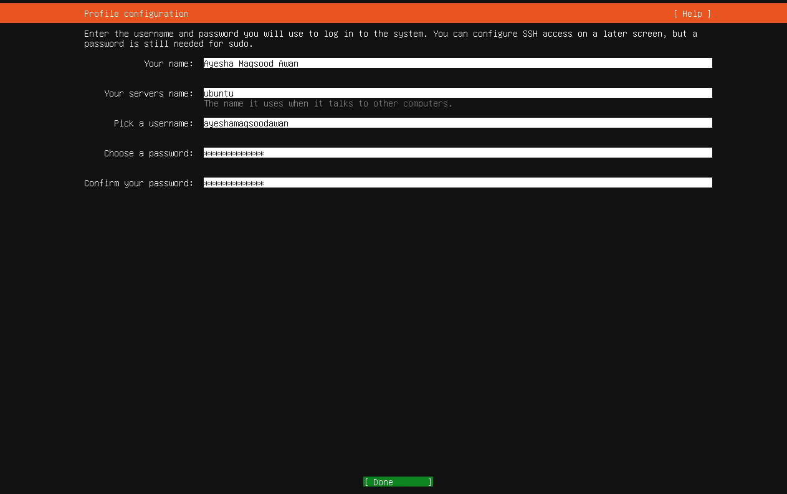
Screenshot 1:Profile showing actual name
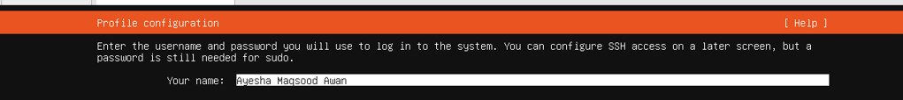

Screenshot 2: server name set to ubuntu.
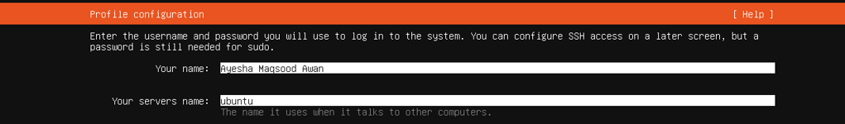
Screenshot 3: username matching github username.

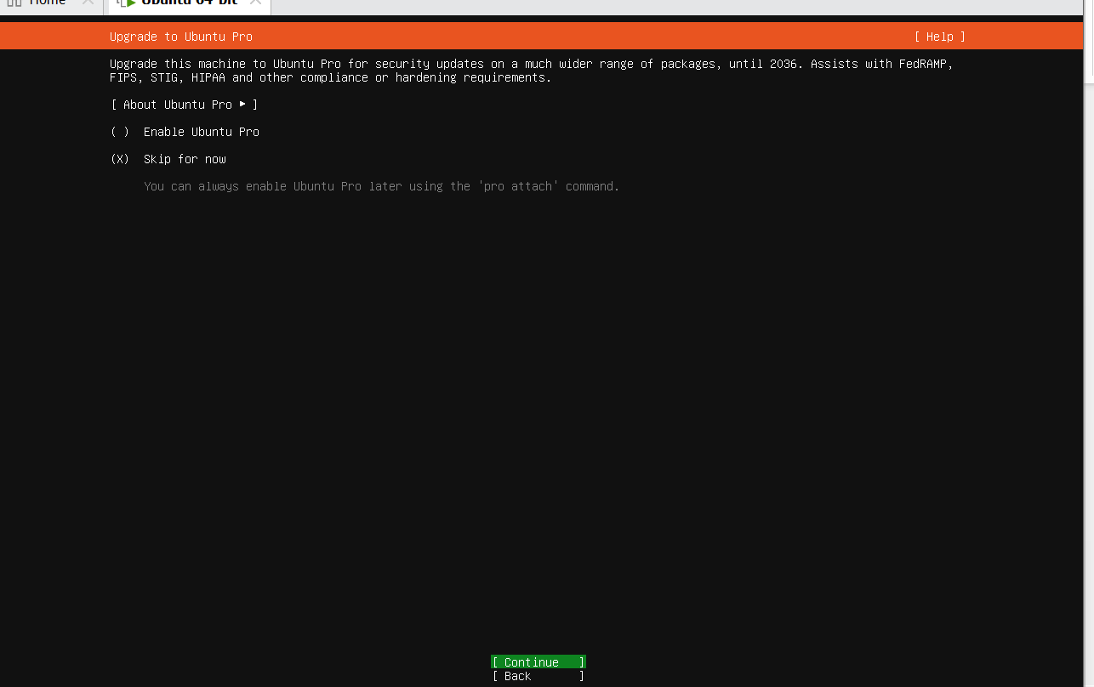

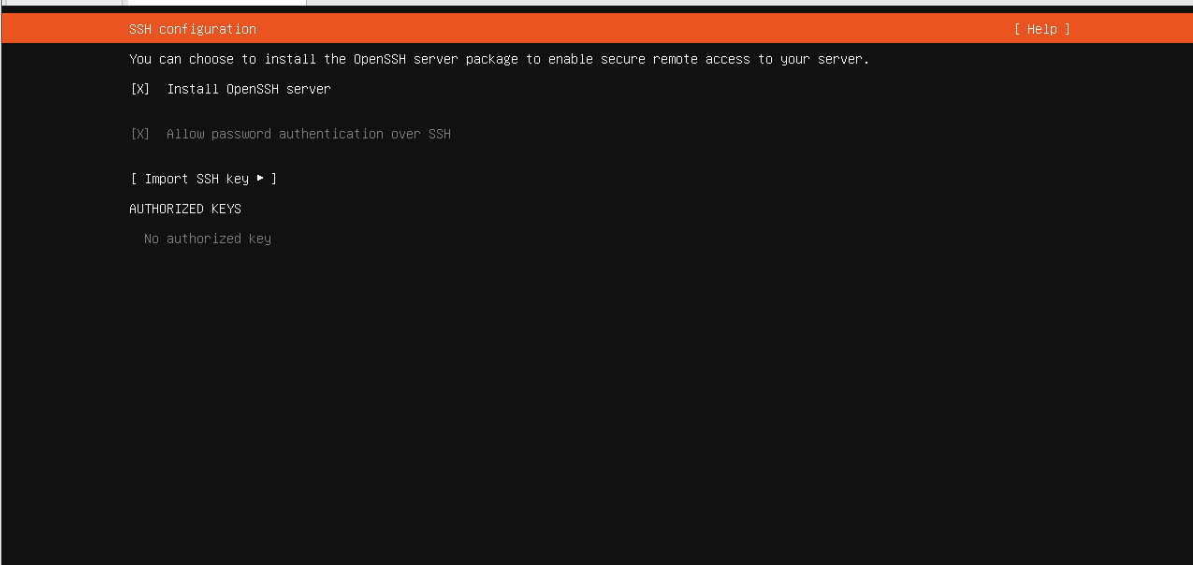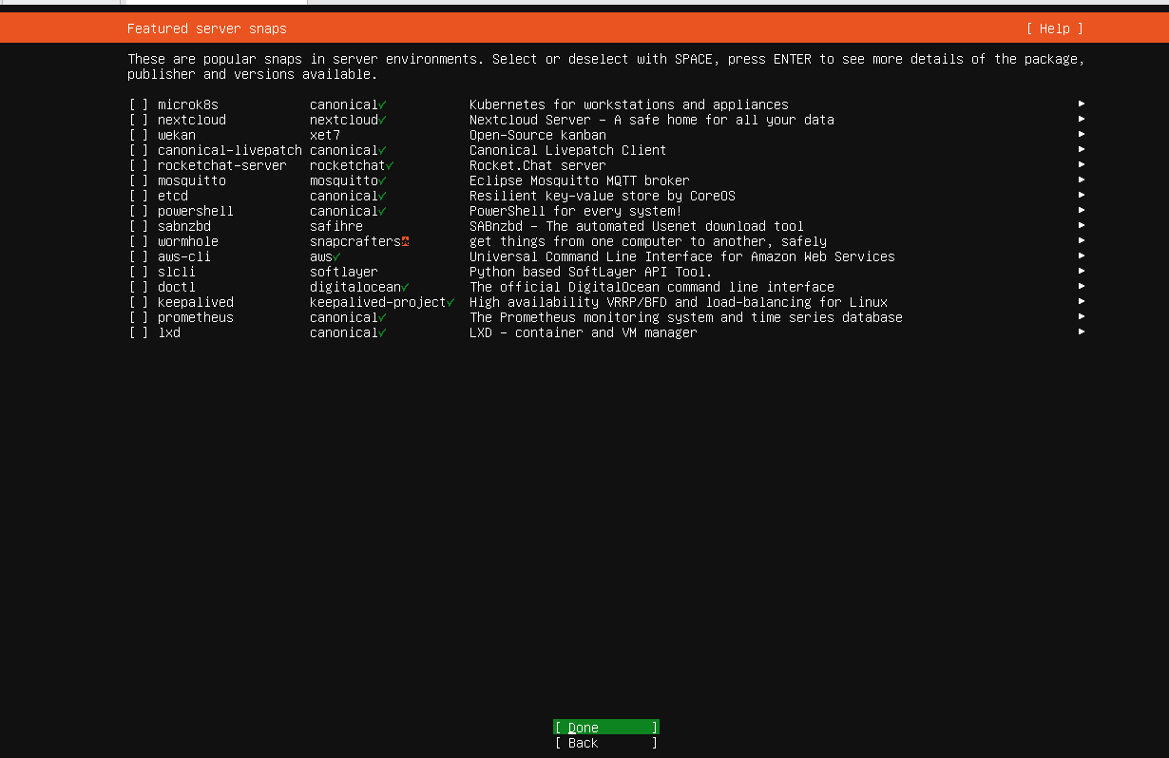

Task 14: Complete the Software Installation
Screenshot 1:
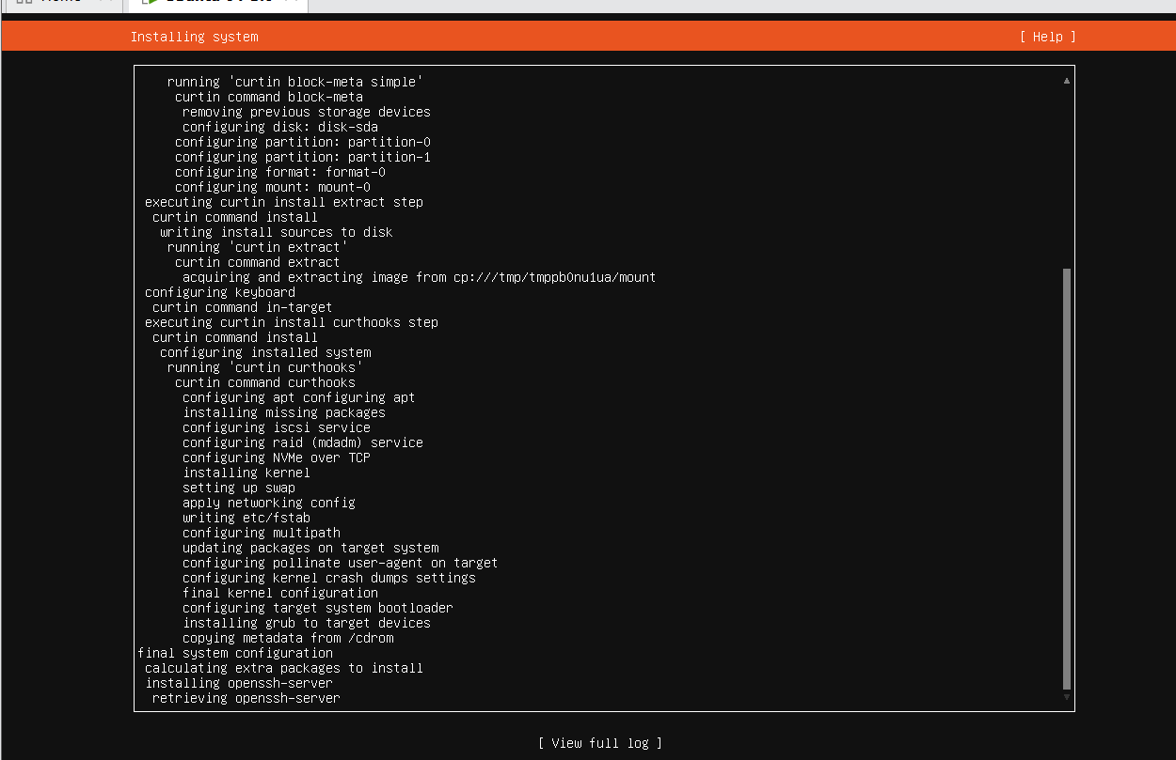

Task 15: Reeboot and verify the ubuntu identity
Screenshot 1:
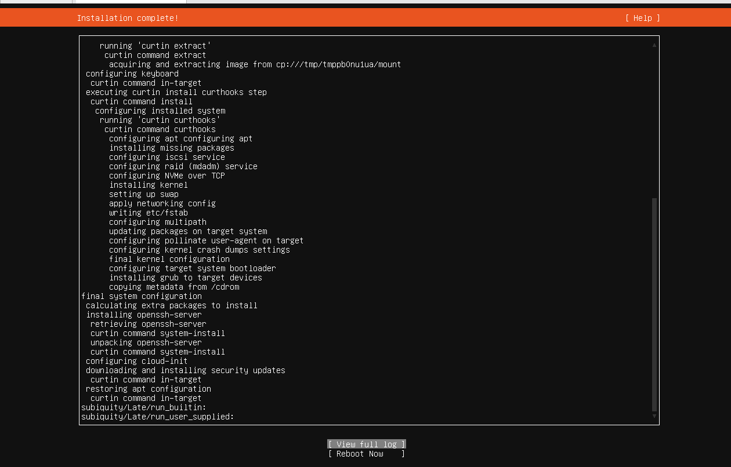
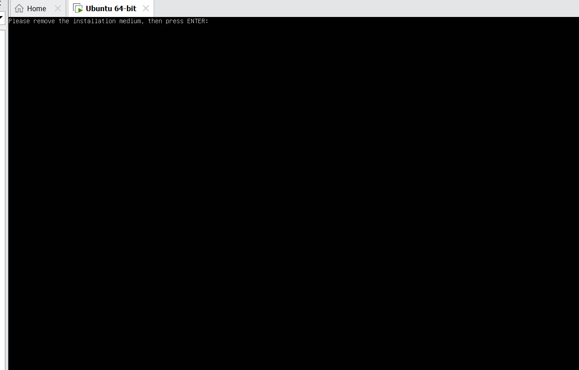

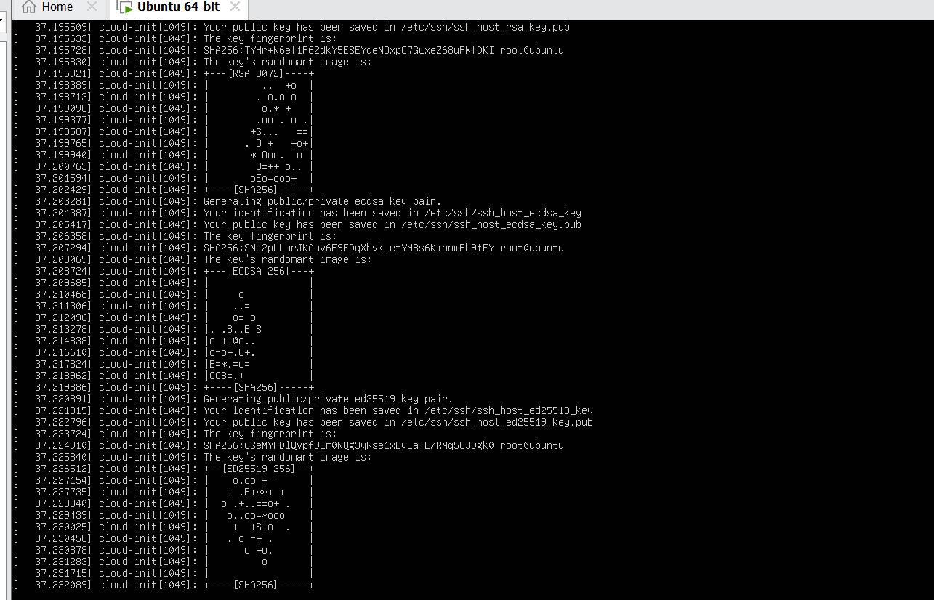
Screenshot 2: Ubuntu login screen
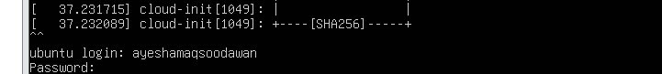
Screenshot 3:Successful terminal login
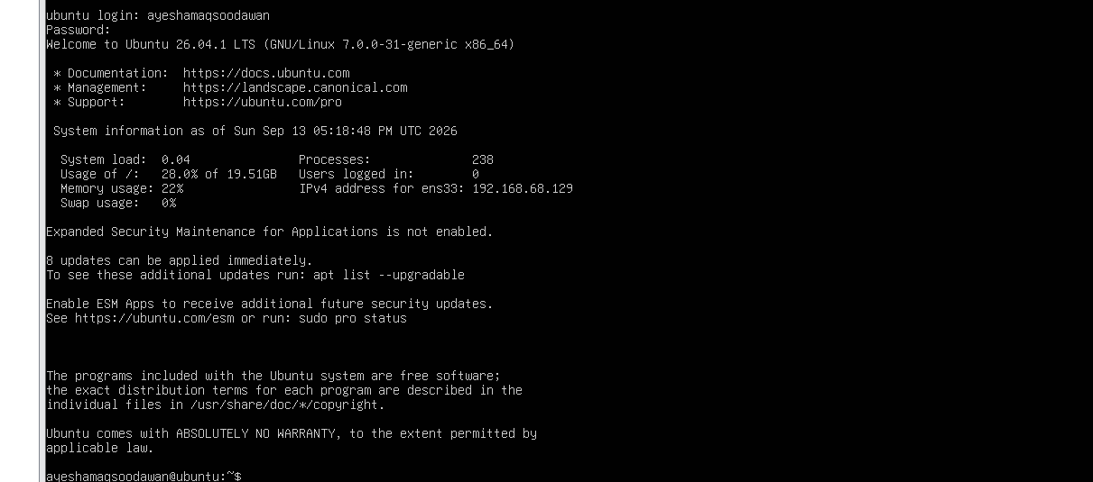
Screenshot 4:<github-username>@ubuntu prompt

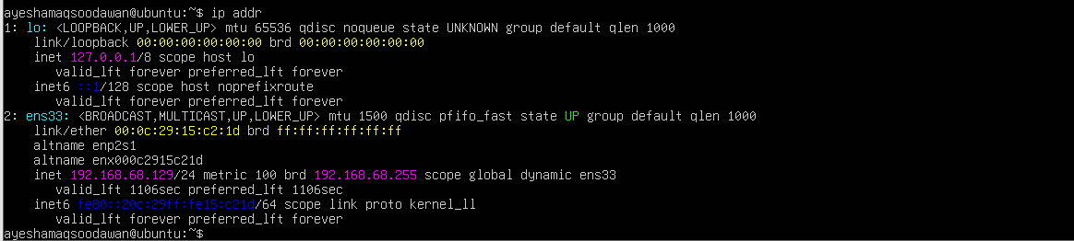
ubuntu_ip_addr_command.png

ubuntu_ip_address.png

Task 17:Connect to ubuntu Server from windows
Screenshot 1:
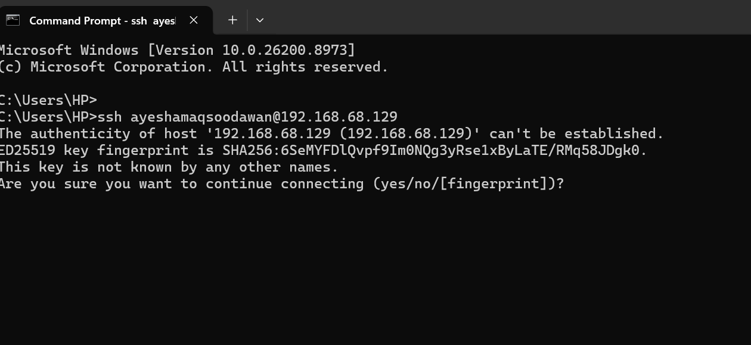
Screenshot 2: Accetped SSH server fingerprint
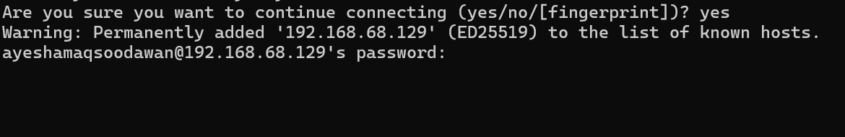

Screenshot 3: Successful SSH session from windows.
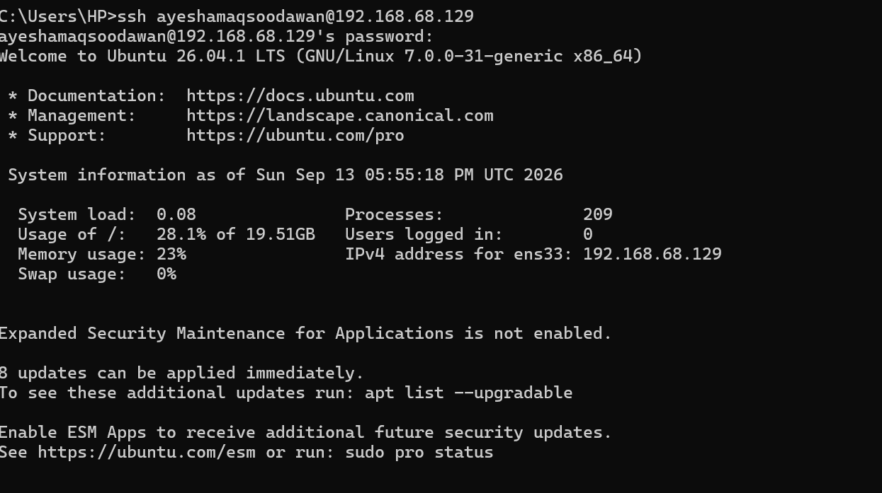

Screenshot 4: Remote SSH prompt showing <github-username>@ubuntu
