**ASSIGNMENT QUESTIONS ON DIGITAL MARKETING**

**NM ID: 97EA806B48B36579261455C290969965**

**Project name: Creating a Social Media Ad Campaign in Facebook**

**1.Create a bog website using Blogspot and Wordpress. Customize the theme design and post new article with 500 words.**

**BLOGGER LINK:**

**https://oceanbreezeeresorts.blogspot.com/**

**WORDPRESS LINK:**

**2.Create a New Facebook Buisness Page and Post one social media poster of your brand.**

**FACEBOOK LINK:**

**https://www.facebook.com/Breezeeocean/**

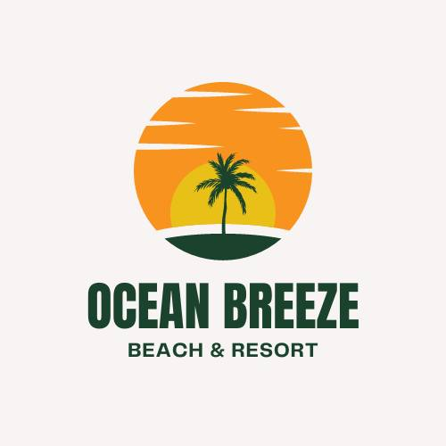

**3.Create and Design a social media advertisement poster using canva.**

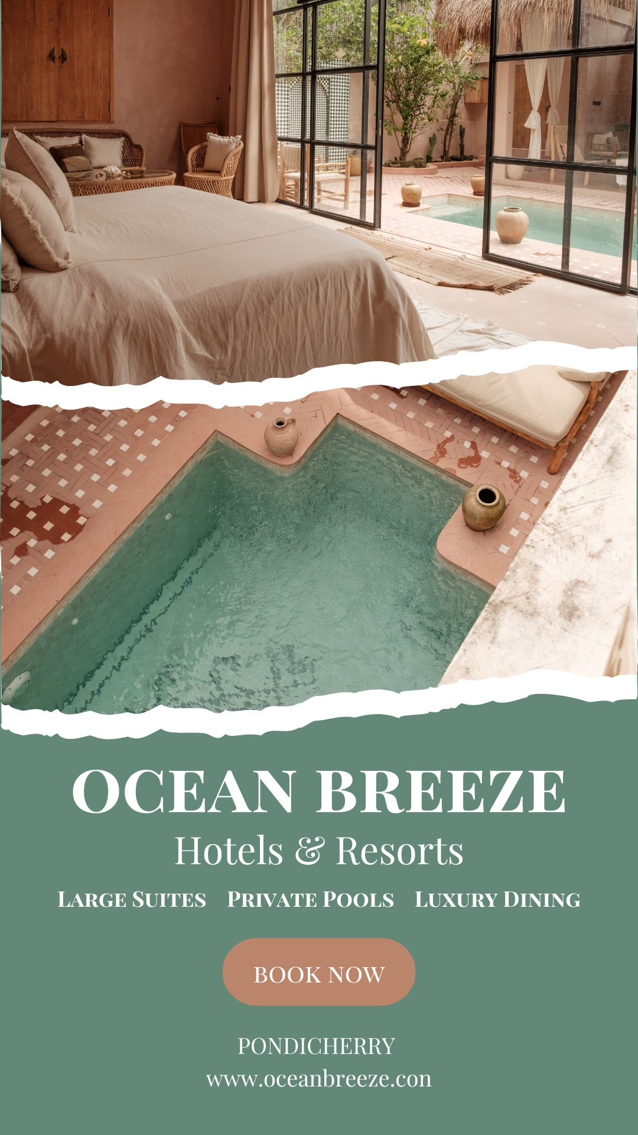

**4.Create email newsletter design using MailChimp or Canva tool.**

