Contents
ABSTRACT: 3
AN ABSTRACT ART: 3
INTRODUCTION: 4
OBJECTIVES 5
MATERIALS AND METHODS 6
RESULT AND DISCUSSION 7
SOLUTION TO OVERCOME 8

lab task #02
report writing
impacts of global warming on climate change

ABSTRACT:
Global warming is intensifying climate change, causing rising temperatures, more frequent and severe extreme weather events like floods, droughts, and heatwaves, and significant sea level rise due to melting ice. These impacts threaten ecosystems, food security, water supplies, and human health, leading to displacement and potential conflict. Efforts to limit warming and adapt to changes are essential to reduce the severe consequences on societies and environments worldwide.
Global warming results from the increasing concentration of carbon dioxide (CO2) and other greenhouse gases that trap heat in the earth's atmosphere. This trapped energy comes from incoming solar radiation absorbed by the earth's surface and re-radiated back into the atmosphere as infrared energy. An abstract on the impacts of global warming on climate change highlights that human activities, especially fossil fuel combustion and deforestation, have caused increased greenhouse gas emissions, leading to global warming and resultant climate change. The impacts are widespread, affecting human systems, biodiversity, and ecosystems, posing a significant threat to human civilization and necessitating urgent global.

AN ABSTRACT ART:


An abstract on the impacts of global warming on climate change highlights that human activities, particularly burning fossil fuels and deforestation, are increasing greenhouse gases and raising global temperatures, leading to severe consequences such as rising sea levels, more extreme weather events (floods, droughts, storms), melting glaciers, disruptions to ecosystems, threats to food security, and negative effects on human health. A typical 2022 abstract about the impacts of global warming on climate change emphasizes human-induced global warming causing widespread adverse effects on natural and social systems, including increased severe heat, floods, droughts, and wildfires, affecting health, agriculture, freshwater supplies, and causing displacement and increased vulnerability for marginalized communities.

INTRODUCTION:
Global warming, the increase in Earth's average temperature, is the primary driver of climate change, causing significant impacts such as rising sea levels from melting ice, more frequent and intense extreme weather events like heatwaves and floods, shifts in plant and animal habitats, disruptions to water supplies and agriculture, and increased ocean acidification. These changes threaten human health and infrastructure, with disproportionate impacts on vulnerable communities and ecosystems worldwide. Global climate change is now widely recognised as one of the foremost – perhaps the foremost – environmental challenge of the 21st century.
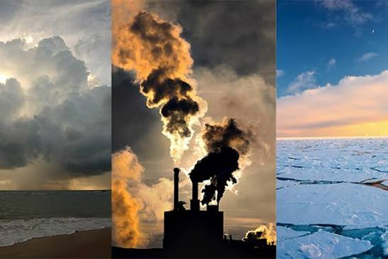
The evidence for human influence on climate change through emissions of greenhouse gases (mainly carbon dioxide from fossil fuel burning, and methane from various sources), is now very strong. Climate change has importance for health in two main ways. First, some degree of climate change now appears inevitable, which means it is necessary to learn to adapt to climate change and to consider how to protect the population against its adverse effects. Those adverse effects include direct effects of extreme weather, changes in the frequency, distribution or burden of ‘climate-sensitive diseases, and indirect effects operating through such mechanisms as changes to crop production and water availability. At the same time, major changes are needed in all sections of the economy to try to reduce human influence on climate change through reduction of greenhouse gas emissions .

OBJECTIVES:
The primary objectives related to the impacts of global warming on climate change are to mitigate global warming by reducing greenhouse gas emissions to limit temperature increases (e.g., the Paris Agreement's goal of < 2°C, striving for 1.5°C), adapt to unavoidable impacts by reducing vulnerability and building resilience in communities and infrastructure, improve understanding of the science to increase awareness and inform action, and integrate climate action into broader policies to achieve sustainable and resilient societies.
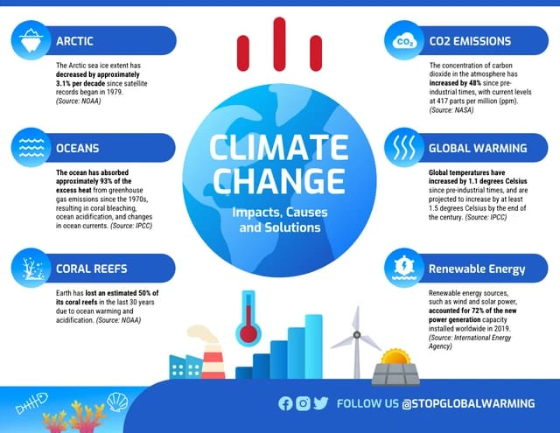

The goals of climate change adaptation are to reduce risk and vulnerability to climate change, strengthen resilience, enhance well-being and the capacity to anticipate, and respond successfully to change.
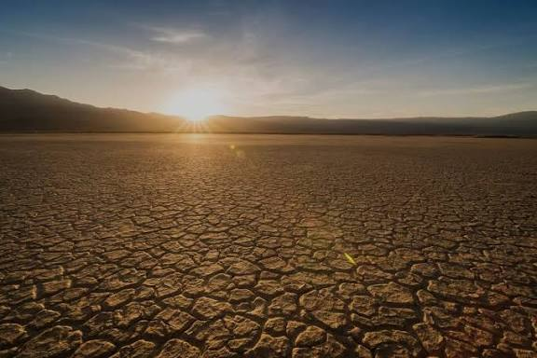
MATERIALS AND METHODS:
To assess the impacts of global warming on climate change, researchers use a combination of observational data and climate models to analyze long-term temperature and precipitation trends, ice mass changes, and sea level rise. The observed impacts include more frequent and intense heat waves, droughts, floods, and storms, alongside rising sea levels from melting ice sheets and thermal expansion of seawater. Materials include satellite imagery, historical weather station data, and ice core samples, while methods involve statistical analysis of these datasets and complex computer simulations to project future climate scenarios.
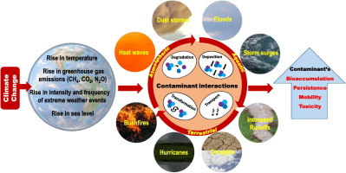
When fossil fuels such as oil and coal are burned for power generation and automobiles, carbon dioxide and other greenhouse gases are produced. In addition, recent deforestation has reduced the amount of carbon dioxide absorbed by trees, which is also a contributing factor to global warming.
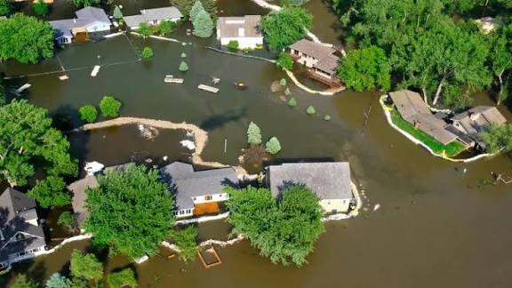
RESULT AND DISCUSSION:

Global warming's impacts on climate change are severe and widespread, including rising global temperatures, melting ice, and sea-level rise that threaten coastal communities. These changes intensify extreme weather events like droughts, heatwaves, and storms, while also disrupting ecosystems, increasing ocean acidification, impacting food and water security, and posing significant risks to human health and economies.
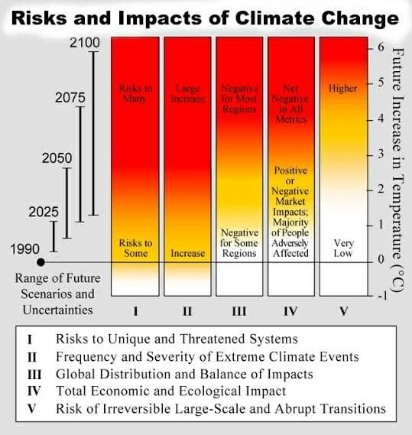

Glaciers and ice sheets are shrinking, river and lake ice is breaking up earlier, plant and animal geographic ranges are shifting.
SOLUTION TO OVERCOME:
To overcome the impacts of global warming, solutions focus on reducing emissions by transitioning from fossil fuels to renewable energy, improving energy efficiency, and adopting sustainable transportation. Additionally, removing carbon from the atmosphere through reforestation and technological solutions like direct air capture is crucial. Lastly, adapting to unavoidable impacts by investing in adaptation strategies like early warning systems and infrastructure improvements is also necessary.
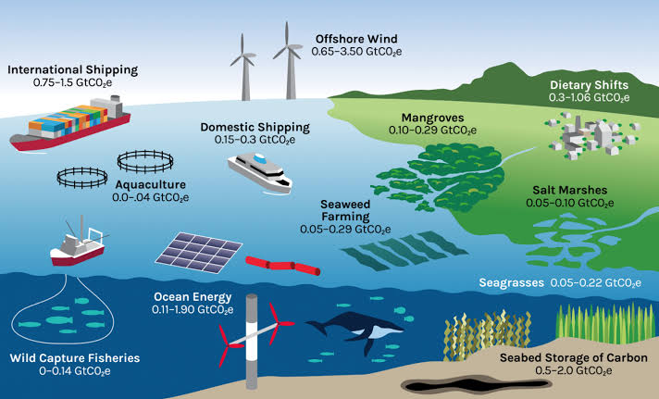

"If you really thinks that the environment is less important then economy try holding your breath while you count your money"

" WE HAVE TO WAKE UP TO FIERECE URGENCY OF THE NOW. "

