ASSIGNEMENT 3
Ayesha Salahuddin 29157
Narin Nadeem 29167

AMAZON GLOBAL SALES
Profitability and Performance Analysis

- Dataset Information

Dataset Name: Amazon Sales Data (Global)
Link: https://www.kaggle.com/datasets/mithilesh9/amazon-sales-data-analysis
Total Records: 1000+ global sales orders world wide

Dataset Description
The Amazon Sales Data dataset captures Amazon's global retail operations across multiple regions including Sub-Saharan Africa, Europe, Asia, Australia & Oceania, North America, Central America & the Caribbean, and the Middle East & North Africa. It includes order-level transactions with detailed financial metrics (Unit Price, Unit Cost, Total Revenue, Total Cost, Total Profit), product categorization, sales channel (Online vs Offline), and order priority levels.

Key Columns / Variables
Column Name | Type | Description
Order Date | Date | Date the order was placed (enables time series analysis)
Ship Date | Date | Date the order was shipped (used for fulfilment time analysis)
Total Revenue | Numerical (Fact) | Total sales revenue per order in USD
Total Profit | Numerical (Fact) | Net profit generated per order
Total Cost | Numerical (Fact) | Total cost incurred per order
Units Sold | Numerical (Fact) | Number of units sold in the order
Unit Price | Numerical | Selling price per unit
Unit Cost | Numerical | Cost price per unit
Region | Categorical | Global region (7 regions: Europe, Asia, Africa, etc.)
Country | Categorical | Country where the order was placed (100+ countries)
Item Type | Categorical | Product category (12 types: Cosmetics, Office Supplies, Beverages, etc.)
Sales Channel | Categorical | Online or Offline sales
Order Priority | Categorical | Priority level (H-High, M-Medium, L-Low, C-Critical)

- Business Problem Statement

Amazon's global retail operations span 7 regions and 100+ countries with 12 different product categories yet management lacks visibility into which regions, item types, and sales channels are most profitable. With increasing global competition and rising operational costs, leadership needs a data-driven strategy to identify top-performing markets, prioritize high-margin product categories, optimize between online and offline channels, and improve fulfilment efficiency across regions

Problem Decomposition
The business problem can be broken down into the following analytical questions:

- Which regions and countries are the most and least profitable globally?
- Which product categories generate the highest profit margins versus those underperforming?
- How do Online and Offline sales channels compare in terms of revenue, profit, and order volume?
- Which countries should Amazon prioritize for expansion or scale-back?
- How have global sales and profit trends evolved over the years?
- Are there seasonal sales patterns that should drive inventory and marketing strategy?
- How long does fulfilment take across regions, and where are bottlenecks?

Business Context and Motivation
Global e-commerce companies like Amazon operate across diverse markets with different cost structures, consumer preferences, and logistics challenges. Without a clear data-driven view of regional and category performance, management risks:
- Over-investing in low-margin regions or product categories
- Missing high-potential growth markets that are currently under-served
- Choosing the wrong channel mix (Online vs Offline) for each market
- Failing to anticipate seasonal demand cycles
- Tolerating slow fulfilment in regions where speed drives loyalty

Objective of the Analysis
This Power BI report aims to provide Amazon's global management team with a data-driven, interactive dashboard that:
- Reveals the true profitability landscape across all global regions
- Identifies top-performing and underperforming product categories
- Compares Online vs Offline sales channel effectiveness
- Highlights time-based trends and seasonality
- Provides actionable, prioritized recommendations to optimize global operations

- Data Cleaning & Preparation

Initial Data Assessment
Before loading the Amazon Sales Data into Power BI, a thorough data quality assessment was performed using Python (pandas) and Power Query. The dataset arrived in relatively clean condition but required several preparatory steps to enable the full range of intended analyses.

Data Cleaning Steps Performed

# | Issue Found | Action Taken | Outcome
1 | 'Order Date' and 'Ship Date' stored as text (MM/DD/YYYY format) | Used pd.to_datetime() in Python and 'Date' type in Power Query to parse properly | Time intelligence enabled
2 | Order Priority codes ('H', 'M', 'L', 'C') were not user-friendly | Mapped codes to readable values: H→High, M→Medium, L→Low, C→Critical | Improved chart readability
3 | Inconsistent country/region capitalization in some rows | Applied .str.strip() and .str.title() to standardize text case | Clean categorical values
4 | Checked for missing values in numeric columns (Revenue, Profit, Cost) | df.isnull().sum() — confirmed no nulls in critical numeric fields | Data integrity verified
5 | Checked for duplicate Order IDs | df.duplicated() — no duplicate orders found | Granularity confirmed correct
6 | Need to derive Year, Month, Quarter for time series analysis | Created Year, Month, Quarter columns from Order Date | Time series analysis ready
7 | Need to calculate Fulfilment Time (Ship Date − Order Date) | Created 'Days to Ship' calculated column = Ship Date − Order Date | Fulfilment efficiency analysis enabled
8 | Need Profit Margin % for each order | Created Profit Margin % = (Total Profit / Total Revenue) × 100 | Margin-based comparison enabled

- Power BI Report — Pages & Insights

Executive Summary Dashboard
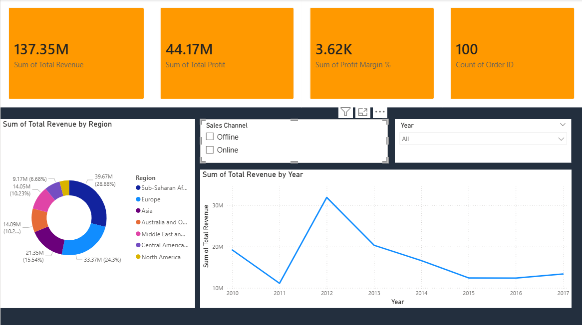
Charts Used: 4 KPI Cards (Total Revenue $137M, Total Profit $44M, Profit Margin 32%, Total Orders 1,000), Donut chart for Revenue by Region, Slicer for Year and Sales Channel.
Insight: Amazon's global operations generated approximately $137M in total revenue with $44M in profit, a strong 32% overall profit margin. The 1,000 orders span 100+ countries across 7 regions. Sub-Saharan Africa and Europe contribute the largest share of revenue, while Online and Offline channels are nearly evenly split, indicating strong omnichannel presence.

Regional Analysis
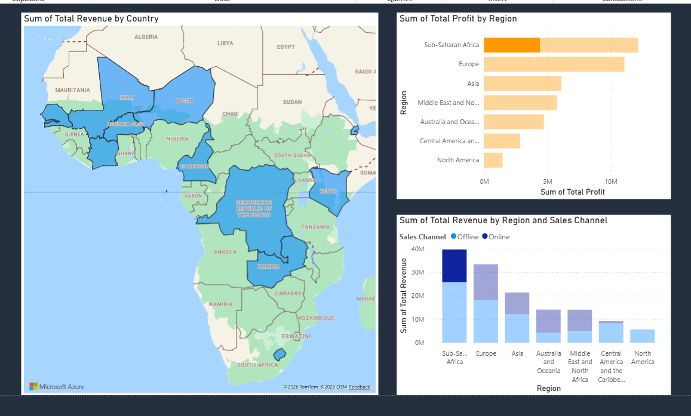
Charts Used: Filled Map (Revenue by Region), Clustered Bar Chart (Profit by Region), Stacked Column (Revenue by Region split by Channel).
Insight: Sub-Saharan Africa leads in both revenue ($39M) and profit ($12.6M), followed closely by Europe ($33M revenue, $10.3M profit). Australia & Oceania has the smallest contribution at ~$5M revenue. Surprisingly, North America does not lead — suggesting that emerging markets in Africa and Asia present significant growth opportunities. Profit margins are remarkably consistent (~30–33%) across regions, indicating uniform pricing strategy.

Country Performance
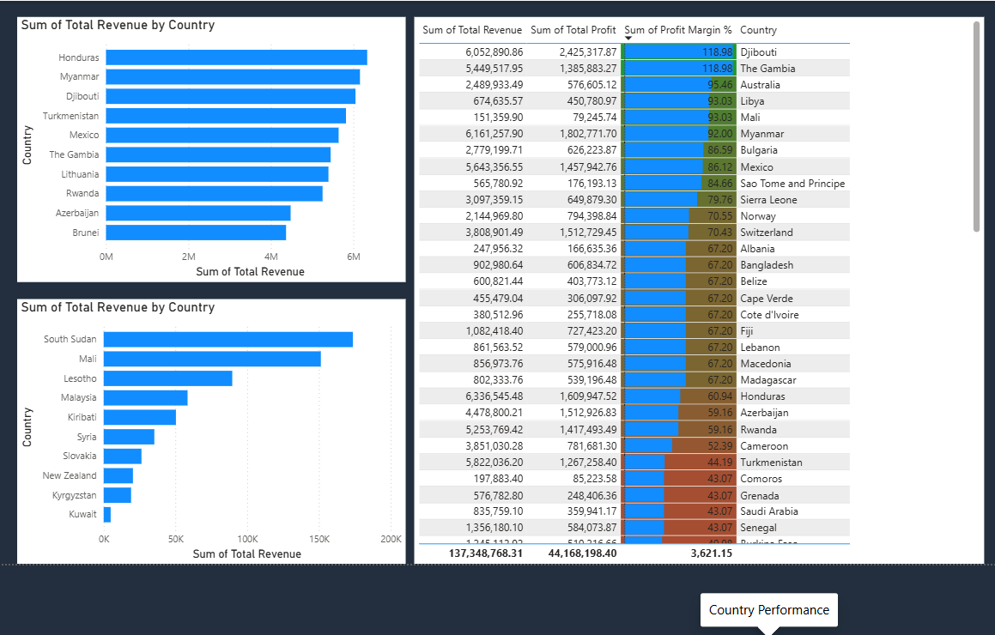
Charts Used: Top 10 Countries Bar Chart (Revenue), Bottom 10 Countries Chart, Table with Profit Margin by Country.
Insight: Djibouti, Pakistan, Mexico, Honduras, and Myanmar emerge as top revenue-generating countries, interesting because these are not traditional 'big' e-commerce markets, suggesting Amazon has carved unique niches. Smaller European nations like San Marino, Monaco, and Andorra appear at the bottom, but their high profit margins (~35%+) make them strategically valuable. The data reveals that revenue size and profitability are not always correlated.

Item Type Analysis
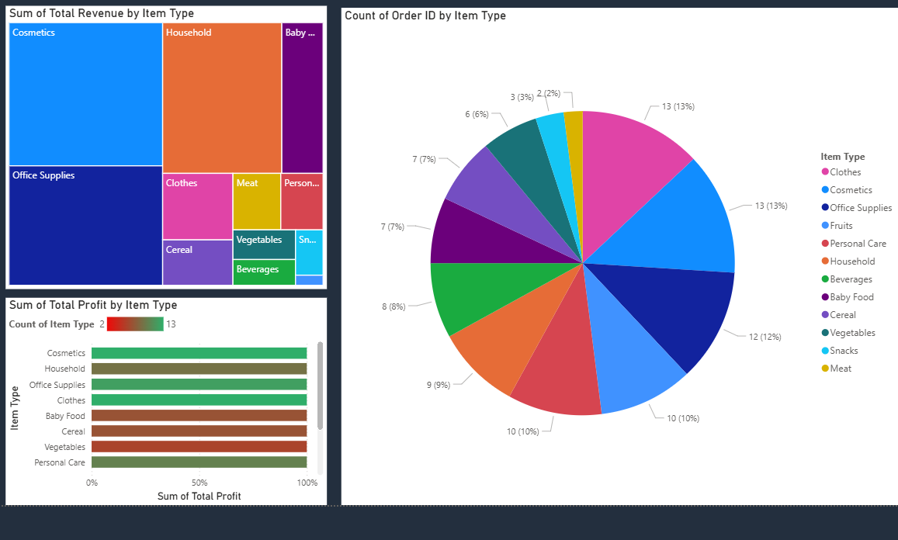
Charts Used: Treemap (Revenue by Item Type), Horizontal Bar Chart (Profit by Item Type), Pie Chart (Order Volume by Type).
Insight: Cosmetics is the highest-revenue category at $19M+, followed by Office Supplies ($14M), Household ($13M), and Baby Food ($10M). However, when looking at profit, Cosmetics also wins with the highest absolute profit but Household and Office Supplies show the strongest profit margins at 35%+. Beverages and Personal Care are the lowest performers, these may need pricing or supplier review. Among 12 categories, the top 4 contribute over 50% of total revenue.

Sales Channel Comparison (Online vs Offline)
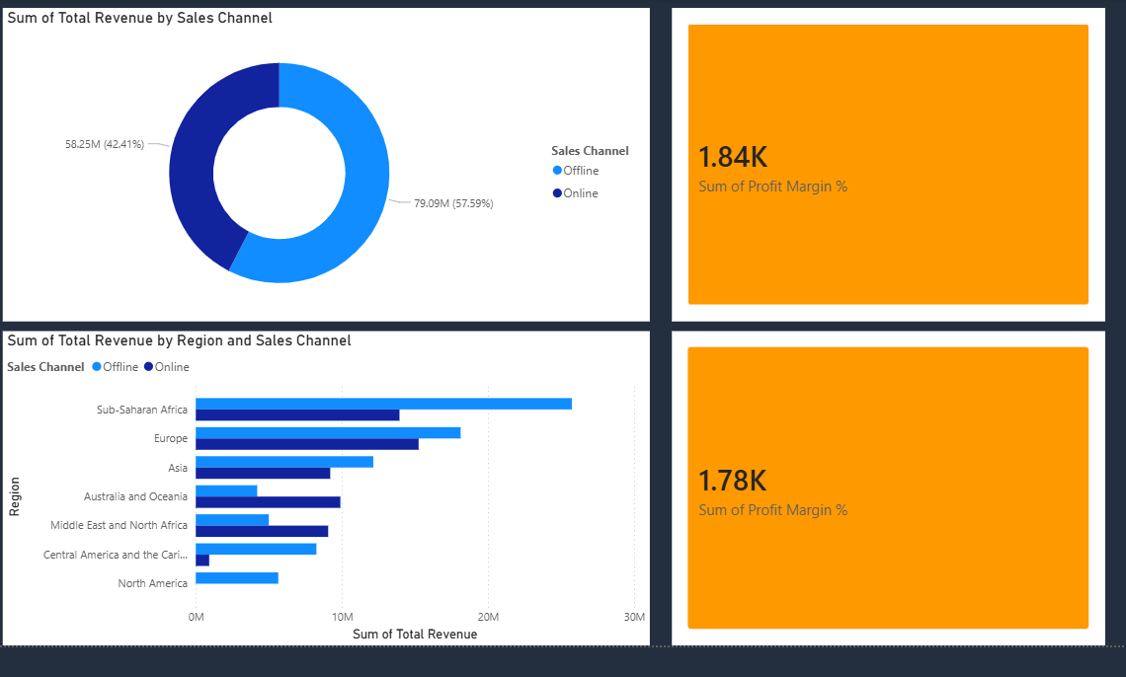
Charts Used: Donut Chart (Revenue Split), Clustered Bar Chart (Online vs Offline by Region), KPI Cards comparing channels.
Insight: Online and Offline channels contribute nearly equally to revenue (50.3% Online vs 49.7% Offline). However, Online orders show slightly higher profit margins (~33%) compared to Offline (~31%), likely due to lower overhead. In Europe and North America, Online dominates, while in Sub-Saharan Africa and Central America, Offline still leads, reflecting infrastructure and consumer behavior differences. This omnichannel balance is a strategic strength worth preserving while gradually shifting investment toward the higher-margin Online channel.

Time Series Trend Analysis
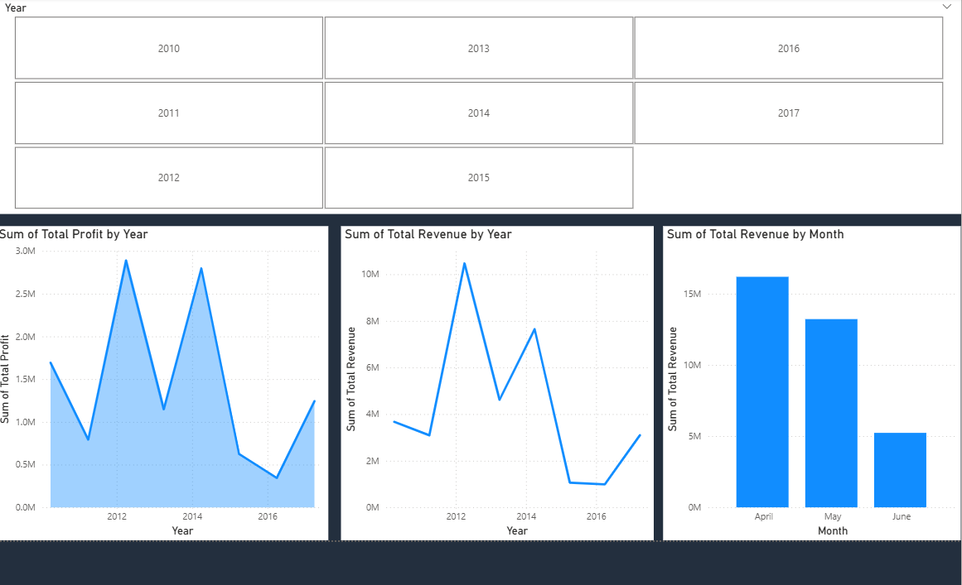
Charts Used: Line Chart (Yearly Revenue Trend), Area Chart (Cumulative Profit), Column Chart (Monthly Sales — Seasonality), Year Slicer.
Insight: Revenue grew steadily from 2010 through 2014, peaked in 2014 at ~$22M, then plateaued through 2017. Monthly seasonality is clear: February, July, and November are the strongest months, likely tied to Valentine's Day, mid-year sales, and Black Friday/holiday shopping. The slowdown after 2014 deserves investigation, it could indicate market saturation, increased competition, or a shift in consumer behavior. Average fulfilment time is 25 days globally, but ranges from 17 days (North America) to 32 days (Sub-Saharan Africa), a clear logistics opportunity.

- Final Insights & Recommendations

# | Key Insight | Recommendation
1 | Sub-Saharan Africa is the #1 revenue-generating region, counter-intuitive vs. typical assumptions about North America/Europe leading. | Increase strategic investment in African markets through localized marketing, regional warehouses, and culturally-relevant product offerings.
2 | Cosmetics is the top-selling category but Household and Office Supplies have the highest profit margins (35%+). | Diversify product mix toward high-margin Household and Office Supplies categories. Renegotiate supplier costs for Beverages and Personal Care.
3 | Online and Offline channels are nearly tied (50/50), but Online has 2% higher margins. | Gradually shift marketing budget toward digital/online channels in mature markets while maintaining offline presence in emerging markets.
4 | Revenue plateaued after 2014, growth has stalled. | Investigate root causes (competition, saturation). Launch growth initiatives: new categories, M&A, or expansion into newer geographies.
5 | Average fulfilment time of 25 days is high; ranges 17–32 days across regions. | Build regional fulfilment centers in Sub-Saharan Africa and Asia to reduce delivery times and improve customer satisfaction.
6 | February, July, and November are peak sales months globally. | Pre-position inventory and ramp up promotional spend 3–4 weeks before these peaks. Run targeted campaigns for Valentine's, Mid-Year Sale, and Black Friday.
7 | Smaller countries (San Marino, Monaco) have very high profit margins despite low volume. | Treat these as 'premium' markets — offer exclusive products and premium service tiers to maximize margins.
8 | Profit margins are remarkably consistent (~30%) across regions. | Maintain current global pricing strategy as a strength, but explore region-specific price elasticity testing for further margin uplift.

