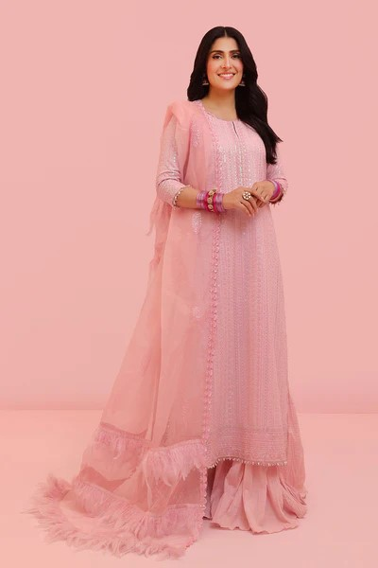**PRODUCT DESCRIPTION:**

**Primrose:**

The pastel pink bloom adorned by Ayeza Khan is a 3 pc unstitched outfit. The lawn shirt is enhanced with a beautiful orchestration of sequins in a monochrome fashion; the heavily glimmering sequins are a reflection of our muse’s charm and playful persona. An intricately designed sequin motif is scattered all over the organza dupatta; the ensemble is completed with lawn dyed pink trousers.

**PRODUCT DETAIL:**

* DYED EMBROIDERED LAWN FRONT
* DYED EMBROIDERED LAWN SLEEVES
* DYED LAWN BACK
* DYED EMBROIDERED ORGANZA DUPATTA
* DYED LAWN TROUSER
* EMBROIDERED BORDERS